STAV | 2000 | BIOLOGY | Written examination 2

SECTION A – Multiple-choice questions

Question 1
Twenty per cent (20%) of the nucleotide bases in human DNA are cytosine (C). What is the percentage of adenine (A) bases in human DNA?
- 40
- 30
- 20
- 80

The diagram below shows a simplified model of a part of a DNA molecule.
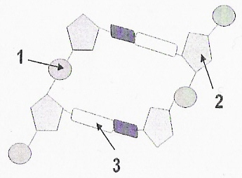

Question 2
The parts labelled 1, 2 and 3 are respectively
- nucleotide base, phosphate group, and sugar molecule
- nucleotide base, sugar molecule and phosphate group
- phosphate group, nucleotide base, and sugar molecule
- phosphate group, sugar molecule, and nucleotide base

Question 3
DNA replication is part of the overall process of
- protein synthesis
- transcription
- mitosis
- translation

Question 4
As a result of meiosis, cells that are normally formed may be described as
- haploid
- diploid
- triploid
- polyploid

Question 5
In which of these examples would you expect to find two different sets of genetic information?
- Two liver cells, one in each of two identical (monozygotic) twins.
- Two nerve cells in the same person.
- A liver cell and a nerve cell in the same person.
- Two sperm cells in the same person.

Question 6
Which one of the following events can cause Down syndrome (Trisomy 21)?
- The failure of a homologous pair of autosomes to separate during the second division of meiosis.
- The failure of sister chromatids to separate during the second division of meiosis.
- The fusion of a gamete containing an extra sex chromosome with a normal gamete.
- The formation of a gamete without a sex chromosome during the second division of meiosis.

Question 7
If a fertilised ovum splits early in development, two genetically identical offspring (identical twins) can be produced. Close friends of identical twins can usually identify each one correctly. This can be explained by
- the influence of the environment on the phenotype
- incomplete dominance of each twin’s alleles
- random segregation of the chromosomes in the development of the mother’s ovum
- crossing over of chromosomes during meiosis

The next four items refer to the following information

In his famous experiments with garden peas, Gregor Mendel found that the allele for purple flowers P is dominant over the allele for white flowers p. The allele for smooth seeds S is dominant over the allele for wrinkled seeds s.

Mendel crossed a plant that was pure breeding for purple flowers and wrinkled seeds with a plant that was pure breeding for white flowers and smooth seeds.

Question 8
The genotypes of the plants used in the cross were
- PpSs and PpSs
- ppSs and Ppss
- ppss and PPSS
- PPss and ppSS

Question 9
It would be expected the phenotypes of the offspring of this cross would be
- all purple flowered with smooth seeds
- all purple flowered with wrinkled seeds
- all white flowered with smooth seeds
- all white flowered with wrinkled seeds

Question 10
When Mendel crossed the offspring of the original cross, he found a ratio of 9:3:3:1 in the four phenotypes of the plants that grew in the next generation. From this we can conclude that
- the genes for purple/white flower colour and smooth/wrinkled seeds are both on the same chromosome
- the genes for purple/white flower colour and smooth/wrinkled seeds are on homologous chromosomes
- the genes for purple/white flower colour and smooth/wrinkled seeds are on different chromosomes
- crossing over has rearranged the distribution of the genes for purple/white flower colour and smooth/wrinkled seeds during meiosis in one of the plants

Question 11
The following gametes are produced by two different pea plants.
Plant 1: TV, Tv, tV, tv
Plant 2: tv, tv, tv, tv
The genotypes of plant 1 and plant 2 would be
- TtVv and TtVv
- Ttvv and ttvv
- TtVV and ttvv
- TtVv and ttvv

The family tree below shows the inheritance of a disease in a human family.
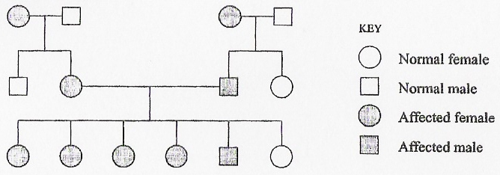

Question 12
This pedigree suggests that the disease is inherited as
- sex-linked and dominant
- sex-linked and recessive
- autosomal and dominant
- autosomal and recessive

Question 13
When two genes are far apart on the same chromosome, they are not always inherited together. The explanation for this is that
- random assortment of chromosomes during meiosis separates them
- mutations cause them to separate
- random segregation of the chromosomes is less likely to occur during gamete formation
- mutations are less likely to occur in rearranged chromosomes

Question 14
The advantage of genes on the same chromosomes failing to be inherited together is that
- there is an increase of genetic variation in the gametes
- this prevents gametes from being clones
- random segregation of the chromosomes is less likely to occur during gamete formation
- mutations are less likely to occur in rearranged chromosomes

The next two questions refer to the following information

The geneticist T.H Morgan worked with the fruit fly, Drosophila melanogaster. He obtained some interesting results when he was investigating flies with different coloured bodies (the wild-type body Bi is dominant over the black body b) and different wing lengths (the wild-type normal wing V is dominant over the vestigial or very small wing). When he crossed Drosophila of known genotypes, BbVv × bbvv, there were 2300 flies produced. Morgan had expected to see four phenotypes in the ratio of 1:1:1:1, but this was not what he observed.

The Table below shows the results that Morgan observed in the 2300 offspring of the cross.

Genotypes | BbVv | bbvv | Bbvv | bbVv
Phenotypes | grey,  normal wings | black,  small wings | grey,  small wings | black,  normal wings
Expected Results | 575 | 575 | 575 | 575
Observed results | 965 | 944 | 206 | 185

Question 15
Why would Morgan have expected a phenotype ratio of 1:1:1:1?
- He was performing a test cross and this is always the restful of a dihybrid test cross.
- When a dihybrid cross between homozygous dominant and homozygous recessive flies occurs this is always the ratio of offspring phenotypes observed.
- He expected that the genes for body colour and wing size were located on different chromosomes.
- He expected that the genes for body colour and wing size were located on the same chromosome.

Question 16
The recombinant frequency that Morgan observed in this experiment is calculated as
- 206/965
- 185/944
- 391/1909
- 391/2300

Question 17
One form of gene mutation is caused by the addition of one extra base pair to the DNA of the gene. This type of mutation is called a
- deletion mutation
- point mutation
- inversion mutation
- lethal mutation

Question 18
The age of the Earth is an important piece of evidence scientists use to support the theory of evolution. The best scientific estimate is
- 45 billion years
- 4.5 billion years
- 4.5 million years
- 4500 years

Question 19
Huntington disease is an autosomal dominant disorder that does not usually appear in an individual until after the normal reproductive age. Natural selection does not usually change the frequency of the alleles of the genes of this disease because
- the genes are not present in the foetus
- sperm carrying the affected genes do not survive
- the disease does not affect reproductive behaviour
- the allele that produces the disease is dominant

Question 20
An echidna and a South American anteater have certain features in common. They both eat ants, they have front claws adapted to digging and they have a tongue that is capable of picking up ants. These similarities have arisen because the two species
- have a recent common ancestor
- are both mammals
- show adaptations to similar factors in their environment
- belong to the same genus

Question 21
The wings of bats and the wings of birds both have five major bones that determine the shape of the limb. This means that
- birds and bats have a recent common ancestor
- bird’s wings and bat’s wings are analogous structures
- the formation of bird’s wings and bat’s wings is determined by the same genes
- bird’s wings and bat’s wings are homologous structures

Question 22
Scientists have found many skeletons of organisms that closely resemble humans. In particular they have found two that they have called Homo erectus and Homo habilus. They think that
- Homo habilus evolved into Homo erectus
- Homo erectus evolved directly into Homo sapiens
- Homo sapiens evolved from chimpanzees
- Homo erectus and Homo habilus belong to the same genus

Question 23
Scientists working in Africa have found a set of footprints in rock that was derived from volcanic ash. The footprints resemble human footprints and are of slightly different shapes and sizes. All the footprints show a clear heel, instep and short toes. No handprints are found in this set of fossils. The rock is about 4.5 million years old. They think that this means that
- the organisms that made the prints had knee structures that allowed them to walk upright
- the fossil footprints were made by chimpanzees running across the hot ash
- the fossil footprints are now in metamorphic rock
- the fossil footprints were made in conditions of low oxygen

Question 24
A geologist found a fossil shell in limestone. He found a fossil insect in sandstone above the limestone. Thirty kilometres away he found a fossil plant in mudstone that was below limestone containing the same fossil shells. He thought that he could regard the shell fossil as an index fossil. This meant that
- the sandstone had to be older than the limestone
- the mudstone had to be younger than the limestone
- the two samples of limestone were the same age
- he could not tell the relative age of the limestone until he had it dated by radiometric means

Examine the diagrams of four skulls of various primates shown in the figure below.
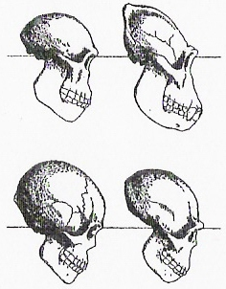

Question 25
Which of the following characteristics is least important in distinguishing a hominid skull from other primate skulls?
- eyebrow ridge
- protruding jaw
- relatively small brain case
- the presence of incisor teeth

SECTION B – Short-answer questions

Question 1
The diagram below shows part of an amino acid sequence of a polypeptide.
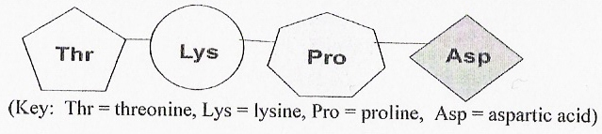

- At what cellular organelle would this peptide be assembled?
________________________________
1 mark
Messenger RNA (mRNA) is the molecule that carries the instructions for the assembly of the peptide. The instructions are in the form of a sequence of bases that are read in groups of three.

- What is the name given to a group of three bases in mRNA that codes for the addition of an amino acid to a growing peptide chain?
________________________________
1 mark
- The four bases found in mRNA are usually abbreviated to the letters that begin their names. Complete the names of these bases below.
U ______________________________
C. ______________________________
A. ______________________________
G ______________________________
2 marks

The Table below can be used to determine the relationship between base sequences and amino acids in the peptide. Use it to write a possible base sequence for the mRNA that coded for the peptide above. (You may ignore start and stop instructions.)

 |  | U |  | C |  | A |  | G
 | U | UUU  UUC  UUA  UUG | phenylalanine  phenylalanine  leucine  leucine | UCU  UCC  UCA  UCG | serine  serine  serine  serine | UAU  UAC  UAA  UAG | tyrosine  tyrosine  stop  stop | UGU  UGC  UGA  UGG | cysteine  cysteine  stop  tryptophan
 | C | CUU  CUC  CUA  CUG | leucine  leucine  leucine  leucine | CCU  CCC  CCA  CCG | proline  proline  proline  proline | CAU  CAC  CAA  CAG | histamine  histamine  glutamine  glutamine | CGU  CGC  CGA  CGG | arginine  arginine  arginine  arginine
 | A | AUU  AUC  AUA  AUG | isoleucine  isoleucine  isoleucine  methionine | ACU  ACC  ACA  ACG | threonine  threonine  threonine  threonine | AAU  AAC  AAA  AAG | asparagine  asparagine  lysine  lysine | AGU  AGC  AGA  AGG | serine  serine  arginine  arginine
 | G | GUU  GUC  GUA  GUG | valine  valine  valine  valine | GCU  GCC  GCA  GCG | alanine  alanine  alanine  alanine | GAU  GAC  GAA  GAG | aspartic acid  aspartic acid  glutamic acid  glutamic acid | GGU  GGC  GGA  GGG | glycine  glycine  glycine  glycine

- Possible mRNA sequence
_______________________________________________________________________________________
1 mark
- What is the name of the process that produces mRNA and where in the cell does this process occur?
Process name ___________________________________
Location in cell ___________________________________
1 mark
- Draw a carefully labelled diagram to show how the piece of mRNA that you identified in pard d. would have been produced.

3 marks
Total 9 marks

Question 2
The thirty or more varieties of wild potatoes that are found in South America are unpalatable, with a very bitter taste due to the presence of potentially toxic amounts of glycoalkaloids. They also carry many other undesirable characteristics concerned with shape and form of the tubers and low crop yield. Their chromosome number is 24, that is, 2n = 24.

For thousands of years, selective breeding has occurred. Potatoes with improved shape and yield and lower levels of glycoalkaloids have been selected and crossed. Today’s potatoes are tetraploid, that is, 2n = 48.

- What is “selective breeding”?
_______________________________________________________________________________________
_______________________________________________________________________________________
1 mark
- Julia could not decide if selective breeding had altered the genotype of phenotype of potatoes over time. Provide an explanation for Julia.
_______________________________________________________________________________________
_______________________________________________________________________________________
_______________________________________________________________________________________
_______________________________________________________________________________________
2 marks
- Describe how wild potatoes, 2n = 24, might have been used to breed modern potatoes, 2n = 48.
_______________________________________________________________________________________
_______________________________________________________________________________________
_______________________________________________________________________________________
1 mark

Although wild potatoes have many undesirable characteristics, it has recently been discovered that they have some very useful traits. Genes for resistance to viruses and insect attack have been isolated from wild potatoes. These genes may now be inserted into commercial potatoes using techniques of biotechnology.

- Describe one advantage of using biotechnology to insert new genes into commercial potatoes.
_______________________________________________________________________________________
_______________________________________________________________________________________
_______________________________________________________________________________________
1 mark
- What biological term is currently used to describe the commercial potatoes with new, beneficial, genes added?
_______________________________________________________________________________________
1 mark

To insert the new genes into potatoes, these genes are first cut from the DNA of the wild potato and inserted in bacterial plasmids. Enzymes are involved in the cutting and insertion of the pieces of DNA. From the bacteria, they are moved to another bacterium, Agrobacterium tumefaciens, which inserts the gene into developing potato plants.

- What is a bacterial plasmid?
_______________________________________________________________________________________
_______________________________________________________________________________________
1 mark
- What is the general name for enzymes used in biotechnology to cut DNA?
_______________________________________________________________________________________
1 mark

Current research is investigating the possibility of using potatoes to manufacture human blood proteins or drugs.

- Describe one advantage of using potatoes in this way.
_______________________________________________________________________________________
_______________________________________________________________________________________
_______________________________________________________________________________________
1 mark
Total 9 marks

Question 3
Ellis-van Creveld (EVC) syndrome is a rare genetic disorder carried by a gene on the short arm of chromosome 4. Individuals with EVC show a variety of phenotypic abnormalities. These include dwarfism, polydactyly (Additional fingers or toes), malformation of wrist bones, heart malfunction and very early appearance of teeth. About two-thirds of individuals with this syndrome survive to adulthood.

The pedigree below shows the inheritance of this syndrome in an Amish population in Lancaster, Pennsylvania, USA. Individuals II7 and III1 are shown in Figure 1a. The hand of individual III1 is shown in Figure 1b.
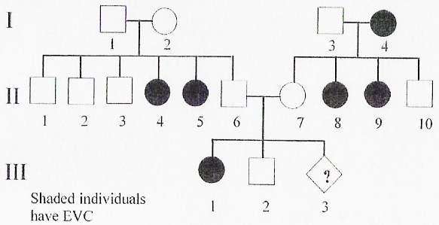

Figure 1 a and b  Left a An Amish woman with her daughter who has Ellis van-Creveld syndrome.  Right b The right hand of the infant in a. | 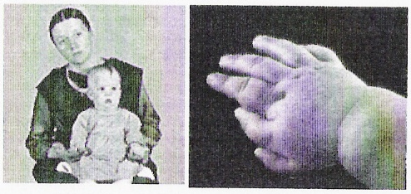

- State the mode of inheritance of EVC.
_______________________________________________________________________________________
1 mark
- Explain your answer to part a.
_______________________________________________________________________________________
_______________________________________________________________________________________
_______________________________________________________________________________________
1 mark

Individual III3 is a foetus at 12 weeks of pregnancy.

- What is the change that III3 will have EVC?
_______________________________________________________________________________________
1 mark
- Explain your answer to part c.
_______________________________________________________________________________________
_______________________________________________________________________________________
_______________________________________________________________________________________
2 marks

The foetus III3 was examine using ultrasound , an image of the hand is shown in Figure 2.

Figure 2. Image of the hand of foetus III3. | 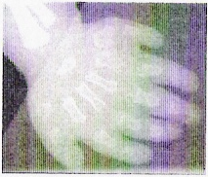

- Do you think that the baby will be born with EVC? Explain your answer.
_______________________________________________________________________________________
_______________________________________________________________________________________
_______________________________________________________________________________________
1 mark

Between the years of 1720 and 1755 about 300 Amish people moved from Germany to Pennsylvania to avoid religious persecution. The EVC syndrome can be traced back to one of these immigrant couples, Samuel King and his wife. Today there are approximately 30 000 Amish in Pennsylvania and the occurrence of EVC is about 5 per 1000 live births, compared to 1 per 150 000 live births in the rest of the USA.

- Explain how a relatively small population of Amish has developed such a high rate of EVC in their community.
_______________________________________________________________________________________
_______________________________________________________________________________________
_______________________________________________________________________________________
1 mark

There are other groups of Amish communities in other states of USA, but the occurrence of EVC in these groups is about 1 per 150 000 live births.

- Suggest an explanation for the lower rate of EVC in these other USA Amish communities.
_______________________________________________________________________________________
_______________________________________________________________________________________
1 mark
Total 9 marks

Question 4
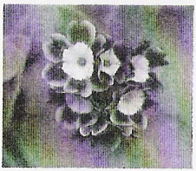
Marie’s friend Martin gave her two primula (Primula auricula) plants in a small pot for her birthday. She planted them in a window box. The plants were small annuals that grew to about 10 cm tall with flower stalks about another 10 cm tall. They produced flowers with attractive purple petals. See photo at right.

After Marie’s primula plants flowered in early spring, they produced seeds and died during summer. She forgot about the box until the next April.

When the seeds from the previous year germinated the window box became a carpet of seedlings. Marie counted 120 seedlings, all less than 1 cm tall. She did not think that all the seedlings would survive.

- Name 3 resources that individual plants would compete for in the window box.
_______________________________________________________________________________________
1 mark

Marie’s friend, Wendy, said that Marie could expect variation in some of the structures of her primula plants.

- Name two structures whose variation would affect the survival of the plants and explain how each affects the survival of the plant concerned.
Structure 1: ______________________________________________________________________________
Survival value: ___________________________________________________________________________
_______________________________________________________________________________________
Structure 2: ______________________________________________________________________________
Survival value: ___________________________________________________________________________
_______________________________________________________________________________________
2 marks

Over the next two years Marie’s primulas flowered and seeded and eventually she had 320 primula plants, some with purple flowers and some with white flowers, growing in the garden around her house.

Marie know of the Hardy-Weinberg law that is written in symbol form, as p² + 2pq + q² = 1. In this case p is the frequency of the allele for purple flowers (P) and q is the frequency of the allele for white flowers (p).

Marie did some tests on her primulas and found the frequency of the allele P for purple flowers to be p = 0.75, or ¾.

- What is the frequency of the allele, q, for white pigment?
_______________________________________________________________________________________
1 mark
- How many white flowering primula plants would Marie theoretically expect to find in her garden? Show your working.
_______________________________________________________________________________________
_______________________________________________________________________________________
_______________________________________________________________________________________
2 marks

Marie pulled purple-flowering plants out of her garden until she estimated that the frequency of allele P was 0.5.

- Describe the effect of the removal of many purple flowering plants on the frequency of theh p allele in the next generation of primula.
_______________________________________________________________________________________
_______________________________________________________________________________________
_______________________________________________________________________________________
2 marks
Total 8 marks

Question 5
Caribou (Rangifer tarandus caribou) are a type of reindeer that live in the tundra of Alaska.
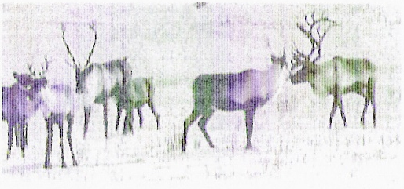

They spend winter in the mountains where the snow cover can be many metres deep. The shape of their antlers is ideal for moving snow. This allows them to find the lichen they need for food in the sinter.

Caribou are affected by grizzly bears, golden eagles, wolves and humans, all of which kill them at some season of the year. Vast herds of caribou make a long annual migration of 1,500 km from the mountains to the coast in spring. Their leg length ad leg muscles allow them to travel long distances. They arrive at the summer pastures in June where they give birth. The coastal pastures provide the nutrients the cows need to manufacture the rich milk their calves need.

- Name one abiotic factor that affects the survival of caribou.
_______________________________________________________________________________________
1 mark
- Name one biotic factor that affects the survival of caribou.
_______________________________________________________________________________________
1 mark

A series of studies was conducted to investigate the impact of various factors on the ability of caribou to survive.

- From the point of view of a biologist, define the term ‘survival’.
_______________________________________________________________________________________
_______________________________________________________________________________________
_______________________________________________________________________________________
_______________________________________________________________________________________
1 mark

There is evidence that global warming is affecting the caribou. Warmer winters trigger heavier than normal snow falls in the mountains. Snow depth affects the time that caribou spend actually eating. This is shown in the graph below.
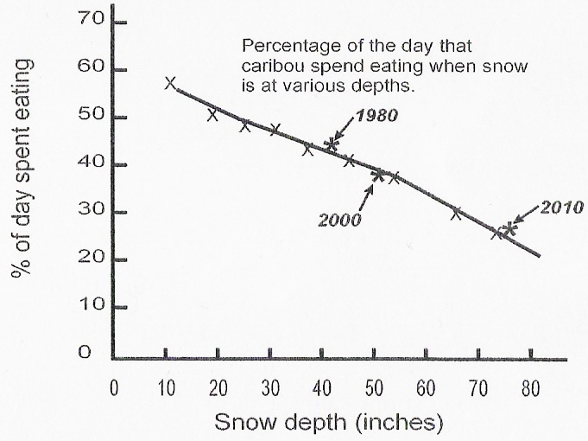

- What percentage of time did caribou spend eating in 1980?
__________________________________
1 mark
- What percentage of time do caribou spend eating in 2000?
__________________________________
1 mark
- Why do you think that there is a difference in the percentage in time eating figures for 1980 and 2000? Explain your answer.
_______________________________________________________________________________________
_______________________________________________________________________________________
_______________________________________________________________________________________
1 mark

Zoologists have observed that global warming makes the caribou journey to the coast slower since deeper snow is harder to walk through. It also increases the amount of water in the streams fed by the snowmelt. As well, warmer summers mean that coastal pastures are often past their best when the caribou arrive to calve.

This year, for the first time, the migration was the latest it has ever been. Cows were giving birth on the way. The combined effect of the late migration and higher than usual river levels meant that calves a few days old were forced to swim the Porcupine River when it was in flood. When the females and calves reached the coast at the beginning of July there was less than half as many calves as cows: a record low ratio.

- Taking all of the information in this question into account, explain what is likely to happen to the Alaskan caribou population if global warming continues to 2010 and beyond.
_______________________________________________________________________________________
_______________________________________________________________________________________
_______________________________________________________________________________________
_______________________________________________________________________________________
_______________________________________________________________________________________
_______________________________________________________________________________________
3 marks
Total 9 marks

Question 6
Many people do not consider humans to be properly classified as a species of the great apes. These people often consider the cultural behaviour of humans as enough to set them apart from the other great apes.

- Name on non-human great ape and describe a structure that it shares with the rest of the great apes.
Great ape: _______________________________________________________________________________
Structure and Description: ___________________________________________________________________
_______________________________________________________________________________________
2 marks

In the early 1930s a fossil skull was found in Southern Africa. It was considered at the time to be the “missing link” between ancestral apes and modern humans. It was classified and named Australopithecus africanus.

In 1974 the skeleton of a primate was found in the Afar triangle region of East Africa. The skeleton, which was almost complete, was thought to be of a female hominid. It was classified as a member of Australopithecus afarensis. It was named Lucy. The knee structure of Lucy was consistent with upright walking. The brain volume, as measured by the volume of the cranium, fell with in the range of other A.afarensis skulls and was similar to that of the Australopithecus africanus found earlier.

The brain volume of various species of hominids is shown in the graph below. Each dot represents data of one individual.
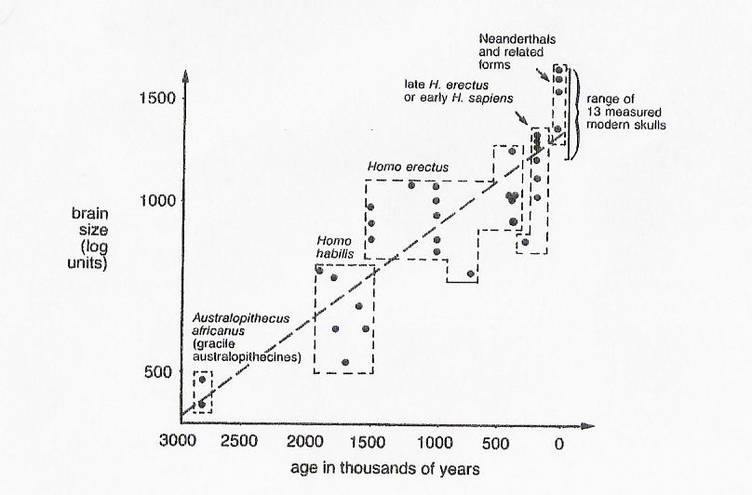

- Using the data in this questions and your knowledge of the biology of the change in hominid brain size over 3 million years explain whether brain size or upright stance evolved first.
_______________________________________________________________________________________
_______________________________________________________________________________________
_______________________________________________________________________________________
_______________________________________________________________________________________
2 marks
- Describe two advantages to individuals that possess upright stance.
I ______________________________________________________________________________________
_______________________________________________________________________________________
II _____________________________________________________________________________________
_______________________________________________________________________________________
2 marks
Total 6 marks

END OF EXAMINATION

