NEAP | 2003 | BIOLOGY | Written examination 2

SECTION A – Multiple-choice questions

Question 1
Semi conservative replication of DNA may best be represented as:
A. | 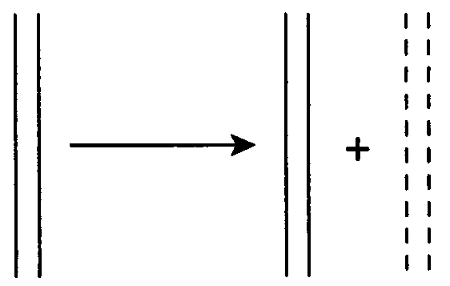 | B. | 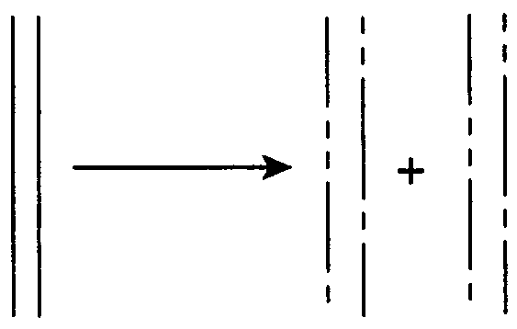 | C. | 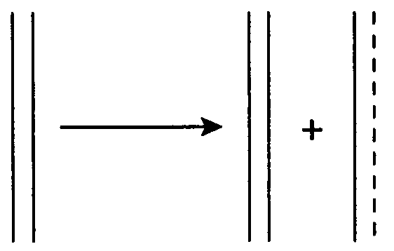 | D. | 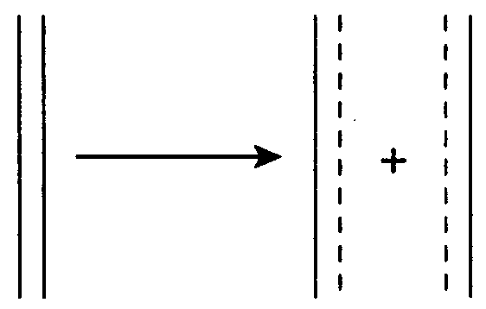

Question 2
Which of the following statements best describes the relationship between the genes and physical characteristics of a human?
- An individual’s gene pool determines all aspects of the phenotype.
- Proteins such as enzymes are part of the phenotype and may modify the genotype.
- Gene expression interacting with the environment produces the phenotype.
- DNA provides the instructions (genotype), which are transcribed at ribosomes to form proteins (phenotype).

Question 3
In respect to the inheritance of freckles, if two freckled parents produce two freckled daughters and two non-freckled sons, it is reasonable to conclude that
- the trait follows an inheritance pattern of co-dominance
- females are hemizygous for the trait, whereas males are homozygous
- the parents are heterozygous for the trait, which is completely dominant
- offspring are homozygous for the trait, whereas the parents are carriers

Question 4
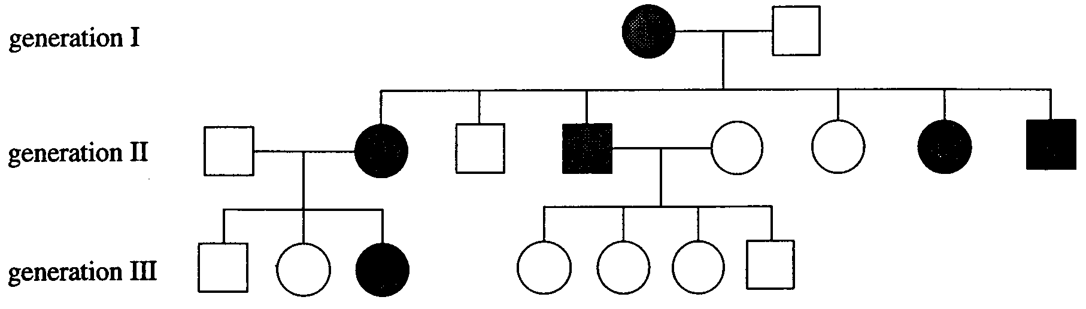
Figure 1

The pattern of inheritance shown in Figure 1 is consistent with
- an X-linked recessive trait
- an autosomal X-linked trait
- an autosomal dominant trait
- an X-linked dominant trait

Use the following information to answer Question 5.

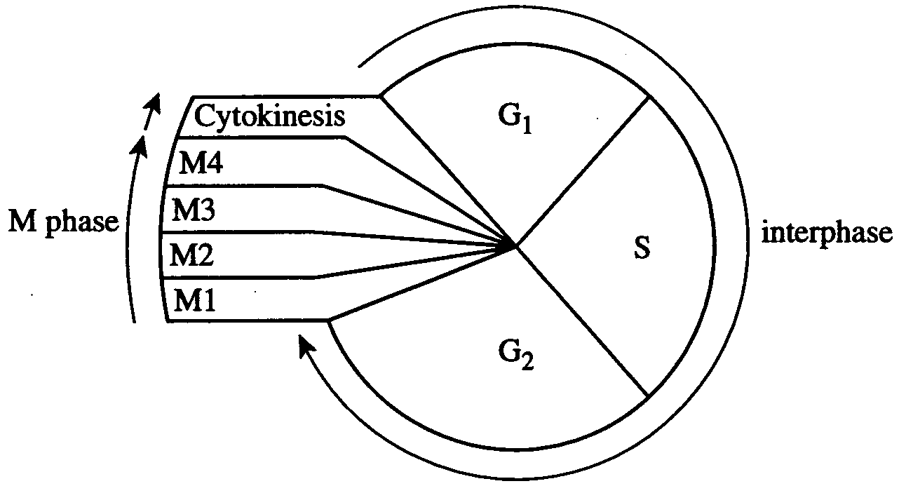
Figure 2: Cell cycle observed in mammalian cells in tissue culture

Question 5
Using Figure 2 above and your knowledge of cell division, it is reasonable to conclude that
- DNA replication occurs during the S phase
- a cell plate forms in the M phase
- segregation of replicated DNA occurs in the G₁ phase
- the cell is inactive during interphase

Question 6
An important difference between mitosis and meiosis is that
- mitosis results in double the number of daughter cells than meiosis
- meiosis results in half the number of chromosomes in daughter cells
- mitosis involves the pairing of homologous chromosomes
- meiosis involves the pairing of heterozygous chromosomes

Question 7
During meiosis, the cell division proceeds through two divisions. Crossing over occurs during
- prophase I, prior to the separation of homologous chromosomes
- anaphase I, prior to the breakdown of the spindle
- anaphase II, prior to the breakdown of the spindle
- metaphase II, following the separation of the chromatids

Question 8
Woolly hair is an inherited condition in humans. Woolly hair is a dominant trait. A man with the genotype Ww and a woman without the woolly hair trait had five children, one of whom had woolly hair. What is the chance that their next child will have woolly hair?
- 25%
- 50%
- 75%
- 100%

Use the following information to answer Questions 9 – 11.

Blood types are identified by testing for different antigens. Antigens are detected by antibodies from the blood, which cause agglutination or clumping. The ability to produce M and N antigens is determined by a gene with two alleles. Heterozygotes produce both M and N antigens.

Diagram | Reactions with anti-sera
Diagram | Anti-M serum | Anti-N serum
i. | 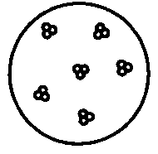 | 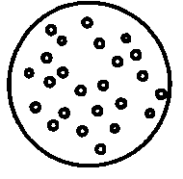
ii. | 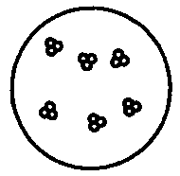 | 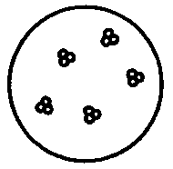
iii. | 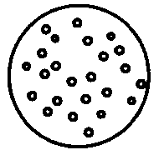 | 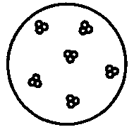
iv. | 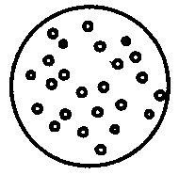 | 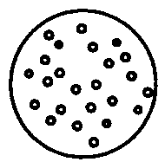

Figure 3

Question 9
Of the diagrams above in Figure 3, which represents the blood sample from a heterozygous individual?
- diagram i.
- diagram ii.
- diagram iii.
- diagram iv.
Question 10
The blood sample in diagram i. may be from an individual
- whose phenotype is homozygous
- whose genotype is L^{M}L^{N}
- whose phenotype is the production of M and N antigens
- whose genotype is L^{M}L^{M}

Question 11
The alleles M and N show
- complete dominance
- incomplete dominance
- co-dominance
- partial dominance

Use the following information to answer Questions 12 and 13.

A peony plant with straight stamens and red petals was crossed with another peony plant having straight stamens and streaky petals. The seeds were collected and germinated and the following offspring were obtained:
62 straight stamens, red petals
59 straight stamens, streaky petals
18 incurved stamens, red petals
22 incurved stamens, streaky petals

Question 12
From the information given we can determine
- straight stamens are dominant to incurved, and red petals are dominant to streaky petals
- straight stamens are dominant to incurved, and the dominance of colour cannot be determined
- incurved stamens are dominant to straight, and streaky petals are dominant to red petals
- incurved stamens are dominant to straight, and red petals are dominant to streaky petals

Question 13
The genotypes of the parental plants would have been
- stamens: both parents heterozygous
petals: one parent heterozygous, one parent homozygous
- stamens: one parent heterozygous, one parent homozygous
both parents heterozygous
- stamens: one parent heterozygous, one parent homozygous
petals: one heterozygous, one homozygous
- stamens: both parents heterozygous
petals: both parents heterozygous

Use the following information to answer Questions 14 and 15.

The wild form of the banana, Musa acuminata, contains many hard seeds and is almost inedible. It is believed that hunter-gatherers may have discovered rare mutant plants that produced soft, seedless fruits. The cells of these soft-fruited banana plants contain three copies of each chromosome instead of the usual two, causing abnormal seed and pollen production, and resulting in the sterility of the mutant plant.

Question 14
Which term best describes the chromosomes in the fruit cells of Musa acuminata?
- haploid
- diploid
- polyploid
- polygenic

Question 15
The action taken by humans in selecting and propagating the soft, seedless varieties of banana plants is best described as
- evolution
- natural selection
- artificial selection
- adaptation

Question 16
In genetic terms, a species would best be defined as
- a gene pool isolated from other gene pools
- individuals who resemble one another
- individuals who do not interbreed in the wild
- races which interbreed to produce fertile offspring

Question 17
The Grampians (or Gariwerd as the Aborigines know them) are a series of ranges and valleys of sandstone in western Victoria. During the Miocene period (approximately 20 million years ago) the sea came far inland, destroying the lowland vegetation, but allowing the vegetation on the peaks to survive.
This inundation of the land by the sea would be described as
- ecological isolation
- geographical isolation
- catastrophic isolation
- behavioural isolation

Question 18
Changes occurring within a gene pool due to the gain or loss of alleles through the movement of individuals or gametes is known as
- genetic drift
- non-random mating
- founder effect
- gene flow

Question 19
A central feature of natural selection is that
- it results in different success rates in reproduction, thus altering allele frequency
- some phenotypes are favoured above others, resulting in individual extinctions
- humans select certain characteristics and breed well adapted individuals
- the ‘fittest’ individuals are those who survive by outrunning predators

Question 20
Evolutionary relationships may be determined through identification of
- analogous structures observed during embryonic development
- homologous structures such as a similar number and arrangement of bones
- analogous structures that have the same function
- homologous structures that have the same function

Use the following information to answer Questions 21 – 23.

The marine iguana Amblyrhynchus cristatus is the only oceanic lizard in the world. It is likely that the ancestors of A. cristatus were a few stray individuals from the South American mainland. As a result of interactions with the unusual environment of the Galapagos islands, A. cristatus shows some extraordinary characteristics not seen in other reptiles. A. cristatus has salt excreting glands, and its flattened tail differs from the rounded tail of the terrestrial iguana.

Question 21
The evolution of A. cristatus compared with terrestrial iguanas is best described as
- convergent evolution
- divergent evolution
- parallel evolution
- hominid evolution

Question 22
The gene pool of A. cristatus would have been largely formed by the influence of
- gene flow
- genetic drift
- founder effect
- human intervention

Question 23
The flattened tail of A. cristatus is best described as a
- structural adaptation
- physiological adaptation
- biochemical adaptation
- behavioural adaptation

Question 24
Humans can be distinguished from other primates by the possession of
- enlarged cerebral hemispheres
- fully bipedal stance and gait
- canine teeth larger than incisor teeth
- possession of a pelvic girdle

Question 25
The Hardy-Weinberg Law, when considering two alleles, requires that
- heterozygotes are twice as likely as homozygotes in a population
- members of adjacent populations interbreed
- large populations are well adapted to their environment
- random mating occurs in the population

SECTION B – Short-answer questions

Question 1
The synthesis of proteins such as human growth hormone occurs in cells in a number of processes (1-3) as illustrated in Figure 4 below.

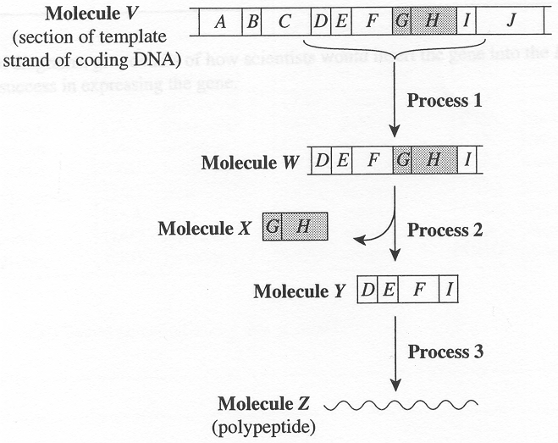
Figure 4

- Complete the following table using the information given above.

Process | Name | Site of process
1
3
2 marks
- Describe the events occurring at process 2.
______________________________________________________________________________________
______________________________________________________________________________________
1 mark
- Name the enzyme involved in process 1.
______________________________________________________________________________________
1 mark

Scientists wish to mass-produce the human growth hormone protein in the bacterium E. coli using a method involving the reverse transcriptase enzyme.

- i. Which of the molecules (V-Z) shown in Figure 4 is most likely the source of the gene for this mass-production process?
__________________________________________________________________________________
ii. Explain why you would select this molecule.
__________________________________________________________________________________
__________________________________________________________________________________
2 marks
- Using labelled diagrams, give details of how scientists would insert the gene into the E. coli to maximise its success in expressing the gene.

______________________________________________________________________________________
______________________________________________________________________________________
______________________________________________________________________________________
______________________________________________________________________________________
4 marks

Part of the sequence of bases on the mRNA is shown below.

G U A U A C C C G A A U G C A G A A

The genetic code is provided below in Figure 5.

First  base | Second base |  |  |  |  |  |  |  |  | Third  base
First  base | G |  | A |  | C |  |  | U |  | Third  base
G | GGG  GGA  GGC  GGU | glycine  glycine  glycine  glycine | GAG  GAA  GAC  GAU | glutamic acid  glutamic acid  aspartic acid  aspartic acid |  | GCG  GCA  GCC  GCU | alanine  alanine  alanine  alanine | GUG  GUA  GUC  GUU | valine  valine  valine  valine | G  A  C  U
A | AGG  AGA  AGC  AGU | arginine  arginine  serine  serine | AAG  AAA  AAC  AAU | lysine  lysine  asparagine  asparagine |  | ACG  ACA  ACC  ACU | threonine  threonine  threonine  threonine | AUG  AUA  AUC  AUU | methionine  isoleucine  isoleucine  isoleucine | G  A  C  U
C | CGG  CGA  CGC  CGU | arginine  arginine  arginine  arginine | CAG  CAA  CAC  CAU | glutamine  glutamine  histidine  histidine |  | CCG  CCA  CCC  CCU | proline  proline  proline  proline | CUG  CUA  CUC  CUU | leucine  leucine  leucine  leucine | G  A  C  U
U | UGG  UGA  UGC  UGU | tryptophan  stop  cysteine  cysteine | UAG  UAA  UAC  UAU | stop  stop  tyrosine  tyrosine |  | UCG  UCA  UCC  UCU | serine  serine  serine  serine | UUG  UUA  UUC  UUU | glycine  glycine  glycine  glycine | G  A  C  U

Figure 5

- What amino acids would be coded for by this section?
______________________________________________________________________________________
______________________________________________________________________________________
1 mark
- What would be the consequences of a point mutation at the 8th base where C is replaced by U?
______________________________________________________________________________________
______________________________________________________________________________________
1 mark
Total 12 marks

Question 2
In a group of mice, scientists found a small number of mice with shorter tails than expected. Geneticists investigated these short-tailed mice and performed several crosses. The results were:

Cross 1 | normal tail | × | normal tail |  | all normal tail offspring
Cross 2 | normal tail | × | short tail |  | half normal tail and half short tail
Cross 3 | normal tail | × | short tail |  | ⅓ normal tail and ⅔ short tail

- What is the dominance relationship between the two alleles?
_______________________________________________________________________________________
_______________________________________________________________________________________
1 mark
- Account for the results in cross 3. Show your working using appropriate symbols.
_______________________________________________________________________________________
_______________________________________________________________________________________
_______________________________________________________________________________________
_______________________________________________________________________________________
_______________________________________________________________________________________
_______________________________________________________________________________________
2 marks
- What biological term describes the homozygous short tail genotype?
_______________________________________________________________________________________
_______________________________________________________________________________________
1 mark
Total 4 marks

Question 3
In an experiment with Drosophila, individuals homozygous for dumpy wings and brown eyes were crossed with a pure breeding wild type (dominant) with normal wings and red eyes. A test cross was carried out where the flies of the resulting F1 generation were backcrossed with individuals of the double recessive parental type. The appearance of the next generation of individuals are as follows:
902 normal wings, red eyes
898 dumpy wings, brown eyes
98 normal wings, brown eyes
102 dumpy wings, red eyes

- This is an example of linkage. What does this term mean?
_______________________________________________________________________________________
_______________________________________________________________________________________
1 mark
- i. Assign suitable allelic symbols for the phenotypes being investigated.
__________________________________________________________________________________
__________________________________________________________________________________
ii. Using the symbols you have assigned, complete the test cross of the F1 offspring and the recessive parent and give the expected phenotypic ratio. Show your working in the space provided.

2 marks
- On a diagram of the chromosome, indicate the relative positions of these genes.

1 mark
- What is the genotype of a test cross individual with dumpy wings and red eyes?
_______________________________________________________________________________________
1 mark
- Name the process by which the combination of dumpy wing and red eye genes has arisen.
_______________________________________________________________________________________
_______________________________________________________________________________________
1 mark
Total 7 marks

Question 4
PAGE 14 MISSING FROM COPY

- Lane X is a standard. What is the reason for including this?
______________________________________________________________________________________
______________________________________________________________________________________
______________________________________________________________________________________
2 marks
- The same experiment was carried out again, but this time the gel was run for twice as long.
What difference would you expect between the two gels? Explain your answer.
______________________________________________________________________________________
______________________________________________________________________________________
______________________________________________________________________________________
______________________________________________________________________________________
2 marks
Total 7 marks

Question 5
Scientists have proposed that chimpanzees, Pan troglodytes be classified as Homo, the same family as humans. Chimpanzees are currently classified as belonging to the Pongidae family along with all apes. This proposal is partly a result of chimpanzees’ ability to carry out complex tasks, solve problems and understand human language.

Members of the Pongidae family are structurally different to humans. In particular, humans are able to walk upright on two feet.

- How does the ability to walk upright benefit humans?
______________________________________________________________________________________
______________________________________________________________________________________
______________________________________________________________________________________
______________________________________________________________________________________
2 marks
- Describe two structural features that humans have to enable upright posture.
______________________________________________________________________________________
______________________________________________________________________________________
______________________________________________________________________________________
______________________________________________________________________________________
2 marks
- What biochemical evidence supports the scientists claim that chimpanzees and humans are closely related?
______________________________________________________________________________________
______________________________________________________________________________________
1 mark
Total 5 marks

Question 6
A. D. Bradshaw and other investigators have studied grasses that grow on the tailings around lead mines in Wales, as the land is rich in lead. Bent grass (Agrostis tonuis) is one of the few plants that will grow there. Bradshaw compared the growth patterns of A. tonuis taken from the leaded tailings with the lead free pasture in areas adjacent to the mines, as shown below in Figure 6.

60 plants from  tailings soil |  |  |  | 60 plants  from pasture
 |  | plants in soil without lead
 | all plants grew
 |  | planted in soil with lead
all plants grew |  |  |  | 57 plants died  3 plants grew

Figure 6

- Why did Bradshaw use a large number of plants from each location?
______________________________________________________________________________________
______________________________________________________________________________________
1 mark
- Name and describe two processes which confer variation to a population.
______________________________________________________________________________________
______________________________________________________________________________________
______________________________________________________________________________________
______________________________________________________________________________________
2 marks
- Name and explain the process by which the population of A. tonuis developed a tolerance to soil containing lead.
______________________________________________________________________________________
______________________________________________________________________________________
______________________________________________________________________________________
______________________________________________________________________________________
______________________________________________________________________________________
______________________________________________________________________________________
3 marks
- Define the term “gene flow”.
______________________________________________________________________________________
______________________________________________________________________________________
1 mark
Total 7 marks

Question 7
An almost complete skeleton of baluchitherium has been found in the hills of Pakistan. It is believed to have lived 20 to 30 million years ago.

- How would the age of the skeleton be assessed
i. comparatively?
__________________________________________________________________________________
__________________________________________________________________________________
ii. absolutely?
__________________________________________________________________________________
__________________________________________________________________________________
2 marks

The fossil is believed to be that of a herbivorous jungle dweller.

- Describe two conditions which are necessary for fossilisation?
______________________________________________________________________________________
______________________________________________________________________________________
______________________________________________________________________________________
______________________________________________________________________________________
2 marks
- What evidence could be used to infer that the skeleton is that of a herbivore?
______________________________________________________________________________________
______________________________________________________________________________________
______________________________________________________________________________________
______________________________________________________________________________________
2 marks
- Gondwana began to break up 150 million years ago and India collided with Laurasia 35 million years ago. As this skeleton was found in Pakistan, would it be likely that this species was also found in Australia? Explain your answer.
______________________________________________________________________________________
______________________________________________________________________________________
______________________________________________________________________________________
______________________________________________________________________________________
2 marks
Total 8 marks

END OF QUESTION AND ANSWER BOOKLET

