IARTV | 2005 | Biology | Solutions

Section A – Multiple choice questions (25 marks)

- A
- B
- C
- D
- C
- B
- B
- A
- D
- C
- D
- A
- C
- B
- B
- A
- B
- C
- B
- D
- B
- D
- A
- D
- B

Section B – Short answer questions (50 marks)

Question 1 (3 marks)
- Heterozygotes show expression of both alleles of a gene in the phenotype. (1 mark)
- S₁S₂ × S₁S₂
 | S₁ | S₂
S₁ | S₁S₁ | S₁S₂ |  | (1 mark)
Expected ratio of phenotypes 1 no patches : 1 small patches (1 mark)

Question 2 (12 marks)
- (i) Meiosis (1 mark)
(ii) Amount of DNA per cell has been reduced from 4 units to 1 unit. (1 mark)
- (i) At points C – Chromosomes are replicating as amount of DNA has doubled. (1 mark)
(ii) At points G – Cytokinesis (cell division) has occurred to produce two daughter cells each with 2 units of DNA. (1 mark)
- Diploid. (1 mark)
- (i) | 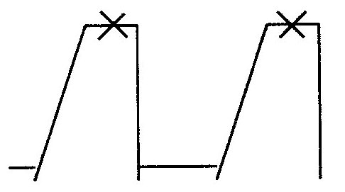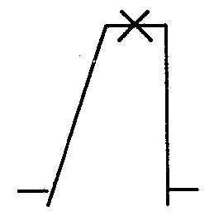 | (1 mark)
(ii) 2, 3, 1, 4. (1 mark)
- (i) Centriole. (1 mark)
(ii) To hold the two chromatids together and to attach to a spindle fibre during cell division. (1 mark)
- (i) Daughter cells produced are identical copies of parent cells (unless mutations occur) (½ mark) therefore the same genetic material is maintained in an organism. (½ mark)
(ii) (1) Random (or Independent) Assortment of chromosomes in which each pair of homologous chromosomes lines up and separates independently of every other pair. (1 mark)
(2) Crossing-over and recombination between the chromatids or a pair of homologous chromosomes. (1 mark)

Question 3 (6 marks)
- All daughters of affected father (6) are affected by this form of rickets. (1 mark)
- Individual 1 – does not have rickets
Individual 2 – cannot decide
Individual 3 – cannot decide
Individual 4 – has rickets (4 × ½ = 2 marks)
 |  | Parent 7 |  | Parent 8
 | Parental phenotype: | female with rickets | × | male without rickets
 | Parental genotype: | X^{R}X^{r} | × | X^{r}Y
 | Genotypes of gametes: | X^{R}, X^{r} |  | X^{r}, Y | (1 mark)

Genotypes of children | X^{R}Y | X^{r}Y | X^{R}X^{r} | X^{r}X^{r}
Phenotypes of children | male with rickets | male no rickets | female with rickets | female no rickets | (4 × ½ = 2 marks)

Question 4 (5 marks)
- (i) | 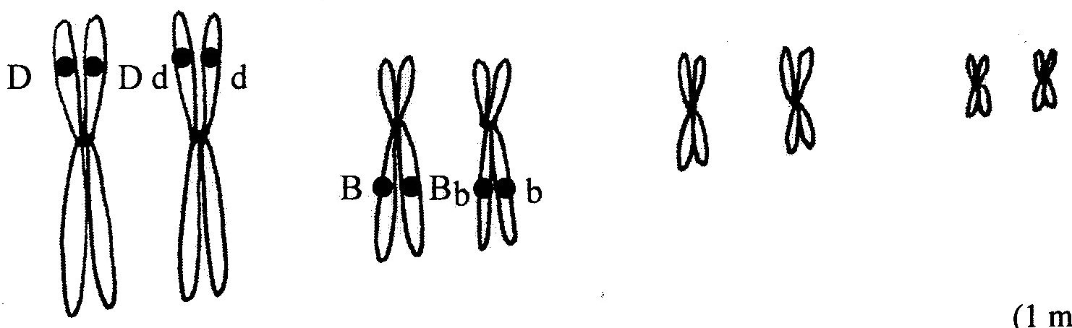 | (1 mark)
(ii) Two gene loci are located on different homologous chromosome pairs. (1 mark)
- (i) Black male mouse: BbDd (1 mark)
Brown female mouse: bbdd (1 mark)
(ii) There were four types of offspring produced in equal numbers, ratio 1:1:1:1, which would not occur if the 2 gene loci were linked. (1 mark)

Question 5 (5 marks)
- Reverse transcriptase. (1 mark)
- TACGTCGGT. (1 mark)
- DNA polymerase. (1 mark)
- Insulin; Growth hormone; Factor VIII or any other suitable suggestion. (1 mark)
To provide large amounts of the protein, identical to human protein, for a particular therapeutic use (specify for example given) (1 mark)

Question 6 (8 marks)
- To prevent gene flow due to successful interbreeding so new species can be formed. (1 mark)
- (i) 63 (½ mark)
(ii) 4 n (½ mark)
- Polyploidy. (1 mark)
- Plants reproduce asexually therefore can multiply whereas animals mostly reproduce sexually and meiosis may not occur to produce gametes in polyploids. (1 mark)
- (i) Geographical isolation. (1 mark)
(ii) – Variation in members of C. pipiens with some above to feed on rats and mice while most feed on birds.
– Isolation of some mosquitoes which found their way into the underground tunnels.
– Natural selection – survival and reproduction of those mosquitoes better suited as they were able to feed on the rats and mice underground whereas bird-biting mosquitoes died.
– After generations of reproductive isolation the tunnel-living mosquitoes could no longer interbreed with the bird-biting mosquitoes. Therefore, Cules molestus was considered a new species.
- – Food sources above and below ground were different therefore strong selection pressures.
– Also the short life cycle of the mosquito which allows more rapid evolution. (1 mark)

Question 7 (6 marks)
- (i) A layer of sedimentary rock. (1 mark)
(ii) It is possible to date the fossils (determine their relative age) by comparing fossils in different strata. Those closest to the top are younger than those down lower. (1 mark)
- When the continents were joined as one large land mass or via land bridges. (1 mark)
- (1) Hard parts would be better preserved. For example, hooves, bones. (1 mark)
(2) Lived in swampy areas so covered more readily by mud therefore less decomposition and better preserved. (1 mark)
- Radioisotope dating (not carbon dating). (1 mark)

Question 8 (5 marks)
- Gorilla, as it had a 1.09 index of similarity to Homo which is closest to 1.0. (1 mark)
 |  |  |  | siamang |  | (6 correct – 2 marks  3-5 correct – 1 mark  0-2 correct – 0 marks)
 |  |  |  | gibbon
 |  |  |  | orang-utan
 |  |  |  | chimpanzee
 |  |  |  | human
 |  |  |  | gorilla
 |  |  |  | Old world monkeys
- Any two of:
  - small brain case compared to skull size
  - presence of prominent eyebrow ridges
  - protruding jaws
or any other reasonable suggestion. (2 marks)

