
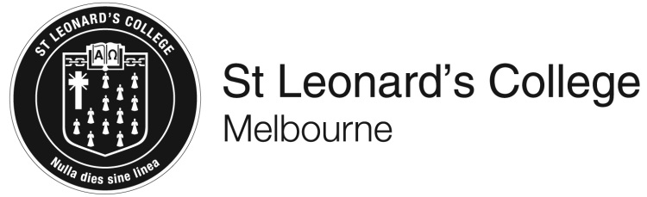

VCE Unit 3 Business Management
Semester 1 – Friday 17th July, 2020 - EME
and
Tuesday 21st July, 2020 – HSP
Question and Answer Booklet

STUDENT NAME: _________________________________________________

TEACHER(S): Ms Emerson-Drake Mr Harris

TIME ALLOWED: Reading time minutes
Writing time minutes

INSTRUCTIONS
You are not permitted to use notes, texts or a dictionary.
You are to answer each question in space provided.
Do not write in pencil.

STRUCTURE OF BOOKLET / MARKING SCHEME
Section Number of questions | Number of questions to be answered | Number of marks
A 4  B 6 | 4  6 | 35  20  Total 55

SECTION A
Instructions for Section A
Answer all questions in the spaces provided.
Flowerpots Café
Bill and Ben own and operate Flowerpots Café. The partners opened the business 12 months ago and have started to experience growth. They recently employed new staff to meet the needs of their customers. When Bill and Ben started the business, they were certain that they would include employees in the decision-making of the café and would encourage positive values, ideas, expectations and beliefs within the workplace. As the business grows, they are concerned that they will not be able to continue to develop this progressive corporate culture.

Question 1 (21 marks)
- Explain the interests of one stakeholder at Flowerpots Café. 2 marks

- Suggest and justify two strategies for developing the corporate culture at Flowerpots Café.
4 marks

- Analyse two management skills that could be used to develop the corporate culture at Flowerpots Café. 4 marks

- Evaluate the appropriateness of the use of the participative management style in developing the corporate culture at Flowerpots Café. 5 marks

- Describe the principles of the Four Drives Theory of motivation, suggesting how Flowerpots Café could use this theory of motivation to increase employee productivity.
6 marks

Question 2 (4 marks)
Discuss two key characteristics of a partnership.

Question 3 (7 marks)
- Compare the use of an award and an agreement in a business workplace.
4 marks

- Suggest why the use of mediation would be suitable for a business involved in a dispute with its employees about the terms and conditions of its agreement.
3 marks

Question 4 (3 marks)
Define termination, explaining one reason why a business would need to terminate employees.

SECTION B
Instructions for Section B
Use the case study provided to answer the questions in this section.
Answers must apply to the case study.
Answer all questions in the spaces provided.

Smile Brightly
Smile Brightly is a clinic established to provide dental hygiene and orthodontic services to people in the local community. It has the capacity to service up to 200 patients in any one day, with peak times occurring at 8 to 9 am and 4 to 5 pm. The business runs to a tight schedule and budget, and is committed to total quality management. It is keen to establish itself as an industry leader by adopting best practice procedures.
Over the past 12 months, Dr Smirk, the director of Smile Brightly, has been making use of forecasting, with the intention of developing a production plan. The business has recently implemented a more efficient inventory control process that has resulted in a 26 per cent decrease in materials cost per patient. He now wants to reorganise the delivery of patient service in an effort to reduce waste, particularly in terms of time, and improve quality.
Patients commonly see three people in the course of their visit, and usually in the following order:
- a hygienist (to clean teeth and gums and generally prepare the patient for the orthodontist)
- an orthodontist (to provide consultation)
- an orthodontic nurse (to provide post-consultation service; for example, to fit bands with dental elastic).
The delivery of service to patients is not always sequential, and delays often occur between stages 1 and 2. Such waste results in inefficiencies.

Question 1 (4 marks)
Define each of the following terms and explain how they could apply to Smile Brightly:

Forecasting________________________________________________________________________

Total quality management_____________________________________________________________

Question 2 (4 marks)
Identify and explain two elements of the operations system at Smile Brightly.

Question 3 (3 marks)
Recommend a strategy related to technological development that could be used to improve the efficiency and effectiveness of Smile Brightly’s operations.

Question 4 (2 marks)
Recommend one lean management strategy to minimise waste at Smile Brightly.

Question 5 (3 marks)
Suggest why on-the-job training could be a useful training option for Smile Brightly.

Question 6 (4 marks)
Propose and justify two motivational strategies to improve staff performance at Smile Brightly.

Extra space for responses
Clearly number all responses in this space.

