Board of Studies
Victorian Certificate of Education
1996

Chemistry

Common Assessment Task 1: Written Examination

Tuesday 11 June 1996: 2.45 pm to 4.30 pm
Reading Time: 2.45 pm to 3.00 pm
Writing Time: 3.00 pm to 4.30 pm
Total Writing Time: 1 hour 30 minutes

QUESTION AND ANSWER BOOK

Structure of Book
Section | Number of Questions | Number of Questions to be answered
A | 18 | 18
B | 6 | 6

Directions to students
Materials
Question and answer book of 18 pages with a detachable data sheet in the centrefold.
Answer sheet for multiple choice questions. You should have at least one pencil and eraser.
An approved calculator may be used.

The task
Detach the data sheet from the centre of this book during reading time.
Please ensure that you write your student number in the space provided on this book and your name and student number in the space provided on the answer sheet for multiple choice questions.
This paper contains two sections, Section A and Section B.
Answer all questions from Section A. Section A is worth 18 marks.
Section A questions should be answered on the answer sheet provided for multiple choice questions.
Answer all questions from Section B. Section B is worth 50 marks.
Section B questions should be answered in the spaces provided in this book.
There is a total of 68 marks available.
Working space is provided throughout this book.
All written responses should be in English.

At the end of the task
Place the answer sheet for multiple choice questions inside the front cover of this book and hand them in.

SECTION A

Specific instructions for Section A

Section A consists of 18 multiple choice questions. Section A is worth approximately 26 per cent of the marks available. You should spend approximately 23 minutes on this section.
Choose the response that is correct or best answers the question, and indicate your choice on the multiple choice answer sheet according to the instructions on that sheet.
A correct answer is worth 1 mark, an incorrect answer is worth no marks. No mark will be given if more than one answer is completed for any question. Marks will not be deducted for incorrect answers. You should attempt every question.

The following graph is referred to in Question 1.

This calibration graph shows the absorbance of a series of standard solutions containing iron, recorded with an atomic absorption spectrometer.

Question 1
In order to release the iron in an 8.40 g sample of peas, the sample was reacted with moderately concentrated hydrochloric acid and the volume made up to 100 mL. The absorbance of a sample of the resultant solution was measured to be 0.10 with an atomic absorption spectrometer, set to an appropriate wavelength. Using the calibration graph given above, the mass of iron in the original sample of peas in milligrams is
- 0.21
- 0.25
- 2.1
- 2.5

Question 2
Consider the reaction
N₂O₃ (g)  NO₂ (g) + NO (g)
If more NO gas is added to this system at equilibrium then there will be
- an increase in the amount of NO₂ gas
- an increase in the value of the equilibrium constant
- an increase in the amount of N₂O₃ gas
- a decrease in the value of the equilibrium constant

Question 3
Acetic acid is a weak acid that ionises in water according to the equation
CH₃COOH (aq) + H₂O (l)  H₃O⁺ (aq) + CH₃COO⁻ (aq)
If a 0.10 M solution of acetic acid is diluted with water, which of the following correctly shows the expected change in the percentage ionisation and pH?
 | percentage ionisation | pH
a. | increases | increases
b. | increases | decreases
c. | decreases | increases
d. | decreases | decreases

Question 4
Which one of the following is not a conjugate acid-base pair?
- H₂O / OH⁻
- H₃O⁺ / H₂O
- H₃O⁺ / OH⁻
- OH⁻ / O²⁻

Question 5
A commercial liquid medication is known to contain 400 mg of magnesium hydroxide, Mg(OH)₂, per 10.0 mL of the medication. How many mole of magnesium would there be in 1.0 L of the medication?
(M_{r} of Mg(OH)₂ is 58.3)
- 6.9 x 10⁻⁴
- 6.9 x 10⁻³
- 6.9 x 10⁻²
- 6.9 x 10⁻¹

Question 6
100 mL of 0.1 M HNO₃ (aq) and 100 mL of 0.1 M NaOH (aq) are mixed. The pH of the resulting solution will be closest to
- 0
- 1
- 7
- 13

Question 7
Some small insects can walk across the surface of a pond without falling through the surface. Their legs are covered with a waxy substance that
- is hydrophobic
- is hydrophilic
- forms an oil in water emulsion
- forms a water in oil emulsion

The diagram below is referred to in Questions 8, 9 and 10.

This diagram is a representation of a liquid rising up a very narrow glass capillary. The case illustrated shows a liquid such as water that wets glass so that the contact angle is very small; that is, close to 0°. The height to which the water rises in the capillary is given by h.

Question 8
Provided a liquid wets the material of a capillary, which of the following combination of conditions would result in a maximum value of h?
 | surface tension of liquid | diameter of capillary
a. | high | large
b. | high | small
c. | low | large
d. | low | small

Question 9
Mercury is a liquid with a very high surface tension that does not wet glass. If the end of a thin glass capillary is dipped into a beaker of mercury, which of the following would be observed?
 | contact angle between mercury and glass | capillary behaviour
a. | θ is greater than 90° | capillary rise observed
b. | θ is greater than 90° | capillary depression observed
c. | θ is less than 90° | capillary rise observed
d. | θ is less than 90° | capillary depression observed

Question 10
Formamide is a liquid with a very high surface tension that wets glass. If the end of a thin glass capillary is dipped into a beaker of formamide, which of the following would be observed?
 | contact angle between formamide and glass | capillary behaviour
a. | θ is greater than 90° | capillary rise observed
b. | θ is greater than 90° | capillary depression observed
c. | θ is less than 90° | capillary rise observed
d. | θ is less than 90° | capillary depression observed

Question 11
You have samples of the following three solid substances
CH₃(CH₂)₁₀SO₃Na
CH₃(CH₂)₁₀N(CH₃)₃Br
CH₃(CH₂)₁₀CH₂OH
Identify the possible cationic detergent and anionic detergent.
 | cationic detergen | anionic detergent
a. | CH₃(CH₂)₁₀N(CH₃)₃Br | CH₃(CH₂)₁₀CH₂OH
b. | CH₃(CH₂)₁₀CH₂OH | CH₃(CH₂)₁₀SO₃Na
c. | CH₃(CH₂)₁₀SO₃Na | CH₃(CH₂)₁₀N(CH₃)₃Br
d. | CH₃(CH₂)₁₀N(CH₃)₃Br | CH₃(CH₂)₁₀SO₃Na

The flow chart below refers to the industrial preparation of ethanol and is referred to in Questions 12, 13, 14 and 15.

Question 12
Process A could best be described as
- reduction
- combustion
- chromatography
- distillation

Question 13
Process B could best be described as
- cracking
- distillation
- hydrogenation
- hydration

Question 14
Process C could best be described as
- cracking
- distillation
- hydrogenation
- hydration

Question 15
The formulas for ethene and propane are, respectively
- C₂H₄; C₂H₆
- C₂H₆; C₃H₈
- C₂H₆; C₃H₆
- C₂H₄; C₃H₈

The following information is referred to in Questions 16, 17 and 18 below.

6.54 g of zinc metal is completely dissolved in 250 mL of concentrated hydrochloric acid to give gaseous hydrogen according to the equation
Zn (s) + 2 HCl (aq) → ZnCl₂ (aq) + H₂ (g)

Question 16
The volume in litres of hydrogen gas produced at 25°C and 1.00 atm pressure is
- 0.205
- 2.44
- 205
- 248

Question 17
The concentration of zinc ions in the solution after all the zinc has reacted would be
- 0.10 M
- 0.20 M
- 0.40 M
- 0.025 M

Question 18

The reaction between zinc and hydrochloric acid is best described as

an acid-base reaction
- a precipitation reaction
- a redox reaction
- a gravimetric reaction

SECTION B

Specific instructions for Section B
Section B consists of six short answer questions. You should answer all of these questions. The section is worth 50 marks or approximately 74 per cent of the total. You should spend approximately 67 minutes on this section.
The marks allotted to each question and suggested time allocations are shown at the end of each question.
Questions should be answered in the spaces provided in this book.
To obtain full marks for your responses you should
- give simplified answers with an appropriate number of significant figures to all numerical questions; unsimplified answers will not be given full marks
- show all working in your answers to numerical questions. No credit will be given for an incorrect answer unless it is accompanied by details of the working
- make sure chemical equations are balanced and that the formulas for individual substances include indications of state, for example, H₂ (g); NaCl (s).

Question 1
- Write a balanced ionic half-equation for the reduction of molecular bromine (Br₂) to bromide ions (Br⁻) in aqueous solution.
___________________________________________________________________________
___________________________________________________________________________
___________________________________________________________________________
- Write a balanced ionic half-equation for the oxidation of hydrogen sulphide (H₂S) to the sulphate ion (SO₄²⁻) in acid solution.
___________________________________________________________________________
___________________________________________________________________________
___________________________________________________________________________
- Write a balanced equation for the oxidation of hydrogen sulphide to sulphate by molecular bromine.
___________________________________________________________________________
___________________________________________________________________________
___________________________________________________________________________
1 + 2 + 1 = 4 marks
(suggested time: 5 minutes)

Question 2
The flow chart shown on the opposite page was drawn in a student’s log book. It describes a procedure to be used in separating and identifying the individual dye components of a commercial food colouring.
- Identify three fundamental errors in the flow chart and in each case explain how the error should be corrected.
Error 1
___________________________________________________________________________
___________________________________________________________________________
___________________________________________________________________________
___________________________________________________________________________
___________________________________________________________________________
Error 2
___________________________________________________________________________
___________________________________________________________________________
___________________________________________________________________________
___________________________________________________________________________
___________________________________________________________________________
Error 3
___________________________________________________________________________
___________________________________________________________________________
___________________________________________________________________________
___________________________________________________________________________
___________________________________________________________________________
- Explain, using a diagram if you wish, how R_{f} values are calculated.
___________________________________________________________________________
___________________________________________________________________________
___________________________________________________________________________
- Paper chromatography is only one kind of chromatographic technique. Briefly explain what features are common to all types of chromatography.
___________________________________________________________________________
___________________________________________________________________________
___________________________________________________________________________
___________________________________________________________________________
___________________________________________________________________________

Using a felt-tip pen, draw a reference line 2 cm from the
bottom of a strip of chromatography paper.
↓
Carefully place a drop of food colouring on the line.
↓
Allow the drop to dry.
↓
Put more drops of the food colouring over the first to make a
concentrated spot that is at least 10 mm in diameter so that it has
adequate contact with the paper and can be easily seen.
↓
Place a solvent consisting of an ethanol-water
mixture in the bottom of a tall jar.
↓
Hang the strip of chromatography paper in the jar, making sure that
the spot of colouring is completely covered by the solvent.
↓
Allow the paper to remain in contact with the solvent until a
solvent front has almost reached the top of the paper.
↓
Observe the separation of the coloured components of the food
colouring. Note that the component that absorbs most strongly
to the paper pulls itself furthest up the paper.
↓
Calculate an R_{f} value for each spot on the chromatogram.
↓
Identify the components of the food colouring by comparing
the R_{f} values of those of known dyes.
6 + 2 + 3 = 11 marks
(suggested time: 14 minutes)

Question 3
Iron and sulphuric acid are two very important industrial chemicals. Oxidation and reduction reactions occur in the preparation of both these substances.
- Give an equation for the reaction in which iron oxide is reduced to iron in a blast furnace.
___________________________________________________________________________
___________________________________________________________________________
- Iron is produced from iron oxide in a reduction reaction, yet molecular oxygen from the air plays a key role in the process. Briefly explain, both in words and with a chemical equation, the part molecular oxygen plays in the production of iron.
___________________________________________________________________________
___________________________________________________________________________
___________________________________________________________________________
___________________________________________________________________________
___________________________________________________________________________
- Give the chemical equation for two reactions in the production of sulphuric acid in which molecular oxygen is directly involved.
___________________________________________________________________________
___________________________________________________________________________
___________________________________________________________________________
___________________________________________________________________________
- Iron will react with dilute aqueous sulphuric acid. Give an ionic equation for this reaction.
___________________________________________________________________________
___________________________________________________________________________
___________________________________________________________________________
- In the boxed provided, give the oxidation numbers of each of the atoms in a sulphuric acid molecule.
H |  | S |  | O
- There are several environmental hazards associated with both the production of iron an sulphuric acid. Give one example for each process.
- iron
___________________________________________________________________________
___________________________________________________________________________
- sulphuric acid
___________________________________________________________________________
___________________________________________________________________________
- Give an example of one important use for each of iron and sulphuric acid.
- iron
___________________________________________________________________________
___________________________________________________________________________
- sulphuric acid
___________________________________________________________________________
___________________________________________________________________________
1 + 2 + 2 + 1 + 3 + 2 + 2 = 13 marks
(suggested time: 18 minutes)

Question 4
Ammonia can be produced according to the equation
N₂(g) + 3 H₂(g)  2 NH₃(g)
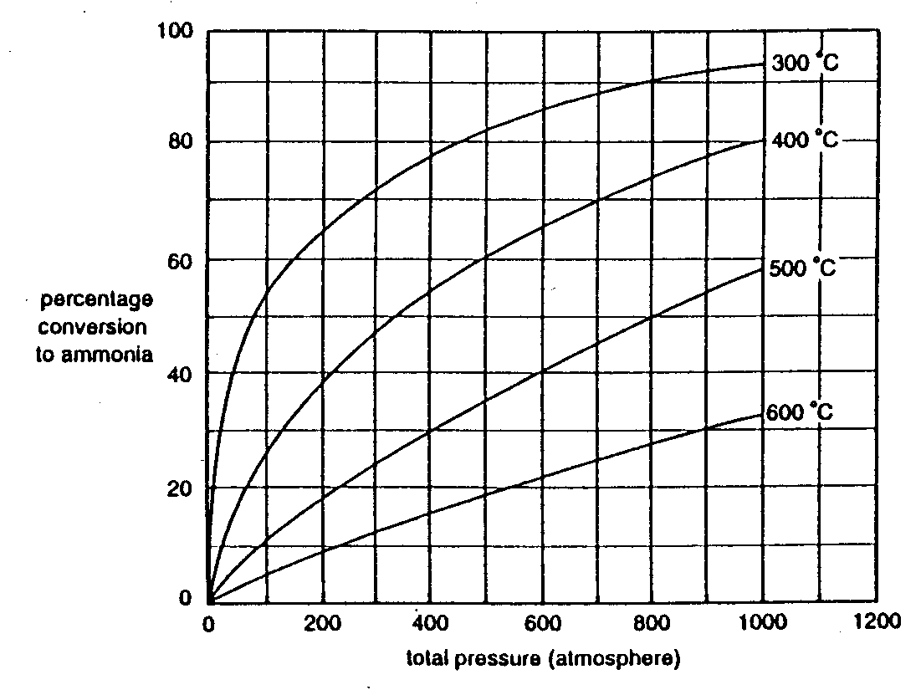
The graph below illustrates the variation in the yield of ammonia with pressure at different temperatures.

- Write an expression for the equilibrium constant for the formation of ammonia from hydrogen and nitrogen.

- A particular process uses a pressure of 300 atm and a temperature of 500°C. From the graph, determine the percentage yield of ammonia under these conditions.
___________________________________________________________________________
___________________________________________________________________________
- State Le Chatelier’s principle.
___________________________________________________________________________
___________________________________________________________________________
___________________________________________________________________________

- Explain how you can deduce from the graph whether the production of ammonia is an exothermic or an endothermic process.
___________________________________________________________________________
___________________________________________________________________________
___________________________________________________________________________
___________________________________________________________________________

- Suggest a possible reason why a temperature of less than 400°C is rarely used even though it would apparently result in a greater yield of ammonia.
___________________________________________________________________________
___________________________________________________________________________
___________________________________________________________________________
___________________________________________________________________________
1 + 1 + 1 + 2 + 1 = 6 marks
(suggested time: 8 minutes)

Question 5
Following a barbecue, where the meal has been eaten off china or glass plates, the soiled and greasy plates are washed in hot water containing detergent.
- Draw and label a simple diagram showing how detergent ions or molecules might first interact with the greasy parts of a plate surface.

- Describe, using diagrams if you wish, the nature of the chemical bonding that is responsible for the interaction between
- the detergent ions or molecules and the water in an aqueous solution.

- the detergent ions or molecules and the greasy plate surface.

- The hot water and detergent removes grease by taking it into solution. Explain, using labelled diagrams if you wish, why grease ‘dissolves’ in water with the help of a detergent, although it is quite insoluble in pure water.

- Why is hot water plus detergent preferable to cold water plus detergent for cleaning plates?
___________________________________________________________________________
___________________________________________________________________________
___________________________________________________________________________
3 + 2 + 2 + 1 = 8 marks
(suggested time: 11 minutes)

Question 6
A new low alcohol beer, ‘LOALC’, was tested for its alcohol (CH₃CH₂OH) content. A 20.00 mL sample was pipetted into a 500 mL standard flask and the solution made up to the mark. A 25.00 mL aliquot was titrated against a 0.0500 M solution of K₂Cr₂O₇ and a titre of 8.20 mL was obtained.
The equation for the reaction is
2 Cr₂O₇²⁻(aq) + 3 CH₃CH₂OH(aq) + 16 H⁺(aq) → 4 Cr³⁺(aq) + 3 CH₂COOH(aq) + 11H₂O(l)
- How many mole of Cr₂O₇²⁻ was used in the titration?
___________________________________________________________________________
___________________________________________________________________________
___________________________________________________________________________
- How many mole of CH₃CH₂OH was present in the 25.00 mL aliquot?
___________________________________________________________________________
___________________________________________________________________________
- What was the alcohol concentration in the aliquot?
___________________________________________________________________________
___________________________________________________________________________
___________________________________________________________________________
- What was the concentration of alcohol in the original sample of the beer?
___________________________________________________________________________
___________________________________________________________________________
___________________________________________________________________________
- Calculate the mass of alcohol in a standard size 200 mL glass of the beer.
___________________________________________________________________________
___________________________________________________________________________
___________________________________________________________________________
- State two safety precautions you should take during this analysis.
___________________________________________________________________________
___________________________________________________________________________
___________________________________________________________________________
2 + 1 + 1 + 1 + 2 + 1 = 8 marks
(suggested time: 11 minutes)

end of question and answer booklet

