VBOS
1999
Chemistry
U3 Exam

SECTION A

Question 1
The principal reductant in the reduction of iron ore to iron in the blast furnace is
- calcium carbonate
- calcium silicate
- carbon dioxide
- carbon monoxide

Question 2
The high temperature in the blast furnace is maintained by
- an exothermic reaction of coke
- an endothermic reaction of coke
- the endothermic decomposition of calcium carbonate
- the exothermic formation of slag

Question 3
Which of the following will not slow the corrosion of iron?
- painting the iron surface
- making the iron negatively charged by connecting it to a direct current power supply
- increasing the amount of carbon in the iron
- mixing chromium with the iron to make an alloy

Question 4
Pig iron is produced in a blast furnace and it is usually immediately made into steel. Pig iron if of limited use because it
- contains unreacted iron oxide and lacks hardness
- contains a high concentration of silica and is too hard
- contains a high concentration of carbon and is too brittle
- is very pure and is too soft

Question 5
The following are analytical instruments:
- gas-liquid chromatograph
- ultra-violet spectrometer
- atomic absorption spectrometer
- high-performance liquid chromatograph
Two features that are common to these instruments are
- reference cells and a recorder
- detector and a recorder
- light source and carrier gas
- monochromator and detector

Question 6
The following two monomers are mixed in an exact 1:1 mole ratio and placed in a reaction vessel
CHCl=CHCl and CH₃CH=CHCH₃
The mixture is heated and polymerisation occurs. The resulting product would be expected to
- be made up of two different types of polymer corresponding to the two different monomers
- be made up of polymer chains in which the two monomer units alternate in every chain
- be quite hard and brittle
- have an empirical formula of C₃H₅Cl

The following information is referred to in Questions 7 and 8

An aqueous solution of hydrochloric acid was standardised with a 0.0500 M solution of sodium carbonate. A 20.0 mL aliquot of this sodium carbonate solution was pipetted into a conical flask and titrated against the hydrochloric acid solution.

Question 7
Which of the following correctly identifies the substance that should be used to rinse each piece of equipment?
 | conical flask | pipette | burette
A. | sodium carbonate solution | sodium carbonate solution | hydrochloric acid solution
B. | water | water | water
C. | sodium carbonate solution | water | water
D. | water | sodium carbonate solution | hydrochloric acid solution

Question 8
The indicator chosen for this titration is methyl orange, which changes colour from yellow to pink when all the carbonate ions have been converted to carbon dioxide. This will occur when the number of
- H⁺ ions added just exceeds double the number of CO₃²⁻ ions present originally
- H⁺ ions added just exceeds the number of CO₃²⁻ ions present originally
- CO₃²⁻ ions present originally is just double the number of H⁺ added
- H⁺ ions added just equals the number of CO₃²⁻ ions present originally

The following information is referred to in Questions 9 and 10

Some carbon monoxide and oxygen gas are mixed in a reaction vessel and heated so that the following equilibrium is established at 1000°C.
2 CO (g) + O₂ (g)  2 CO₂ (g) ΔH = -546 kJ mol⁻¹
The equilibrium constant for the reaction is K.

Question 9
If the temperature is raised above 1000°C and equilibrium is re-establised
- the value of K will decrease and [CO₂] will increase
- the value of K will decrease and [CO₂] will decrease
- the value of K will increase and [CO₂] will increase
- the value of K will increase and [CO₂] will decrease

Question 10
The system is returned to 1000°C and equilibrium at that temperature is established. If the volume of the vessel is then doubled
- the value of K will decrease and [CO₂] will decrease
- the value of K will decrease and [CO₂] will remain unchanged
- the value of K will remain unchanged and [CO₂] will decrease
- the value of K will remain unchanged and [CO₂] will also remain unchanged

Question 11
In which of the following species does oxygen have the highest oxidation number?
- O₂
- H₂O₂
- Na₂O
- H₂SO₄

Question 12
The half equation for the dichromate ion acting as an oxidising agent is
Cr₂O₇⁻ (aq) + 14 H⁺ (aq) + n e⁻  2 Cr³⁺ (aq) + 7 H₂O (l)
The value of n in this equation is
- 3
- 6
- 9
- 12

Question 13
If 150 mL of 0.10 M NaOH is mixed with 50 mL of 0.30 M HCl, then the pH of the resultant solution is closest to
- 1
- 2
- 7
- 13

Question 14
A section of polymer chain is given below
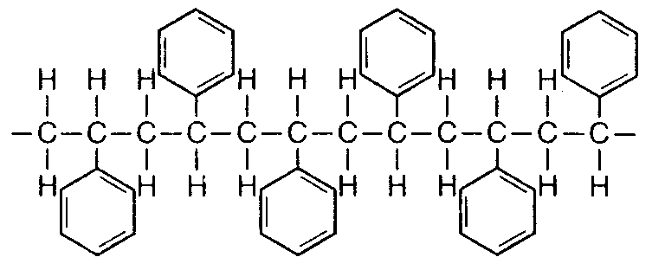
The monomer for this polymer would be
A. | 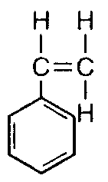 | B. | 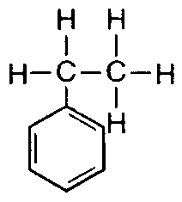 | C. | 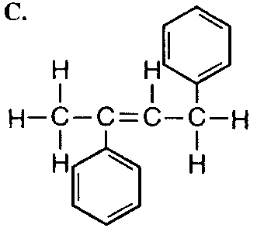 | D. | 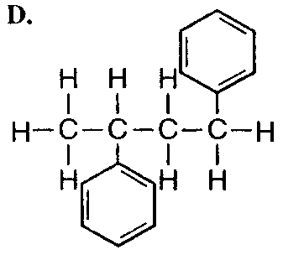

Question 15
You are in a car that is taken through four cleaning steps in a commercial car wash.
Step 1: A mixture of detergent and water is sprayed onto the car and brushes scrub the car’s surface.
Step 2: he car is rinsed and a second spray of detergent and water is applied.
Step 3: The car is rinsed thoroughly to remove all traces of the detergent.
Step 4: Wax is applied to the car to protect the surface.
Imagine the shapes of the drops of water that are on the roof of the car at the end of Steps 3 and 4. The shapes would be best represented as:
 | shape of drop after Step 3 | shape of drop after Step 4
A. |  | 
B.
C.
D.

The following information is referred to in Questions 16 and 17

Shown below is a representation of a liquid rising up a very narrow glass capillary. The case illustrated shows a liquid such as water that wets glass. The height to which the water rises in the capillary is given by h.
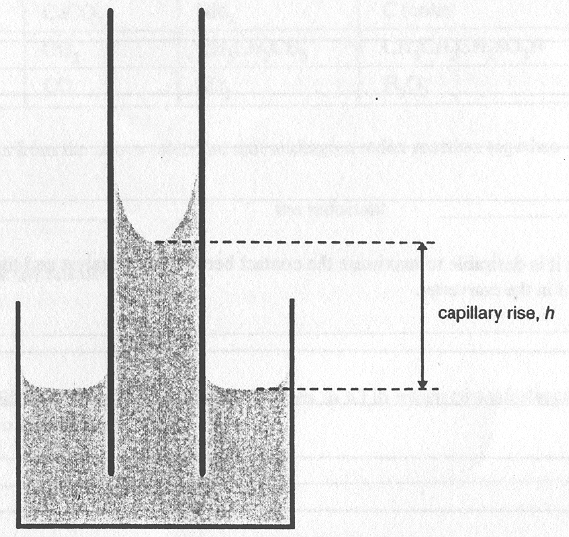

Question 16
Comparing a sample of pure water and an aqueous solution of detergent, the detergent solution would have a
- higher surface tension than water and a higher value of h
- higher surface tension than water and a lower value of h
- lower surface tension than water and a higher value of h
- lower surface tension than water and a lower value of h

Question 17
Two liquids, A and B, have identical surface tensions. However, liquid A wets glass while liquid B does not wet glass. Comparing these two liquids,
- the value of h would be the same for both A and B
- both liquids would have positive values of h, but h would be greater for A than for B
- both liquids would have positive values of h, but h would be smaller for A than for B
- liquid A would have a positive value of h while liquid B would have a negative value of h

Question 18
Two drops of mercury are close to each other on a clean glass surface. The glass is moved slightly and the two drops collide, quickly combining to form a single larger drop. The best explanation for this observation is that
- the total surface energy of the mercury is lowered
- the contact angle between the mercury and the glass is decreased
- the surface tension of the mercury is lowered
- mercury does not wet clean glass

Question 19
A mixture of butane (C₄H₁₀), pentane (C₅H₁₂) and hexane (C₆H₁₄) was analysed in a gas-liquid chromatography column. The following output was obtained.
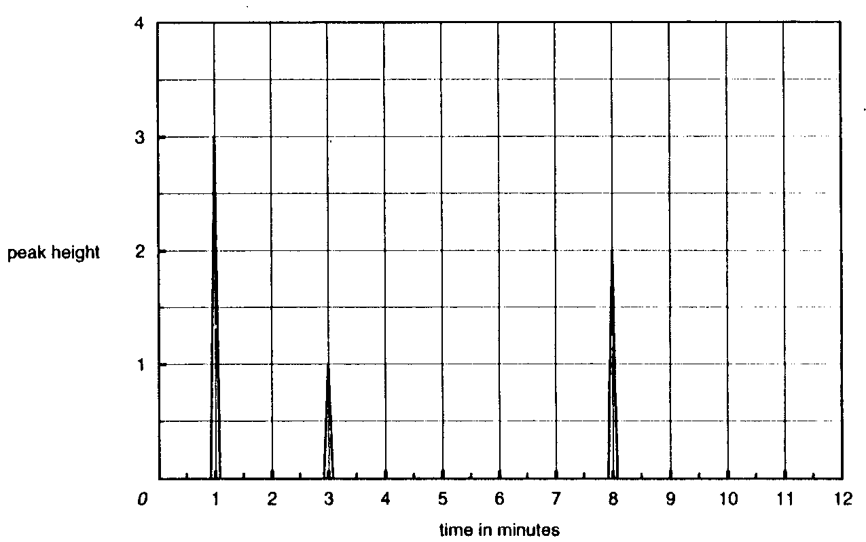
Given that the sensitivity of the detector is the same per molecule for all three substances, the mole percentage of hexane in the sample is closest to
- 20
- 30
- 33
- 50

Question 20
Which combination of the following factors will affect the time taken for a sample to pass through a high performance liquid chromatography column?
I temperature
II length of the column
III flow rate of the carrier gas
- I and II
- II and III
- I and III
- I, II and III

SECTION B

Question 1
Below is a diagram illustrating the first two stages of the contact process for the production of sulfuric acid.
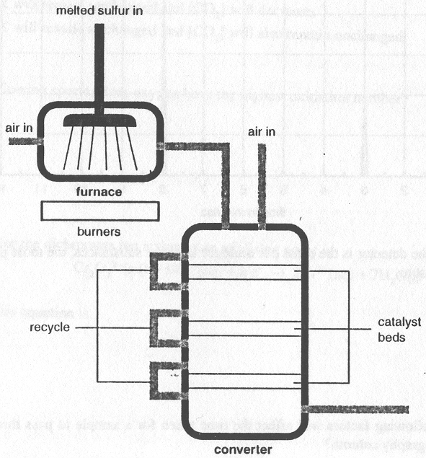

- Give the equation for
the reaction occurring in the furnace
____________________________________________________________________________________
the reaction occurring in the converter
____________________________________________________________________________________
2 marks
- The reaction occurring in the converter is reversible and exothermic. Given that equilibrium is achieved in the converter, state two conditions that will help maximise the amount of the desired product.
____________________________________________________________________________________
____________________________________________________________________________________
____________________________________________________________________________________
____________________________________________________________________________________
____________________________________________________________________________________
2 marks
- In this process it is desirable to maximise the contact between the catalyst and the reactant. Explain how this is achieved in the converter.
____________________________________________________________________________________
____________________________________________________________________________________
____________________________________________________________________________________
____________________________________________________________________________________
2 marks
- Write an equation to show sulfuric acid acting as an acid.
____________________________________________________________________________________
1 mark
- Write an equation to show sulfuric acid acting as an oxidant.
____________________________________________________________________________________
1 mark
- Give the formula of a compound that would be dehydrated by reaction with concentrated sulfuric acid.
____________________________________________________________________________________
1 mark
Total: 9 marks

Question 2
The substances in the table below are referred to in the rest of this question.

CH₃CH₂CH=CH₂ | H₂O | Fe | Fe₂O₃
N₂ | CaCO₃ | NH₃ | C (coke)
HNO₃ | CO₂ | CH₃CH₂CH₃ | CH₃CH₂CH₂SO₃H
Cl₂ | CO | SO₂ | H₂O₂

- Select two substances from the above table that can undergo a redox reaction together.

the oxidant _________________
the reductant _________________

Write an equation for this reaction
____________________________________________________________________________________
2 marks
- Write an equation (different from the one you have given in a.) in which two substance from the above table react together to form a gas.
____________________________________________________________________________________
1 mark
- Identify a substance from the above table tha can be made to polymerise.
____________________________________________________________________________________
1 mark
- i. Identify a substance from the above table that can act as a surfactant.
________________________________________________________________________________
ii. Describe two features of your chosen molecule that are responsible for its ability to act as a surfactant.
________________________________________________________________________________
________________________________________________________________________________
________________________________________________________________________________
1 + 2 = 3 marks
- Select one substance from the above table which is a common atmospheric pollutant and identify a common source of that particular pollutant.
____________________________________________________________________________________
1 mark
Total: 9 marks

Question 3
Peter is preparing a salad. He makes a simple salad dressing by mixing three parts of olive oil with one part of vinegar and shaking the mixture. However, the mixture quickly separates into two layers on standing. When some fresh egg yolk is added to the mixture and it is again shaken, a stable emulsion is formed that does not quickly separate into two layers.

- What type of substance must be present in the egg yolk in order to have this effect?
____________________________________________________________________________________
1 mark
- Describe two simple tests that would enable you to determine whether a salad dressing is an oil-in-water emulsion or a water-in-oil emulsion.
____________________________________________________________________________________
____________________________________________________________________________________
____________________________________________________________________________________
____________________________________________________________________________________
2 marks
- Given that your tests indicate that the salad dressing is an oil-in-water emulsion, what results would have been obtained.
____________________________________________________________________________________
____________________________________________________________________________________
____________________________________________________________________________________
____________________________________________________________________________________
1 mark
- Sketch and label a diagram of the structure of the emulsion, illustrating how the substance in the egg yolk keeps the two liquids from separating.

1 mark
Total: 7 marks

Question 4
0.012 g of powdered magnesium was added to 250 mL of 0.010 M hydrochloric acid. (This was more than enough hydrochloric acid to react completely with all the magnesium.) The hydrogen gas produced was collected in a gas syringe and its volume recorded every minute. During this time the temperature of the syringe was held at 23°C.
The following graph shows the volume of hydrogen collected every minute at 23°C at a pressure of 102.0 kPa.
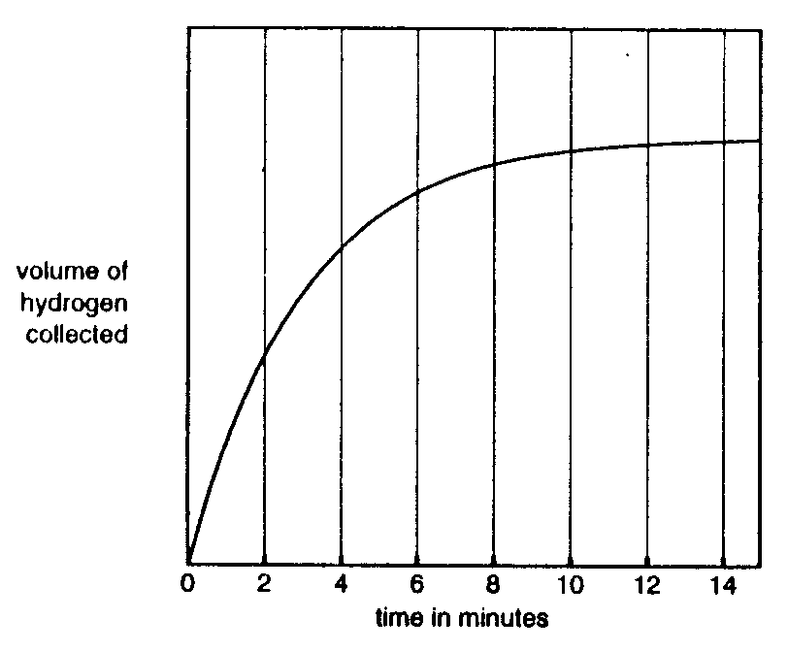

- Write an equation for the reaction that occurs.
____________________________________________________________________________________
1 mark
- What amount, in mole, of hydrochloric acid will have been used up when the reaction is complete?
____________________________________________________________________________________
____________________________________________________________________________________
____________________________________________________________________________________
2 marks
- What volume of hydrogen in mL will have been collected in the syringe when the reaction is complete?
____________________________________________________________________________________
____________________________________________________________________________________
____________________________________________________________________________________
____________________________________________________________________________________
3 marks
- The reaction between magnesium and hydrochloric acid above is repeated at a higher temperature, with all other conditions the same. On the axes above, sketch the graph you would expect to obtain.
1 mark
Total: 7 marks

Question 5
A local chemical manufacturer uses the process of catalytic cracking to prepare ethene and propene.

- i. Give the structure of one molecule that could be fed into the cracking tower to produce either ethene (C₂H₄) or propene.

ii. Draw the structure of ethene and propene.

1 + 2 = 3 marks
- Ethene can be reacted further to produce a variety of widely used chemicals. Complete each of the four reactions given below.

Reaction 1: | C₂H₄ | H₂O / catalyst | Draw the structure of the product.
 | Give the name of the product of reaction 1.
Reaction 2: | C₂H₄ | H₂ / catalyst | Draw the structure of the product.
 | Give the name of the product of reaction 2.
Reaction 3: | C₂H₄ | HBr | Draw the structure of the product.
Reaction 4: | C₂H₄ | catalyst | Draw the structure of the product.
6 marks
Total: 9 marks
Question 6
Five vitamin C tablets (vitamin C = ascorbic acid, C₆H₈O₆) of total mass 6.67 g were crushed and dissolved in 200.0 mL of distilled water. A 25.00 mL sample was taken from the solution and quickly titrated against a standardised iodine solution whose concentration was 0.110 M. Starch was used as an indicator. The titration was then carefully repeated three more times. The following gives a complete set of titres obtained.

Titration number | Titration in mL
First | 26.5
Second | 25.10
Third | 25.21
Fourth | 25.17

The equation for the reaction is
C₆H₈O₆ (aq) + I₂ (aq)  C₆H₆O₆ (aq) + 2 H⁺ (aq) + 2 I⁻ (aq)

- Imagine you had performed this experiment in the laboratory and had obtained the set of titration results shown above. Examine the titres given and then calculate the average titre you would use to calculate the concentration of the vitamin C solution.
____________________________________________________________________________________
1 mark
- What amount, in mole, of molecular iodine reacted with the ascorbic acid?
____________________________________________________________________________________
____________________________________________________________________________________
2 marks
- What amount, in mole, of ascorbic acid was present in the 200 mL of the ascorbic acid solution?
____________________________________________________________________________________
____________________________________________________________________________________
1 mark
- What mass of ascorbic acid was present in each vitamin C tablet?
____________________________________________________________________________________
____________________________________________________________________________________
____________________________________________________________________________________
2 marks
- What is the percentage by mass of ascorbic acid in each tablet?
____________________________________________________________________________________
____________________________________________________________________________________
____________________________________________________________________________________
1 mark
Total: 7 marks

END OF QUESTION AND ANSWER BOOK

