Board of Studies | Victorian Certificate of Education | 1999 | Chemistry | CAT 3

Instructions for students

There are 11 questions. Answer all questions.
To obtain full credit for your responses, you should
- give simplified answers with an appropriate number of significant figures to all numerical questions; unsimplified answers will not be given full credit
- show all working in your answers to numerical questions. No credit will be given for an incorrect answer unless it is accompanied by details of the working
- make sure chemical equations are balanced and that the formulas for individual substances include indications of state, for example
H₂ (g); NaCl (s).

Question 1
This question tests you recall of some of the factual material studied in Unit 4.
- Some amino acids are classified as ‘essential’ whereas others as ‘nonessential’. What is meant by essential and nonessential amino acids?
Essential amino acids __________________________________________________________________________
____________________________________________________________________________________________
Nonessential amino acids _______________________________________________________________________
____________________________________________________________________________________________
2 marks
- Give the formulas of two ions which can be a direct source of nitrogen for plants.
____________________________________________________________________________________________
2 marks
- Give the formula of an oxide which dissolves in water to produce an acidic solution.
____________________________________________________________________________________________
1 mark
- Why is a salt bridge used in a galvanic cell?
____________________________________________________________________________________________
____________________________________________________________________________________________
2 marks
- Give the formula of a suitable compound which can be used in solution in a salt bridge.
____________________________________________________________________________________________
1 mark
Total: 8 marks

Question 2
For each of the following statements, state whether it is true or false and give a reason for your choice.
- When an aqueous solution of potassium iodide is electrolysed, potassium is deposited at the cathode.
True or False? _______________
Reason _____________________________________________________________________________________
____________________________________________________________________________________________
2 marks
- In the following galvanic cell, the mass of copper deposited at the cathode must equal the mass of zinc lost as zinc ions at the anode.
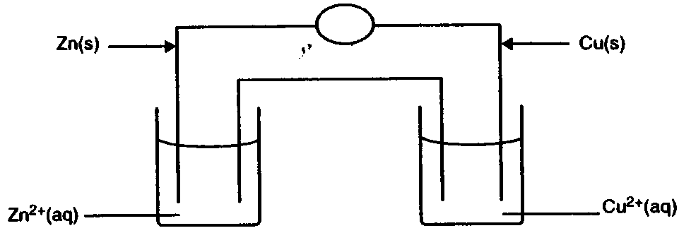
True or False? _______________
Reason _____________________________________________________________________________________
____________________________________________________________________________________________
____________________________________________________________________________________________
2 marks
- The electronic configuration for potassium has one electron in a 4th shell even though the 3rd shell is not full.
True or False? _______________
Reason _____________________________________________________________________________________
____________________________________________________________________________________________
2 marks
Total: 6 marks

Question 3
Electrolysis is used to coat an iron badge with copper metal. A sketch of the experimental setup is given below.
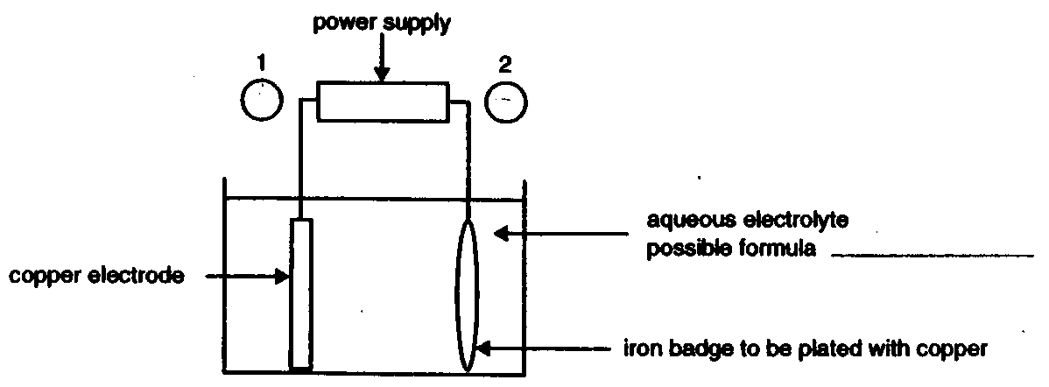
- On the diagram above
- label the polarity of the electrodes at points 1 and 2
- write the formula of a possible electrolyte in the space provided.
2 marks
- (i) Write an equation for the half reaction that occurs on the badge surface.
________________________________________________________________________________________
(ii) A current of 2.7 A is passed through the cell for 24 minutes. Calculate the mass of copper that would be deposited on the badge in that time.
________________________________________________________________________________________
________________________________________________________________________________________
________________________________________________________________________________________
________________________________________________________________________________________
________________________________________________________________________________________
4 marks
- A student is asked to coat another badge. Accidentally, the circuit was connected so that the direction of current flow was reversed. Describe what you expect to happen at the badge surface.
____________________________________________________________________________________________
____________________________________________________________________________________________
____________________________________________________________________________________________
1 mark
Total: 7 marks
Question 4
This question refers to energy transformations.
- (i) Complete the following equation:
4 | 1 | H | → |  | He | + | 2 |  | e | + | energy
4 |  | H | → | 2 | He | + | 2 |  | e | + | energy

(ii) What type of nuclear reaction is represented by this equation?
________________________________________________________________________________________
(iii) Name one place where this reaction could occur.
________________________________________________________________________________________
(iv) What is the source of the energy released in this reaction?
________________________________________________________________________________________
5 marks
- The diagram below represents the process of generating electricity from coal in a power station.

coal mine |  | furnace |  | boiler |  | turbine |  | generator |  | power grid
 |  |  |  | pump |  | condenser |  |  |  | cooling tower
 |  |  |  |  |  | condenser |  | pump |  | cooling tower

Briefly identify the nature of the energy transformation that occurs in the
(i) furnace __________________________________________________________________________
(ii) turbine __________________________________________________________________________
(iii) generator __________________________________________________________________________
3 marks
- List two renewable energy sources.
____________________________________________________________________________________________
1 mark
Total: 9 marks

Question 5
Two different fuels, (propane C₃H₈ (g) and ethanol C₂H₅OH (l)) were tested in a car.
- Write an equation for the complete combustion of each of these fuels in oxygen.
Propane C₃H₈
____________________________________________________________________________________________
Ethanol C₂H₅OH
____________________________________________________________________________________________
3 marks
- When one mole of propane undergoes complete combustion, 2220 kJ of energy are released.
Calculate the energy released from the combustion of 1.00 kg of propane.
____________________________________________________________________________________________
____________________________________________________________________________________________
____________________________________________________________________________________________
____________________________________________________________________________________________
____________________________________________________________________________________________
2 marks
- When 1.00 kg of ethanol undergoes complete combustion, 30000 kJ of energy are released.
List three factors to consider when choosing between propane and ethanol for use as a fuel for a car.
____________________________________________________________________________________________
____________________________________________________________________________________________
____________________________________________________________________________________________
2 marks
Total: 7 marks

Question 6
In answering this question, you will need to refer to the following compounds.

C₃H₅(OH)₃ | 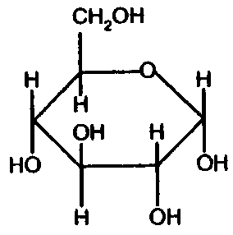 | HNCH(CH₃)COOH | HOCOC₁₇H₃₅ | H₂NCH₂COOH | 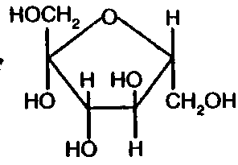
glycerol | glucose | alanine | stearic acid | glycine | fructose

- Give the names of two of the above compounds which can react together to form a disaccharide.
____________________________________________________________________________________________
1 mark
- (i) Select two of the above compounds which can react together to form a dipeptide and give an equation for the reaction.
________________________________________________________________________________________
________________________________________________________________________________________
(ii) Name the type of reaction involved.
________________________________________________________________________________________
(iii) Circle the peptide link in the dipeptide.

4 marks
Total: 5 marks

Question 7
On the label of a bottle of vegetable oil is the following information.
The information refers to 100 gram of oil.

Energy (kJ) |  | 3400
Fats | - polyunsaturated | 27%
 | - monounsaturated | 58%
 | - saturated | 15%

- State the fundamental difference between polyunsaturated, monounsaturated and saturated fats.
____________________________________________________________________________________________
____________________________________________________________________________________________
____________________________________________________________________________________________
2 marks
- In order to check the energy content of the oil, a bomb calorimeter was first calibrated and its calibration factor determined.
(i) The calibration factor of the calorimeter was found by passing a current of 1.32 A, at a potential difference of 5.91 V, through the calorimeter for 6.50 minutes and recording the temperature rise of the water surrounding the bomb.
On the basis of the experimental results, the calibration factor was calculated to be 1135 J °C⁻¹.
If the final temperature of the water bath was found to be 22.36°C, what was the initial temperature of the water bath in this experiment?
________________________________________________________________________________________
________________________________________________________________________________________
________________________________________________________________________________________
________________________________________________________________________________________
________________________________________________________________________________________
________________________________________________________________________________________
(ii) The same calorimeter was then used to determine the energy content of the oil. A mass of 0.500 g of the oil was burnt in the bomb in the presence of excess oxygen. The temperature of the water bath was found to increase from 20.02°C to 34.48°C.
Calculate the energy content of the oil in kJ g⁻¹.
________________________________________________________________________________________
________________________________________________________________________________________
________________________________________________________________________________________
________________________________________________________________________________________
________________________________________________________________________________________
(iii) Compare your answer in (ii) to the nutritional information given on the label of the bottle and describe one possible reason for the difference between the two values.
________________________________________________________________________________________
________________________________________________________________________________________
7 marks
- The following structural formula represents a fat molecule with three different fatty acid chains.
Circle any unsaturated fatty acid chains in the molecule.
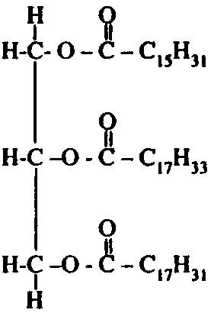
1 mark
Total: 10 marks

Question 8
A biscuit is crushed and mixed with water. The biscuit contains starch, a carbohydrate polymer. The biscuit-water mixture is divided into three equal parts. Each part is placed in a separate water bath, maintained at a different temperature (90°C, 35°C and 5°C)
Equal amounts of the enzyme, amylase, found in human saliva, are added to the samples of the mixture and the concentration of starch in each sample is measured over time.
The results are represented as follows.
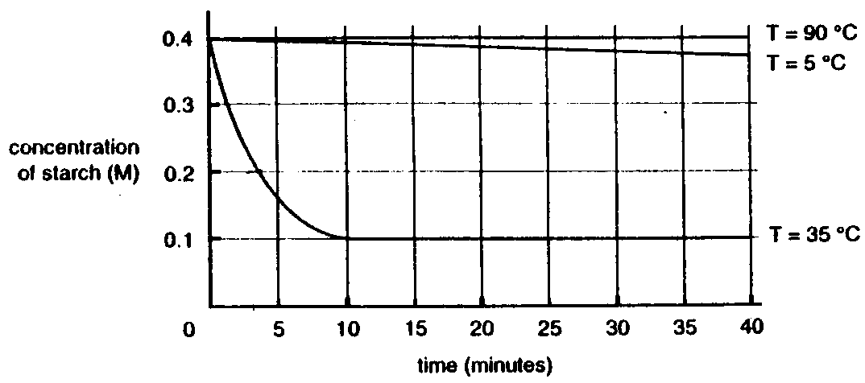
- For the experiment conducted at 35°C, estimate the time taken for the starch concentration to fall to half its original value.
____________________________________________________________________________________________
1 mark
- Explain why the rate of decrease of starch was less at 5°C than at 35°C.
____________________________________________________________________________________________
____________________________________________________________________________________________
1 mark
- Explain why the reaction is so slow at 90°C.
____________________________________________________________________________________________
____________________________________________________________________________________________
1 mark
- Give the name for this type of chemical reaction.
____________________________________________________________________________________________
1 mark
- Name one possible product of this reaction.
____________________________________________________________________________________________
1 mark
Total: 5 marks

Question 9
 |  | B  5 | C  6
Li  3 | Be  4
H  1 | He  2

Shown above is an unusual version of the periodic table. It has been arranged so that he positions of the electronic shells and subshells reflect their relative energies.
- Place the symbols for the elements nitrogen, oxygen, fluorine and neon in their correct positions on the table.
- Place the symbol for chlorine in its correct position in the table.
- Give the electronic configuration for titanium by completing the following:
Electronic configuration of titanium = 1s² 2s² 2p⁶ 3s² ___________________________
- Place the symbol for titanium in its correct position in the table.
- Write the words ‘lanthanides’ and ‘actinides’ in their correct places in the table.
Total: 6 marks

Question 10
Naturally occurring rhenium, an element in the second series of transition metals, consists of a mixture of two isotopes in the following approximate proportions.
¹⁸⁵Re (relative isotopic mass 184.95) = 37.50%
¹⁸⁷Re (relative isotopic mass 186.96) = 62.50%

- ¹⁸⁵Re is a stable isotope while ¹⁸⁷Re is radioactive.
(i) Explain the term ‘stable’ isotope.
________________________________________________________________________________________
________________________________________________________________________________________
(ii) Nuclei of ¹⁸⁷Re decay by emitting beta particles (electrons). Write the symbol of the element that is produced as a result of this decay process.
________________________________________________________________________________________
(iii) Calculate the mass, in gram, of a single ¹⁸⁵Re atom.
________________________________________________________________________________________
________________________________________________________________________________________
________________________________________________________________________________________
4 marks
- Below is shown a portion of the mass spectrum of a sample of naturally occurring rhenium.
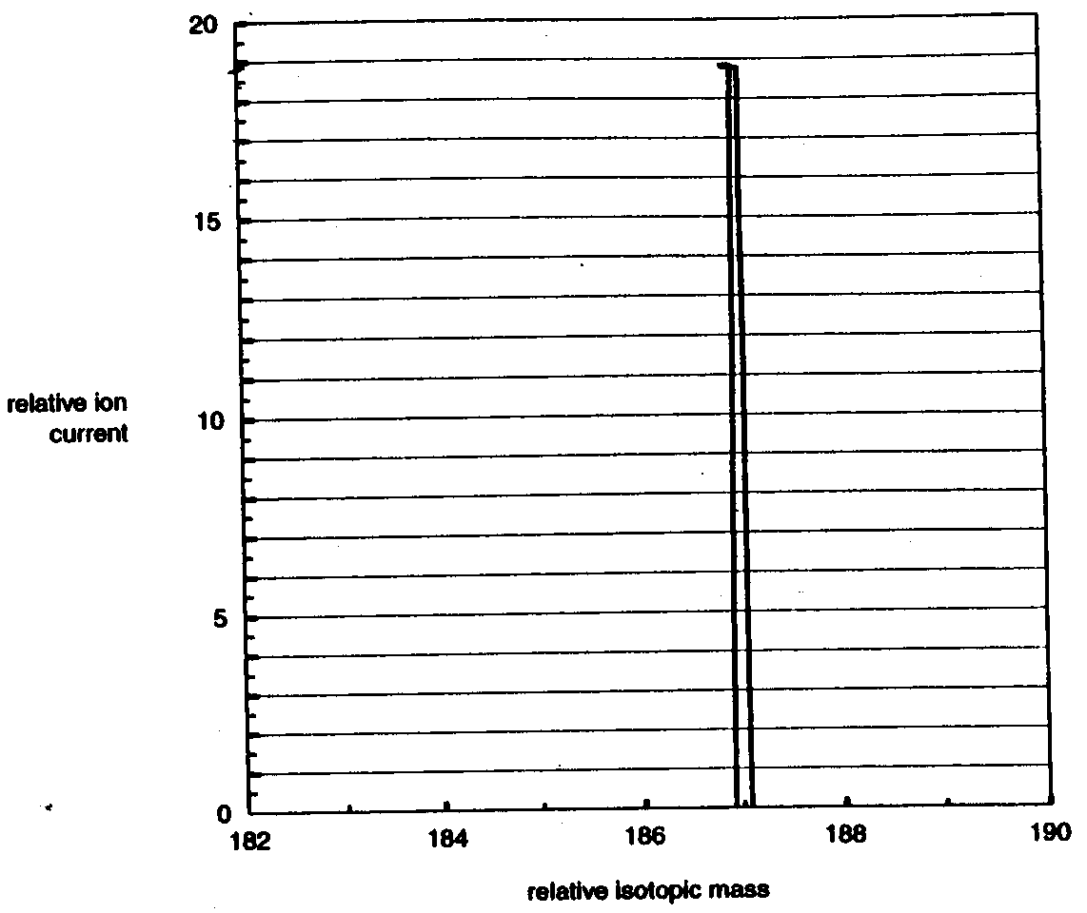v
(i) Calculate the height and position of the other peak you would expect to observe in the mass spectrum and sketch it on the above graph.
________________________________________________________________________________________
________________________________________________________________________________________
________________________________________________________________________________________
(ii) Calculate the relative atomic mass of rhenium.
________________________________________________________________________________________
________________________________________________________________________________________
________________________________________________________________________________________
4 marks
Total: 8 marks

Question 11
- You are given two different metals. One of them is a group I metal, the other a transition metal.
Suggest a physical property that you could measure to distinguish between the two metals. Explain how the results of this measurement would enable you to make the distinction.
____________________________________________________________________________________________
____________________________________________________________________________________________
____________________________________________________________________________________________
1 mark
- Select a transition metal that shows variable oxidation states and has some compounds that are coloured.
(i) Give formulas of two compounds to illustrate the different oxidation states of your chosen element.
________________________________________________________________________________________
(ii) Identify a coloured compound (that is, one that is not white) of the element and write an equation showing how the compound might be formed from the element.
________________________________________________________________________________________
________________________________________________________________________________________
4 marks
- The structural formula below represents a complex ion of a transition metal, M, with ammonia.
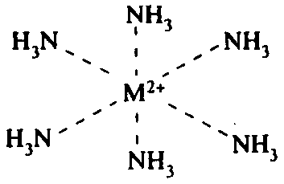
Describe the bonding between the metal ion and the ammonia molecules.
____________________________________________________________________________________________
____________________________________________________________________________________________
1 mark
Total: 6 marks

