IARTV
2000
UNIT 4 CHEMISTRY

SECTION A – Multiple-choice questions

Question 1
If a solution of hydrochloric acid is added to a solution of sodium hydroxide the equation for the reaction is:
HCl (aq) + NaOH (aq)  NaCl (aq) + H₂O (l) ΔH = –57.2 kJ mol^{–1}
In an experiment a student added 20.0 mL of 0.100 M HCl to 10.0 mL of 0.500 M NaOH. How much energy was produced by the reaction?
- 286 kJ
- 114 kJ
- 286 J
- 114 J

Question 2
For endothermic reactions
- the value of the activation energy is greater than the value for ΔH
- the value of the activation energy is less than the value for ΔH
- the value of the activation energy is equal to the value for ΔH
- the value of the activation energy is sometimes greater and sometimes smaller than the value for ΔH

Question 3
Water is evaporated according to the equation:
H₂O (l)  H₂O (g) ΔH = +44 kJ mol^{–1}
The activation energy for this reaction is 52 kJ mol^{–1}. What is the value of the activation energy for the condensation of water?
- –96 kJ mol^{–1}
- –8 kJ mol^{–1}
- +8 kJ mol^{–1}
- +96 kJ mol^{–1}

Question 4
A galvanic cell at 25°C consists of zinc metal dipping into 1 M zinc nitrate connected to nickel metal dipping into 1 M nickel nitrate. For this cell the reductant will be
- Zn
- Ni
- Ni²⁺
- Zn²⁺

Question 5
Two cells were connected as shown in the diagram below. The experiment was conducted at 25°C and the cations were at 1 M concentration.
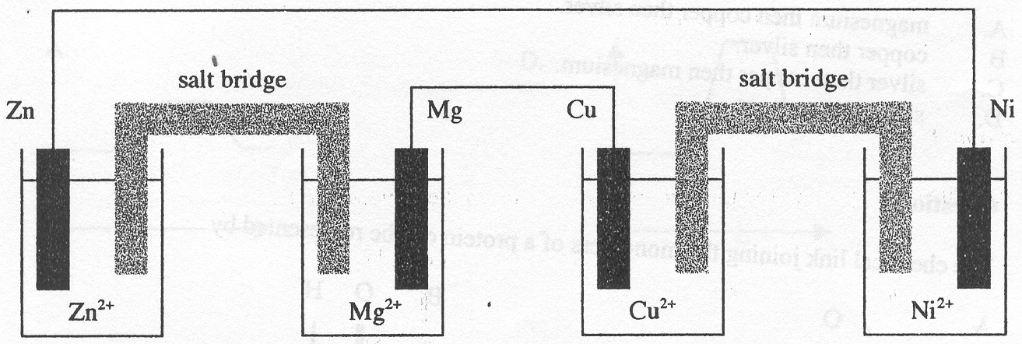
Which of the following statements is correct? Electrons moved from the
- magnesium to the copper electrode
- copper to the magnesium electrode
- zinc to the magnesium electrode
- zinc to the nickel electrode

Question 6
A galvanic cell consists of the standard hydrogen electrode half-cell connected to a half-cell consisting of copper dipping into 1 M CuSO₄ solution. Which of the following statements is correct?
- The copper electrode is the site of the oxidation.
- The copper electrode is decreasing in mass.
- The pH of the solution in the standard hydrogen electrode half-cell is increasing.
- The pH of the solution in the standard hydrogen electrode half-cell is decreasing.

Question 7
Aluminium is produced in the Hall-Heroult cell by the electrolysis of molten aluminium oxide using molten cryolite as an anhydrous solvent. This solvent is used because
- it prevents oxygen gas production at the anode
- the cell reaction produces less toxic products
- less energy is used when compared with the electrolysis of the pure molten compound
- the aluminium ion is a stronger oxidant than water

Question 8
Electrolysis is carried out on a solution containing a mixture of 0.1 M silver nitrate, 0.1 M copper (II) nitrate and 0.1 M magnesium nitrate using graphite electrodes. After all possible reactants have been consumed, the cathode consists of graphite coated initially with
- magnesium then copper then silver
- copper then silver
- silver then copper then magnesium
- silver then copper

Question 9
The chemical link joining the monomers of a protein can be represented by
A. | 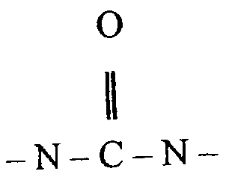 | B. | 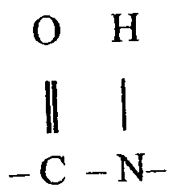 | C. | 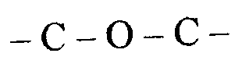 | D. | 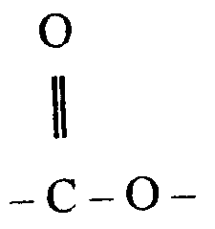

Question 10
The fat tripalmitin is shown below.
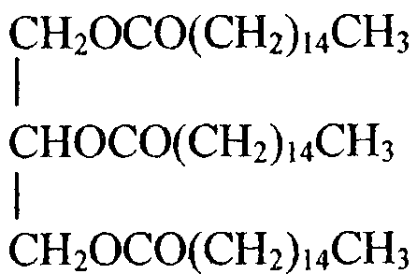
The products of complete combustion of tripalmitin are carbon dioxide and water.
To achieve complete combustion of 1.0 mol of tripalmitin the amount of oxygen required would be closest to
- 151 mol
- 145 mol
- 75.5 mol
- 72.5 mol

Question 11
The energy profile diagram that best represents the complete combustion of tripalmitin is
A. | 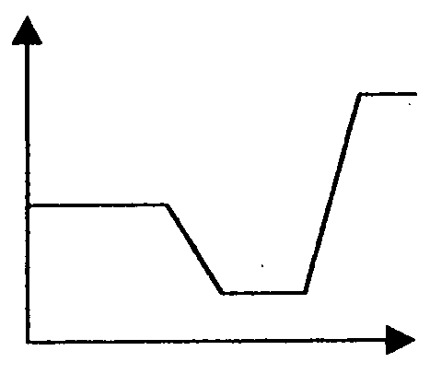 | B. | 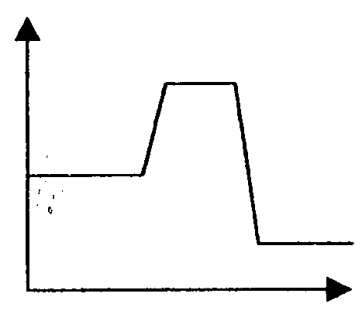 | C. | 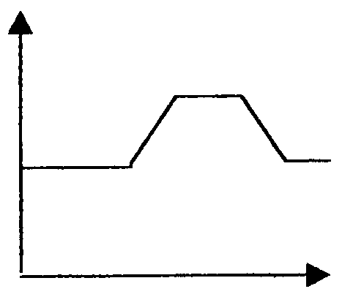 | D. | 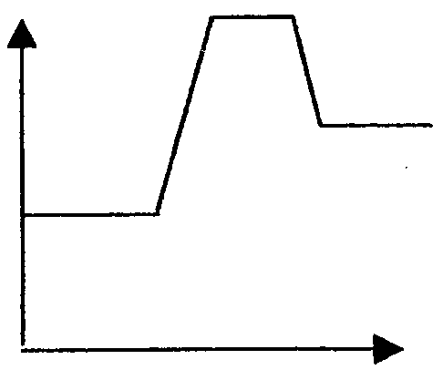

Question 12
The enzyme amylase, found in saliva, is denatured by high temperatures. When amylase is subjected to an increase in temperature, which of the following is least likely to occur?
- The hydrogen bonding holding the enzyme molecule in its shape is disrupted.
- The primary structure of the enzyme is disrupted.
- The shape of the active site of the enzyme is disrupted.
- The tertiary structure of the enzyme is disrupted.

Question 13
Which of the following is a possible product of the hydrolysis of glycogen?
- H₂O
- NH₂CONH₂
- CO₂
- C₁₂H₂₂O₁₁

Question 14
Antioxidants are added to margarine
- to emulsify the oil and water components
- to add on to the carbon-carbon double bonds of the oil components to increase their melting point
- to develop the yellow colour of the product
- to slow down the production of rancid particles

Question 15
Our Sun produces helium by hydrogen fusion. Over time, the number of nuclei in our Sun
- is decreasing
- is increasing
- remains constant
- varies according to temperature

Question 16
The mass of hydrogen in our universe
- is decreasing
- is increasing
- remains constant
- varies according to temperature

Question 17
The elements carbon, nitrogen and oxygen in our bodies were originally formed
- on the Earth
- in the Sun
- in a supernova star
- in a black hole

Question 18
Fusion reactions are difficult to produce on Earth because
- there is not enough hydrogen
- the products of fusion are radioactive
- the reactions need extremely high temperatures to start
- fission produces more energy than fusion when small atoms react

Question 19
In the modern Periodic Table, the oxidising strength of elements
- increases across each period and increases down each group
- increases across each period and decreases down each group
- decreases across each period and increases down each group
- decreases across each period and decreases down each group

Question 20
The first row of transition metals contains the elements scandium to zinc. Zinc has many properties that are different from the other transition elements. This is because
- zinc has a full 4s subshell
- zinc has a full 3d subshell
- zinc has a higher atomic number
- zinc has a higher relative atomic mass

SECTION B – Short-answer questions

Question 1 (12 minutes, 9 marks)
A student calibrated a bomb calorimeter by burning some methane in it. The heat of combustion for methane is 890 kJ mol^{–1}. The following data was obtained:
- 9.50 × 10^{–3} mol of methane was burnt in excess oxygen in the bomb calorimeter
- the temperature rose from 22.2°C to 23.8°C

- Write a balanced thermochemical equation for the combustion of methane.
_______________________________________________________________________________________
1 mark
- Using the information above, calculate the calibration factor for the calorimeter in J °C^{–1}.
_______________________________________________________________________________________
_______________________________________________________________________________________
_______________________________________________________________________________________
_______________________________________________________________________________________
_______________________________________________________________________________________
2 marks
- The student checked the results obtained in the above experiment by carrying out a further experiment using electrical calibration. With a power pack, the student heated the electric heater in the calorimeter with a voltage of 6.01 volts and a current of 5.00 ampere for 3.00 minutes.
(i) Calculate the energy transferred to the calorimeter.
____________________________________________________________________________________
____________________________________________________________________________________
____________________________________________________________________________________
(ii) 100 mL of water surrounds the calorimeter inner casing. If the calibration factor calculated in part b. is correct, then to what temperature will the water rise if the initial temperature is 23.8°C?
____________________________________________________________________________________
____________________________________________________________________________________
____________________________________________________________________________________
____________________________________________________________________________________
____________________________________________________________________________________
____________________________________________________________________________________
4 marks
- Methane is used in the Newport power station but most of the demand for electricity in Victoria is met by the coal-fired power stations in the Latrobe Valley. List one disadvantage and one advantage of this reliance on coal as opposed to methane.
_______________________________________________________________________________________
_______________________________________________________________________________________
_______________________________________________________________________________________
_______________________________________________________________________________________
2 marks

Question 2 (17 minutes, 13 marks)
A chemist believed that a sample consisted of tetraammine diaqua copper(II) sulfate, (Cu(NH₃₄(H₂O)₂SO₄). To show that this was indeed the case, 2.868 g of the solid was dissolved in water and all the copper was deposited onto a graphite electrode by electrolysis. This required a current of 3.50 amperes for 10.00 minutes.

- What is the polarity of the electrode at which the copper was deposited?
_______________________________________________________________________________________
1 mark
- What is the name of the electrode at which the copper is deposited?
_______________________________________________________________________________________
1 mark
- Write an equation for the copper ions reacting at the graphite electrode.
_______________________________________________________________________________________
1 mark
- What quantity of charge was required for the deposition of the copper metal?
_______________________________________________________________________________________
_______________________________________________________________________________________
1 mark
- What mass of copper was deposited on the electrode?
_______________________________________________________________________________________
_______________________________________________________________________________________
_______________________________________________________________________________________
_______________________________________________________________________________________
_______________________________________________________________________________________
3 marks
- Using the amount of copper calculated in e., determine the relative formula mass of the complex and show that it is the same as that arrived at by using relative atomic masses as listed in the data sheet.
_______________________________________________________________________________________
_______________________________________________________________________________________
_______________________________________________________________________________________
_______________________________________________________________________________________
3 marks
- In the space below, sketch the structure of the tetraammine diaqua copper(II) ion, orienting the ligands appropriately. Label the types of bonds present.

3 marks
Question 3 (6 minutes, 5 marks)
The development of fuel cells progressed rapidly as a need to supply energy to the spacecraft in the Apollo Space Program increased.

- Suggest two reasons why fuel cells are used in spacecraft rather than the more conventional lead-acid accumulator found in cars.
(i) ____________________________________________________________________________________
(ii) ____________________________________________________________________________________
1 mark
The schematic diagram below shows an oxygen-hydrogen fuel cell with a sulfuric acid electrolyte.
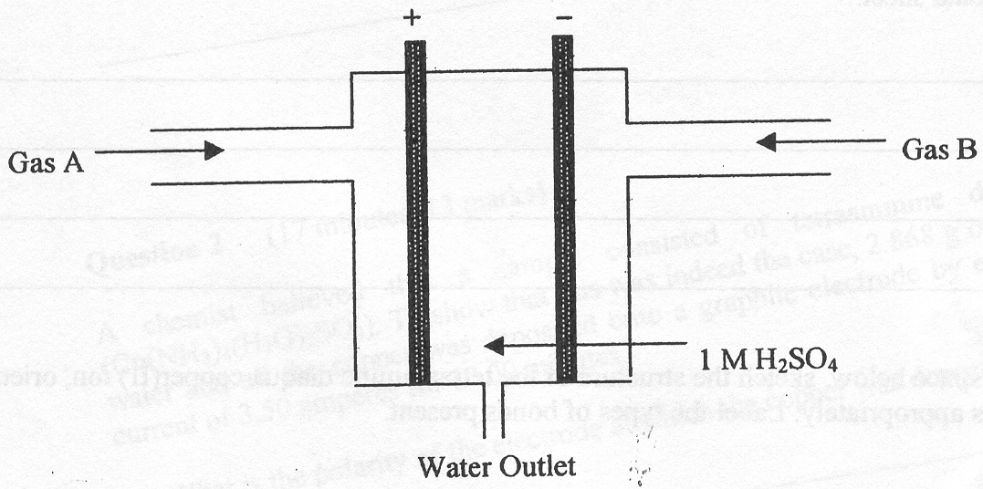
- (i) Name Gas A.
____________________________________________________________________________________
(ii) Write balanced equations for the half-reactions that occur at the anode and the cathode in this fuel cell.
anode: ____________________________________________________________________________
cathode: ____________________________________________________________________________
(iii) Write the overall reaction for this fuel cell.
____________________________________________________________________________________
3 marks
- A great deal of research has been carried out on the structure and composition of the electrodes in fuel cells. Name one extra function the electrodes must carry out when compared with those used in galvanic cells.
_______________________________________________________________________________________
_______________________________________________________________________________________
1 mark

Question 4 (5 minutes, 4 marks)
The following structure shows part of a common molecule found in nature.
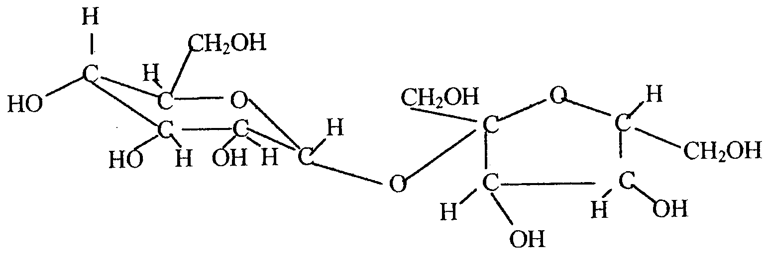
- To which food group does this molecule belong?
_______________________________________________________________________________________
1 mark
- Give a chemical equation for the complete oxidation of this molecule.
_______________________________________________________________________________________
_______________________________________________________________________________________
1 mark
- Draw the structural formula of one of the monomer units of this molecule.

1 mark
- Circle and name a functional group on the monomer you have drawn.
1 mark

Question 5 (10 minutes, 8 marks)
The diagram below shows some of the stages in the nitrogen cycle.

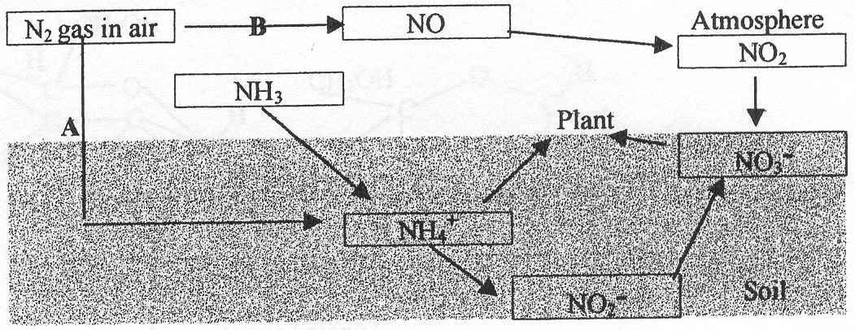

- What is the name for the type of reaction shown by step A?
_______________________________________________________________________________________
1 mark
- Describe one way that the reaction at A could occur in nature.
_______________________________________________________________________________________
_______________________________________________________________________________________
1 mark
- Why do plants need nitrogen?
_______________________________________________________________________________________
_______________________________________________________________________________________
1 mark
- Draw the structural formula of one molecule containing nitrogen that plants could make.

1 mark
- Write a balanced chemical equation for reaction B.
_______________________________________________________________________________________
1 mark
- The table below shows three products of human digestion that are used by cells and produce wastes. Complete the table giving the symbols of the elements present in each and naming the wastes eliminated by the body.

Products of digestion | Elements present | Names of waste products
glucose
glycine
glycerol
3 marks

Question 6 (14 minutes, 11 marks)
A student wrote in a report that a new element had been discovered with a relative atomic mass between that of neon and sodium.

- (i) Is it possible that a new element with this mass could exist? Explain.
____________________________________________________________________________________
____________________________________________________________________________________
____________________________________________________________________________________
(ii) If a substance with the relative atomic mass as stated is found, how could this be explained?
____________________________________________________________________________________
____________________________________________________________________________________
____________________________________________________________________________________
2 marks
- Ernest Rutherford showed in 1912 that in the lighter elements then umber of positive charges in the nucleus of an atom (now called the atomic number) is often close to half of the atomic weight (now called the relative atomic mass). For example helium (Z = 2) has a relative atomic mass of 4.003, while nitrogen (Z = 7) has a relative atomic mass of 14.008. Why was Rutherford not able to satisfactorily explain this observation.
_______________________________________________________________________________________
_______________________________________________________________________________________
_______________________________________________________________________________________
_______________________________________________________________________________________
1 mark
- Copper has two isotopes, copper-63 and copper-65, but the relative atomic mass of copper is 63.5. Explain why this is so.
_______________________________________________________________________________________
_______________________________________________________________________________________
_______________________________________________________________________________________
1 mark
- Sodium atoms and chlorine atoms both have 3 occupied shells. Explain why a sodium atom is larger than a chlorine atom.
_______________________________________________________________________________________
_______________________________________________________________________________________
_______________________________________________________________________________________
1 mark
- Write balanced full equations for the following reactions.
(i) Solid sodium oxide reaction with dilute sulfuric acid.
____________________________________________________________________________________
(ii) Sulfur trioxide reacting with dilute sodium hydroxide solution.
____________________________________________________________________________________
2 marks
- Chromium is a transition element with important industrial applications. The electron configuration of chromium is unusual in that it contains only one electron in the 4s subshell.
(i) Write the electron configuration for chromium.
____________________________________________________________________________________
(ii) Chromium-50 can be bombarded with alpha particles to form iron-53. A small particle is liberated in the process. Write a balanced nuclear equation showing this reaction.
____________________________________________________________________________________
(iii) Name the small particle produced in (ii).
____________________________________________________________________________________
(iv) Chromium is founding a variety of compounds. These include:
- potassium chromite, KCrO₂ (green)
- potassium chromate, K₂CrO₄ (yellow)
- potassium dichromate, K₂Cr₂O₇ (orange)
Hydrated chromium (III) chloride, Cr(H₂O)₆Cl₃ is found in solutions What colour would you expect it to be? Justify your answer.
____________________________________________________________________________________
____________________________________________________________________________________
4 marks

