IARTV
2001
CHEMISTRY
Unit 3 Exam

Section A – Multiple Choice

Question 1
The volume of 0.20 M H₂SO₄ solution required to neutralise 100 mL of 0.10 M NaOH solution is
- 200 mL
- 100 mL
- 50 mL
- 25 mL

Question 2
40 mL of 0.40 M HCl solution is added to the neutralised solution in Question 1. The pH of the resulting solution is
- 1.0
- 1.5
- 3.0
- 13

Question 3
A sample of hydrochloric acid is to be standardised by titrating against 20.00 mL aliquots of a standard sodium carbonate solution prepared by using a 250 mL standard (volumetric) flask. The calculated hydrochloric acid concentration will be lower than its true value if
- the burette is rinsed with water just before use
- the standard flask is rinsed with water just before use
- the reaction flasks are rinsed with water just before use
- the pipette is rinsed with water just before use

Question 4
The mass of ammonium nitrate, NH₄OH, of 80% purity, which contains 1.4 g of nitrogen is approximately
- 1.4 g
- 2.5 g
- 3.2 g
- 5.0 g

Question 5
Which of the following is not a requirement of a primary standard?
- It should not react with substances in the air.
- It must be soluble in all solvents.
- It should have a high molar mass.
- It must be easily obtained in a pure form.

Question 6
In which of the following half-equations does the oxidation number of sulfur increase by 2?
- SO₄^{2–} (aq) + 2 H⁺ (aq) + 2 e– → SO₃^{2–} (aq) + H₂O (l)
- SO₄^{2–} (aq) + 4 H⁺ (aq) + 2 e– → SO₂ (aq) + 2 H₂O (l)
- SO₄^{2–} (aq) + 10 H⁺ (aq) + 8 e– → H₂S (aq) + 4 H₂O (l)
- H₂S (aq) → S (s) + 2 H⁺ (aq) + 2 e–

Question 7
The hypochlorite ion, OCl–, can act as either an oxidant or a reductant. Which of the following could be produced if OCl– acts as an oxidant?
- ClO₂
- HClO₄
- HCl
- ClO₃–

Question 8
A 33.5 g sample of iron is heated, producing 46.3 g of iron oxide. The empirical formula of the iron oxide is
- FeO
- FeO₂
- Fe₂O₃
- Fe₃O₄

Question 9
A badly tuned car can release up to 1.00 mol of carbon monoxide in the first minute after starting the engine. At 22°C and 1.2 atm, the volume of CO released in these circumstances is
- 49 mL
- 1.5 L
- 20 L
- 22.4 L

Question 10
Liquid chromatography was first discovered in 1901 by Mikhail Tvset, a Russian botanist who wanted to isolate the pigments in plant leaves. He ground the leaves in a solvent of petroleum ether and washed the mixture down a glass column that he had packed with chalk powder. As the mixture passed down the column, coloured bands formed showing eight different pigments in the plant mixture. The pigment that travelled the least distance in the time was
- more strongly absorbed to the chalk column and more soluble in the solvent than the other pigments
- more strongly absorbed to the chalk column and less soluble in the solvent than the other pigments
- less strongly absorbed to the chalk column and more soluble in the solvent than the other pigments
- less strongly absorbed to the chalk column and less soluble in the solvent than the other pigments

Question 11
Human blood plasma contains many dissolved substances including glucose, urea, amino acids and the ions Fe²⁺, Na⁺, Cl–, K⁺, HCO₃–, Ca²⁺, and Mg²⁺. There may also be other chemicals such as caffeine, alcohol or other drugs present in the plasma. The most suitable method for analysis for the following substances would be

 | Ca²⁺ | Glucose | Caffeine
A. | Atomic Absorption  Spectroscopy | Gas Chromatography | Gas Chromatography
B. | UV-Visible Spectroscopy | Atomic Absorption  Spectroscopy | Gas Chromatography
C. | Atomic Absorption  Spectroscopy | High Performance  Liquid Chromatography | High Performance  Liquid Chromatography
D. | Gas Chromatography | UV-Visible Spectroscopy | Atomic Absorption  Spectroscopy

Question 12
I | 
II | 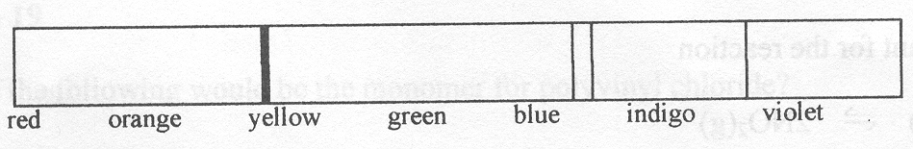
The above spectra are applied in a number of analytical procedures. Identify the instruments that match the spectra listed below.

 | I | II
A. | Atomic Absorption Spectrometer | UV-Visible Spectrophotometer
B. | Atomic Absorption Spectrometer | Colorimeter
C. | Spectroscope | Atomic Absorption Spectrometer
D. | Colorimeter | Spectroscope

Question 13
A chemist was investigating the decomposition of hydrogen peroxide, H₂O₂. Which graph below would correctly represent the relationship between the rate of reaction (vertical axis) and the temperature (horizontal axis)?
A. | 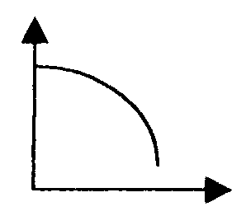 | B. | 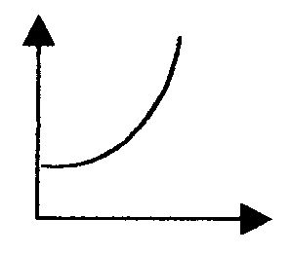 | C. | 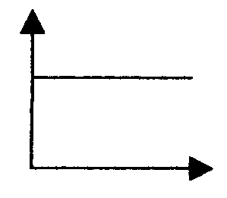 | D. | 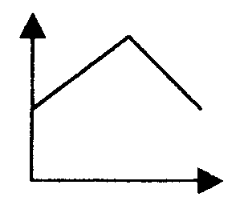

Question 14
In the Haber process, nitrogen and hydrogen gases are reacted to produce ammonia, NH₃, as shown
N₂ (g) + 3 H₂ (g)  2 NH₃ (g) ΔH = –91 kJ mol^{–1}
Iron, which is used as a catalyst in this process, is powdered prior to use. This makes the catalyst more efficient because it
- lowers the activation energy of the reaction
- increases the contact between the catalyst and the reactant molecules
- decreases the enthalpy of the reaction
- lowers the change of the catalyst being ‘poisoned’

Question 15
The equilibrium constant for the reaction
N₂O₄ (g)  2 NO₂ (g)
is 0.98 M at 298 K. In a 2.00 L vessel the amount of N₂O₄ (g) is found to be 0.425 mol at equilibrium. The concentration of NO₂ (g) in this system will therefore be
- 0.65 M
- 0.46 M
- 0.42 M
- 0.21 M

Question 16
In a particular equilibrium system, an increase in temperature causes the reaction to shift to the reactant side of the equation. This indicates that the reaction is
- exothermic and the equilibrium constant is decreasing in value
- endothermic and the equilibrium constant is decreasing in value
- exothermic and the equilibrium constant remains unchanged in value
- endothermic and the equilibrium constant remains unchanged in value

Question 17
The molecule CH₃CH(CH₃)CH₂CH _{is}
- an alkene
- an ester
- an alkane
- a polymer

Question 18
In the production of low density polyethene (LDPE) from ethene, more extreme conditions of temperature and pressure are used than for the production of high density polyethene (HDPE) because
- this promotes bond breaking so the final product is highly branched
- there is a higher demand for LDPE and this increases the rate of reaction
- this prevents branching occurring in the chains
- this promotes closer packing of the polymer chains

Question 19
Which of the following would be the monomer for polyvinyl chloride?
- ClCH₂CH₂Cl
- CH₃CHClCH₃
- CCl₂CCl₂
- CH₂CHCl

Question 20
The number of structural isomers with the formula C₄H₉Cl is
- 3
- 4
- 5
- 6

Section B – Short Answer Questions

Question 1 (13 minutes, 10 marks)
Hydroxylamin, NH₂OH, is a compound used in the manufacture of synthetic fibres.

A 150.00 mL sample of hydroxylamine solution was treated with 50.00 mL of 0.1045 M Fe(NO₃)₃ solution so that all of the hydroxylamine reacted according to the equation
2 NH₂OH (aq) + 4 Fe³⁺ (aq) → N₂O (g) + 4 Fe²⁺ (aq) + 4 H⁺ (aq) + H₂O (l)

The Fe²⁺ ions produced were then titrated with 28.65 mL of 0.1162 M KMnO₄ solution, forming Fe³⁺ ions and Mn²⁺ ions.

- Write the balanced half-equation for the oxidation that occurred in the titration.
________________________________________________________________________________________________
- Write the balanced half-equation for the reduction that occurred in the titration.
________________________________________________________________________________________________
- Write the overall ionic equation for the titration.
________________________________________________________________________________________________
- Calculate the number of mole of MnO₄– used in the titration.
________________________________________________________________________________________________
________________________________________________________________________________________________
- Calculate the number of mole of Fe²⁺ reacting with the MnO₄–.
________________________________________________________________________________________________
________________________________________________________________________________________________
________________________________________________________________________________________________
- Calculate the number of mole of Fe³⁺ reacting with the hydroxylamine.
________________________________________________________________________________________________
________________________________________________________________________________________________
- Calculate the % (w/v) of the hydroxylamine in the original sample.
________________________________________________________________________________________________
________________________________________________________________________________________________
________________________________________________________________________________________________
________________________________________________________________________________________________
- Explain why you would expect hydroxylamine to be very soluble in water?
________________________________________________________________________________________________
________________________________________________________________________________________________
- Would an indicator be required for the titration reaction? Justify your answer.
________________________________________________________________________________________________
________________________________________________________________________________________________
(1 + 1 + 1 + 1 + 1 + 1 + 2 + 1 + 1 = 10 marks)

Question 2 (9 minutes, 7 marks)
The diagram below represents a simple UV-visible spectrophotometer.
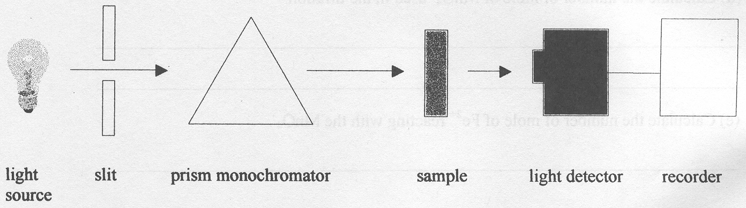

- The prism monochromator controls the wavelength of light passed through the sample? On what basis is this wavelength selected.
________________________________________________________________________________________________
________________________________________________________________________________________________
________________________________________________________________________________________________
- What is the function of the light detector?
________________________________________________________________________________________________
________________________________________________________________________________________________
- This UV-visible spectrophotometer was used to measure the copper content of a fungicide powder. 1.55 g of the fungicide was dissolved in 20.00 mL of distilled water and filtered. A 2.00 mL sample of the filtrate was analysed in the UV-visible spectrophotometer and an absorbance of 0.55 was obtained. Immediately before this analysis, standard solutions of copper were tested in this instrument and the results are shown in the table below.

Concentration of Cu²⁺ | Absorbance
0.25 M | 0.215
0.50 M | 0.430
0.75 M | 0.645

On the graph below draw a calibration curve for Cu²⁺ ions.

- Calculate the number of moles of ozone in the original air sample
________________________________________________________________________________________________
________________________________________________________________________________________________
- Calculate the % (w/w) of Cu²⁺ ions in the fungicide powder.
________________________________________________________________________________________________
________________________________________________________________________________________________
________________________________________________________________________________________________
________________________________________________________________________________________________
(1 + 1 + 2 + 1 + 2 = 7 marks)

Question 3 (7 minutes, 6 marks)
The following endothermic reaction was allowed to come to equilibrium.
2 CO₂ (g)  2 CO (g) + O₂ (g)

Changes were made to the system and the equilibrium allowed to re-establish.

Place a tick in the box for the change to the equilibrium concentration of oxygen due to the stated change of reaction conditions.

Change | Increase | Decrease | No Change
- Addition of NaOH (s) to the reaction vessel at constant temperature
- Halving of the reaction vessel volume at constant temperature
- Addition of a catalyst to the reaction vessel at constant temperature
- Decreasing the pressure of the gases at constant temperature
- Increasing of the vessel temperature at constant volume
- Addition of CO (g) to the reaction vessel at constant temperature
(1 + 1 + 1 + 1 + 1 + 1 = 6 marks)

Question 4 (14 minutes, 11 marks)
In an industrial experiment, at 450°c, and in a 2.00 L closed evacuated vessel, 1.56 mol of sulfur dioxide and 0.860 mol of oxygen gas were added to the vessel. The reaction was allowed to come to equilibrium and 1.48 mol of sulfur trioxide was detected.

- Calculate the final concentration of each component in the equilibrium mixture.
________________________________________________________________________________________________
________________________________________________________________________________________________
________________________________________________________________________________________________
________________________________________________________________________________________________
________________________________________________________________________________________________
- Write the equilibrium expression for this reaction.

- Calculate the equilibrium constant for the reaction at 450°C.
________________________________________________________________________________________________
________________________________________________________________________________________________
________________________________________________________________________________________________
- There are two important oxidation reactions in the Contact Process for the production of sulfuric acid from molten sulfur. Write balanced equations for these two reactions.
________________________________________________________________________________________________
________________________________________________________________________________________________
- What will happen to the manufacturing process if there is a temperature drop in the Converter?
________________________________________________________________________________________________
________________________________________________________________________________________________
- An important use of sulfuric acid is to ‘pickle’ iron by removing the oxide coating prior to galvanising. Write an equation for this reaction.
________________________________________________________________________________________________
- What property of sulfuric acid is shown in f.?
________________________________________________________________________________________________
(3 + 1 + 1 + 2 + 2 + 1 + 1 = 11 marks)

Question 5 (5 minutes, 4 marks)
Perspiration has an acid taste because lactic acid is produced from glucose in sweat glands. It is also produced in the muscle tissue of athletes if insufficient oxygen is present. The acidity constant for lactic acid, CH₃CH(OH)COOH, is 8.4 × 10^{–4} at 25°C.

- Draw the structural formula for lactic acid.

- Write the expression for the acidity constant.

- Calculate the pH of 0.020 M lactic acid solution.
________________________________________________________________________________________________
________________________________________________________________________________________________
________________________________________________________________________________________________
________________________________________________________________________________________________
________________________________________________________________________________________________
(1 + 1 + 2 = 4 marks)

Question 6 (7 minutes, 6 marks)
Consider the following molecules

- CH₂CH₂ | - H₂O | - HOCH₂CH₂OH | - CH₃COOH
- CH₃CH₂Cl | - CH₂CHCl | - CH₃CHCH₂ | - CH₃CH₃

Write the letter or letters that fit each description.

- Monomers that can undergo addition polymerisation.
________________________________________________________________________________________________
- Members of the same homologous series.
________________________________________________________________________________________________
- A product of a substitution reaction between molecule H and chlorine gas.
________________________________________________________________________________________________
- Molecules that can form ester links.
________________________________________________________________________________________________
- Molecules that will decolourise bromine solution.
________________________________________________________________________________________________
- Molecules that undergo condensation reactions.
________________________________________________________________________________________________
(1 + 1 + 1 + 1 + 1 + 1 = 6 marks)

Question 7 (10 minutes, 8 marks)
The diagram below is a schematic representation of the important reactions in the petroleum industry.
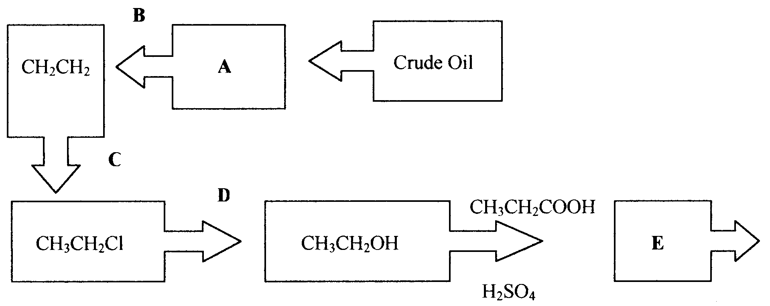

- Write the chemical formulae for these substances.
A _______________________
C _______________________
D _______________________
E _______________________
- Name compound E.
________________________________________________________________________________________________
- Name a process that could occur at B to produce ethene.
________________________________________________________________________________________________
- Give the conditions that best improve the equilibrium yield in Process B and explain why they are used.
________________________________________________________________________________________________
________________________________________________________________________________________________
(4 + 1 + 1 + 2 = 8 marks)

