NEAP
2002
CHEMISTRY
Unit 3 Exam

Section A – Multiple Choice

Question 1
In a certain hydrocarbon, for every one gram of hydrogen there are six grams of carbon. This hydrocarbon could be
- Identifying the presence of steroids in a urine sample using UV-visible spectroscopy.
- Detecting traces of methanol in petrol samples using gas-liquid chromatography.
- Separating the pigments in a plant leaf extract using thin-layer chromatography.
- Analysing the alcohol content of a home-brewed beer using titration with acidified dichromate solution.

Question 2
Haemoglobin is the protein responsible for carrying oxygen in the blood. Its molecular formula is
C₂₉₅₂H₄₆₆₄N₈₁₂O₈₃₂S₈Fe₄
The mass of one haemoglobin molecule is
- 6.02 × 10⁻²³ g
- 1.54 × 10⁻²⁰ g
- 1.08 × 10⁻¹⁹ g
- 9.13 × 10⁻¹⁷ g

Question 3
Petrol requires a spark to start its combustion. This spark is required because
- combustion is an endothermic process and so requires energy
- the enthalpy of the products of a combustion reaction is greater than the enthalpy of the reactants
- energy is required to form the bonds in the product molecules
- energy is required to break bonds within and between reactant molecules

Question 4
Consider the equilibrium reaction
2 P (g) + 4 Q (g)  3 R (g) K = 80 at 400 K
If [P] = 0.0651 M and [R] = 1.13 M, the [Q] at this temperature when the system is in equilibrium will be
- 0.217 M
- 0.70 M
- 1.44 M
- 3.77 M

Question 5
Which of the structures below is incorrectly named?
A. | 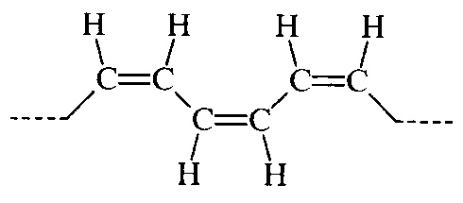 |  | C. | 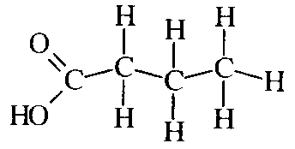
 | polyethylene |  |  | butanoic acid
B. | 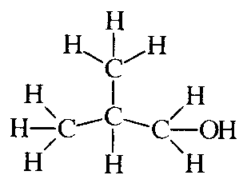 |  | D. | 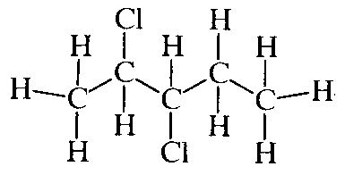
 | 2-methylpropanol |  |  | 2,3-dichloropentane

The following information is referred to in questions 6 and 7

Phosphorus(V) chloride is an unstable and highly reactive compound that decomposes to phosphorus(III) chloride at elevated temperatures.
PCl₅ (g)  PCl₃ (g) + Cl₂ (g) ΔH = +126 kJ mol⁻¹

Question 6
0.60 mole of PCl₅ is introduced into a sealed 2.00 L vessel which is heated to 180°C. When equilibrium is established, the concentration of Cl₂ is 0.054 M. The value of the equilibrium constant, K, for this reaction at 180°C is
- 0.0097
- 0.0059
- 0.012
- 84

Question 7
The yield of PCl₃ in this reaction could be decreased by
- adding PCl₅
- increasing the pressure
- adding argon to the mixture at constant volume
- increasing the temperature

Question 8
Which of the following is not a property of sulfuric acid?

Sulfuric acid is
- a colourless, viscous liquid at room temperature
- a corrosive chemical
- a powerful dehydrating agent
- used extensively as a fertiliser

Question 9
Three compounds are shown below.
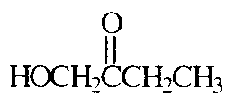 | 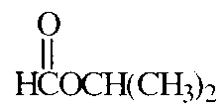 | 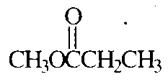
Which of the following statements concerning the three compounds is incorrect?

They
- are structural isomers of each other
- all belong to the same homologous series
- all have the same molecular formula
- all have the same molar mass

Question 10
At high temperatures, gaseous ammonia reacts with copper(II) oxide according to the equation:
3 CuO (s) + 2 NH₃ (g) → 3 Cu (s) + 3 H₂) (g) + N₂ (g)
In this reaction, the ammonia is acting as
- a reductant
- a base
- a dehydrating agent
- an oxidant

Question 11
A sealed container of gas with a fixed volume has a temperature of 25°C. The container is rapidly heated to 100°C. The pressure inside the container will
- remain constant
- increase by a factor of 4
- decrease to ¼ of its original value
- increase by approximately 25%

Question 12
For the reaction
CoCl₂ (g)  CO (g) + Cl₂ (g)
the equilibrium constant, K, has a value of 0.40 M at T°C. 0.70 mol of CO, 2.5 mol of Cl₂ and 31 mol of CoCl₂ are mixed in a 2.0 L vessel at T°C. The reaction will
- move to the left to establish equilibrium because the concentration fraction is less than K
- move to the right to establish equilibrium because the concentration fraction is less than K
- move to the left to establish equilibrium because the concentration fraction is greater than K
- move to the right to establish equilibrium because the concentration fraction is greater than K

The following information is referred to in questions 13 to 15

In the manufacture of sulfuric acid by the Contact process, sulfur is burnt in air to produce SO₂ which then undergoes several other reactions to eventually produce H₂SO₄. The process can be summarised as shown.

 |  | air |  | air |  | H₂SO₄ |  | water
S |  | burner |  | converter |  | absorber |  | diluter

Question 13
In the converter, SO₂ reacts to produce SO₃. To maximise the rate of conversion of SO₂ to SO₃, the conditions used would be
- high temperature, high pressure, V₂O₅ catalyst in pellet form
- low temperature, high pressure, iron catalyst in pellet form
- high temperature, low pressure, V₂O₅ catalyst in powder form
- low temperature, high pressure, V₂O₅ catalyst in sheet form

Question 14
Which of the following reactions dos not usually occur during the Contact process?
- SO₃ (g) + H₂O (l) → H₂SO₄ (aq)
- S (l) + O₂ (g) → SO₂ (g)
- 2 SO₂ (g) + O₂ (g)  2 SO₃ (g)
- H₂S₂O₇ (l) + H₂O (l) → 2 H₂SO₄ (l)

Question 15
In which stage, or stages, of the Contact process does the sulfur atom undergo oxidation?
- burner only
- burner and converter only
- burner, converter and absorber only
- burner, converter, absorber and diluter

Question 16
The pH of a 0.01 M solution of the weak base aminomethane (CH₃CH₃) would be
- between 2.0 and 7.0
- between 7.0 and 12
- 12
- greater than 12

Question 17
Three features of a chemical reaction are listed below.
I Enthalpy change (ΔH)
II Equilibrium constant (K)
III Energy of activation (E_{A})
Which of these features is not altered by the use of a catalyst?
- II only
- II and III only
- I and II only
- I, II and III

The following information is referred to in questions 18 and 19

Lead is an extremely toxic, cumulative poison for humans, with concentrations as low as 0.40 ppm in the blood considered dangerous. A sample of blood from a person suspected of having lead poisoning was analysed using atomic absorption spectroscopy. A standard curve was first generated by measuring the absorbance of a number of samples of known concentration.
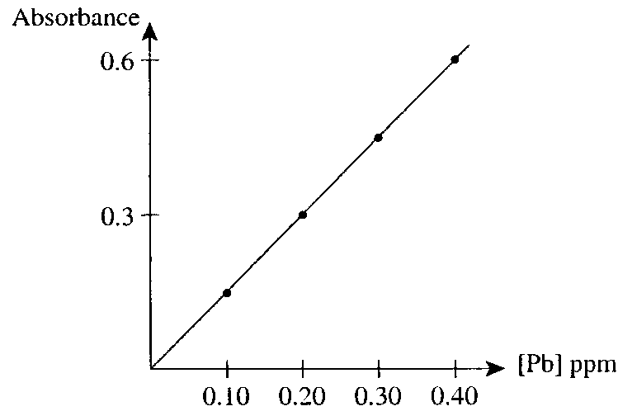

Question 18
A 5.0 mL sample of blood was first diluted to 20.0 mL and then tested. An absorbance reading of 0.24 was recorded. The concentration of lead in the person’s blood was
- 0.040 ppm
- 0.16 ppm
- 0.32 ppm
- 0.64 ppm

Question 19
Assuming an adult carries 5 L of blood, and that the blood has a density of 1.0 g mL⁻¹, the mass of lead in the bloodstream with a lead concentration of 0.040 ppm is
- 2 × 10⁻⁵ g
- 2 × 10⁻⁴ g
- 4 × 10⁻⁴ g
- 2 × 10⁻³ g

Question 20
Which of the following graphs best represents the change in pH as a solution of ammonia (NH₃) is titrated with hydrochloric acid (HCl)? (Point E represents the equivalence point for each titration.)
A. | 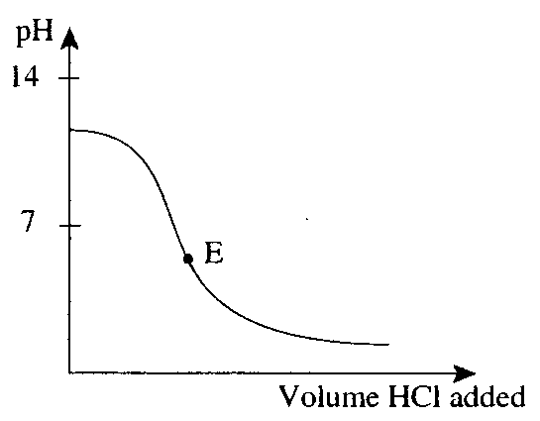 | C. | 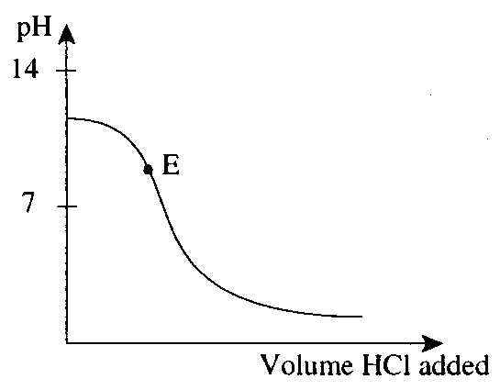
B. | 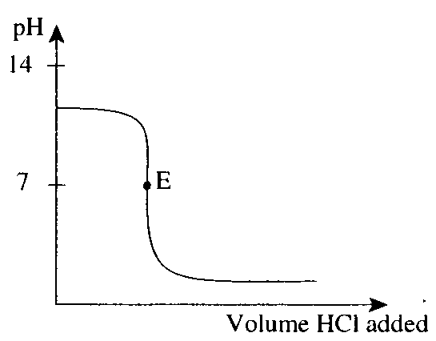 | D. | 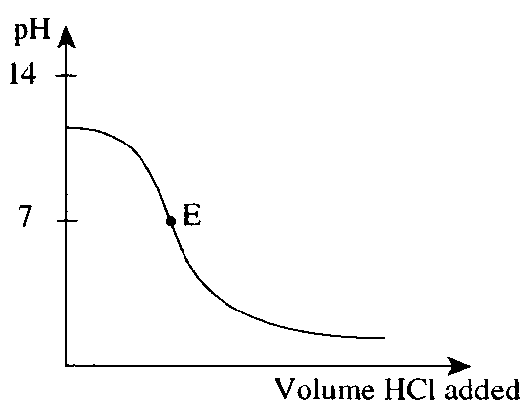

Section B – Short Answer Questions

Question 1
An experiment was conducted to determine the proportion of sulfur in a fertilizer using the procedure outlined in the flowchart below.

1. Grind a small quantity of fertilizer using a mortar and pestle.
↓
2. Accurately weigh approximately 1.0 g of fertilizer into a small beaker.
↓
3. Add 50.0 mL of distilled water to the fertilizer and stir.
↓
4. Filter the mixture, washing the residue with distilled water.
↓
5. Add 5.0 mL of 2.0 M HCl to the filtrate
Add 100 mL of water. Boil the mixture.
↓
6. Slowly add 20.0 mL of 0.50 M BaCl₂ solution to the warm mixture, stirring constantly.
↓
7. Leave the mixture to stand overnight.
↓
8. Collect the precipitate and wash with water.
↓
9. Dry, then weigh the precipitate

The results obtained during one experiment were:
mass of fertilizer used 1.026 g
mass of precipitate obtained 0.7183 g

The relevant equation for the precipitation is
Ba²⁺ (aq) + SO₄²⁻ (aq) → BaSO₄ (s)

- Explain the purpose of Step 4 in the procedure outlined in the flowchart.
________________________________________________________________________________________________
________________________________________________________________________________________________
1 mark
- Calculate
i. the amount (in mol) of BaSO₄ obtained.
____________________________________________________________________________________________
____________________________________________________________________________________________
ii. the percentage by mass (% w/w) of sulfur in the fertiliser.
____________________________________________________________________________________________
____________________________________________________________________________________________
____________________________________________________________________________________________
3 marks
- A number of possible sources of error in this gravimetric analysis are listed in the table below. For each error, state the likely effect of the error on the calculated percentage composition of the fertiliser.
(Indicate your answers by placing ticks in the appropriate columns.)

Possible source of error |  | Effect of error on the calculated  % S in the fertiliser
 |  | Increased | Decreased | No change
i. | Step 1 of the procedure in the flowchart was not carried out.
ii. | In Step 6, 25.0 mL of BaCl₂ was added.
iii. | In Step 8, the precipitate was not washed with water.
iv. | In Step 9, the precipitate was not completely dry when weighed.

v. Explain your choice in iii. in the table above.
____________________________________________________________________________________________
____________________________________________________________________________________________
____________________________________________________________________________________________
3 marks
Total 7 marks

Question 2
- Ethanoic acid (CH₃COOH) is a weak, monoprotic acid.
i. Write and expression for the ionisation constant, K_{a}, of ethanoic acid.

ii. The pH of an 0.100 M solution of ethanoic acid at 25°C is 2.88. Determine the value of the ionisation constant, K_{a}.

3 marks
- Ethanoic acid may be prepared in the laboratory using ethene as a starting material. Consider the flowchart of reactants shown below.

 | Catalyst II |  |  |  | Ethyl  ethanoate
Compound  X |  | Cr₂O₇²⁻ (aq) / H⁺ (aq) | Ethanoic  acid
Reactant A | Catalyst I
Ethene

Write the chemical formulas for
i. reactant A ______________________________
ii. compound X ______________________________
iii. catalyst I ______________________________
iv. catalyst II ______________________________
2 marks
- Write a balanced chemical equation for the reaction of ethanoic acid with methanol to form the ester, methyl ethanoate.
________________________________________________________________________________________________
1 mark
- The formula of a small section of a polyester is shown below. Draw the two monomers used to form this polyester.
… OCC₆H₄COOCH₂CH₂OOCC₆H₄COOCH₂CH₂O …

2 marks
Total 8 marks

Question 3
SO₂ and CO₂ are both acidic oxides. The atmosphere contains low concentrations of both these oxides. Both contribute to making rain water slightly acidic.

- One natural source of SO₂ is the oxidation of hydrogen sulfide (H₂S) produced by certain bacteria.
Write a balanced half-equation for the oxidation of H₂S to form SO₂.
________________________________________________________________________________________________
1 mark
- The combustion of the fossil fuels coal and petroleum generates considerable quantities of SO₂. A certain sample of coal contains 1. 4 percent sulfur by mass (1.4% w/w). When the coal is burnt, the sulfur is converted to sulfur dioxide.
S (coal) + O₂ (g) → SO₂ (g)
To help prevent the release of SO₂, it is reacted with calcium oxide to form calcium sulfite.
SO₂ (g) + CaO (s) → CaSO₃ (s)
A particular power plant burns 5.90 × 10⁶ kg of coal every day. Calculate
i. the amount (in mol) of sulphur burnt each day.
____________________________________________________________________________________________
____________________________________________________________________________________________
____________________________________________________________________________________________
ii. the mass of calcium oxide needed to remove the sulfur dioxide produced each day.
____________________________________________________________________________________________
____________________________________________________________________________________________
____________________________________________________________________________________________
3 marks
- CO₂ is slightly soluble in water, establishing an equilibrium between gaseous and dissolved forms according to the equation:
I CO₂ (g)  CO₂ (aq) ΔH = -19 kJ mol⁻¹
The dissolved CO₂ reacts with water according to the equation:
II CO₂ (aq) + H₂O (l)  H₂CO₃ (aq)
The carbonic acid (H₂CO₃) established equilibria according to the equations:
III H₂CO₃ (aq)  H⁺ (aq) + HCO₃⁻ (aq)
IV HCO₃⁻ (aq)  H⁺ (aq) + CO₃²⁻ (aq)

Bottles of soft drink contain dissolved carbon dioxide. The gas above the drink in the bottles contains carbon dioxide at a pressure of around 4 atmospheres. Soft drink becomes ‘flat’ when the bubbles of CO₂ gas come out of solution.
In terms of these equilibrium reactions (I-IV) explain why
i. heating a soft drink increases the rate at which it goes ‘flat’.
____________________________________________________________________________________________
____________________________________________________________________________________________
____________________________________________________________________________________________
____________________________________________________________________________________________
ii. adding orange juice (a source of acidity) causes the soft drink to go ‘flat’.
____________________________________________________________________________________________
____________________________________________________________________________________________
____________________________________________________________________________________________
____________________________________________________________________________________________
4 marks
Total 9 marks

Question 4
The apparatus shown below was used in a laboratory experiment to investigate the cracking of hydrocarbons present in paraffin oil. The oil and boiling chips were placed in the test tube. Steel wool was loosely packed above the oil. The test tube was strongly heated. After the air was expelled from the test tube, the gas produced was collected over water as shown.
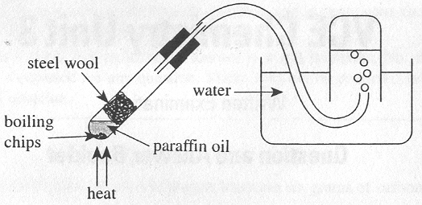
Paraffin oil is composed of relatively large saturated hydrocarbons. The gas collected during the experiment contained smaller hydrocarbons and some unsaturated hydrocarbons.

- What type of chemical bonds are broken during the cracking of hydrocarbons?
________________________________________________________________________________________________
1 mark
- Suggest one method which could be used to separate the hydrocarbons in the gas collected during the experiment.
________________________________________________________________________________________________
1 mark
- When saturated hydrocarbons are cracked, at least one of the products must be unsaturated. Explain why.
________________________________________________________________________________________________
________________________________________________________________________________________________
________________________________________________________________________________________________
1 mark
- Explain why the products of the cracking process have lower boiling points than the reactants.
________________________________________________________________________________________________
________________________________________________________________________________________________
________________________________________________________________________________________________
________________________________________________________________________________________________
2 marks
- State one difference between this laboratory cracking process and the industrial cracking process used to produce ethene.
________________________________________________________________________________________________
________________________________________________________________________________________________
1 mark
Total 6 marks

Question 5
A sample of hydrated sodium carbonate (Na₂CO₃.xH₂O) was analysed to determine the number of molecules of water of crystallisation (x). 2.767 g of the sample was dissolved in water and made up to a volume of 250.0 mL in a volumetric flask. 25.0 mL aliquots of this solution were titrated with 0.100 M hydrochloric acid using a suitable indicator. The average titre required was 19.33 mL.

- Write a balanced equation for the neutralisation of Na₂CO₃ by HCl.
________________________________________________________________________________________________
1 mark
- Calculate the
i. amount (in mol) of hydrochloric acid used.
____________________________________________________________________________________________
____________________________________________________________________________________________
ii. amount (in mol) of hydrated sodium carbonate in the 2.767 g sample.
____________________________________________________________________________________________
____________________________________________________________________________________________
____________________________________________________________________________________________
____________________________________________________________________________________________
iii. molar mass of the hydrated sodium carbonate.
____________________________________________________________________________________________
____________________________________________________________________________________________
iv. value of x, in Na₂CO₃.xH₂O.
____________________________________________________________________________________________
5 marks
- During another experiment, the value of x was determined to be 10.5. Explain why this answer cannot be correct.
________________________________________________________________________________________________
1 mark
Total 7 marks
Question 6
Hydrogen may be prepared industrially by reacting methane and steam, according to the equation:
CH₄ (g) + H₂O (g)  3 H₂ (g) + CO (g) ΔH = +206 kJ mol⁻¹
The graph below shows the results of an experiment conducted to investigate the rate of this reaction. A measured mass of methane was reacted with excess steam. The mass of hydrogen formed was recorded at 10 minute intervals.
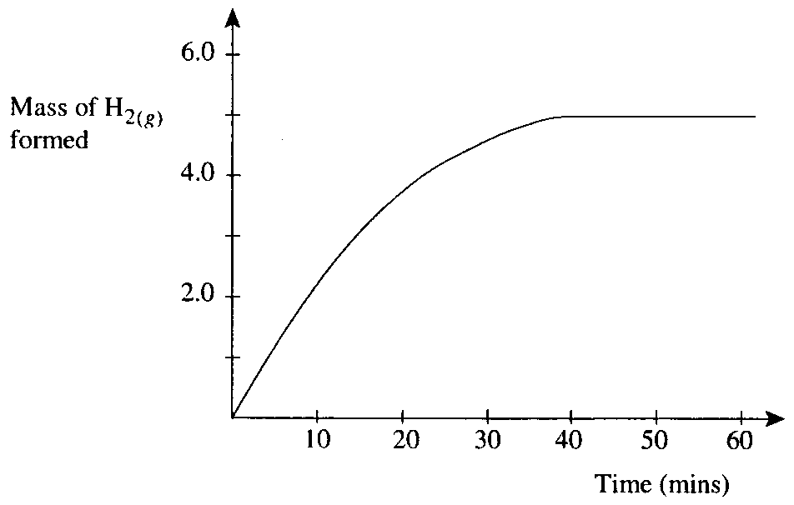
A second experiment was conducted using the same mass of methane with excess steam, but at a much higher temperature.

- On the axes above, sketch the expected results of this second experiment.
1 mark
- Carefully explain the shape of your graph.
________________________________________________________________________________________________
________________________________________________________________________________________________
________________________________________________________________________________________________
________________________________________________________________________________________________
2 marks
Total 3 marks

END OF QUESTION AND ANSWER BOOKLET

