STAV
2002
CHEMISTRY
Unit 3 Exam

Section A – Multiple Choice

Question 1
The flame colours of three ionic compounds are given below:

Compound | Flame Colour
NaCl | yellow
CaCl₂ | brick-red
KCl | lilac

A sample of an unknown pure ionic compound was crushed, then a clean piece of nichrome wire was dipped into it and then inserted into the hottest region of a Bunsen burner flame. Three students observed this test and described their observations as follows:
Student 1: ‘The flame was reddish.’
Student 2: ‘The flame was brownish red and then became blue again.’
Student 3: ‘The flame became full red when the wire was inserted.’

On the basis of these observations it may be concluded that the compound contained a considerable proportion of
- chlorine
- calcium
- calcium chloride
- potassium chloride and sodium chloride

Question 2
An excess of nitric acid is added to 2.374 g of metallic tin and heated. After the reaction is completed, the sample is dried to give a solid containing only tin and oxygen.

If the mass of this solid is 3.014 g, what is the empirical formula of the compound?
- Sn₂O
- SnO
- SnO₂
- Sn₂O₃

Question 3
Insulin is the hormone that regulates the blood sugar level in humans. It consists of two small protein chains joined together by means of a disulfide bridge. Of the following analytical techniques, the most suitable to determine the insulin level in a patient’s blood sample is
- high performance liquid chromatography (HPLC)
- atomic absorption spectroscopy
- gas chromatography (GC)
- paper chromatography

Question 4
Laundry bleach contains sodium hypochlorite, NaOCl, as an active ingredient.

The concentration on the label is stated as 5.0% m/v (5.0 g/100 mL). In a 1.0 L bottle of bleach, the amount of NaOCl would be
- 0.067 mol
- 0.35 mol
- 0.67 mol
- 1.3 mol

Question 5
Increasing the temperature of a reaction system will cause a change in the rate of the chemical reaction as a result of
- an increase in the frequency of collision between reactants
- an increase in the energy of collision between reactants
- an increase in both the frequency and energy of collision between reactants
- a decrease in the energy of activation, E_{A}, of the reaction

Question 6
Consider the equation:
H₂SO₃ (aq) + 2 Fe³⁺ (aq) + H₂O (l) → 2 Fe²⁺ (aq) + HSO₄– (aq) + 3 H⁺ (aq)

It is correct to state that
- H₂SO₃ is the oxidant because is gains electrons
- H₂O is the reductant because it loses oxygen
- H⁺ is the reductant because it has lost an electron
- Fe³⁺ is the oxidant because it gains electrons

Question 7
To determine the Al³⁺ concentration in an aqueous aluminium sulfate solution, students precipitated the sulfate ions as barium sulfate.

Excess Ba(NO₃)₂ (aq) was reacted with 20 mL of Al₂(SO₄)₃ (aq). It was found that 0.699 g of BaSO₄ (s) precipitate was formed. The molarity of the original Al³⁺ (aq) was
- 0.20 M
- 0.15 M
- 0.10 M
- 0.05 M

Question 8
In volumetric analysis work, the following gitems of glassware are typically used:
- pipette
- burette
- conical flask

Which of these items must be rinsed with a sample of the solution they will contain prior to them being filled with this solution ready for titrating?
- I only
- I and II only
- I and III only
- I, II and III

Question 9
A student takes 10 mL of a solution that has a pH of 5 and dilutes it by adding 90 mL of water. The hydroxide concentration , in mol L^{–1}, of the new solution would be
- 10^{–5}
- 10^{–6}
- 10^{–8}
- 10^{–9}

Questions 10 and 11 relate to the following graph.

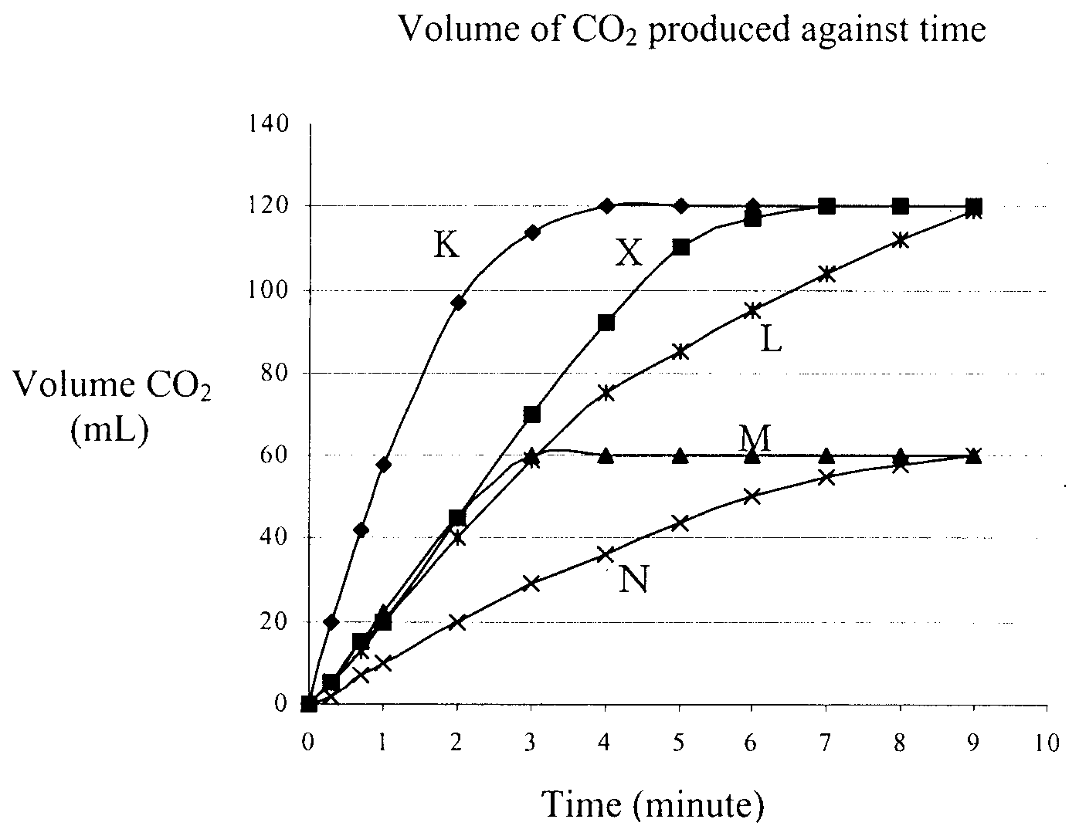
The curve labelled X was obtained when 1 g of calcium carbonate powder reacted with excess dilute hydrochloric acid at 20°C.

Question 10
Which curve would represent the reaction of a single piece of calcium carbonate of mass 0.5 g with excess dilute hydrochloric acid at 20°C?
- K
- L
- M
- N

Question 11
Which curve would represent the reaction of 1 g of calcium carbonate powder with excess dilute hydrochloric acid at 15°C?
- K
- L
- M
- N

Question 12
Consider the following equilibrium that exists in water containing bromine:
Br₂ (aq) + H₂O (l)  Br– (aq) + 2 H⁺ (aq) + BrO– (aq)

The equilibrium position could be moved towards the products by adding one drop of concentrated
- potassium nitrate solution
- sodium carbonate solution
- sulfuric acid solution
- sodium bromide solution

Question 13
The solution with the lowest pH is
- 0.10 M NaOH
- 0.10 M HCl
- 0.10 M CH₃COOH
- 0.10 M NaCl

Question 14
The possible number of isomers with the chemical formula C₄H₁₀O that contain the –OH functional group is
- 1
- 2
- 3
- 4

Question 15
The reaction producing NO₂ is exothermicL
2 N₂O (g) + 3 O₂ (g)  4 NO₂ (g)
Which of the following will decrease the equilibrium yield of NO₂?
- Increasing the temperature at constant pressure
- Increasing the pressure at constant temperature
- I only
- II only
- both I and II
- neither I nor II

Question 16
The polyester, |  | , is formed from the monomer, HOCH₂COOH.

How does the percentage of carbon, by mass, in the polyester compare with the percentage, by mass, of carbon in the monomer?
- The percentages of equal.
- The percentage of carbon in the polymer is less.
- The percentage of carbon in the polymer is greater.
- There is not enough information to make this comparison.

Question 17
In the general formula, C_{x}H_{y}, the value of y for an alkene containing 6 carbon atoms is
- 6
- 8
- 10
- 12

Question 18
Crude oil is an important source of hydrocarbons. Ethene is obtained by the process of fractional distillation followed by
- catalytic cracking
- polymerisation
- a substitution reaction
- an addition reaction
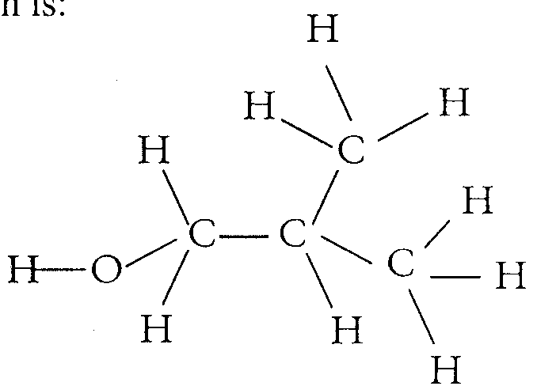
Question 19
A systematic name for the compound shown is
- 2-methyl propan-1-ol
- 2-methyl propan-2-ol
- butan-1-ol
- 2,2-dimethyl ethanol

Question 20
What process is ethanol undergoing when it is converted to ethanoic acid?
- reduction
- hydrogenation
- condensation
- oxidation

Question 21
When chlorine gas and ethene react the product is
- 1,2-dichloroethane
- 1,1-dichloroethane
- chloroethane
- hydrogen chloride

Question 22
Sulfuric acid cannot be used as
- a catalyst
- an oxidant
- a dehydrating agent
- a fertiliser
Section B – Short Answer Questions

Question 1
A gas chromatogram of a premium-grade petrol is shown below.
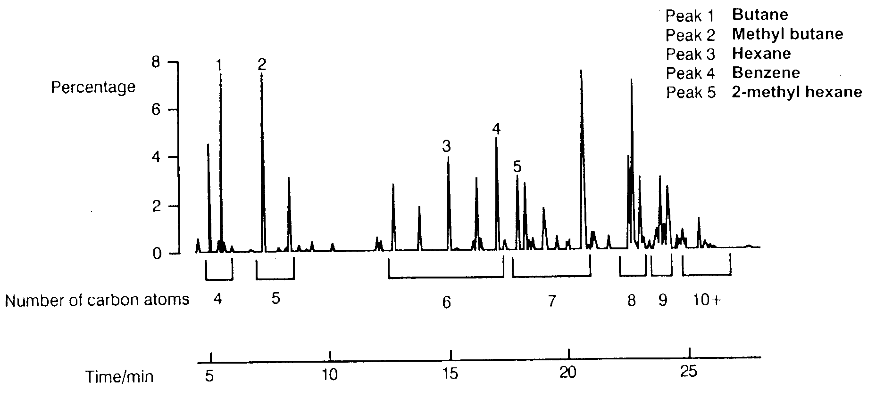

- Referring to the chromatogram, there are two major peaks corresponding to four carbon atoms, peak 1 labelled as butane, and a second peak at retention time 5 minutes. Give the structural formula of the substance represented by the second peak.

- How does the number of carbon atoms affect how long it takes a compound to travel along the column? Suggest a reason for your answer.
__________________________________________________________________________________________________
__________________________________________________________________________________________________
__________________________________________________________________________________________________
__________________________________________________________________________________________________
- How would the chromatogram change if the column were
(i) longer?
_______________________________________________________________________________________________
_______________________________________________________________________________________________
_______________________________________________________________________________________________
(ii) hotter?
_______________________________________________________________________________________________
_______________________________________________________________________________________________
_______________________________________________________________________________________________
1 + 2 + 2 = 5 marks
Suggested time: 6 minutes

Question 2
Atomic absorption spectroscopy, AAS, is widely used in metal industries as a means of providing quantitative information of both ore samples and samples of metals during the extraction and purification process.

- Explain the difference in meaning of the terms qualitative and quantitative analysis.
__________________________________________________________________________________________________
__________________________________________________________________________________________________
__________________________________________________________________________________________________
__________________________________________________________________________________________________
__________________________________________________________________________________________________

The laboratories of a mining company were analysing ore samples for nickel using AAS. Prior to analysing the sample, a calibration graph was generated by measuring the absorption of aqueous nickel solutions of known concentration. The table gives the absorption readings for aqueous solutions of nickel with a range of concentrations.

Concentration (µg mL^{–1}) | Absorption
0.00 | 0.00
50.0 | 0.26
100 | 0.50
150 | 0.69
200 | 0.85

- Use the data to plot a calibration graph for nickel on the axes provided.
Absorption

Concentration (µg mL^{–1)}

- Explain the importance of the calibration graph.
__________________________________________________________________________________________________
__________________________________________________________________________________________________
__________________________________________________________________________________________________
__________________________________________________________________________________________________
- A solution of the ore was obtained by dissolving it in concentrated nitric acid. A sample of this solution was diluted by 1 in 100. This diluted solution gave an absorption reading of 0.61. What is the concentration of nickel in the original ore sample? Give your answer in mg mL⁻¹.

- What reason was there to dilute the original ore solution by 1 in 100?
__________________________________________________________________________________________________
__________________________________________________________________________________________________
__________________________________________________________________________________________________
2 + 2 + 1 + 3 + 1 = 9 marks
Suggested time: 11 minutes

Question 3
The packaging of potato chips indicates that the chips contain sodium. A student decided to perform gravimetric analysis on the chips to determine the mass of sodium in the chips, assuming the sodium was all present in the form of sodium chloride.

The student ground up a 10.0 g sample of potato chips, then added hot distilled water. After thorough mixing, undissolved material was removed by filtration. The chloride ions present in the filtrate were precipitated by the addition of 10.0 mL of 0.500 mol L^{–1} silver nitrate solution. The mixture was made up to 50 mL using distilled water.

The precipitate of silver chloride was collected by filtration, washed thoroughly and dried until a constant mass was achieved. At this point, the precipitate had a mass of 0.327 g.

- Write a balanced ionic equation to show the formation of the silver chloride precipitate.
__________________________________________________________________________________________________
- Use the data provided to calculate:
(i) the amount, in mol, of silver chloride formed.

(ii) the amount, in mol, of the silver nitrate that was in excess.

(iii) the amount, in mol, of sodium, as Na⁺, present in the potato chips.

(iv) the mass of sodium, as Na⁺, present in the 10.0 g sample of potato chips.

(v) the percentage by mass of sodium in these potato chips.

- Would the calculated percentage mass be higher, lower or the same if the student had not dried the precipitate until a constant mass was achieved? Explain your answer.
__________________________________________________________________________________________________
__________________________________________________________________________________________________
__________________________________________________________________________________________________
__________________________________________________________________________________________________
__________________________________________________________________________________________________
1 + 6 + 1 = 8 marks
Suggested time: 10 minutes

Question 4
Consider the K_{a} values for three weak acids at 25°C in Table 1.

Table 1
Acid | Equation | K_{a}( mol L^{–1})
HCN | HCN (aq) + H₂O (l)  CN– + H₃O⁺ (aq) | 8.2 × 10^{–10}
NH₄⁺ | NH₄⁺ (aq) + H₂O (l)  NH₃ + H₃O⁺ (aq) | 5.7 × 10^{–10}
CH₃COOH | CH₃COOH (aq) + H₂O (l)  CH₃COO– + H₃O⁺ (aq) | 1.8 × 10^{–5}

- Which of the three acids is the strongest acid? Explain.
__________________________________________________________________________________________________
__________________________________________________________________________________________________
- (i) Write the expression for K_{a} for CH₃COOH.

(ii) Calculate the pH of a 0.10 M CH₃COOH solution.

(iii) Calculate the percentage of ionisation of CH₃COOH in the 0.10 M solution.

- At 25°C, solid sodium cyanide, NaCN, is added to a solution of hydrocyanic acid, HCN, causing the pH to increase from 3.0 to 6.7.
(i) Explain the pH change in terms of Le Chatelier’s Principle.
_______________________________________________________________________________________________
_______________________________________________________________________________________________
_______________________________________________________________________________________________
_______________________________________________________________________________________________
(ii) Once equilibrium is re-established, would the K_{a} value for the acid be more, less or the same as that given in Table 1? Explain.
_______________________________________________________________________________________________
_______________________________________________________________________________________________
_______________________________________________________________________________________________
_______________________________________________________________________________________________
- The hydrolysis reactions for the three acids shown in Table 1 are all exothermic. A 0.5 M aqueous solution of NH₄⁺ has its temperature changed causing the pH to decrease from 5.8 to 4.2. Was the temperature of the solution raised or lowered? Explain your answer.
__________________________________________________________________________________________________
__________________________________________________________________________________________________
__________________________________________________________________________________________________
__________________________________________________________________________________________________
__________________________________________________________________________________________________
2 + 4 + 4 + 2 = 12 marks
Suggested time: 15 minutes

Question 5
An important step in the Contact Process is the reaction between sulfur dioxide and oxygen.

- Write an equation for the equilibrium reaction between sulfur dioxide and oxygen.
__________________________________________________________________________________________________
- Write an expression for the equilibrium constant for the reaction shown in part a.

- A small-scale experiment is conducted to find the ideal conditions for carrying out the reaction. In a trial, sulfur dioxide and oxygen are added to a 5.0 L closed vessel at 450°C in the presence of the usual industrial catalyst and allowed to reach equilibrium.
(i) What is the usual industrial catalyst for this reaction?
_______________________________________________________________________________________________
(ii) The equilibrium constant for the reaction in part a. is 1.2 × 10³ L mol^{–1} at 450°C. If, at equilibrium, the amount of sulfur dioxide is 10.0 mol and the amount of oxygen is 2.0 mol in the 5.0 L closed vessel, calculate the concentration of the third component in the equilibrium mixture.

- The graph below shows the equilibrium yield of SO₃ produced at various temperatures for the reaction between sulfur dioxide and oxygen.
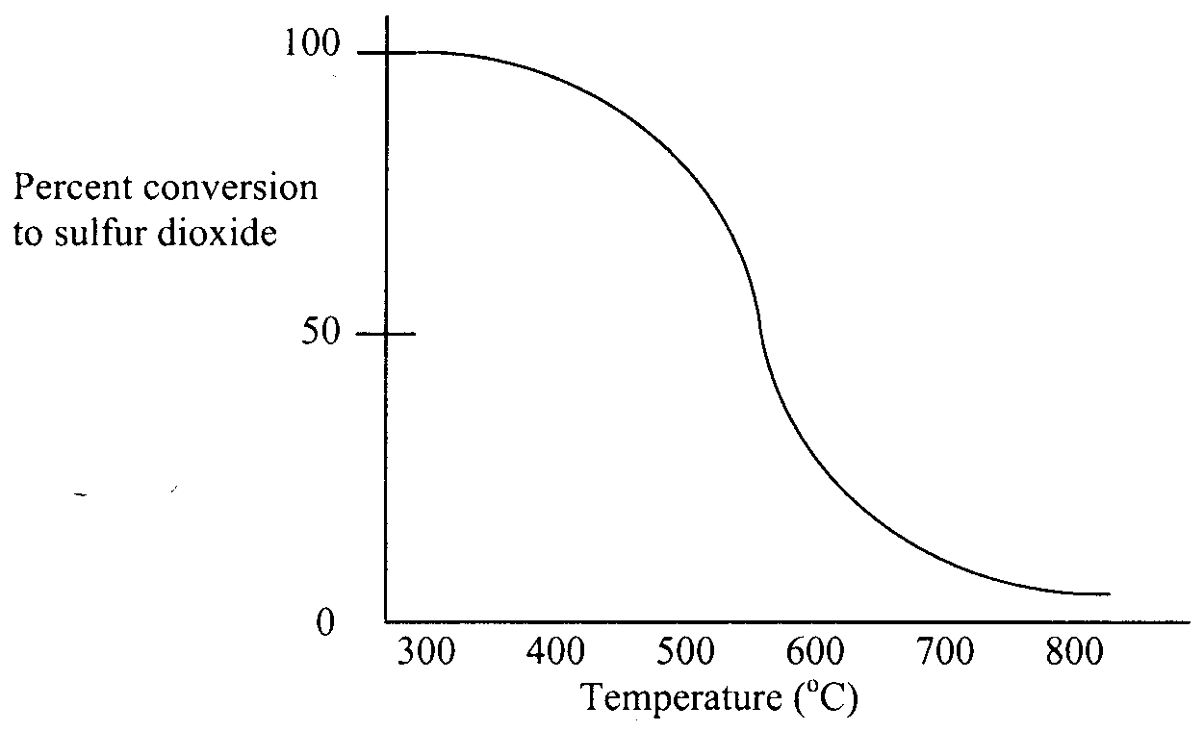
Complete conversion to SO₃ occurs at about 300°C. However industrial plants using the Contact Process typically carry out this conversion at about 450°C. Explain why the higher temperature is used in industrial plants.
__________________________________________________________________________________________________
__________________________________________________________________________________________________
__________________________________________________________________________________________________
__________________________________________________________________________________________________
1 + 1 + 3 + 1 = 6 marks
Suggested time: 7 minutes

Question 6
Propene is an important organic chemical obtained from crude oil. Almost one third of the propene produced is used to produce polymers.

- Draw a structural formula for propene.

- The chemical properties of propene are similar to those of ethene.
(i) Name the produce of the reaction between propene and hydrogen, in the presence of a nickel catalyst.
_______________________________________________________________________________________________
(ii) Name the type of chemical reaction in part (i).
_______________________________________________________________________________________________
- Propane can be reacted with chlorine gas to produce 1-chloropropane.
(i) Draw a structural formula for 1-chloropropane.

(ii) The formation of 1-chloropropane from propane is an example of a substitution reaction. Using this reaction as an example, explain what is meant by a ‘substitution reaction’.
_______________________________________________________________________________________________
_______________________________________________________________________________________________
_______________________________________________________________________________________________
_______________________________________________________________________________________________
- The substitution reaction between propane and chlorine can produce another product with the same molecular formula as 1-chloropropane.
(i) Name this second product.
_______________________________________________________________________________________________
(ii) Both chlorinated compounds can be converted into alcohols (alkanols) by heating them with a suitable reagent. Name a suitable reagent.
_______________________________________________________________________________________________
- The alkanol homologous series, also known as alcohols, include propan-1-ol.
(i) Using semi-structural formulas write an equation to represent the reaction between propan-1-ol and ethanoic acid, in the presence of concentrated sulfuric acid as a catalyst. Label the formula of propan-1-ol.

(ii) Name the functional group in the product of the reaction between propan-1-ol and ethanoic acid.
_______________________________________________________________________________________________
(iii) Name the product of the reaction between propan-1-ol and ethanoic acid.
_______________________________________________________________________________________________
1 + 2 + 2 + 2 + 5 = 12 marks
Suggested time: 14 minutes

END OF EXAMINATION

