Lisachem 2003 Chemistry Unit 3 exam

Section A

Question 1
Consider the section of a polymer chain represented below.
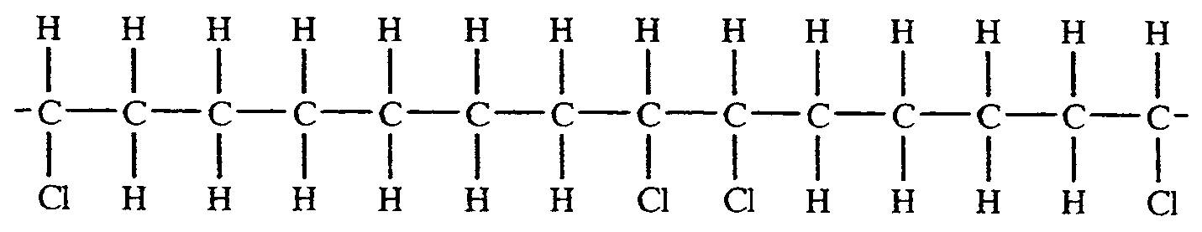
The monomers which are added together to produce this polymer are
- styrene and ethene
- propene and ethene
- vinyl chloride and propene
- ethene and vinyl chloride

Question 2
A pure sample of a compound was shown to contain 18.4 per cent by mass of sulfur. The compound was most probably
- PbSO₄
- K₂SO₄
- Na₂SO₄
- (NH₄)₂SO₄

Question 3
The value of the ratio [H⁺] / [OH⁻] in 10 M HCl (aq) at 25°C is
- 10
- 10⁷
- 10⁻¹⁵
- 10¹⁶

Question 4
Carbon monoxide and oxygen can both form complexes with haemoglobin, Hb₄, in the blood as shown below:
I Hb₄ + 4 O₂  Hb₄(O₂)₄
II Hb₄ + 4 CO  Hb₄(CO)₄
Carbon monoxide is poisonous because
- the rate of reaction II is much greater than the rate of reaction I
- reaction II is much easier to reverse than reaction I
- the equilibrium constant for reaction II is greater than the equilibrium constant for reaction I
- Hb(CO)₄ is much larger than Hb₄(O₂)₄, restricting its transportation rate in the blood stream

Question 5
Methanal is manufactured by the oxidation of methanol
CH₃COH (g) + ½ O₂ (g)  CH₂O (g) + H₂O (g)
If the equilibrium constant for this reaction was K₁, the equilibrium constant for the reaction
2 H₂O (g) + 2 CH₂O (g)  O₂ (g) + 2 CH₃OH (g)
at the same temperature would be
- -2K₁
- 2 / K₁
- 1 / K₁²
- 1 / 2K₁²

Question 6
A key step in the production of sulfuric acid is the reaction
2 SO₂ (g) + O₂ (g)  2 SO₃ (g); ΔH = -197.8 kJ mol⁻¹
The ratio m(SO₃) / m(SO₂) at equilibrium could be increased by an increase in
- pressure only
- temperature only
- both temperature and pressure
- neither temperature nor pressure

Question 7
Two 25.0 mL samples of an aqueous solution of sodium hydroxide were neutralized separately by exactly
- 22.5 mL of 0.100 M HNO₃ (aq)
- 7.50 mL of sulfuric acid
The concentration of the sulfuric acid was
- 0.012 M
- 0.208 M
- 0.150 M
- 0.300 M

Question 8
The graph below shows the concentrations, as a function of time, for a mixture of gases, X, Y and Z reacting and achieving equilibrium in a 1 L vessel.
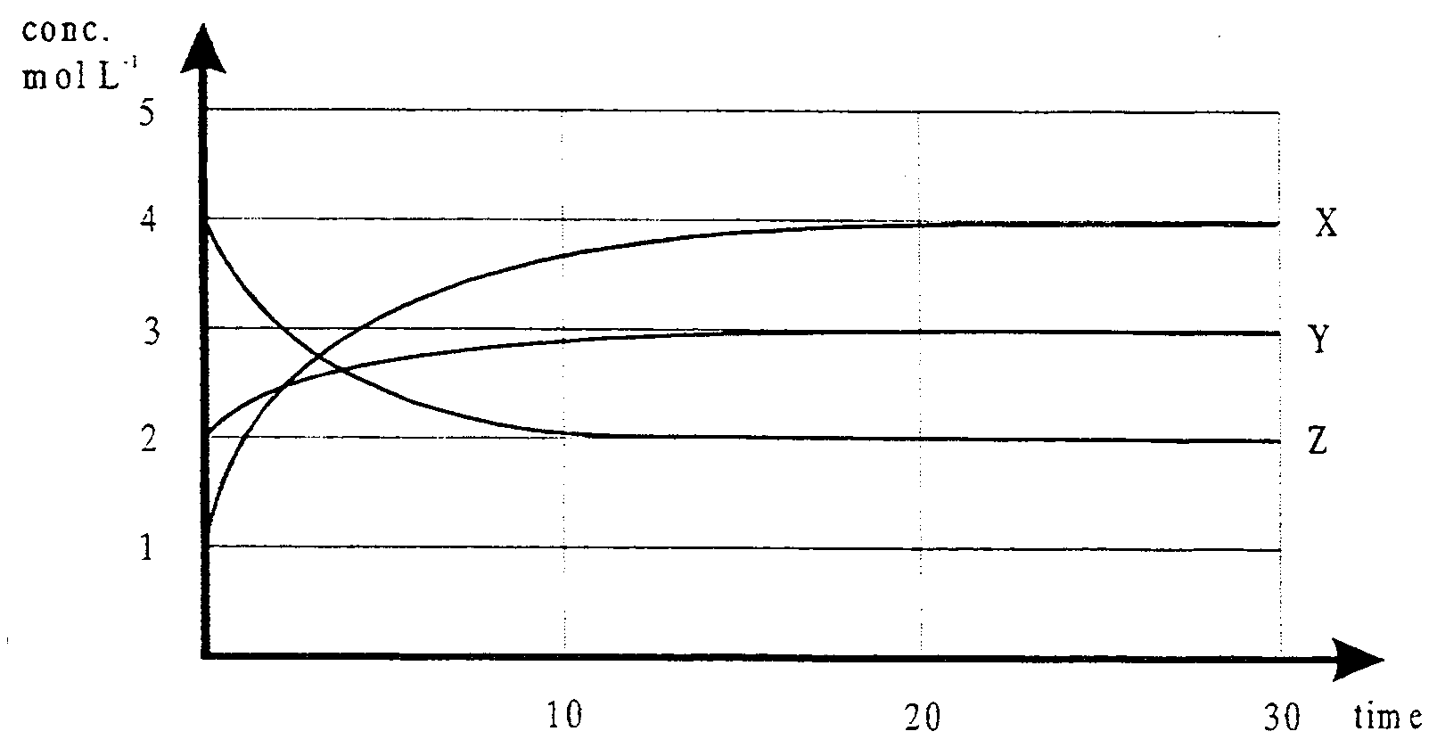
The equation describing the equilibrium system is
- X +Y  Z
- 3 X + Y  2 Z
- Z  X + Y
- 4 Z  X + 2 Y

Question 9
For which of the following conversions is an oxidant required?
- Cl⁻ (aq)  ClO⁻ (aq)
- SO₃ (g)  SO₄²⁻ (aq)
- 2 H⁺ (aq)  H₂ (g)
- CrO₃ (s)  Cr₂O₇²⁻ (aq)

Question 10
0.1 M HCl (aq) has a hydronium ion concentration of about 0.1 M. However 0.1 M CH₃COOH (aq) has a hydronium ion concentration of about 0.001 M. This difference is best explained by
- the electrical conductivity of 0.1 M HCl (aq) is about 100 times the electrical conductivity of 0.1 M CH₃COOH (aq)
- HCl is ionic and the H⁺ and Cl⁻ ions separate completely in aqueous solution
- all HCl molecules can donate protons but only about 1 percent of CH₃COOH molecules are capable of donating protons
- HCl molecules donate protons more readily than CH₃COOH molecules, so a higher percentage of HCl molecules will react with water to form H₃O⁺ (aq) ions than will CH₃COOH molecules

Question 11
Consider the equilibrium system N₂O₄ (g)  2 NO₂ (g). If the volume of a sample of this equilibrium mixture was halved and the temperature restored to its original value it would be expected that, when equilibrium was established in the smaller volume, the
- [NO₂] would have increased and the m(NO₂) would have increased
- [NO₂] would have increased even though the m(NO₂) would have decreased
- [NO₂] would have decreased and the m(NO₂) would have decreased
- [NO₂] would have decreased even though the m(NO₂) would have increased

Question 12
A flask containing 1 L of nitrogen at 101.3 kPa is connected to a flask containing 5 L of neon at 202.6 kPa at the same temperature, and the gases are allowed to mix. When the gases have mixed, and assuming the temperature remains constant, what will be the final pressure in the connected flasks?
- 169.0 kPa
- 185.7 kPa
- 202.6 kPa
- 303.9 kPa

Question 13
In demonstrating the properties of sulfuric acid, a chemistry teacher carefully dropped some 18 M sulfuric acid onto some paper. Within a few seconds the paper turned black. This is an example of sulfuric acid acting as
- a dehydrating agent
- an acid
- a base
- an oxidant

Question 14
When heated calcium carbonate decomposes as shown in the equation below
CaCO₃ (s)  CaO (s) + CO₂ (g)
When a 20.0 g sample of impure calcium carbonate is decomposed by heating, 6.60 g of CO₂ is produced.
Assuming none of the impurities present in the sample produce CO₂ on heating, what was the percentage, by mass, of calcium carbonate in the impure sample?
- 15.0%
- 20.0%
- 33.0%
- 75.0%

Question 15
Explosions have occurred in coal mines relatively free of combustible gases and in flour mills. The most significant factor in causing explosions in these situations is most likely
- the concentration of oxygen
- the temperature
- the surface area of coal dust or flour
- the presence of a suitable catalyst

Question 16
What is the systematic name of the compound which has the structural formula shown below?
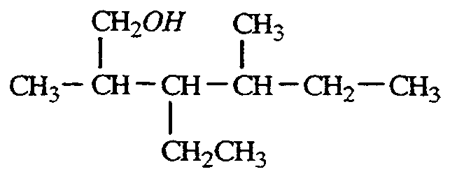
- 2-methyl-3,5-diethyl-2-hexanol
- 3,5-dimethyl-2-ethyl-1-heptanol
- 3,5-dimethyl-4-ehtyl-6-hexanol
- 2,4-dimethyl-3-ethyl-1-hexanol

Question 17
In the chemical reaction represented by the equation
2 H₂SO₄ (aq) + 6 H₂S (aq)  S₈ (s) + 8 H₂O (l)
- sulfur is both oxidised and reduced
- sulfur is reduced and hydrogen is oxidised
- sulfur is oxidised and hydrogen is reduced
- sulfur is neither oxidised nor reduced

Question 18
In an experiment to separate and identify the three components of a mixture using gas chromatography, the following chromatogram was produced.
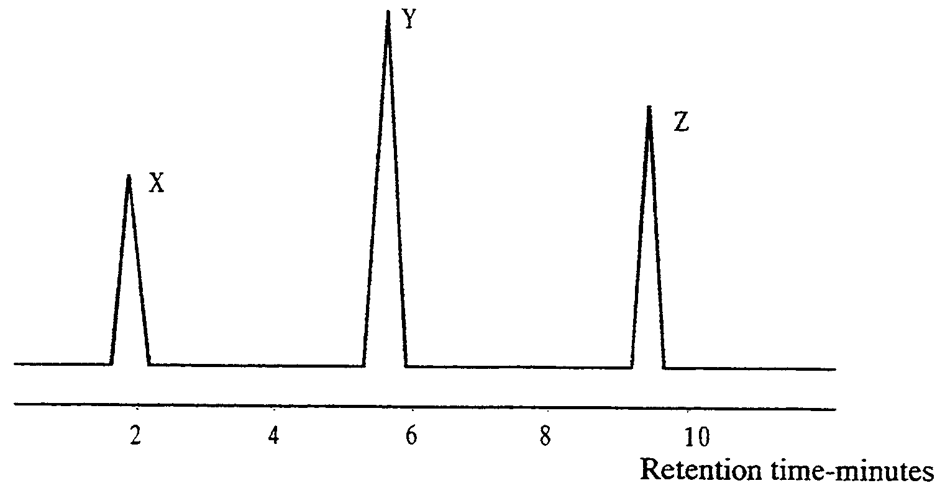
Which component of the mixture spent the longest time in the mobile phase?
- X
- Y
- Z
- all three components spent the same amount of time in the mobile phase

Question 19
Identification of the components of the mixture separated by chromatographic techniques is often based on retardation factor, R_{F}, values of retention times, R_{t}, depending on the type of chromatography used. Which of the following statements about R_{F} values and retention times is incorrect?
- the higher the R_{F} value the greater the attraction to the stationary phase
- the higher the retention time the greater the attraction to the stationary phase
- a higher retention time is similar to a low R_{F} value
- R_{F} values are never greater than 1

Question 20
A catalyst is used in the production of sulfuric acid. The best description of the effect of the catalyst is that it
- increases the proportion of H₂SO₄ in the mixture at equilibrium
- increases the rate of oxidation of SO₂
- increases both the rate of oxidation of SO₂ and the rate of reduction of SO₃
- decreases the rate of reduction of SO₃

Question 21
To assist in working out the molecular formula of a compound with empirical formula CH₂O, its relative molecular mass was determined experimentally.
A 1.45 g sample of the compound was vaporised. The vapour occupied a volume of 484 mL at 1.25×10⁵ Pa and 179°C.
The molecular formula of the compound was
- CH₂O
- C₂H₄O₂
- C₃H₆O₃
- C₄H₈O₄

Section B

Question 1
A VCE chemistry student analyses a sample of ‘Ethac’ vinegar for ethanoic acid content by titrating an aliquot of a diluted solution of the vinegar with sodium hydroxide solution.
The student had previously standardised the sodium hydroxide solution by reacting it with hydrochloric acid, which had previously been standardised against an aqueous solution of sodium carbonate.
The students records the data for the three reactions involved in the analysis in the following way:

Na₂CO₃ (aq) | + | 2 HCl (aq) |  2 NaCl (aq) + CO₂ (g) + H₂O (l)
20.00 mL  from 250.0 mL containing  1.330 g Na₂CO₃ |  | 20.30 mL  of ‘x’ M

HCl (aq) | + | NaOH (aq) |  NaCl (aq) + H₂O (l)
20.00 mL  of ‘x’ M |  | 29.85 mL  of ‘y’ M

CH₃COOH (aq) | + | NaOH (aq) |  CH₃COONa (aq) + H₂O (l)
in 20.00 mL  from 250.0 mL  containing  20.00 mL (19.95 g)  of ‘Ethac’ vinegar |  | 19.00 mL  of ‘y’ M

- Calculate the amount, in moles, of Na₂CO₃ present in 20.00 mL of the sodium carbonate solution used.

2 marks
- Calculate the concentration of the hydrochloric acid used.

2 marks
- Calculate the concentration of the sodium hydroxide solution used.

2 marks
- Calculate the amount, in moles, of CH₃COOH present in 20.00 mL of diluted vinegar.

1 mark
- Calculate the amount, in moles, of CH₃COOH present in 19.95 g of ‘Ethac’ vinegar.

1 mark
- Calculate the concentration of ethanoic acid in ‘Ethac’ vinegar.

1 mark
- Determine the percentage, by mass, of ethanoic acid in ‘Ethac’ vinegar.

2 marks
Total 11 marks

Question 2
Consider the equilibrium described by the equation
CH₃CH₂OH (l) + CH₃COOH (l)  CH₃COOCH₂CH₃ (l) + H₂O (l)

- 8.64 mol of ethanoic acid and 8.64 mol of ethanol are introduced to a 1.00 L flask, along with a little sulfuric acid and the system is allowed to come to equilibrium. After equilibrium has been established 172.8 g of ethanoic acid was present in the equilibrium mixture. Determine the equilibrium constant for the reaction.

3 marks
- What is the general name given to reactions in which an acid reacts with an alcohol n the presence of sulfuric acid?

1 mark
- Describe how both ethanol and ethanoic acid may be produced from ethene. Give the names of chemical formulae of other chemicals involved and indicate the types of reaction occurring at each stage.

4 marks
Total 8 marks

Question 3
For most adults the body’s requirement for iron is between 1 and 4 mg per day but higher amounts may be necessary during puberty, pregnancy, or lactation. Iron is obtained from such foods as eggs, lean meats, legumes, whole grains, and green leafy vegetables.
The amount of iron in a particular brand of cereal is determined by atomic absorption spectroscopy.
28.4 g of cereal is crushed to a fine powder and added to 150 mL of deionised water.
20.0 mL of acid is added and the mixture carefully heated to dissolve the iron as Fe²⁺ (aq).
The mixture is made up to 500 mL with deionised water.
A series of Fe²⁺ (aq) standard solutions were prepared, their absorbance were measured using an AAS and used to establish the calibration curve shown below.
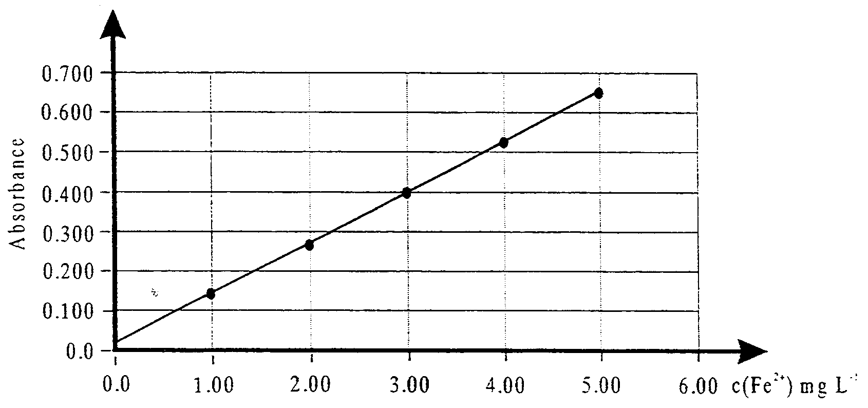
When samples of the 500 mL of cereal solution were aspirated into the same atomic absorption spectrometer the average absorbance was 0.510.

- Determine the mass of iron present in a standard serve (45 g) of the cereal).

3 marks
- State the type of light source used in the spectrometer during the analysis, and explain why this lamp is used.

2 marks
- Give the names of three other components of an atomic absorption spectrometer.

1 mark
Total 8 marks

Question 4
Ammonia, NH₃, is manufactured from nitrogen and hydrogen by the Haber process according to the following equilibrium
N₂ (g) + 3 H₂ (g)  2 NH₃ (g)
The data in the table below gives approximate values for the percentage yield of ammonia at various temperatures and pressures.

Temperature (°C) | Pressure (kPa) | % of NH₃ at equilibrium
400 | 2.00 × 10⁻⁵ | 36.3
400 | 3.00 × 10⁻⁵ | 49.2
400 | 4.00 × 10⁻⁵ | 56.5
300 | 2.00 × 10⁻⁵ | 62.8
500 | 2.00 × 10⁻⁵ | 17.6

Use this data to help you answer the following questions.

- Is the observed effect of pressure upon the yield of ammonia consistent with Le Chatelier’s principle? Explain your answer.

1 mark
- Is the production of ammonia endothermic or exothermic? Explain your answer.

2 marks
- State what combination of pressure (ie high or low) and temperature (ie high or low) would, in theory, give the highest yield of ammonia. Also suggest two reasons why this combination of conditions might not be used in practice.

2 marks
- Write the equilibrium constant expression, K_{c}, for the formation of ammonia.

1 mark
- State and explain what happens to the value of K_{c} if the temperature is increased.

1 mark
- How would the use of a catalyst be expected to affect
  - the rate of formation of ammonia?

  - The position of equilibrium?

2 marks
Total 9 marks
Question 5
The acidity constant for ethanoic acid, CH₃COOH (aq) is 1.76 × 10⁻⁵ at 25°C.

- Determine the pH of a 0.0500 M solution of ethanoic acid at 25°C.

2 marks
- A base in water produces hydroxide ions by accepting a proton from water. So a solution of sodium acetate, CH₃COONa (aq) contains some hydroxide ions because the ethanoate ion, CH₃COO⁻ (aq), a weak base, reacts with water according to
CH₃COO⁻ (aq) + H₂O (l)  CH₃COOH (aq) + OH⁻ (aq)
The equilibrium constant for this reaction, known as a basicity constant, K_{b}, is given by the equilibrium law
K_{b} = $\frac{[{\text{CH}}_{3}\text{COOH}][{\text{OH}}^{−}]}{[{\text{CH}}_{3}{\text{COO}}^{−}]}$
The basicity constant for a weak base and the acidity constant for its conjugate acid are linked by the relationship
K_{a} × K_{b} = K_{w}
- By using the equilibrium laws for the acidity constant of ethanoic acid and the basicity constant of the ethanoate ion show that K_{a} × K_{b} = K_{w}.

2 marks
- Determine the K_{b} for the ethanoate ion at 25°C.

1 mark
- Determine the [OH⁻] in a 0.200 M aqueous solution of sodium ethanoate.

2 marks
- Determine the pH of a 0.200 M solution of sodium ethanoate.

1 mark
Total 8 marks

Question 6
A portion of a simple flowchart for the production of alkenes is shown below:
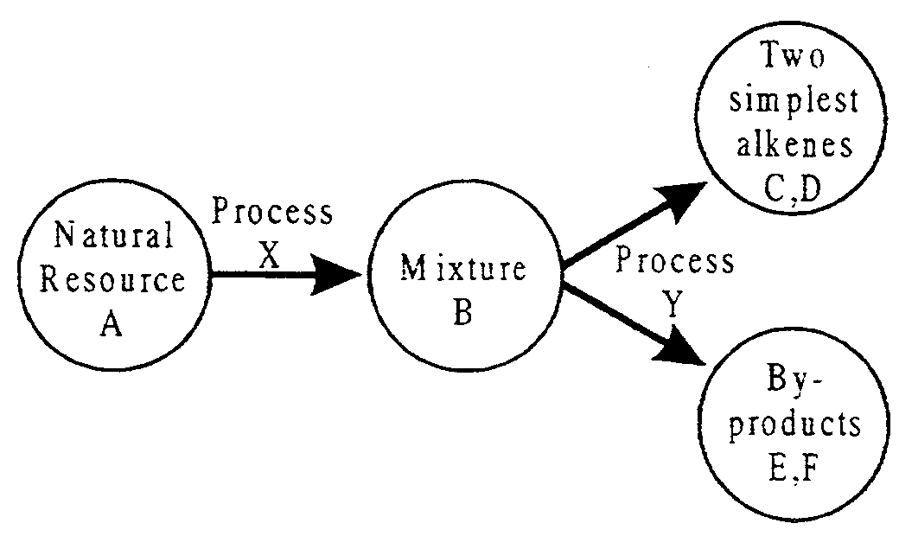
- Give the names of
- Natural Resource A

- Process X

- Process Y

3 marks
- Describe three characteristics of the substances which make up Mixture B.

2 marks
- Give the names and chemical formulae of substances
- C and D

- E and F (the two smallest possible by-product molecules)

4 marks
- Write a balanced equation describing the production of 1-butene from heptane.

1 mark
- Indicate what temperature and pressure conditions would be favoured to maximise the yield of 1-butene and explain why these conditions are favoured.

2 marks
Total 12 marks

