STAV
2003
CHEMISTRY
Unit 3 Exam

Section A – Multiple Choice

Question 1
Which of the following substances would give a pH of 7.0 in aqueous solution at 25°C?
- KNO₃
- CH₃COONa
- KOH
- NH₄CO₃

Question 2
At 20°C and 101 kPa pressure, 3.9 g of methane occupies 5.88 L. The same volume of another unknown gaseous hydrocarbon at the same temperature and pressure has a mass of 10.7 g. The unknown gas could be
- C₂H₄
- C₂H₆
- C₃H₈
- C₄H₁₀

Question 3
In the reaction of 20 g of sulfuric acid with 20 g of sodium hydroxide approximately
- 20 g of sodium sulfate are formed
- 9.1 g of sufuric acid remains
- 9.0 g of water is formed
- 3.7 g of sodium hydroxide remains

Question 4
Which of the following is most accurate in determining the concentration of a component using HPLC?
- peak height
- retention time
- R_{f} value
- peak area

Question 5
Which of the following does not apply in Atomic Absorption Spectroscopy?
- Light passes through a sample tube (cuvette).
- The lamp produces more than one wavelength.
- The sample is aspirated into a flame.
- A solvent blank is used in the calibration of the instrument.

Question 6
The gravimetric analysis of the iron content in sandstone involves the formation of iron(III) hydroxide. This compound is unstable and must be heated strongly to convert the iron(III) hydroxide to pure iron(III) oxide.
During the gravimetric analysis of a sample of sandstone the precipitate was not heated to constant mass and still contained some iron(III) hydroxide. As a result of this, the calculated percentage content of iron in the sandstone sample would
- be increased
- be decreased
- be unchanged
- vary depending on room temperature

Questions 7 and 8 refer to the equilibria involving haemoglobin, Hb, and the transport of oxygen, O₂, and carbon monoxide, CO, by the blood.

Hb₄ + 4 O₂  Hb₄(O₂)₄ Equilibrium 1
Hb₄ + 4 CO  Hb₄(CO)₄ Equilibrium 2

Question 7
Considering Equilibrium 1, under normal conditions, in blood entering the lung tissue, it is correct to state
- [Hb₄] will be low, [O₂] will be high and so the equilibrium will move right
- [Hb₄] will be high, [O₂] will be high and so the equilibrium will move right
- [Hb₄] will be low, [O₂] will be high and so the equilibrium will move left
- [Hb₄] will be high, [O₂] will be high and so the equilibrium will move left

Question 8
Oxygen is used as a treatment for carbon monoxide poisoning. The basis of this treatment is to move
- Equilibrium 1 to the right, so causing Equilibrium 2 to move to the right
- Equilibrium 1 to the left, so causing Equilibrium 2 to move to the left
- Equilibrium 1 to the right, so causing Equilibrium 2 to move to the left
- Equilibrium 1 to the left, so causing Equilibrium 2 to move to the right

Question 9
When 100 mL of 1.0 M HCl are added to 1.0 g of granulated zinc at 20°C, hydrogen gas is evolved. All of the following will increase the initial rate oat which hydrogen gas is released except
- increasing the temperature of the 1.0 M HCl to 40°C
- using 150 mL of 1.0 M HCl instead of 100 mL
- using finely powdered zinc instead of granular zinc
- using 2.0 M HCl instead of 1.0 M HCl

Questions 10 to 14 relate to the following information

Nitrogen dioxide dissociates according to the following equation
2 NO₂ (g)  2 NO (g) + O₂ (g) ΔH = +181 kJ mol^{–1}

Question 10
If a mixture of NO₂, NO and O₂ at equilibrium at 500°C is cooled to 300°C at constant volume, then when equilibrium is re-established
- the concentration of NO has decreased
- the concentration of NO₂ has decreased
- the equilibrium constant has increased
- the equilibrium constant is unchanged

Question 11
If NO is added to another equilibrium mixture at 300°C and at constant volume, when equilibrium is re-established
- the concentration of O₂ has increased
- the concentration of NO₂ has increased
- the equilibrium constant has increased
- the concentrations of O₂ and NO₂ are unaffected

Question 12
An equilibrium mixture contains 4.0 mol NO₂, 0.50 mol NO and 0.20 mol O₂ in a 2000 mL reaction vessel at a constant temperature. The equilibrium constant, K would be
- 1.6 × 10^{–3} M
- 3.1 × 10^{–3} M
- 3.2 × 10² M
- 6.4 × 10² M

Question 13
If the equation was written as 4 NO₂ (g)  4 NO (g) + 2 O₂ (g), the equilibrium constant would be
- unchanged
- 2 K
- K²
- K/2

Question 14
The graph below shows the equilibrium yield of SO₃ produced at various temperatures according to the equation:
2 SO₂ (g) + O₂ (g)  2 SO₃ (g)
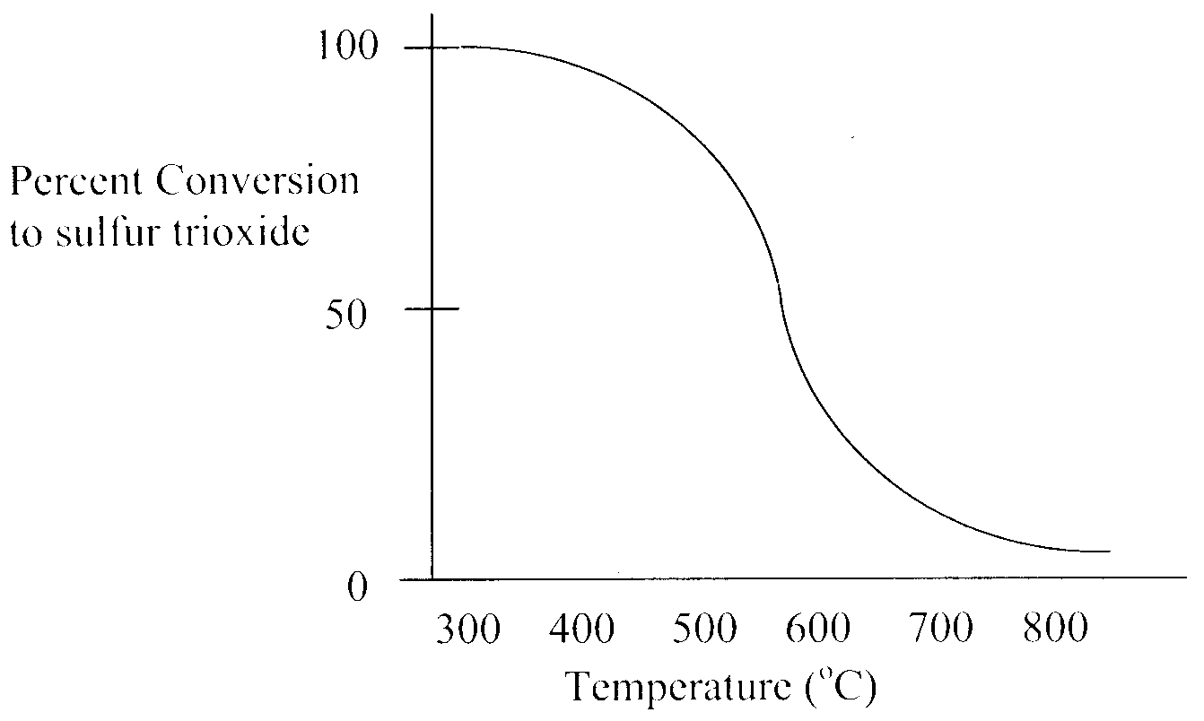
Almost complete conversion to SO₃ occurs at about 300°C. However, Contact Process plants producing sulfuric acid typically carry out this conversion at about 450°C.
The most likely explanation for this is
- the percentage conversion of sO₂ to SO₃ is at a maximum
- the reaction converting SO₂ to SO₃ is endothermic
- the rate of the reaction at 300°C is much slower than at 450°C
- the product, SO₃, become liquid at 300°C

Question 15
The formation of sulfur trioxide, SO₃, from sulfur dioxide, SO₂ occurs according to the equation:
2 SO₂ (g) + O₂ (g)  2 SO₃ (g)
In this reaction sulfur dioxide is acting as
- an oxidant
- a reductant
- an acid
- a base

Question 16
Which of the following compounds would be least soluble in water?
- ethanoic acid
- ethanol
- methyl methanoate
- ethene

Question 17
Ethyl butanoate, CH₃CH₂OOCCH₂CH₂CH₃, is used in pineapple flavouring. The formulae for the molecules from which is is made are
- C₃H₇OH and CH₃COOH
- C₂H₅OH and C₂H₅COOH
- C₃H₇COOH and C₂H₅OH
- C₂H₅COOH and C₃H₇OH

Question 18
The conversion of ethanol to ethanoic acid may be achieved using
- acidified potassium dichromate solution and heat
- sodium hydroxide solution and heat
- steam with concentrated sulfuric acid as a catalyst
- hydrogen with a nickel catalyst at high temperature

Question 19
How does the mass percentage of carbon in the polyester, | 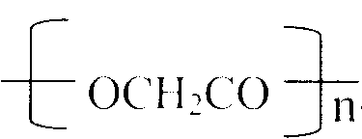 | , compare with the mass percentage of
carbon in its monomer, HOCH₂COOH, from which it is formed?
- The percentage of carbon in the polymer is greater.
- The percentage of carbon in the polymer is less.
- The percentages are equal.
- There is not enough information to make this comparison.
Question 20
One mole of methane and one mole of chlorine gas are mixed in an appropriate reaction vessel and the mixture exposed to a UV light source. The chlorinated organic product(s) of the reaction is (are)
- CH₂Cl₂
- CCl₄
- CH₃Cl
- CH₃Cl, CH₂Cl₂CHCl₃, CCl₄

Question 21
How many of the following compounds can undergo addition polymerisation?
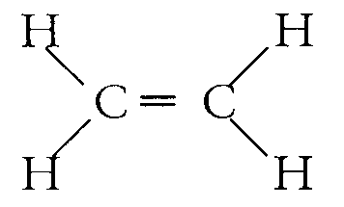 | 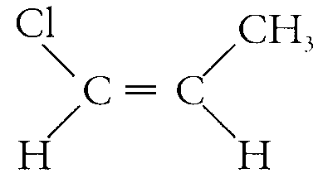 | 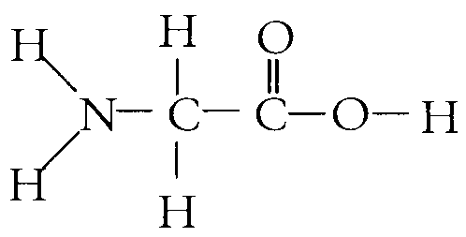 | 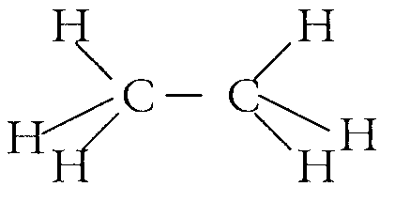
- 0
- 1
- 2
- 3

Question 22
The reaction between ethanol and methanoic acid is called
- an addition reaction
- a condensation reaction
- a neutralisation reaction
- a substitution reaction

Section B – Short Answer Questions

Question 1
A pure sample of an organic compound with a mass of 895 mg is found by microanalysis to contain, by mass, 48.65% C and 8.11% H. The remainder of the compound is oxygen.

- Determine the empirical formula of the organic compound.

- If the relative molecular mass is 74, what is the molecular formula of the organic compound?

- The organic compound is a monoprotic acid. Draw the structural formula of the organic acid and state its name.

- The organic compound can be represented by the chemical formula HA. The organic acid, HA, has a K_{a} value of 4.0 × 10⁻⁵.
(i) Write an equation to represent the reaction of HA with water.
_______________________________________________________________________________________________
(ii) If 100.0 mL of a 0.100 M solution of HA was prepared, what would be the pH of the solution?

(iii) What volume of 0.0500 M NaOH would be needed to completely neutralise 100.0 mL of a 0.100 M solution of HA?

2 + 1 + 2 + [2 + 3 + 1] = 11 marks
Suggested time: 14 minutes

Question 2
Wine labels are required by law to state the alcohol content. The alcohol content can be determined by a titration involving a standard solution of acidified potassium dichromate that reacts to form the chromium(III) ion, Cr³⁺. The alcohol is converted into an aldehyde according to the partial redox equation:
C₂H₅OH (aq) → CH₃CHO (aq) + 2 H⁺ (aq) + 2 e–

- (i) Complete the partial ionic equation for the conversion of the dichromate ion into the chromium(III) ion.
______ Cr₂O₇^{2–} (aq) + _______________ → _______ Cr³⁺ (aq) + _______________
(ii) State whether the dichromate ion is oxidised or reduced in this process and, using oxidation numbers, explain your response.
_______________________________________________________________________________________________
_______________________________________________________________________________________________
_______________________________________________________________________________________________
_______________________________________________________________________________________________
- (i) What is meant by the term ‘standard solution’?
_______________________________________________________________________________________________
_______________________________________________________________________________________________
(ii) Give two characteristics of a primary standard.
_______________________________________________________________________________________________
_______________________________________________________________________________________________
_______________________________________________________________________________________________
_______________________________________________________________________________________________
_______________________________________________________________________________________________
_______________________________________________________________________________________________
_______________________________________________________________________________________________
[1 + 2] + [1 + 2] = 6 marks
Suggested time: 8 minutes

Question 3
Increasing salinity is a serious problem across many parts of South Eastern Australia. A 50 g sample of soil was stirred in water to dissolve the sodium chloride; the solution was filtered, and then titrated with a solution of 0.4998 M silver nitrate. Using the titration data, the amount of sodium chloride present in the soil sample was determined to be 1380 percent by mass.

- Write a balanced equation for the reaction occurring in the titration.
__________________________________________________________________________________________________
- State whether this analysis is qualitative or quantitative. Explain your response.
__________________________________________________________________________________________________
__________________________________________________________________________________________________
__________________________________________________________________________________________________
- Calculate the volume, in mL, of silver nitrate used in the titration. Indicate your answer to the appropriate number of significant figures.

- Suggest one systematic error that would result in this method overestimating the percentage of sodium chloride in the soil.
__________________________________________________________________________________________________
__________________________________________________________________________________________________
__________________________________________________________________________________________________
1 + 1 + 3 + 1 = 6 marks
Suggested time: 7 minutes

Question 4
Gas chromatography (GC) can be used to identify and determine the amounts of substances that are stable and readily vaporised. Diagram A is of a section of a chromatogram showing the first three components to be eluted fro an unknown mixture of alkanes. Diagram B shows a chromatogram obtained for octane at 10 mg/L and hexane at 10 mg/L run under the same conditions.
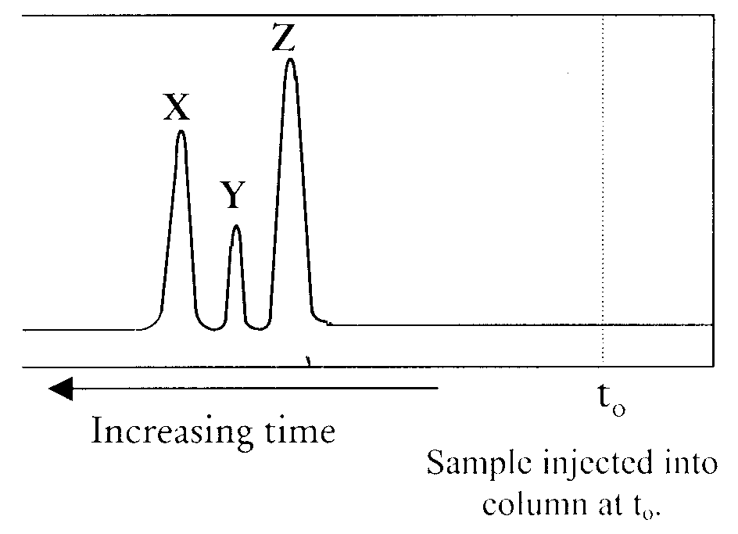 | Diagram A
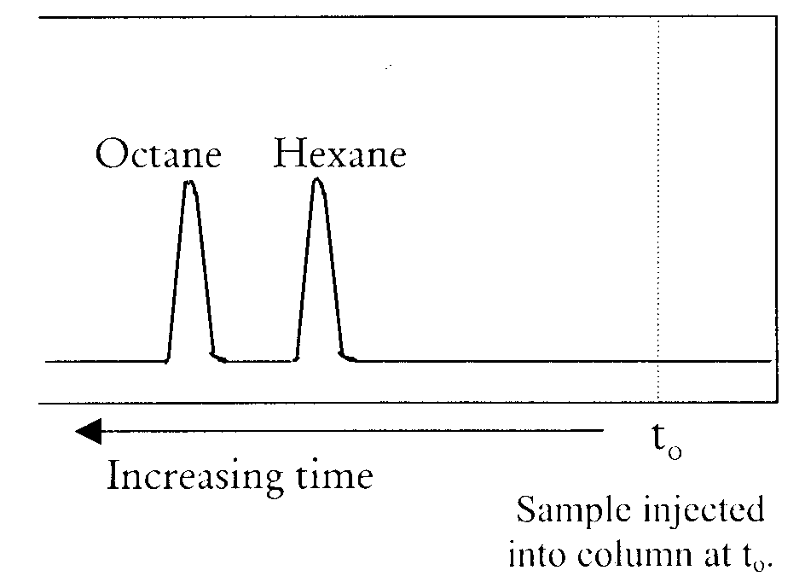 | Diagram B

- For component Y in the chromatogram shown in diagram A
(i) suggest its chemical formula _____________________________
(ii) write its name _____________________________
- Give an estimate of the concentration of hexane in the unknown mixture of alkanes. _____________________________
- The conditions operating in the GC were changed to produce an additional chromatogram. The original chromatogram is shown as a dotted line on Diagram C. Using Diagram C, indicated the position of the peaks if the temperature of the column was significantly increased.

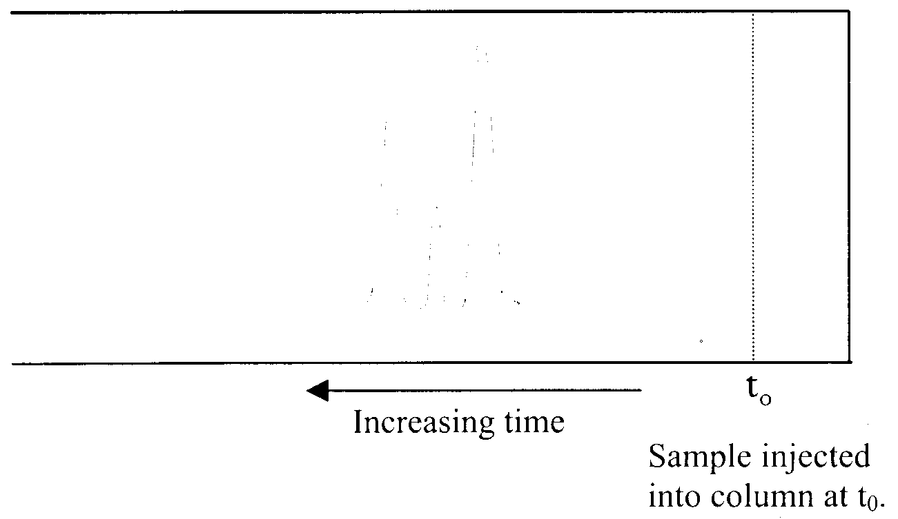 | Diagram C
[1 + 1] + 1 + 1 = 4 marks
Suggested time: 5 minutes

Question 5
Standard solutions of a blue dye were prepared and absorbance measurements taken using a UV-visible spectrophotometer at a wavelength of 600 nm.

Concentration (mol L^{–1}) | Absorbance
0.0050 | 0.12
0.010 | 0.23
0.015 | 0.35
0.020 | 0.46
0.025 | 0.57

- On the axes provided construct a calibration curve for the standard blue dye solutions.
Choose an appropriate scale for each axis.

Absorbance

Blue dye concentration in mol L^{–1}

- A 1.000 mL sample of the blue dye was analysed using the UV-visible spectrophotometer. The procedure involved diluting the sample by making the solution up to 100.0 mL with distilled water in a standard flask. The spectrum represented below was obtained using this diluted solution.
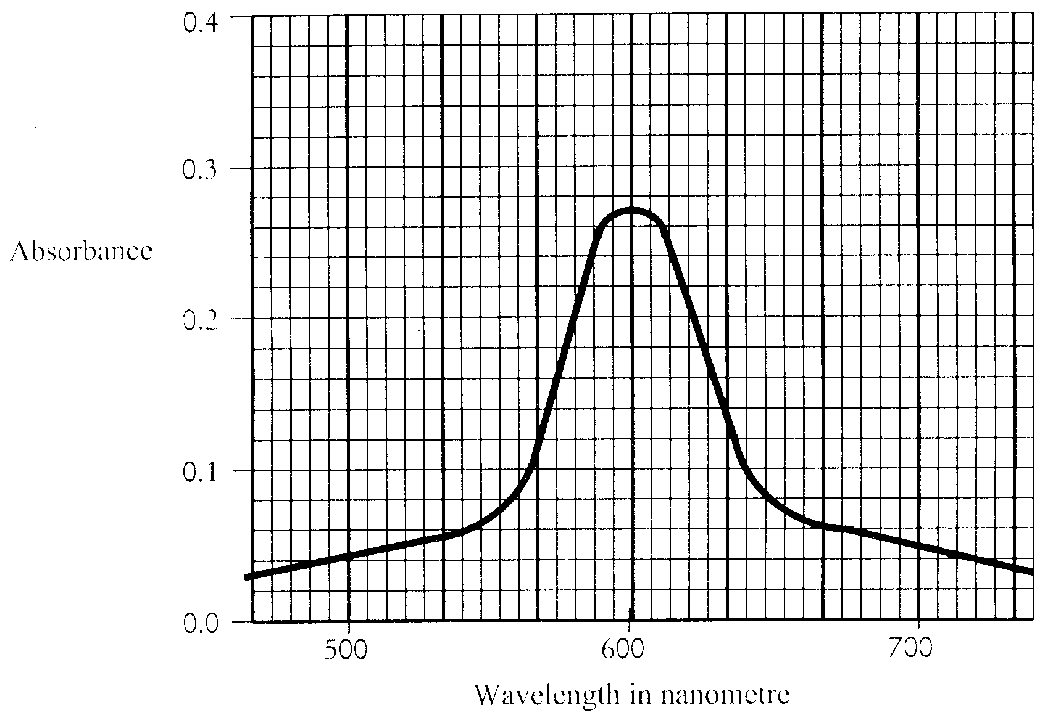
Use the calibration curve and the spectrum of the diluted blue dye to determine the concentration of the original blue dye solution.

- Explain why a wavelength of 600 nm was chosen for this analysis.
__________________________________________________________________________________________________
__________________________________________________________________________________________________
__________________________________________________________________________________________________
2 + 3 + 1 = 6 marks
Suggested time: 8 minutes

Question 6
Internal combustion engines produce the pollutant nitrogen(II) oxide according to the equation:
N₂ (g) + O₂ (g)  2 NO (g) ΔJ = +181 kJ mol^{–1}

- Write an expression for the equilibrium constant for this reaction.

- State whether (i) the equilibrium concentration of NO and
(ii) the equilibrium constant, K
are increased, decreased or remain unchanged when the changes indicated in the table below are made to the conditions operating in an internal combustion engine.
Give an explanation for your response in the spaces provided.

Change to conditions  (all other conditions remain unchanged.) |  | Insert ‘increase’, ‘decrease’, or ‘remains unchanged’ | Explanation
1. | Temperature is increased | (i) Effect on [NO]
 |  | (ii) Effect on K
2. | O₂ is added | (i) Effect on [NO]
 |  | (ii) Effect on K
3. | Pressure is reduced by increasing the volume | (i) Effect on [NO]

1 + 5 = 6 marks
Suggested time: 8 minutes
Question 7
- Ethanol can be produced via the yeast fermentation of glucose. However for industrial purposes it is produced from chemicals produced from crude oil.
Write chemical equations and, where appropriate, indicated important reaction conditions for the production of ethanol from
(i) chloroethane
_______________________________________________________________________________________________
(ii) ethene
_______________________________________________________________________________________________
- Ethanol is the second member of the homologous series known as the alcohols (alkanols).
(i) Define the term ‘homologous series’ and give a general formula to describe the alcohols which includes ethanol.
_______________________________________________________________________________________________
_______________________________________________________________________________________________
_______________________________________________________________________________________________
(ii) Draw the structural formulae and name all isomers of the alcohols with the chemical formula C₃H₈O.

[1 + 2] + [2 + 4] = 9 marks
Suggested time: 12 minutes

END OF QUESTION AND ANSWER BOOKLET

