STAV 2003 | CHEMISTRY | Unit 4 | Trial Examination Solutions

Section A Multiple Choice Questions

- C
- A
- D
- C
- B
- B
- B
- B
- A
- C
- C
- A
- D
- B
- C
- A
- D
- D
- D
- A

Section B Short Answer

Question 1
- A car battery is an example of a secondary galvanic cell. In this type of cell the electrode processes can be reversed. | 1 mark
This can occur because the reaction product(s) stay in contact with the electrodes. | 1 mark
- The loss of electrons is a typical metallic property. As you move down a Group, the outer shell electrons are further from the nucleus. | 1 mark
Therefore the outer shell electrons are less strongly held to the nucleus and are therefore more easily removed. | 1 mark
- As you move across a Period of the Periodic Table the core charge (the attraction for the nucleus for the outer shell electrons increases. | 1 mark
This results in the electrons being pulled closer to the nucleus and therefore the atomic radius decreases. | 1 mark
- Electronegativity is a measure of the electron attracting power of an atom for electrons of other atoms in a chemical bond. | 1 mark
As chlorine has the greater atomic radius (due to more occupied shells) its nucleus has less attraction for the electrons of another atom compared to fluorine. | 1 mark
- Zinc only forms a Zn²⁺ ion which has a complete 3d subshell. | 1 mark
Therefore zinc is unable to promote electrons to other 3d orbitals. | 1 mark
- Antioxidants are included to prevent the oxidation by oxygen of the double bonds in unsaturated fats in the margarine. | 1 mark
Emulsifiers allow water and oil to form a homogenous mixture. In margarine (a ‘water in oil’ emulsion) they prevent fat and water from separating. | 1 mark

Question 2
- (i) The electrons move from the zinc electrode through the globe to the copper cylinder (electrode). | 1 mark
(ii) The zinc rod is negative and the copper cylinder is positive. | 1 mark
- Positive electrode (cathode) Cu²⁺ (aq) + 2 e–  Cu (s)  Negative electrode (anode) Zn (s)  Zn²⁺ (aq) + 2 e– | 1 mark  1 mark
- Cu²⁺ (aq) + Zn (s)  Zn²⁺ (aq) + Cu (s) | 1 mark
- It completes the electrical circuit by allowing the slow migration of ions to maintain electrical neutrality around the electrodes. | 1 mark
- A zinc outer cylinder would eventually corrode and leak. | 1 mark
- (i) n(Zn) = m / M = 125 / 65.4 = 1.9113 mol  n(e–) = 2 × n(Zn) = 2 × 1.9113 = 3.8226 mol | 1 mark
Q = n(e–) × F = 3.8226 × 96500 = 368 880.9 C  Charge = 3.69 × 10⁵ C | 1 mark
(ii) Energy = V × Q (joules) = 1.10 × 3.69 × 10⁵ = 4.06 × 10⁵ J = 406 kJ | 1 mark

Question 3
 |  | Electrode material | Electrode reaction
 | Anode | Carbon | C (s) + 2 O^{2–} (in cryolite)  CO₂ (g) + 4 e– |  | 1 mark
 | Cathode | Carbon / molten Al | Al³⁺ (in cryolite) + 3 e–  Al (l) |  | 1 mark
- Molten cryolite, Na₃AlF₆, acts as a solvent, dissolving the alumina and enabling the Al³⁺ and O^{2–} ions to be dissociated at a lower temperature. |  |  |  |  | 1 mark
(Note: cryolite melting point of about 1000°C is much lower than that of alumina (greater than 2000°C). In addition, when the cryolite dissolves the alumina, the solution has a lower melting point of about 850°C.)
- Water is a stronger oxidant than the Al³⁺ ions and would be reduced in preference. |  |  |  |  | 1 mark
- Any two of the following examples:
- Large amounts of CO₂ are produced both from generation of electricity and due to the anode reaction. CO₂ is a ‘Greenhouse Gas’.  - Mining of the bauxite to produce the alumina has a negative impact on flora and fauna.  - Mining of coal does much damage to the environment.  - Fluorine compounds and fluorine gas are emitted with the flue gases. These substances are highly toxic.  - Visual impact of power lines from source to energy site of aluminium production. |  |  |  |  | 2 × 1 = 2 marks

Question 4
- Condensation (polymerisation) reaction. | 1 mark
- H₂O (Do not accept ‘water’/) | 1 mark
- (1) Either monosaccharides or hexoses. | 1 mark
(2) Disaccharides. | 1 mark
- (i) Glucose or α-glucose | 1 mark
(ii) C₆H₁₂O₆ + 6 O₂  6 CO₂ + 6 H₂O (Subscripts not required on this equation) | 1 mark
(iii) Name: glycogen | 1 mark
Empirical formula: C₆H₁₀O₅ or [C₆H₁₀O₅] _{n} | 1 mark
Function: (Short term) Storage of energy (in the liver). | 1 mark

Question 5
 | 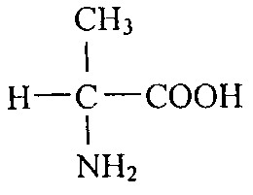 |  |  |  |  | 1 mark
- The three functional groups are: hydroxy(l), carboxyl and amino. (All three needed for 1 mark) |  |  |  |  |  | 1 mark
 | (i) | 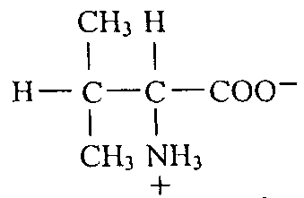 | 1 mark | (ii) | 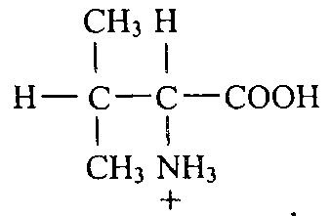 | 1 mark
- (i) Proteins (accept catalysts) |  |  |  |  |  | 1 mark
(ii) • denaturation |  |  |  |  |  | 1 mark
• eg. one of ‘pH change’ or ‘temperature change’ |  |  |  |  |  | 1 mark

Question 6
 | 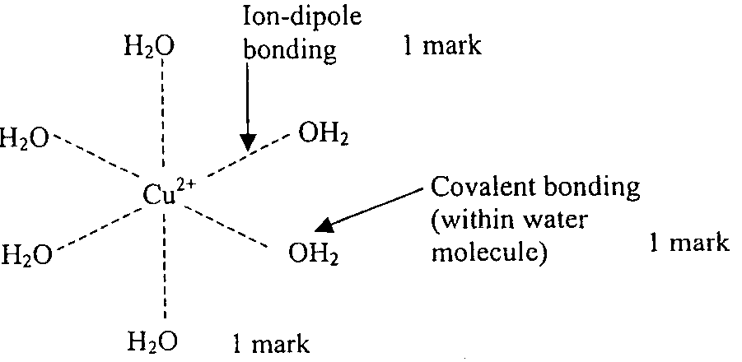 | 2 marks
- ligands. |  | 1 mark
- Cu²⁺ (aq) + 2 OH– (aq)  Cu(OH)₂ (s) |  | 1 mark
- The presence of the ligands around the Cu²⁺ cation causes the energy levels of the electrons in the 3d orbitals to change (be distorted). |  | 1 mark
NH₃ ligands cause a different distorting of the 3d orbitals than H₂O ligands. Therefore the wavelengths of the light absorbed are different resulting in a change of colour of the transmitted light. |  | 1 mark
- 1s² 2s² 2p⁶ 3s² 3p⁶3d⁹  (Must use s, p, d notation for mark) |  | 1 mark

