CHEMOLOGY
2004
CHEMISTRY
Unit 3 Exam

Section A – Multiple Choice

Question 1
The following equation can be considered as a simplification of the reaction that takes place when iron rusts:
4 Fe (s) + 3 O₂ (g)  2 Fe₂O₃ (s)
Which of the following statements is not correct for this reaction?
- Metallic iron is reduced to Fe³⁺.
- Fe³⁺ is an oxidising agent.
- Fe is a reducing agent.
- O₂ is an oxidising agent.

Question 2
The group which bestows appreciable acidic properties on a compound to which it is attached is
- –CO
- –CHO
- –COOH
- –OCH₃

Question 3
Which one of the following would not change the initial rate of reaction between zinc and 1 M hydrochloric acid solution?
- the addition of a catalyst
- a change in the temperature of the reactants
- using double the volume of hydrochloric acid solution
- breaking down the zinc into smaller pieces

Question 4
A catalyst is a substance which, when present during a chemical reaction, changes the
- amount of products obtained at equilibrium
- rate of attaining equilibrium
- concentration of the products at equilibrium
- equilibrium constant at a given temperature

Question 5
3.00 mol of HI was placed in a 1 L container at 600 K. The HI partially decomposed, forming 0.44 mol of H₂ and 0.44 mol of I₂ at equilibrium. The equilibrium constant for the reaction 2 HI (g)  H₂ (g) + I₂ (g) is
- 0.065
- 15.5
- 11.0
- 0.091

Question 6
In the unbalanced reaction MnO₄⁻ (aq) + MnO₂ (s) + OH⁻ (aq)  MnO₄²⁻ (aq) + H₂O (l) manganese occurs in the following oxidation states
- +2 and +3 only
- +4 and +6 only
- 0, -1 and -2 only
- +4, +6 and +7 only

Question 7
The reaction CH₃COOH (aq) + NH₃ (aq)  NH₄⁺ (aq) + CH₃COO⁻ (aq) has an equilibrium constant of 9.0.
Which of the following statements is true?
- The reaction favours the formation of reactants rather than the formation of products.
- [CH₃COOH][NH₃] = [NH₄⁺][CH₃COO⁻]
- CH₃COO⁻ (aq) is a stronger acid than is NH₄⁺ (aq).
- CH₃COOH (aq) is a stronger acid than is NH₄⁺ (aq).

Question 8
A sulfuric acid solution has a concentration of 5×10⁻⁴ M.
What is the pH of this solution, assuming the sulfuric acid is fully ionised?
- 3.0
- 3.3
- 3.6
- 4.0

Question 9
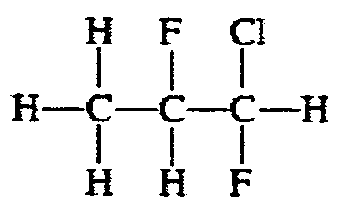
What is the name of the compound shown?
- 1-chloro-1,2-difluoropropane
- 3-chloro-2,3-difluoropropane
- 1,2-difluoro-1-chloropropane
- 1-chloro-1,2 difluoropentane

Question 10
Which polymer is made by the polymerisation of methyl methacrylate?
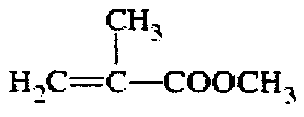
methyl methacrylate
A. | 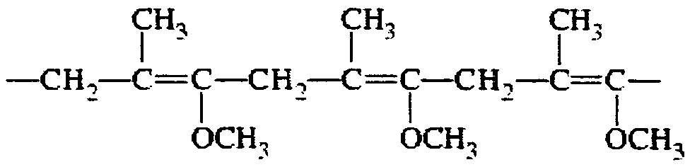 | C. | 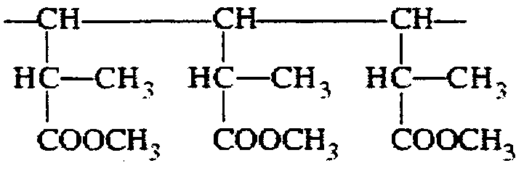
B. | 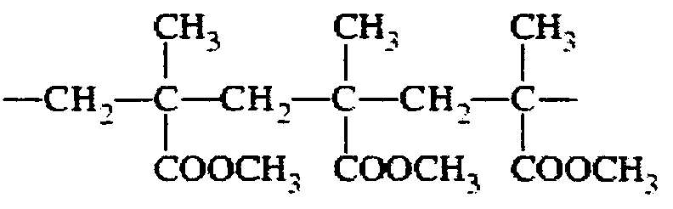 | D. | 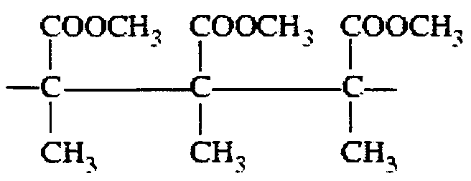

Question 11
In a titration of a strong base with a strong acid, the following procedure was used:
- A burette was filled with the standard acid.
- A pipette was rinsed with some base solution.
- A conical flask was rinsed with some base solution.
- A pipette was used to transfer a measured volume of base solution into the conical flask.
- Indicator was added to the base sample and it was titrated to the endpoint with the acid.
Which statement is correct?
- The calculated base concentration will be correct.
- The calculated base concentration will be too low.
- The calculated base concentration will be too high.
- No definite conclusion can be reached about the base concentration.

The next three questions refer to the following information

A 0.243 g piece of magnesium metal is added to 100 mL of 0.5 M HCl solution until it completely dissolves.
The equation is shown below:
Mg (s) + 2 HCl (aq)  MgCl₂ (aq) + H₂ (g)

Question 12
The pH of the HCl before the reaction with zinc would be
- 0.3
- 1.3
- -0.3
- 14

Question 13
The volume of hydrogen gas produced at 1 atmosphere and 25°C would be
- 0.224 L
- 0.245 L
- 1.12 L
- 1.23 L

Question 14
The pH of the solution after the reaction is complete would be
- 0.5
- 0.4
- 0.3
- 7
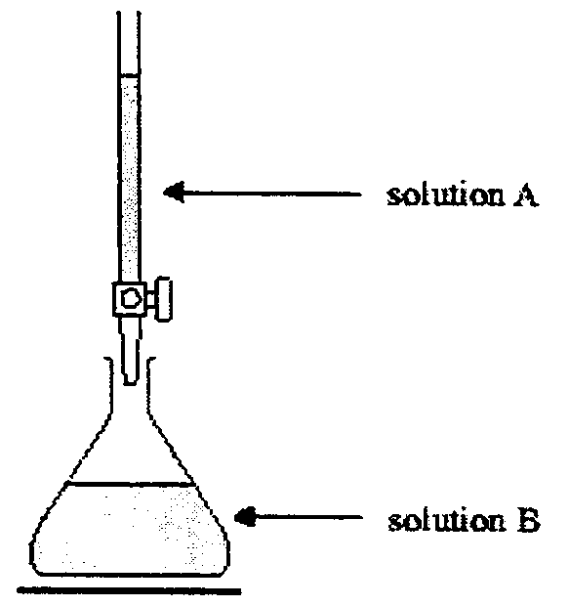
Question 15
In a titration experiment, 0.1 M sodium hydroxide solution (A) was to be added to 20 mL of 0.1 M hydrochloric acid solution (B) using the apparatus shown.
Which one of the following procedures should have been done before titrating?

 | Conical flask washed with | Burette washed with
A. | solution B | solution A
B. | distilled water | distilled water
C. | solution B | distilled water
D. | distilled water | solution A

Question 16
If the K_{a} of ammonium chloride, NH₄Cl, is 6.03×10⁻¹⁰ M, then the pH of 0.25 M NH₄Cl will be
- 4.6
- 9.8
- 10.1
- 4.9

Question 17
Gas Liquid Chromatography would be the most suitable technique to
- separate the food dyes in smarties
- separate the components in petrol
- determine the amount of sugar in soft drinks
- determine the amount of mercury in a sample of contaminated water

The following information is referred to in Question 18

Mining companies make extensive use of atomic absorption spectroscopy to analyse mineral samples. To measure the amount of copper in an ore sample a series of standard copper solutions were prepared. Their absorbances were measured and a graph of the results is shown below.
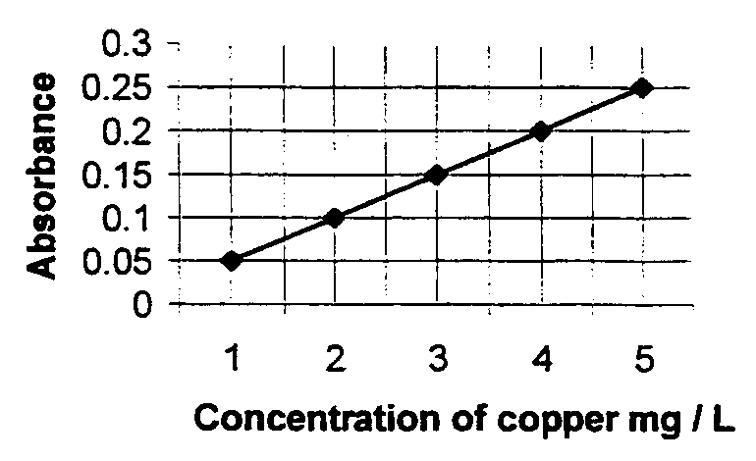

Question 18
A 0.32 g ore sample was dissolved in acid and the volume made up to 10 mL. 1 mL of this solution was then diluted to 100 mL. The absorbance of this resulting solution was found to be 0.15. The percentage of copper in the ore sample is closest to
- 0.94
- 0.94
- 3
- 0.3
The following information is referred to in Question 18

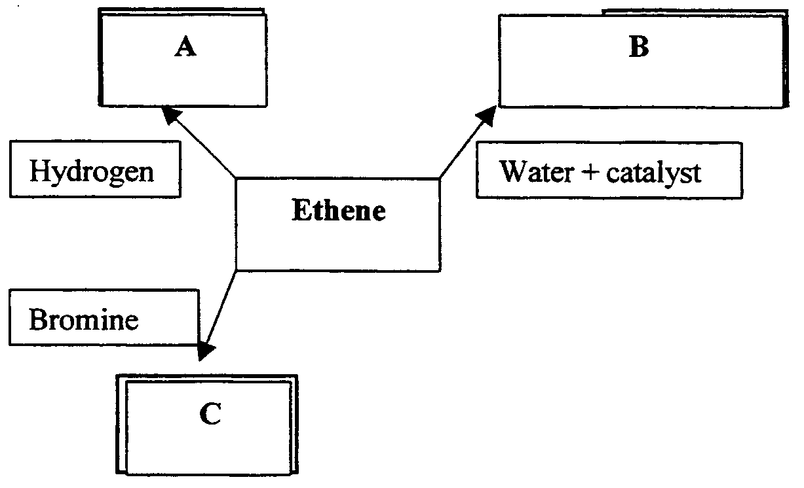

Question 19
Substance A would be
- ethyne
- ethane
- methane
- ethene

Question 20
Substance B would be
- CH₃OH
- CH₃CH₂OH
- C₂H₄(OH)₂
- CH₃COOH

Question 21
Substance C would be
- CH₃Br
- C₂H₅Br
- C₂H₄Br₂
- CH₂Br₂

Section B – Short Answer Questions

Question 1 (12 marks, 16 minutes)
Analysis of a clear, colourless liquid compound (X) showed it contained 64.9% C, 13.5% H, and 21.6% O by mass.

The compound X had a molar mass of 74. It was easily oxidised to an acidic liquid of molar mass 88 (compound Y), which was resistant to further oxidation.
Compound X also reacted with ethanoic acid to form a liquid Z, which had a sweet fruity odour.

- Determine the empirical formula of compound X.
________________________________________________________________________________________________
________________________________________________________________________________________________
________________________________________________________________________________________________
________________________________________________________________________________________________
________________________________________________________________________________________________
3 marks
- Determine the molecular formula of compound X.
________________________________________________________________________________________________
________________________________________________________________________________________________
________________________________________________________________________________________________
2 marks
- Suggest a possible structure and name for compound X.

________________________________________________________________________________________________
2 marks
- Suggest a possible structure and name for compound Y.

________________________________________________________________________________________________
2 marks
- In the space below shown how compound X reacts with ethanoic acid to form compound Z.

2 marks
- Suggest a possible name for compound Z.
________________________________________________________________________________________________
1 mark

Question 2 (4 marks, 5 minutes)
10.0 g of scrap copper water pipe was dissolved in a beaker containing 500 mL of 2.00 M nitric acid according to the following equation:
3 Cu (s) + 8 HNO₃ (aq)  3 Cu(NO₃)₂ (aq) + 2 NO (g) + 4 H₂O (l)
The changing mass of the mixture was observed against time, and the following graph obtained.
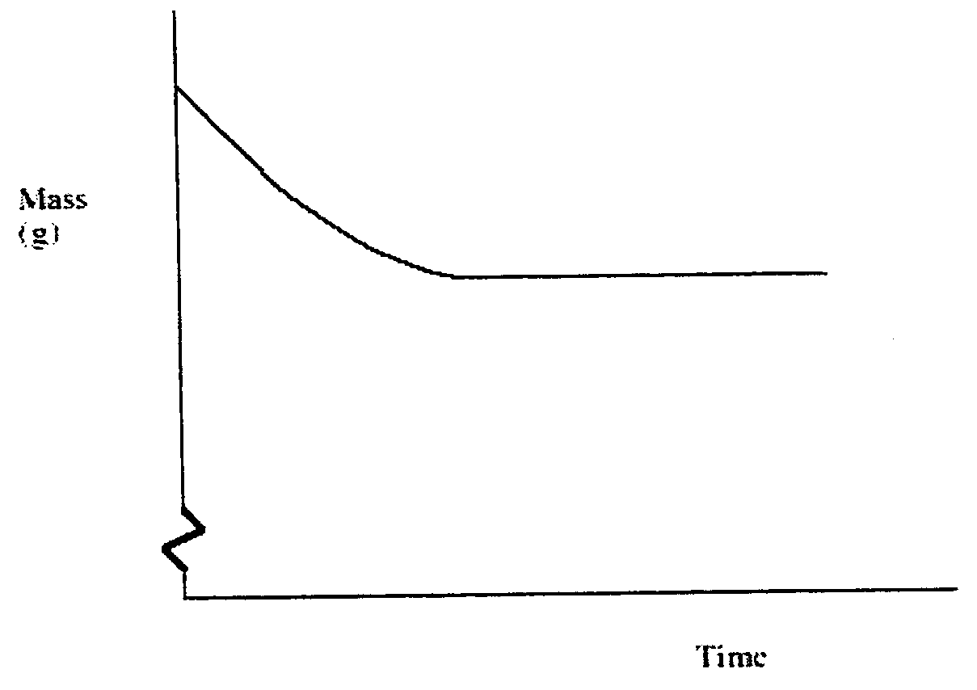

- On the graph above, sketch the expected curve if 500 mL of 1.00 M nitric acid had been used instead. Label your new graph line.
Explain the difference in shape.
________________________________________________________________________________________________
________________________________________________________________________________________________
________________________________________________________________________________________________
2 marks
- Show on the graph above the expected line if the 10.0 g of scrap copper had previously been ground up in a hmmer mill. Label this graph line.
Explain the difference in shape.
________________________________________________________________________________________________
________________________________________________________________________________________________
________________________________________________________________________________________________
2 marks

Question 3 (7 marks, 10 minutes)
A mixture of gases was placed in a closed reaction vessel. The temperature was maintained at 727°C until equilibrium was established. The reaction that occurred in the vessel is shown in the following equation:
H₂ + Br₂  2 HBr
The final concentrations of all three components and the initial concentration of hydrogen are shown in the table below:

Component | initial concentration (mol L⁻¹) | final concentration (mol L⁻¹)
H₂ | 50×10⁻³ | 0.5×10⁻³
Br₂ |  | 0.5×10⁻³
HBr |  | 99×10⁻³

- Write the expression for the equilibrium constant for this equilibrium.

1 mark
- Calculate the value for K.
________________________________________________________________________________________________
________________________________________________________________________________________________
________________________________________________________________________________________________
2 marks
- Determine the initial concentrations of bromine and hydrogen bromide in the reaction vessel, and hence complete the table above.
________________________________________________________________________________________________
________________________________________________________________________________________________
________________________________________________________________________________________________
________________________________________________________________________________________________
________________________________________________________________________________________________
________________________________________________________________________________________________
3 marks

In another experiment equilibrium was established between hydrogen, bromine and hydrogen bromide.
The following diagram shows the change in concentration of bromine over time.
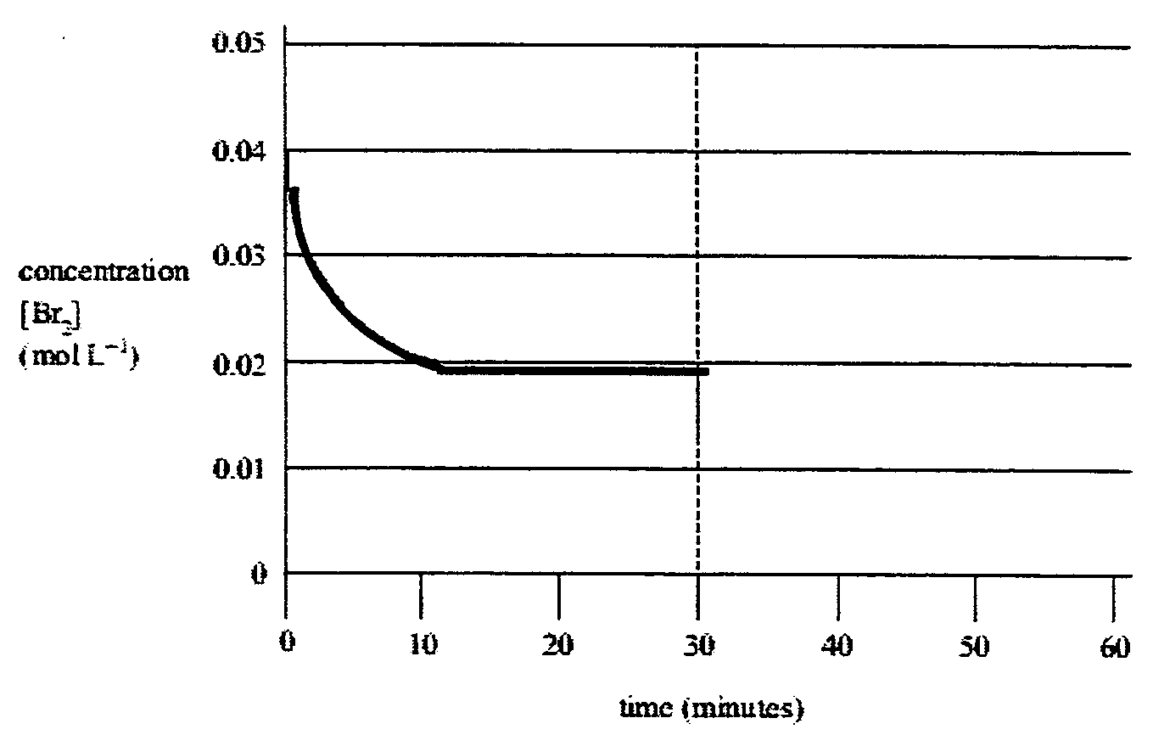

- At the 30 minute mark, some of the bromine was removed. Equilibrium was re-established at 45 minutes. Extend the graph of bromine concentration from 30 to 60 minutes.
1 mark

Question 4 (10 marks, 10 minutes)
This question refers to some of the chemical reactions studied in this unit.
Write balanced chemical equations for the following reactions.

- The equilibrium reaction between sulfur dioxide and oxygen, a step in the production of sulfuric acid.
________________________________________________________________________________________________
- The reaction between sulfur trioxide and oleum.
________________________________________________________________________________________________
- The cracking of octane to produce ethane.
________________________________________________________________________________________________
- The reaction of ethene with water.
________________________________________________________________________________________________
- The reaction of sulfuric acid as a dehydrating agent.
________________________________________________________________________________________________

Question 5 (5 marks, 3 minutes)
Identify the following substances. Write their names in the adjacent spaces.

a. | C₂H₂ | ________________________________
b. | 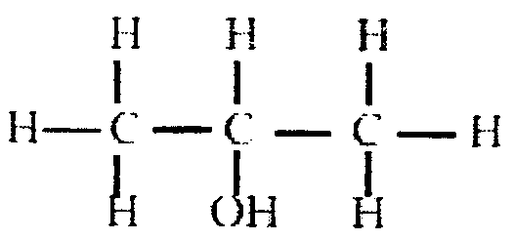 | ________________________________
c. | 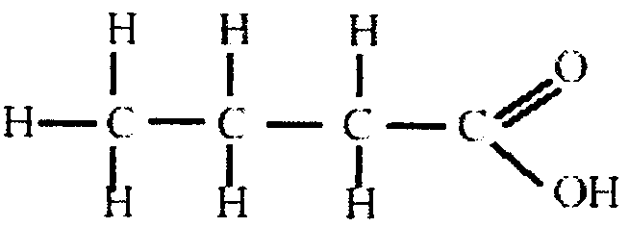 | ________________________________
d. | C₃H₇COOC₂H₅ | ________________________________
e. | 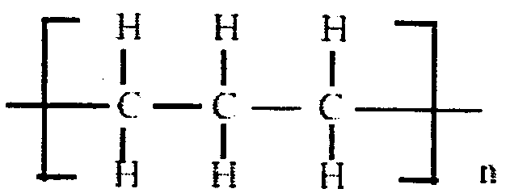 | ________________________________

Question 6 (14 marks, 15 minutes)
Rainwater contains dissolved carbon dioxide. Carbon dioxide reacts with rainwater to form carbonic acid, H₂CO₃, which then ionises according to the two reactions shown in the equations below:
Equation 1 | H₂CO₃  H⁺ + HCO₃⁻ | K₁ = 2.0×10⁻⁴

Equation 2 | HCO₃⁻  H⁺ + CO₃²⁻ | K₂ = 7.9×10⁻¹¹
Graphs of the relative percentage concentrations of HCO₃⁻ and CO₃²⁻ in rainwater of different pH values are shown in the diagram below:
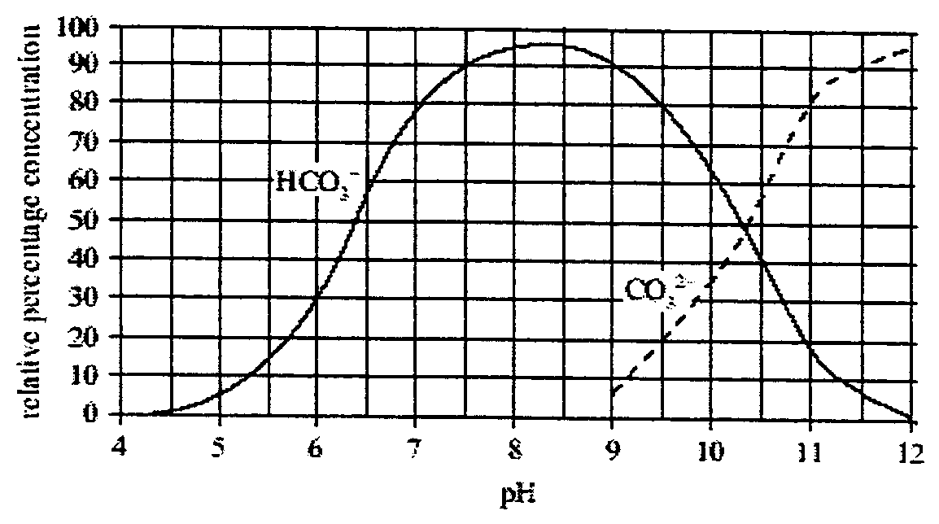
In areas of acid rain, H₂SO₄ dissolved in rainwater ionises according to the reaction shown in the equation below:
Equation 3 | H₂SO₄  H⁺ + HSO₄⁻ | K₃ = 1.0×10¹⁰

- State the effect that the addition of H₂SO₄ has on the pH of rainwater.
________________________________________________________________________________________________
1 mark
- Using the diagram above, determine the relative percentage concentration of HCO₃⁻ at pH = 5.0.
________________________________________________________________________________________________
1 mark
- Using Equation 1 and Equation 3, explain, in terms of equilibria, why the concentration of HCO₃⁻ in acid rain approaches zero.
________________________________________________________________________________________________
________________________________________________________________________________________________
________________________________________________________________________________________________
________________________________________________________________________________________________
3 marks
- Using the diagram above, calculate the pH when the ratio of CO₃²⁻ to HCO₃⁻ is 1:4.
________________________________________________________________________________________________
________________________________________________________________________________________________
1 mark
- (i) Write an expression for the equilibrium constant, K, for Equation 2.

1 mark
(ii) Using this expression, determine the [H⁺] when the ratio of CO₃²⁻ to HCO₃⁻ is 1:4 in Equation 2. Show your working.
____________________________________________________________________________________________
____________________________________________________________________________________________
2 marks
(iii) Using the [H⁺], determine the pH when the ratio of CO₃²⁻ to HCO₃⁻ is 1 : 4. Show your working.
____________________________________________________________________________________________
____________________________________________________________________________________________
2 marks
The concentration of H⁺ in a lake affected by acid rain was 3.2×10⁻⁵ M. CaCO₃ was added to the lake to neutralise the excess acid. The neutralisation reaction between CaCO₃ and H⁺ is shown in the equation below.
CaCO₃ (s) + 2 H⁺ (aq)  Ca²⁺ (aq) + H₂O (l) + CO₂ (g)

- Calculate the mass of CaCO₃ required to neutralise the 1.0×10⁹ L of water in the lake.
________________________________________________________________________________________________
________________________________________________________________________________________________
________________________________________________________________________________________________
________________________________________________________________________________________________
________________________________________________________________________________________________
________________________________________________________________________________________________
3 marks

Question 7 (9 marks, 13 minutes)
Proteins are important biological compounds. The nitrogen content of a sample of dried protein, with a mass of 0.895 g, was determined by converting all the nitrogen in the protein into ammonia gas, NH₃. The ammonia was then bubbled through 50.0 mL of 0.197 M HCl solution. A reaction occurred, as shown in the equation below.
NH₃ (g) + HCl (aq)  NH₄⁺ (aq) + Cl⁻ (aq)

- Calculate the initial number of moles of HCl present before the reaction with ammonia.
________________________________________________________________________________________________
1 mark

After the ammonia had reacted, excess HCl remained. The excess HCl was neutralised by titrating with 5.90 mL of 1.000 M NaOH. A reaction occurred, as shown in the equation below:
HCl (aq) + NaOH (aq)  NaCl (aq) + H₂O (l)

- Determine the number of moles of excess HCl.
________________________________________________________________________________________________
________________________________________________________________________________________________
________________________________________________________________________________________________
________________________________________________________________________________________________
________________________________________________________________________________________________
3 marks
- Hence determine the number of moles of NH₃ that reacted with the HCl solution.
________________________________________________________________________________________________
________________________________________________________________________________________________
________________________________________________________________________________________________
2 marks
- Calculate the percentage mass of nitrogen in the sample of dried protein.
________________________________________________________________________________________________
________________________________________________________________________________________________
________________________________________________________________________________________________
3 marks

END OF QUESTION AND ANSWER BOOKLET

