NEAP
2005
CHEMISTRY
Unit 3 Exam

Section A – Multiple Choice

Question 1
In common with sulfuric acid, nitric acid can act as both a strong acid and a strong oxidant. Which of the following equations shows nitric acid functioning as an oxidant?
- 8 HNO₃ (aq) + 3 Cu (s) → 3 Cu(NO₃)₂ (aq) + 2 NO (g) + 4 H₂O (l)
- 2 HNO₃ (aq) + MgCO₃ (s) → Mg(NO₃)₂ (aq) + CO₂ (g) + H₂O (l)
- HNO₃ (aq) + KOH (aq) → KNO₃ (aq) + 4 H₂O (l)
- H₂SO₄ (aq) + NaNO₃ (s) → NaHSO₄ (l) + HNO₃ (aq)

Question 2
A sample of sulphur was burnt in air and the gas evolved bubbled through water. Which of the following ions would be present in the greatest concentration in the resulting solution?

- S²⁻
- SO₄²⁻
- HSO₃⁻
- HSO₄⁻

Question 3
Which of the following processes is exothermic?

- 2 Cl (g) → Cl₂
- CH₃CH₃ (g)  CH₂CH₂ (g) + H₂ (g)
- I₂ (s) → I₂ (g)
- H₂SO₄ (aq) → SO₃ (g) + H₂O (l)

Question 4
2.0 mol of SO₂ and 2.0 mol of NO₂ were added to an evacuated 1.0 L vessel and the system was allowed to come to equilibrium at T°C, according to the equation:
SO₂ (g) + NO₂ (g)  SO₃ (g) + NO (g)
At equilibrium, 1.6 mol of NO was found to be present. The value of the equilibrium constant, K, for this reaction at T°C is

- 0.063
- 0.64
- 16
- 64

Question 5
Kodol is a polymer used to make fibres of stain-resistant carpet. The structure of a segment of Kodol is shown below.
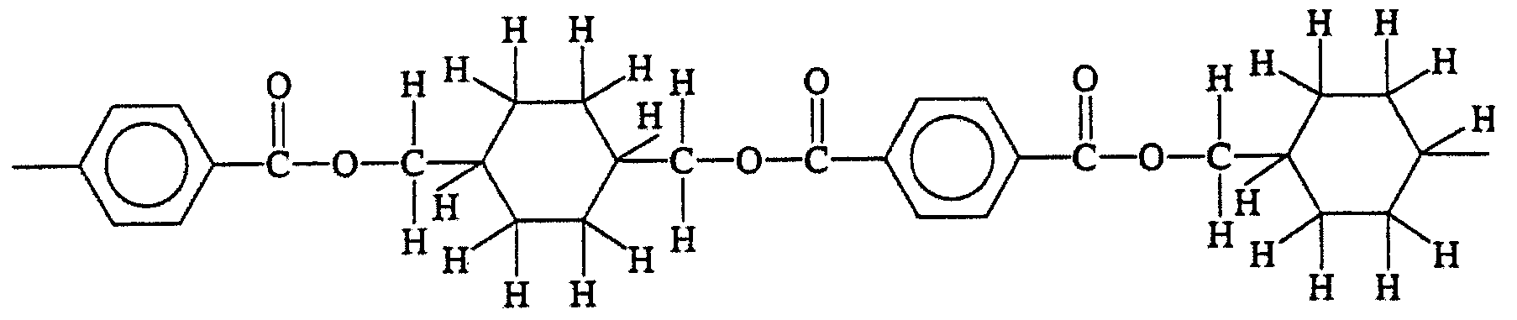
Kodol would be produced by the process of
- addition polymerisation using the monomers HOCH₂(C₆H₁₀)CH₂OH and HO₂C(C₆H₄)CO₂H
- condensation polymerisation using the monomers HOCH₂(C₆H₁₀)CH₂OH and HO₂C(C₆H₄)CO₂H
- addition polymerisation using the monomers HOCH₂(C₆H₁₀)CO₂H and HOCH₂(C₆H₄)CO₂H
- condensation polymerisation using the monomers HOCH₂(C₆H₁₀)CO₂H and HOCH₂(C₆H₄)CO₂H

Question 6
The pH of a 0.00500 M solution of barium hydroxide, Ba(OH)₂, at 25°C, would be

- 2.00
- 2.30
- 11.7
- 12.0

Question 7
Monosodium glutamate (MSG) is a flavour-enhancer widely used in convenience foods. Its percentage composition by mass is 35.51% carbon, 4.74% hydrogen, 37.87% oxygen, 8.28% nitrogen and 13.60% sodium. The empirical formula of MSG is

- C₃H₅O₂NNa
- C₆H₁₀O₅NNa
- C₅H₈O₄NNa
- C₃H₅O₃NNa

Question 8
When dilute HCl solution is added to a solution of Na₂S₂O₃ a precipitate of S forms according to the ionic equation:
2 H⁺ (aq) + S₂O₃²⁻ (aq) → S (s) + SO₂ (g) + H₂O (l)
The rate at which this reaction proceeds would be increased by

- increasing the concentration of HCl
- cooling the reactant solutions
- removing the S precipitate as it forms
- increasing the pressure on the system

Question 9
Which of the following is not an isomer of chlorobutene?

- CH₂ClCH₂CHCH₂
- CH₃CHClCH₂CH₃
- CH₂C(CH₃)CH₂Cl
- CH₃CHCClCH₃

Question 10
During the Contact process for production of sulfuric acid, and SO₂/O₂ mixture is passed over a catalyst bed in a converter. The gas mixture is passed over the catalyst four times.
One pass over the catalyst is not adequate because
- although the reaction occurs rapidly at the converter temperature, reaction does not occur to completion
- the reaction rate is very slow and several passes are needed to ensure sufficient contact with the catalyst
- the pressure increase as the reaction occurs would damage the catalyst if the mixture was in prolonged contact with its surface
- the reaction is endothermic and the gas mixture needs to be heated between passes to increase the yield

The following information is referred to in Questions 11 to 13
Two experimental determinations of the sodium content of tomato sauce were conducted.

Question 11
An atomic absorption spectroscopy experiment was conducted to determine the sodium content of the tomato sauce. A calibration curve was constructed using the absorbance readings obtained for a series of sodium standards. The curve is shown below.
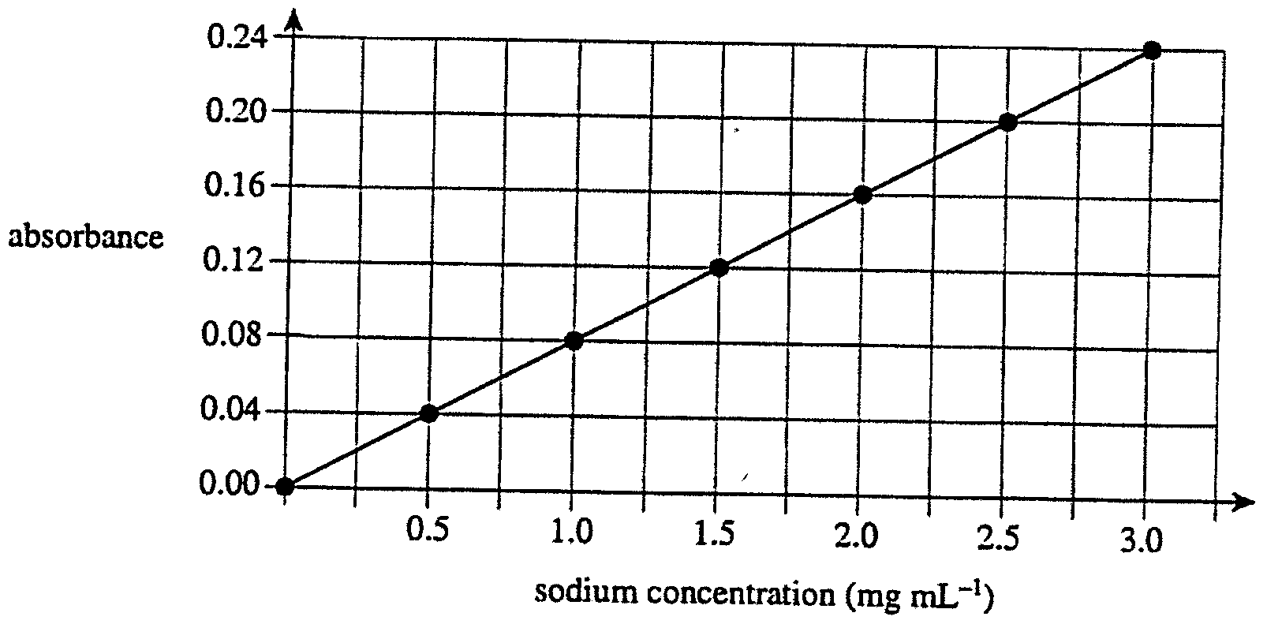
A 10.0 mL sauce sample was diluted to give a total volume of 50.0 mL. The absorbance of this diluted sample was found to be 0.14.
Based on the data provided, the concentration of sodium in the tomato sauce in mg mL⁻¹ is

- 0.35
- 0.70
- 1.8
- 8.8

Question 12
A second experiment was conducted using gravimetric analysis. A 1.00 mL sample of tomato sauce was diluted with deionised water to give a total volume of 10.0 mL. Excess AgNO₃ (aq) solution was added to precipitate the chloride ion according to the ionic equation:
Ag⁺ (aq)+ Cl⁻ (aq) → AgCl (s)
0.0740 g of Ag Cl precipitate was obtained.
{M(AgCl) = 143.4 g mol⁻¹, M(Na) = 23.0 g mol⁻¹}
Based on the data provided, the concentration of sodium in the tomato sauce in mg mL⁻¹ is

- 1.92
- 8.91
- 11.9
- 30.2

Question 13
Which of the following explanations could not account for the difference between the values found using the two methods of analysis?
- The precipitate obtained in the gravimetric analysis was not completely dried.
- In the gravimetric analysis, the sauce sample was diluted by a larger factor than in the atomic absorption analysis.
- The silver chloride precipitate was contaminated with traces of solid particles present in the sauce.
- In the gravimetric analysis, anions in addition to chloride precipitated from the sauce solution.

Question 14
Magnesium reacts vigorously with acid to produce the colourless, highly explosive hydrogen gas. The reaction between magnesium and hydrochloric acid may be represented by the equation:
Mg (s) + 2 HCl (aq) → Mg₂Cl (aq) + H₂ (g)
When this reaction is conducted in the laboratory, using a 1.05 g magnesium strip in excess acid, the volume of hydrogen gas produced at SLC would be

- 0.968 L
- 1.06 L
- 1.94 L
- 2.12 L

Question 15
When a solution of NaOH is left exposed to the air, its pH will slowly
- decrease because CO₂ is absorbed from the air and forms Na₂CO₃
- increase because CO₂ is absorbed from the air and forms Na₂CO₃
- decrease because some of the water evaporates
- increase because O₂ is absorbed from the air and to form the strong base Na₂O

Use the following information to answer Questions 16 and 17
Hydrogen and iodine react to form hydrogen iodide according tot eh equation shown below:
H₂ (g) + I₂ (g)  2 HI (g) K = 2.02 at 470°C
A 2.00 L equilibrium mixture at 470°C was found to contain iodine at a concentration of 0.234 M and hydrogen at a concentration of 0.143 M.

Question 16
The concentration of hydrogen iodide in the equilibrium mixture was

- 0.0169
- 0.0676
- 0.130
- 0.260

Question 17
The total pressure (in kPa) of the equilibrium mixture at 470°C was

- 1.61 × 10³
- 1.97 × 10³
- 2.49 × 10³
- 3.93 × 10³

Use the following information to answer Questions 18 and 19
To standardise a solution of HCl, a standard solution of 0.100 M Na₂CO₃ was prepared. A 20.00 mL aliquot of Na₂CO₃ was pipetted into a conical flask and a few drops of methyl orange indicator were added. The Na₂CO₃ aliquot was titrated with the HCl solution until the endpoint was reached. The procedure was repeated four times to obtain concordant results.

Question 18
All the glassware used during each titration was rinsed only with water and not dried. The effect of these rinsings on the calculated concentration of HCl would be that the calculated concentration
- would be higher than the actual concentration
- would be lower than the actual concentration
- would be equal to the actual concentration
- would be higher or lower than the actual concentration, depending on how much water remained in each piece of glassware

Question 19
The experiment was repeated, but this time the glassware used was correctly rinsed. During each of the repeated titrations, the endpoint was incorrectly taken to be when the solution turned red. The correct endpoint is the pink/orange colour that occurs before the red colour is reached. The effect of this error in endpoint determination would be that the calculated concentration of HCl
- would be higher than the actual concentration
- would be lower than the actual concentration
- would be equal to the actual concentration
- would be higher or lower than the actual concentration, depending on how red the solution had become at the endpoint

Use the following information to answer Question 20
The graph below shows the change in pH as 20.0 mL of 0.1 M NaOH is titrated with a HCl solution of concentration X M.
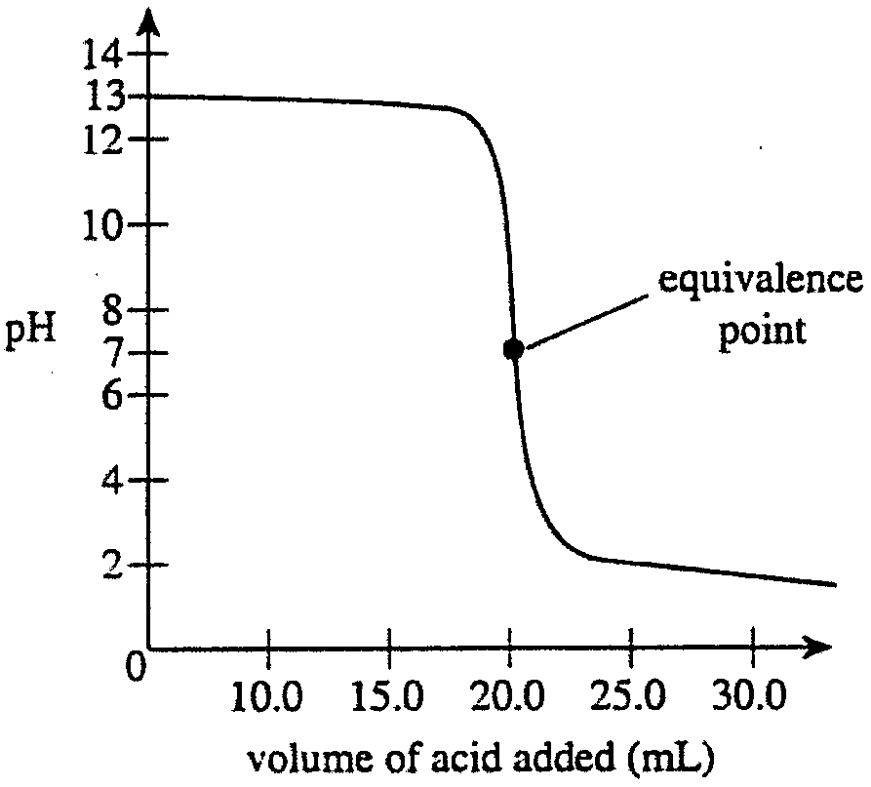

Question 20
Which of the graphs below shows the change in pH as 20.0 mL of 0.10 M NaOH is titrated with a CH₃COOH solution of concentration X M?
A. | 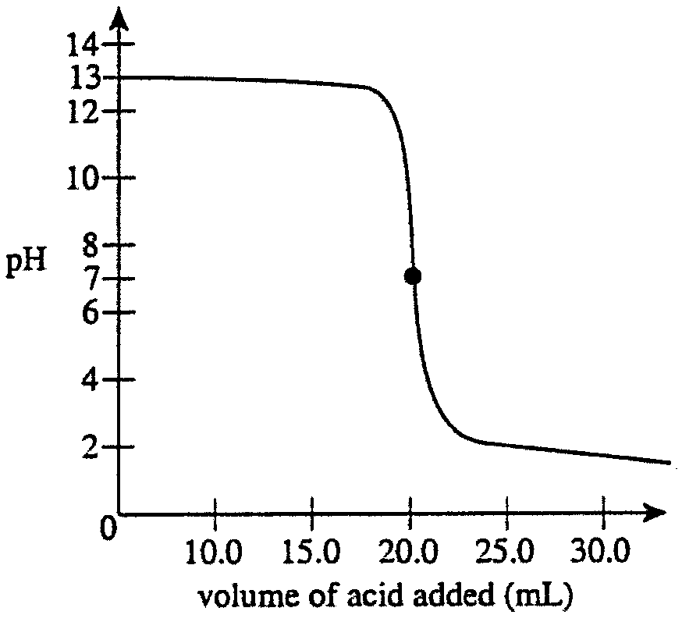 | C. | 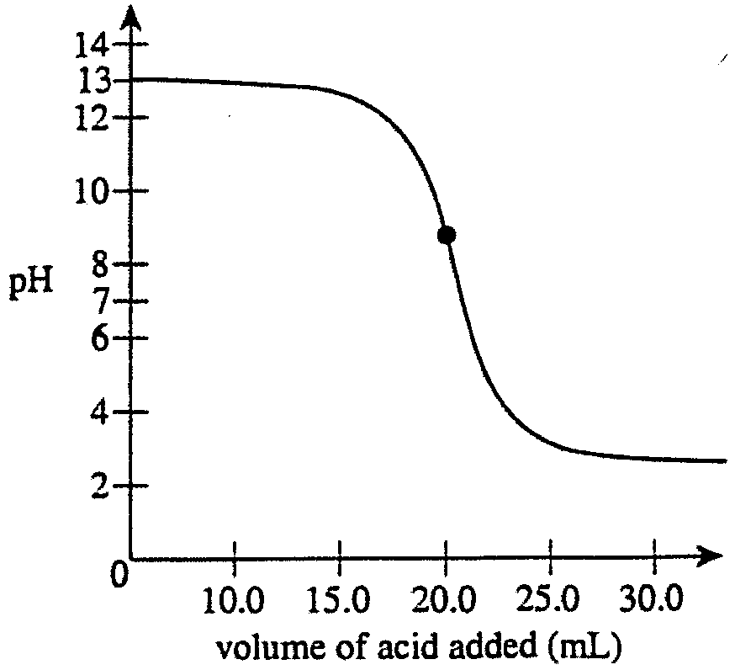
B. | 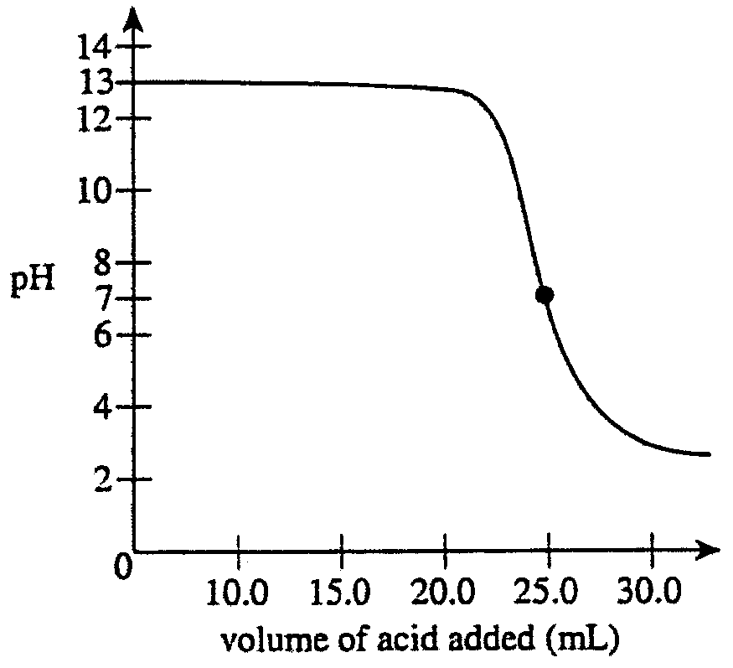 | D. | 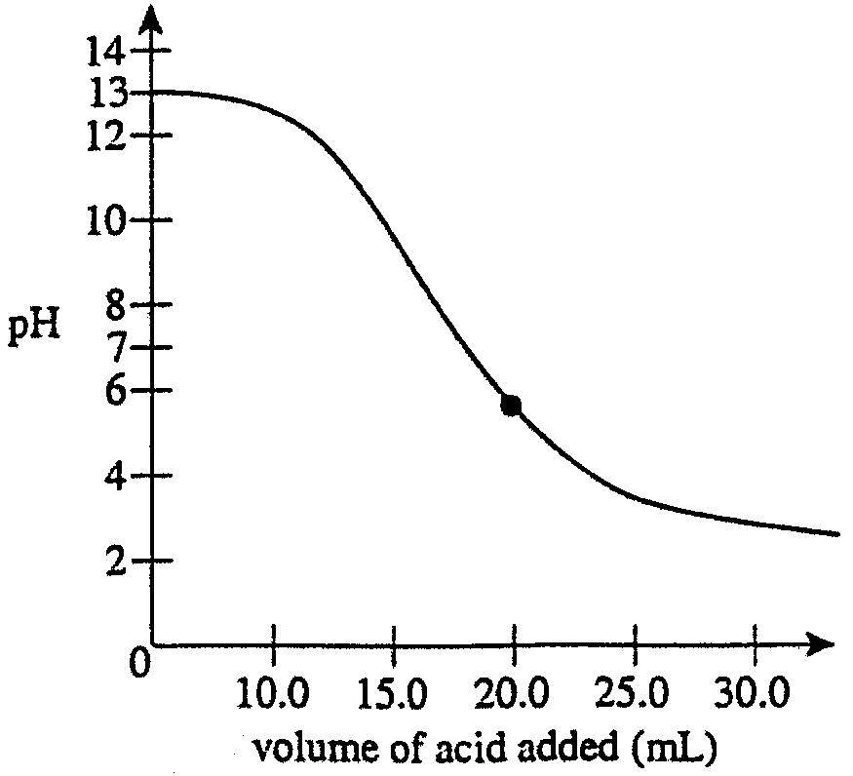

Section B – Short Answer Questions

Question 1
A mixture containing three components (A, B and C) was separated using gas-liquid chromatography (GLC). The data obtained is shown in the table below, where R_{t} represents the retention time for each component.

Component | Peak height (cm) | R_{t} (minutes)
A | 3.5 | 2.3
B | 5.1 | 4.2
C | 2.9 | 1.5

- Explain why the three components separate as they pass through the GLC column.
________________________________________________________________________________________________
________________________________________________________________________________________________
________________________________________________________________________________________________
________________________________________________________________________________________________
________________________________________________________________________________________________
________________________________________________________________________________________________
2 marks
- Using the grid below, draw a fully labelled chromatogram based on the data shown above.

3 marks
- If the three components were propanol, pentanol and butanol, which letter (A, B or C) would correspond to propanol? Explain your choice.
________________________________________________________________________________________________
________________________________________________________________________________________________
________________________________________________________________________________________________
________________________________________________________________________________________________
________________________________________________________________________________________________
________________________________________________________________________________________________
2 marks
Total 7 marks

Question 2
Acrylic acid (CH₂=CHCO₂H) is used as a starting material in the manufacture of many important plastics. It may undergo addition polymerisation to form a polymer.

- Draw a section of the polymer formed when acrylic acid is polymerised.

1 mark
- Acrylic acid is a weak acid that ionises in water according to the equation:
CH₂CHCO₂H (aq) + H₂O (l)  CH₂CHCO₂⁻ (aq) + H₃O⁺ (aq)
The ionisation constant, K_{a}, for acrylic acid is 5.6 × 10⁻⁵.
(i) Write an expression for K_{a} for acrylic acid.

(ii) Calculate the pH of a 0.10 M solution of acrylic acid.

1 + 2 = 3 marks
- A 20.0 mL solution of 0.10 M acrylic acid is diluted by the addition of 5.0 mL of water. Indicate by placing a tick in the appropriate column, what happens to each of the characteristics listed when this dilution takes place.

Characteristic | Effect of dilution: the characteristic
Characteristic | increases | decreases | is unchanged
pH
value of K_{a}
percent ionisation of CH₂CHCO₂H
3 marks
Total 7 marks

Question 3
Chemical treatment of swimming pool water uses the disinfectant hypochlorous acid, HOCl. The amount of HOCl in a pool is influenced by the pool’s pH. The graph below shows the variation in the amount of HOCl as the pH of the water increases.
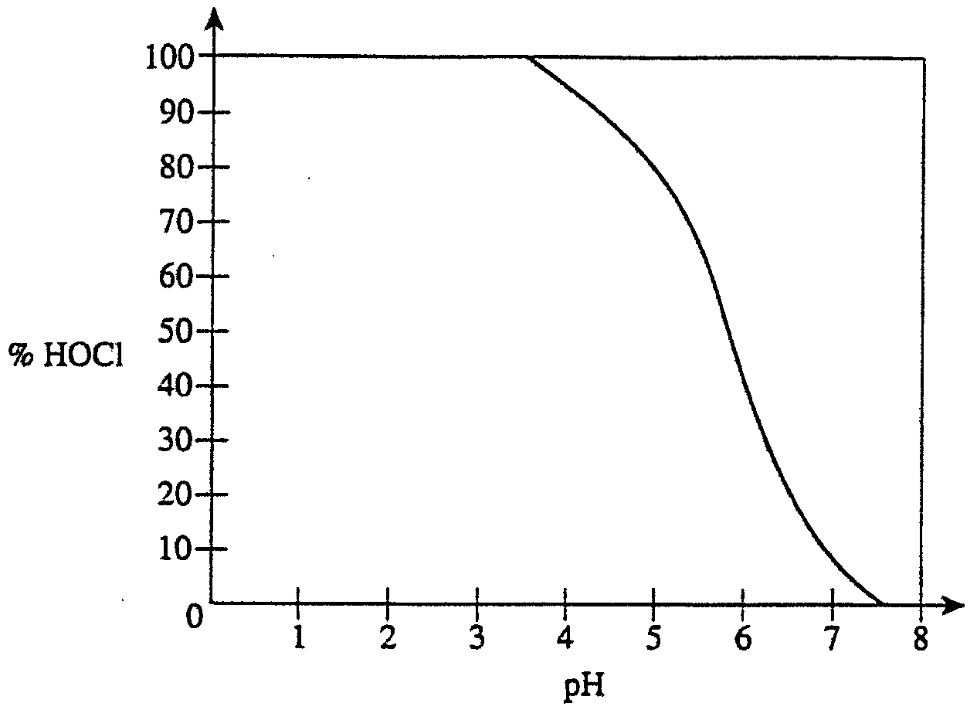
HOCl ionises in water according to the equilibrium equation:
HOCl (aq) + H₂O (l)  ClO⁻ (aq) + H₃O⁺ (aq)

While the HOCl molecule is a strong disinfectant, the ClO⁻ ion is not.

- State the oxidation number of chlorine in the ClO⁻ ion.
________________________________________________________________________________________________
1 mark
- i. Explain why the level of HOCl decreases as the pH of the water increases.
___________________________________________________________________________________________
___________________________________________________________________________________________
___________________________________________________________________________________________
___________________________________________________________________________________________
___________________________________________________________________________________________
___________________________________________________________________________________________
  - The data indicates that the most effective operation of HOCl as a disinfectant occurs when pool water is acidic. Suggest one reason why lowering the pool’s pH may be undesirable.
___________________________________________________________________________________________
___________________________________________________________________________________________
2 + 1 = 3 marks
- The hypochlorite ion, ClO⁻, also plays a role in bleaching agents. One bleach consists of a solution of sodium hypochlorite, NaOCl, in water. The concentration of NaOCl can be determined using volumetric analysis. Excess potassium iodide solution, KI, is added to a sample of the bleach.
Reaction occurs according to the equation:
OCl⁻ (aq) + 2 I⁻ (aq) + 2 H⁺ (aq) → Cl⁻ (aq) + I₂ (aq) + H₂O (l)
The iodine, I₂, liberated from this reaction, is then titrated with a standardised solution of sodium thiosulfate, Na₂S₂O₃, according to the equation:
2 S₂O₃²⁻ (aq) + I₂ (aq) → S₄O₆²⁻ (aq) + 2 I⁻ (aq)
Three 20.00 mL aliquots of bleach were transferred by pipette into three separate dry conical flasks. Excess KI was added to each sample. A standardised 0.400 M sodium thiosulfate solution was added slowly from a burette until an endpoint was reached. An average titre of 19.16 mL was obtained.
  - Calculate the amount (in mol) of thiosulfate used in the reaction.
___________________________________________________________________________________________
___________________________________________________________________________________________
  - Calculate the amount (in mol) of I₂ produced in the reaction with the hypochlorite ion.
___________________________________________________________________________________________
___________________________________________________________________________________________
  - Hence calculate the mass of sodium hypochlorite in the 20.00 mL sample.
___________________________________________________________________________________________
___________________________________________________________________________________________
___________________________________________________________________________________________
  - Find the concentration of sodium hypochlorite in the bleach in g L⁻¹.
___________________________________________________________________________________________
___________________________________________________________________________________________
1 + 1 + 2 + 1 = 5 marks
Total 9 marks

Question 4
This question refers to the graph below, which shows the variation of the boiling points of certain alkenes.
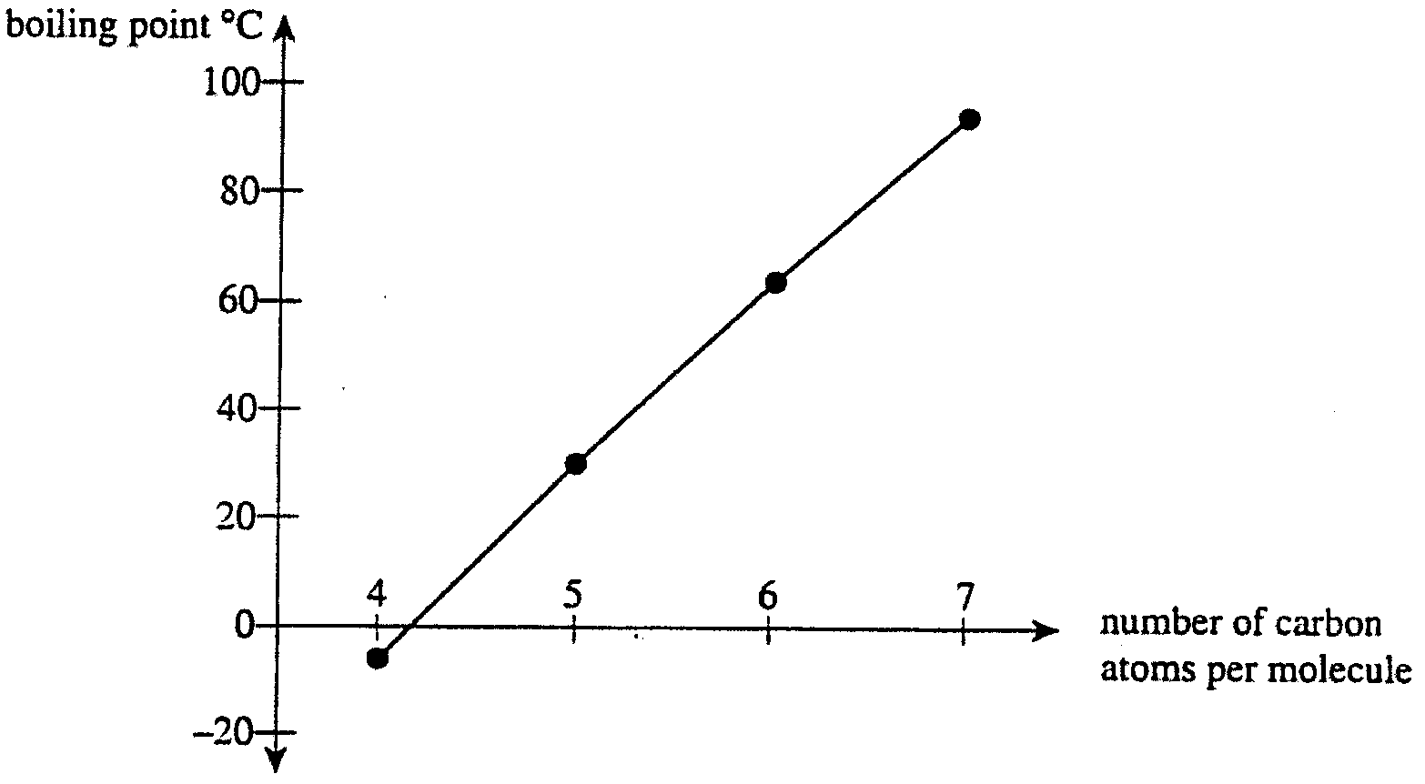

- Explain why the boiling point of the alkenes increases as the number of carbon atoms per molecule increases.
________________________________________________________________________________________________
________________________________________________________________________________________________
________________________________________________________________________________________________
1 mark
- Alkene Z has a boiling point around 65°c. Draw two possible structures for molecules of alkene Z.

2 marks
- Alkane X has the same number of carbon atoms per molecule as alkene Z.
- Give the molecular formula of alkane X.
___________________________________________________________________________________________
- Alkane X is subjected to a thermal cracking process. Which of the features listed below would occur during the thermal cracking of alkane X?

Feature | Tick in this column if the  feature occurs during cracking
Breaking of a C-C bond
Breaking of a C-H bond
Increase in the number of particles present
Pressure in reaction vessel decreases
Production of an alkene
1 + 2 = 3 marks
Total 6 marks

Question 5
World-wide demand for nitrogen containing fertilisers is high. Production of these fertilisers usually begins with the production of ammonia by the Haber process. The reaction for this process is represented by the equation:
N₂ (g) + 3 H₂ (g)  2 NH₃ (g)
The table below shows how the value of the equilibrium constant (K) varies with temperature for this reaction.

Temperature (°C) | K
350 | 0.0266
400 | 0.0129
450 | 0.00659
500 | 0.00381

- Based on the data provided, is the reaction to produce ammonia ‘exothermic’ or ‘endothermic’? Explain your choice.
________________________________________________________________________________________________
________________________________________________________________________________________________
________________________________________________________________________________________________
2 marks
- During the Haber process, nitrogen and hydrogen enter a reactor chamber in a 1:3 ratio. Within the reactor, a temperature of 450°C and a pressure of 250 atm are used. An Fe/Fe₃O₄ catalyst is used.
- Explain why high pressures are used in the reactor.
___________________________________________________________________________________________
___________________________________________________________________________________________
___________________________________________________________________________________________
___________________________________________________________________________________________
___________________________________________________________________________________________
- Both nitrogen and hydrogen are thoroughly purified before they enter the reactor chamber. Suggest a reason for this purification.
___________________________________________________________________________________________
___________________________________________________________________________________________
2 + 1 = 3 marks
Total 5 marks

Question 6
Consider the flow chart, which shows a reaction sequence involving some simple organic molecules.
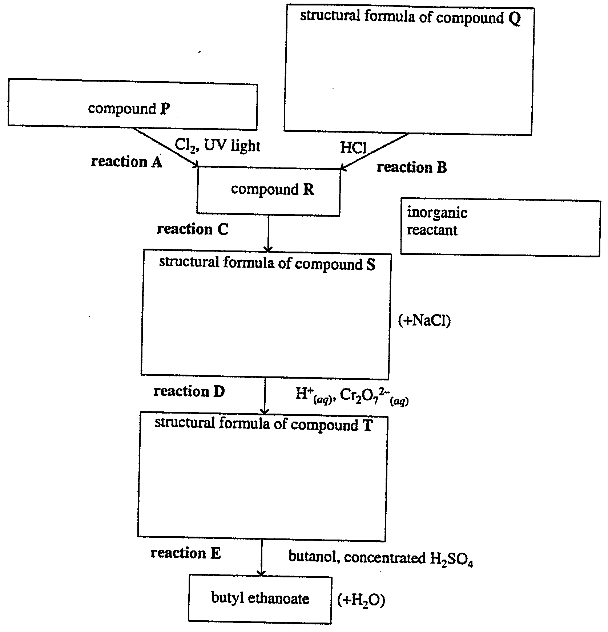

- In the boxes provided on the flow chart, draw the structural formula of each of the compounds Q, S and T.
3 marks
- In the box provided, give the chemical formula of the inorganic reactant required in reaction C.
1 mark
- Selecting from reactions A to E, in the box provide place the letter corresponding to

i. | an oxidation reaction
ii. | a substitution reaction
2 marks
Total 6 marks

END OF QUESTION AND ANSWER BOOKLET

