STAV
2005
CHEMISTRY
Unit 3 Exam

Section A – Multiple Choice

Question 1
A 30 g sample of metal M (molar mass = 60 g mol⁻¹) combines with 12 g of gaseous oxygen.
The formula of the oxide of M would be

- MO₂
- M₂O
- M₂O₃
- M₃O₂

Question 2
A mixture consisting of a number of components is separated by high performance liquid chromatography. The component in the mixture with the shortest retention time has
- a greater affinity for the mobile phase than the stationary phase
- a greater affinity for the stationary phase than the mobile phase
- the lowest concentration
- the greatest concentration

Question 3
Which of the following would NOT be a suitable mobile phase for gas chromatography?

- helium
- neon
- nitrogen
- oxygen

Question 4
Two substances are tested using paper chromatography. Under certain conditions, Substance A has an R_{f} value of 0.60 and Substance B has an R_{f} value of 0.65. In another experiment under the same conditions, the solvent front moves 9.5 cm. It is true to say that
- Substance A is more strongly absorbed and moves 6.2 cm from the origin
- Substance A is less strongly absorbed and moves 6.2 cm from the origin
- Substance B is more strongly absorbed and moves 6.2 cm from the origin
- Substance B is less strongly absorbed and moves 6.2 cm from the origin

Question 5
Airbags contain a mixture of sodium azide, NaN₃, potassium nitrate and silicon dioxide. The initial reaction process releases nitrogen gas according to the equation:
10 NaN₃ (s) + 2 KNO₃ (s) → 16 N₂ (g) + K₂O (s) + 5 Na₂O (s)
If 24.9 g of NaN₃ (molar mass = 65.0 g mol⁻¹) was reacted with 10.3 g of KNO₃ (molar mass = 101.1 g mol⁻¹) the volume of N₂ released at SLC would be

- 13.7 L
- 15.0 L
- 20.0 L
- 24.5 L

Question 6
Washing soda crystals have the formula Na₂CO₃.10H₂O. A sample of hard water has a concentration of calcium ions of 1.00 × 10⁻³ M. The minimum mass of washing soda crystals needed to precipitate the calcium ions in 10.0 L of water is

- 0.142 g
- 0.286 g
- 1.42 g
- 2.86 g

Question 7
The following equation represents a redox equation.
2 NaBr (aq) + H₂O₂ (aq) + H₂SO₄ (aq) → Na₂SO₄ (aq) + Br₂ (aq) + 2 H₂O (l)
The atoms undergoing reduction belong to the element

- oxygen
- hydrogen
- sulphur
- bromine

Question 8
To determine the percentage of titanium in a given mass of titanium ore by the technique of gravimetric analysis, it would be necessary to
- use an indicator to determine the end point
- first prepare a solution which contains the titanium component of the ore sample
- select a solvent for use as the mobile phase in which the titanium compound will dissolve
- prepare a range of solutions of known concentration of the titanium compound

Question 9
In which of the following equilibria would increasing the volume at the same time as adding hydrogen definitely result in the reaction moving in a forward direction?

- 2 HI (g)  H₂ (g) + I₂ (g)
- N₂ (g) + 3 H₂ (g)  2 NH₃ (g)
- H₂ (g) + CO₂ (g)  H₂O (g) + CO (g)
- 2 H₂O (g)  2 H₂ (g) + O₂ (g)

Question 10
The equilibrium constants for the two reactions given below involving NO are indicated as K₁ and K₂ respectively.
N₂ (g) + O₂ (g)  2 NO (g): K₁ and 2 NO (g) + O₂ (g)  2 NO₂ (g): K₂
The equilibrium constant for the reaction given by the equation:
N₂ (g) + 2 O₂ (g)  2 NO₂ (g) is

- K₁ + K₂
- K₁ – K₂
- K₁ × K₂
- K₁ ÷ K₂

Questions 11, 12 and 13 refer to the following information.
An analyst is required to find the concentration of ethanoic acid in vinegar. A 25.0 mL sample of the vinegar is diluted with distilled water and made up to 250.0 mL in a volumetric flask.
Several 20.00 mL aliquots of the diluted vinegar solution were titrated with freshly standardised 0.0500 M NaOH solution using a suitable indicator. An average titre of 19.50 mL was obtained.

Question 11
Which one of the following graphs represents the change in pH during the titration?
A. | 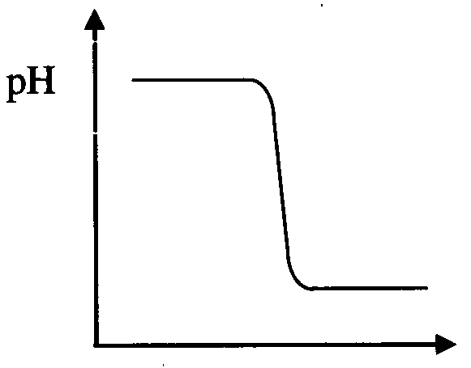 | C. | 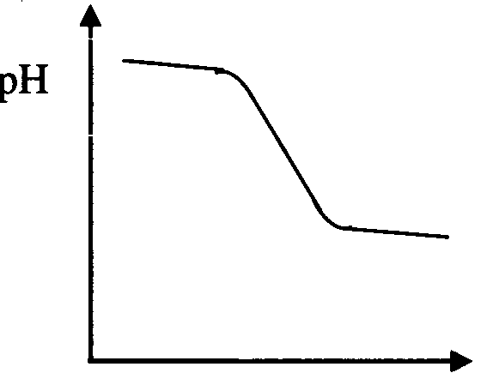
B. | 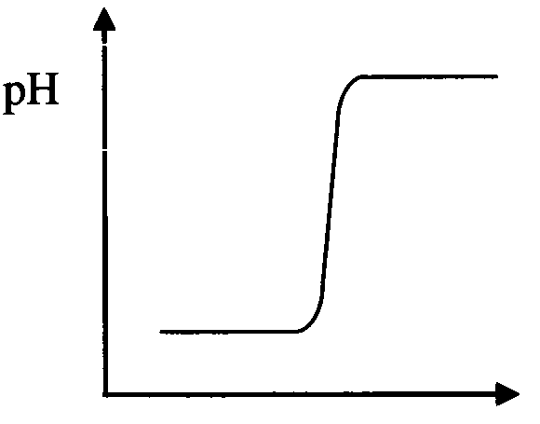 | D. | 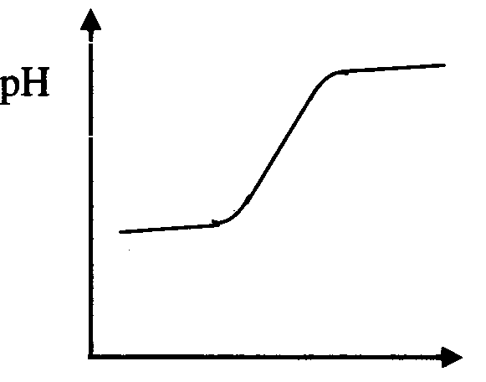

Question 12
The concentration of the ethanoic acid in the undiluted vinegar was

- 0.0244 M
- 0.244 M
- 0.488 M
- 0.828 M

Question 13
If the volumetric flask was rinsed with distilled water prior to the addition of the vinegar, the calculated concentration of the ethanoic acid would be

- increased
- decreased
- unchanged
- unable to be determined without further information

Question 14
In the chlorination of methane the initial step involves the dissociation of the chlorine molecules in UV light.
Cl₂ (g)  2 Cl (g)
The concentrations at equilibrium are:
[Cl₂] = 5.0 × 10⁻² mol L⁻¹
[Cl] = 2.0 × 10⁻⁴ mol L⁻¹
The numerical value for the equilibrium constant is

- 8.0 × 10⁻⁷
- 1.0 × 10⁻⁵
- 8.0 × 10⁻³
- 1.3 × 10⁶

Question 15
Given the following equation for the hydrolysis of oxalic acid,
H₂C₂O₄ (aq) + H₂O (l)  H₃O⁺ (aq) + HC₂O₄⁻ (aq): K_{a}(298 K) = 6.4 × 10⁻⁵
A 1.0 M aqueous solution of H₂C₂O₄ was prepared at 25°C. The concentration of the species shown in the equation, from highest to lowest, is

- H₂O (l), H₂C₂O₄ (aq), H₃O⁺ (aq), HC₂O₄⁻ (aq)
- H₂C₂O₄ (aq), H₃O⁺ (aq), HC₂O₄⁻ (aq), H₂O (l)
- H₃O⁺ (aq), HC₂O₄⁻ (aq),H₂C₂O₄ (aq), H₂O (l)
- HC₂O₄⁻ (aq), H₂O (l), H₂C₂O₄ (aq), H₃O⁺ (aq)

Question 16
The K_{a} value for ethanoic acid is 1.8 × 10⁻⁵ at 25°C. The pH of a 0.10 M solution of ethanoic acid is approximately

- 11.1
- 2.9
- 1.0 × 10⁻¹
- 1.3 × 10⁻³

Question 17
The graph below shows how the percentage, by mass, of a substance X in an equilibrium mixture varies with pressure at temperatures of 300 K and 500 K.
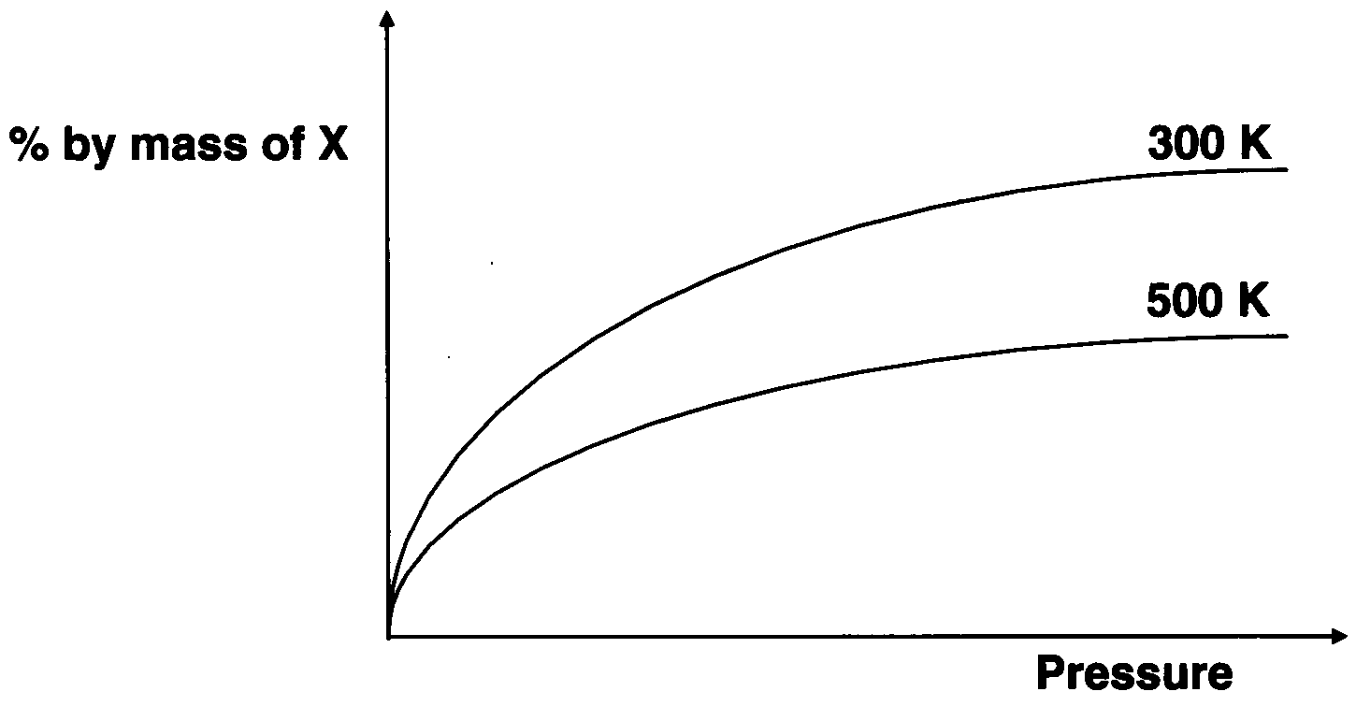
In which one of the following equilibria could the underlined species by substance X?
- N₂ (g) + O₂ (g)  2 NO (g); ΔH = +176 kJ mol⁻¹
- 4 NH₃ (g) + 5 O₂ (g)  4 NO (g) + 6 H₂O (l); ΔH = –9 07 kJ mol⁻¹
- N₂O₄ (g)  2 NO₂ (g); ΔH = +58 kJ mol⁻¹
- N₂ (g) + 3 H₂ (g)  2 NH₃ (g); ΔH = –92 kJ mol⁻¹

Question 18
Which one of the following would NOT affect the rate of a given chemical reaction?

- the magnitude of the equilibria constant
- the size of solid reactant particles
- the reaction temperature
- the concentration of the reactants

Question 19
When Cl₂ (g) is mixed with a large excess of 2-butene in the dark, the major organic produce is

- ClCH₂CH₂CH₂CH₂Cl
- CHCH₂CH₂CH₂Cl
- CH₃CHClCHClCH₃
- CH₂ClCHClCH₂CH₃

Questions 20 and 21 refer to the following information.
Ethene can be produced from decane by catalytic cracking. A sample of gaseous decane was cracked in the presence of zeolite and allowed to reach equilibrium.

Question 20
A possible reaction for the production of ethene from decane is

- C₁₀H₂₀  C₂H₄ + C₈H₁₆
- C₁₀H₂₂  C₂H₄ + C₈H₁₈
- C₁₀H₂₄  C₂H₆ + C₈H₁₈
- C₁₀H₂₂  C₂H₆ + C₈H₁₆

Question 21
The equilibrium yield of ethene and the rate of reaction would be increased by
- decreasing the volume of the reaction vessel at constant temperature
- increasing the volume of the reaction vessel at constant temperature
- decreasing the volume of the reaction vessel at constant pressure
- increasing the volume of the reaction vessel at constant pressure

Question 22
The number of unbranched structural isomers with the chemical formula C₇H₁₅Cl is

- 1
- 4
- 6
- 7

Section B – Short Answer Questions

Question 1
In microanalysis a weighed sample of a pure compound, such as an alcohol, is burnt in oxygen.
A diagram of the equipment is shown below.
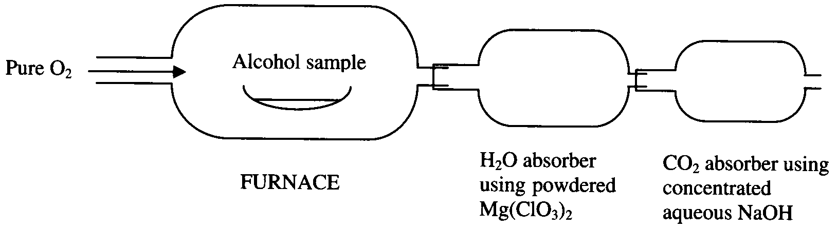
A 6.12 mg sample of an alcohol was combusted and the following results were obtained:
- increase in mass of CO₂ absorber: 13.5 mg
- increase in mss of H₂O absorber: 7.34 mg

- (i) Determine the amount, in mol, of carbon in the alcohol.

(ii) Determine the amount, in mol, of hydrogen in the alcohol.

(iii) Determine the mass, and hence the amount, in mol, of oxygen in the alcohol.

- Determine the empirical formula of the alcohol.

- The molar mass of the alcohol is 60.0 g mol⁻¹. Determine the molecular formula of the alcohol.

- Write the equation for the reaction between the CO₂ and the NaOH in the second absorber.
________________________________________________________________________________________________
- In another experiment a different liquid alcohol was combusted. The formula of this alcohol was determined to be C₅H₁₁OH.
(i) Write the equation for the combustion reaction of the alcohol, C₅H₁₁OH, in the furnace.
____________________________________________________________________________________________
(ii) Draw a possible structural formula for the liquid alcohol, C₅H₁₁OH, AND state the name corresponding to your structure

(7 + 2 + 1 + 1 + [1 + 2] = 14 marks)
Suggested time: 18 minutes

Question 2
A sample of blood from a cotton farmer was analysed for the possibility of the presence of the metabolic products of pentachlorophenol, a compound used as a pesticide. The processed blood sample was passed through a high performance liquid chromatograph, HPLC, and a series of peaks was obtained in the resulting chromatogram.
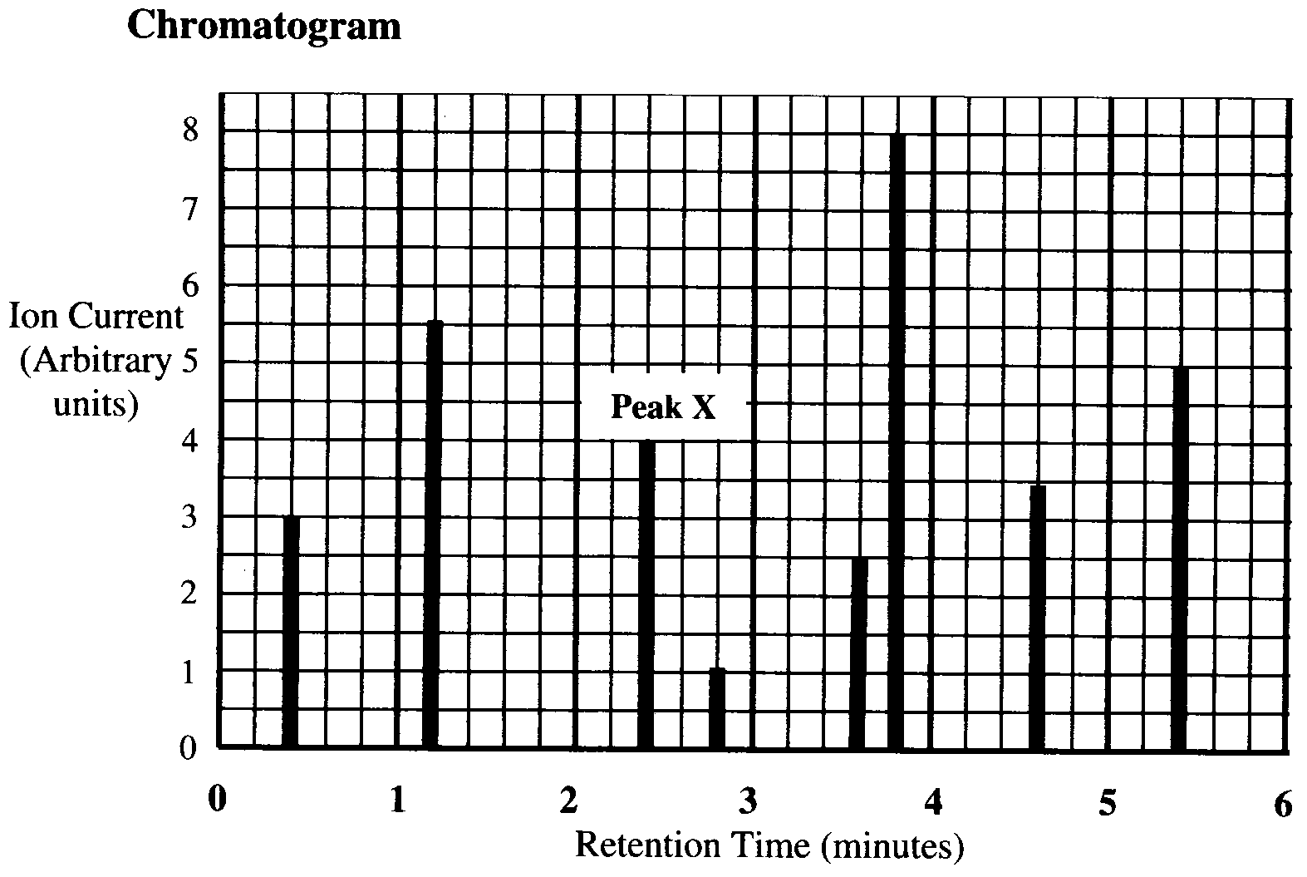
All of the peaks obtained correspond to known organic components found in blood except for peak X. This corresponds to a suspected metabolic product of pentachlorophenol.

- Explain the term retention time as applied to HPLC.
________________________________________________________________________________________________
________________________________________________________________________________________________
________________________________________________________________________________________________
- In terms of the mechanism of chromatography, briefly explain why different organic components have different retention times in the column.
________________________________________________________________________________________________
________________________________________________________________________________________________
________________________________________________________________________________________________
________________________________________________________________________________________________
________________________________________________________________________________________________
________________________________________________________________________________________________
- A solution of pure sample of the metabolic product of pentachlorophenol was prepared. This solution had a concentration of 0.010 mg L⁻¹. It was then injected into the same HPLC under identical conditions which produced the original chromatogram.
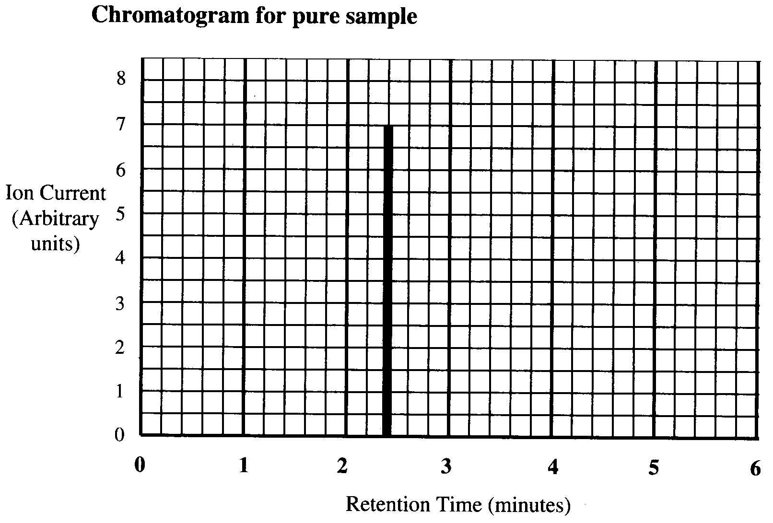
(i) Explain how the second chromatogram confirms that the peak X is most likely due to the metabolic product of pentachlorophenol in the farmer’s blood.
____________________________________________________________________________________________
____________________________________________________________________________________________
____________________________________________________________________________________________
(ii) Calculate the concentration of the metabolic produce of pentachlorophenol that is present in the blood of the farmer in mg L⁻¹. Show your working.
____________________________________________________________________________________________
____________________________________________________________________________________________
____________________________________________________________________________________________
____________________________________________________________________________________________
____________________________________________________________________________________________
(1 + 2 + [1 + 1] = 5 marks)
Suggested time: 6 minutes

Question 3
The reaction between marble chips (calcium carbonate) and hydrochloric acid can be sued to study the factors that affect the rate of a reaction.

- Write a balanced equation for the reaction.
________________________________________________________________________________________________
- During the reaction, a gas escapes from the reacting mixture so there is a decrease in the overall mass. In experiment I, thirty small marble chips, with a total mass of 10 g, reacted with 100 mL of dilute hydrochloric acid. In experiment II, six large marble chips, with a total mass of 10 g, reacted with the same amount of hydrochloric acid. In both cases the acid is in excess.
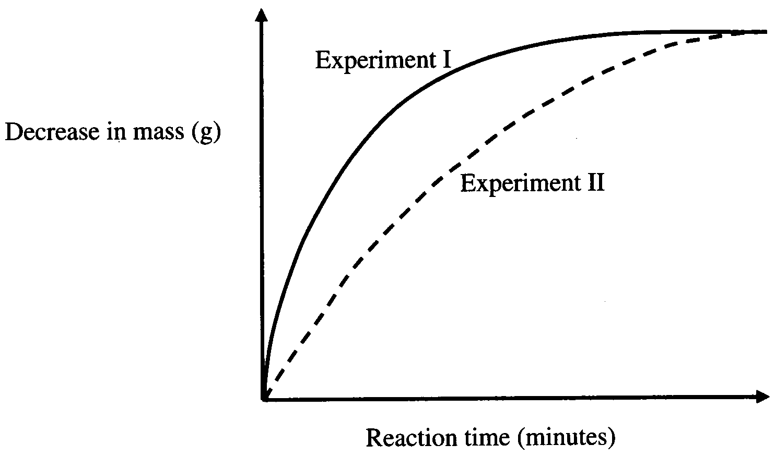
  - Why is the overall decrease in mass the same in both experiments?
___________________________________________________________________________________________
___________________________________________________________________________________________
  - Why do the graphs become flat after a period of time?
___________________________________________________________________________________________
___________________________________________________________________________________________
  - Which experiment begins at a faster rate?
___________________________________________________________________________________________
  - Why is the reaction rate different in the two experiments?
___________________________________________________________________________________________
___________________________________________________________________________________________
(1 + [1 + 1 + 1 + 2] = 6 marks)
Suggested time: 8 minutes
Question 4
Crude oil can be used to make a wide range of organic compounds. The following chart shows a sequence of physical and chemical processes that can be used to make several important organic compounds.

Complete the chart by
- naming Process A and Process B
- naming Compound (i), Compound (ii) and Compound (iii).
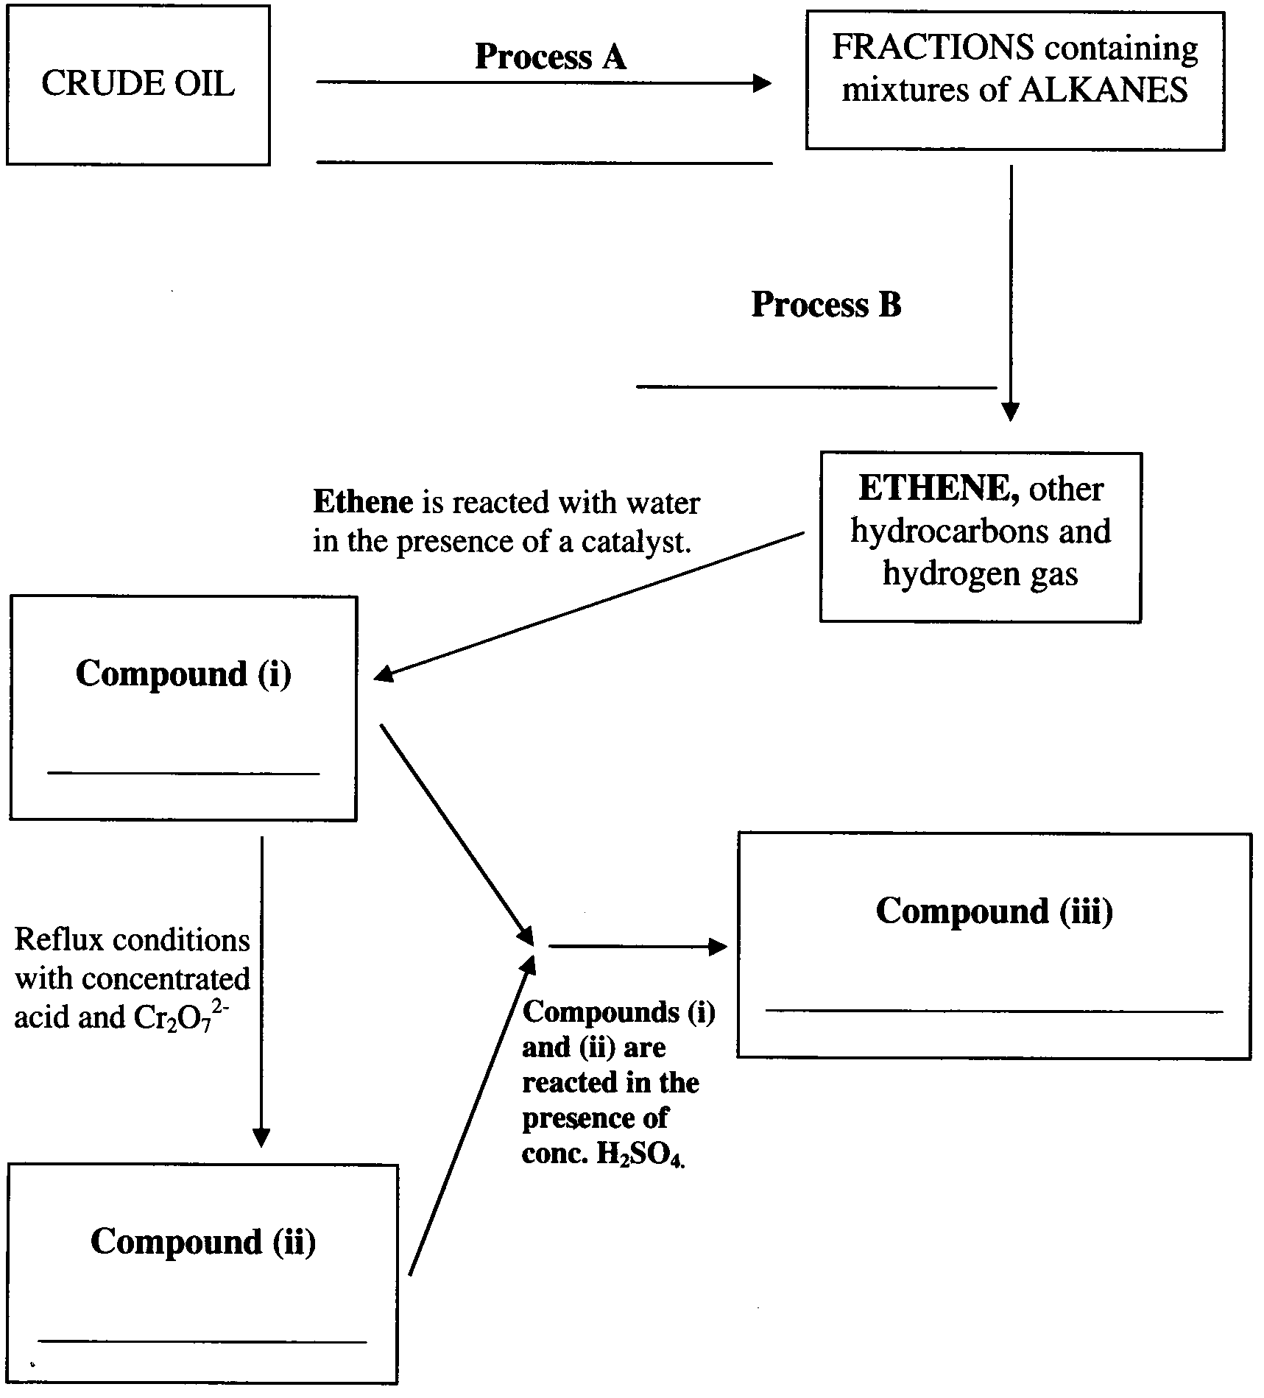
5 × 1 = 5 marks
Suggested time: 6 minutes

Question 5
Before galvanising steel, a layer of iron oxides must be removed. This is typically done using sulfuric acid.

- Write a chemical equation for the reaction of sulfuric acid with iron (III) oxide.
________________________________________________________________________________________________
- State whether the sulfuric acid is acting as an oxidant, an acid or a dehydrating agent in this reaction, and explain your choice.
________________________________________________________________________________________________
________________________________________________________________________________________________
________________________________________________________________________________________________
________________________________________________________________________________________________
________________________________________________________________________________________________
- The following table lists several compounds and ions.

SO₄²⁻ | SO₂ | SO₃
HSO₄⁻ | H₂SO₄ | H₂S₂O₇
Na₂CO₃ | NaOH | NaCl
C₁₈H₃₈ | C₆H₁₂O₆ | CO₂

A substance from the table above may be used more than once to answer the following questions.
Write the chemical formula for the substance that
- is known as oleum ________________________
- is the conjugate base of sulfuric acid ________________________
- could be dehydrated by concentrated sulfuric acid ________________________
- contains sulfur in a +4 oxidation state ________________________
- would be neutralized by sulfuric acid to forma salt and water only ________________________
- could be a produce of the reduction of sulfuric acid ________________________
(1 + 2 + 6 = 9 marks)
Suggested time: 12 minutes

Question 6
Lactic acid, CH₃CH(OH)COOH, is a waste produce that accumulates in muscle tissue during exertion, leading to the feelings of fatigue and pain. A 0.0900 M aqueous solution of lactic acid at 25°C is 3.7% ionised.

- Show the structural formula for lactic acid and clearly circle AND name ALL the functional groups on the diagram of the lactic acid molecule.

- Write the equation for the reaction of lactic acid and water.
________________________________________________________________________________________________
- Write a general expression for th acidity constant, K_{a}, of lactic acid in water.

- Calculate the K_{a} for this acid.

- Some people administer sodium hydrogen carbonate in a ‘milkshake’ to racing animals. The hydrogen carbonate ion lessens the build up of lactic acid in the animal’s muscles, sustaining performance. The level of the sodium ion in a horse’s blood can be used to indicate that it has been given a ‘milkshake’ prior to racing.
Which analytical instrument would give the most accurate reading of the level of sodium ions in the horse’s blood?
________________________________________________________________________________________________
(3 + 1 + 1 + 3 + 1 = 9 marks)
Suggested time: 12 minutes

END OF QUESTION AND ANSWER BOOKLET

