IARTV
2006
CHEMISTRY
Unit 3 Exam

Section A – Multiple Choice

Question 1
The conjugate acid of HPO₄^{2–} is
- H₂PO₄–
- H₃PO₄
- PO₄^{3–}
- H₂PO₄^{2–}

Question 2
1.0 mol of HNO₃ was added to water at 25°C and the solution diluted until its volume was exactly 5.0 L.
What was the resulting change of the pH of the water?
- 0.70
- 6.3
- 7.0
- 7.7

Question 3
When 0.250 mol of propanol, C₃H₇OH, reacts completely with oxygen, the volume of carbon dioxide formed at STP is
- 0.600 L
- 5.36 L
- 6.80 L
- 16.8 L

Question 4
2 MnO₄– (aq) + 3 S^{2–} (aq) + 8 H⁺ (aq) → 2 MnO₂ (s) + 3 S (s) + 4 H₂O (l)
The atoms whose oxidation numbers change in the above equation are
- Mn, S, O and H
- Mn, S and O
- Mn and S
- Mn

Question 5
25.00 mL of 0.140 M Ba(OH)₂ solution was mixed with 30.00 mL of 0.102 M H₂SO₄ solution. The resulting precipitate was filtered, dried and weighed. The expected mass of precipitate should have been
- 3.06 × 10^{–3} g
- 3.50 × 10^{–3} g
- 0.714 g
- 0.817 g

Question 6
If 0.562 g of MgCO₃ reacted completely with dilute nitric acid what will be the volume of CO₂ produced if the gas was collected at 22.0°C and 102310 Pa?
- 13.4 L
- 160 mL
- 13.4 mL
- 11.9 mL

Question 7
A food chemist wishes to determine the type of starch in a sample of custard powder. The instrument best suited to this type of analysis is
- an atomic absorption spectrometer
- an UV-visible spectrophotometer
- a gas chromatograph
- a high performance liquid chromatograph

Question 8
4.65 g of metal X formed an oxide with an empirical formula of XO₃ and a mass of 8.94 g. What is the relative atomic mass of the metal X?
- 55.9
- 52.0
- 27.0
- 10.8

Question 9
Lactic acid, CH₃CH(OH)COOH, is a weak acid that is slightly ionised in aqueous solution according to the equation
CH₃CH(OH)COOH (aq) + H₂O (l)  H₃O⁺ (aq) + CH₃CH(OH)COO– (aq)
If solid sodium hydroxide is added to an aqueous solution of lactic acid the
- [CH₃CH(OH)COO–] will increase
- [H₃O⁺] will increase
- [CH₃CH(OH)COOH] will increase
- [OH–] will decrease

Question 10
When nitrogen gas reacts with oxygen gas at high temperatures, an equilibrium constant of 1.47 at 2400 K is obtained. At 1900 K the equilibrium constant is 1.28.
N₂ (g) + O₂ (g)  2 NO (g)
This would indicate that the reaction is
- fast
- slow
- exothermic
- endothermic

Question 11
The self-ionisation of pure water (K_{w}) with a value of 1.0 × 10^{–14} M² at 25°C can be written as
2 H₂O (l)  H₃O⁺ (aq) + OH– (aq) ΔH = +57 kJ mol^{–1}
The pH of pure water at 20°C would be closest to
- 6.9
- 7.0
- 7.1
- 14.0

Question 12
Ammonia gas can be reacted with oxygen to produce nitrogen monoxide and water according to the equation
4 NH₃ (g) + 5 O₂ (g)  4NO (g) + 6 H₂O (g)
A decrease in pressure at constant temperature causes the equilibrium to move
- to the right and a rate increase
- to the left and a rate increase
- to the right and a rate decrease
- to the left and a rate decrease

Question 13
Nitrogen dioxide decomposes at high temperatures according to the equation
2 NO₂ (g)  2 NO (g) + O₂ (g) K = 0.012 M at 700°C
The value of K for the reaction NO (g) + ½ O₂ (g)  NO₂ (g) is
- 0.11
- 9.1
- 83
- –0.012

Question 14
An important use of sulfuric acid is for the manufacture of superphosphate according to the equation
Ca₃(PO₄)₂ (s) + 2 H₂SO₄ (aq) + 4 H₂O (l) → Ca₂(PO₄)₂ (s) + 2 CaSO₄.2H₂O (s)
In this reaction sulfuric acid is acting as
- a dehydrating agent
- an oxidant
- a reductant
- an acid

Question 15
In the Contact process, the yield of the conversion of SO₂ into SO₃ is increased by
- operating at high pressure
- use of closely packed porous pellets of vanadium(V) oxide
- operating at high temperature
- using a higher ratio of air

Question 16
Concentrated sulfuric acid is used to dry many gases. It cannot, however, be used to dry
- ammonia
- carbon dioxide
- sulfur dioxide
- oxygen

Question 17
In a classroom experiment to determine which fruit produces the most ethene gas, the fruit was placed in sealed bags and the gases produced were collected. The best method of detecting ethene gas is by
- bubbling the gas through bromine water
- dissolving the gas in water and checking the pH
- reacting the gas with ethanoic acid and checking for a fruity smell
- checking the gas with a burning taper

Question 18
The compound | 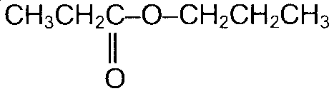 | is named
- propyl propanoate
- ethyl butanoate
- propyl ethanoate
- ethyl propanoate

Question 19
Two different monomers were used to produce this polymer.
– CH₂–CHBr– CHCl–CHBr– CH₂–CHBr– CHCl–CHBr–
The two monomers are
- 1-bromo-2-chloroethene and 1-bromoethane
- 1-bromo-2-chloroethene and 1-bromoethene
- 1-bromo-2-chloroethene and 1-chloroethene
- 1,3-dibromo-2-chloropropene and 1-bromoethene

Question 20
The structural formula of the alcohol formed by hydrolysis of CH₃CH₂CH₂COOCH(CH₃)₂ is
A. | 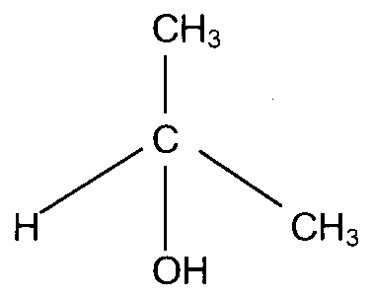 | C. | 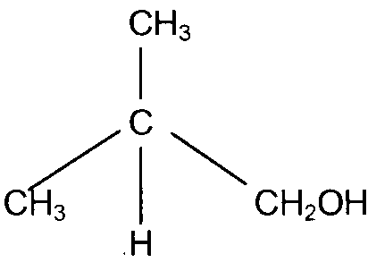
B. | 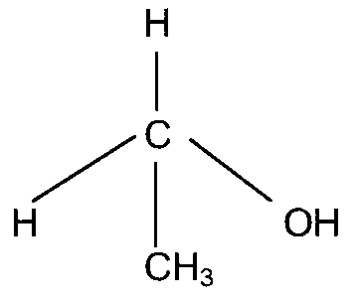 | D. | 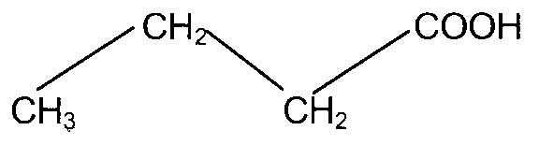

Section B – Short Answer Questions

Question 1
A sample of the drain cleaner Grease-Buster is to be analysed for its sodium hydroxide content. Firstly the approximately 0.1 M hydrochloric acid must be standardised with a primary standard.

- Primary standards have several characteristics. Name two of them.
________________________________________________________________________________________________
________________________________________________________________________________________________
1 mark
- Suggest a suitable primary standard that could be used to standardise the HCl.
________________________________________________________________________________________________
1 mark
- Write an equation for the reaction between HCl and the primary standard that you have chosen.
________________________________________________________________________________________________
1 mark
- What would be a suitable indicator for this standardisation?
________________________________________________________________________________________________
1 mark
- Assume that you want to prepare a 250.0 mL solution of the primary standard of 0.0500 M concentration. Calculate the mass of the primary standard needed and describe the steps that you would take.
________________________________________________________________________________________________
________________________________________________________________________________________________
________________________________________________________________________________________________
________________________________________________________________________________________________
________________________________________________________________________________________________
________________________________________________________________________________________________
3 mark

After standardisation, the concentration of the HCl was found to be 0.117 M. A mass of 7.71 g of Grease-Buster was weighed into a standard flask and made up to 250.0 mL with deionised water.
Aliquots of 20.00 mL of the diluted solution were titrated with the standardised HCl and the average titre was found to be 21.10 mL.

- Calculate the amount in moles of HCl used.

1 mark
- Calculate the amount in moles of NaOH in the original sample.

1 mark
- Calculate the concentration of NaOH in Grease-Buster in %(w/w)

1 mark
Total 10 marks

Question 2
A gas chromatograph was used to analyse the main components in a sample of imported whisky. Four components were identified namely ethanol and smaller amounts of 2-methylbutan-1-ol, propan-1-ol and butan-1-ol.

- Which of the alcohols would you expect to emerge from the chromatograph first and which last?
________________________________________________________________________________________________
1 mark
- Draw the structural formulae of the two alcohols you have identified in part a.

2 marks
- How might a calibration curve for ethanol be constructed?
________________________________________________________________________________________________
________________________________________________________________________________________________
________________________________________________________________________________________________
________________________________________________________________________________________________
________________________________________________________________________________________________
________________________________________________________________________________________________
2 marks
- Why must the coil be heated?
________________________________________________________________________________________________
1 mark
- What is the mobile phase used in this process?
________________________________________________________________________________________________
1 mark
- Explain why analysis of hexann-1-ol is possible in a gas chromatograph but no glucose and yet both are organic molecules containing 6 carbon atoms.
________________________________________________________________________________________________
________________________________________________________________________________________________
________________________________________________________________________________________________
________________________________________________________________________________________________
________________________________________________________________________________________________
2 marks
- How could hexan-1-ol be identified using a gas chromatograph?
________________________________________________________________________________________________
________________________________________________________________________________________________
________________________________________________________________________________________________
________________________________________________________________________________________________
1 mark
Total 10 marks

Question 3
A solution was prepared by dissolving 7.89 g of iron(II) sulfate in 100.0 mL of deionised water in a volumetric flask. This solution was left to stand open to the air for some time. The solution changed colour from pale green to orange. This indicated that some of the Fe(II) ions had oxidised to form Fe(III) ions.

To determine the amount of Fe(II) ions remaining, a technician performed the following volumetric analysis.

25.00 mL aliquots of the solution were taken from the 100.0 mL volumetric flask then titrated with acidified 0.150 M potassium dichromate solution. An average titre of 13.55 mL was required to reach the endpoint.

- Complete the half equations and write a balanced overall redox equation
 |  |  |  | Fe²⁺ (aq) | → | Fe³⁺ (aq) | + | e–
Cr₂O₇^{2–} (aq) | + | H⁺ (aq) | + | e– | → | Cr³⁺ (aq) | + | H₂O (l)
__________________________________________________→____________________________________________
3 marks
- Calculate the amount in moles of dichromate ions that reacted with the Fe²⁺ (aq) solution.

1 mark
- Calculate the amount in moles of Fe²⁺ (aq) ions present in the aliquot.

1 mark
- Calculate the mass of Fe²⁺ (aq) remaining unoxidised that was present in the original 100.0 mL volumetric flask.

1 mark
- Compare the experimental percentage mass of Fe²⁺ (aq) that was unoxidised in the 100.0 mL volumetric flask with the expected percentage mass of iron in the original sample.

2 marks
Total 8 marks

Question 4
‘Town gas’ can be prepared by the reaction of methane and water with a suitable catalyst according to the equation
CH₄ (g) + H₂O (g)  CO (g) + 3 H₂ (g) ΔH = +206 kJ mol^{–1}

- Write an equation for the equilibrium constant, K, for this reaction.

1 mark
- At 250°C the equilibrium constant, K, has a vlue of 8.6 M². For a particular reaction mixture, at this temperature, in a container of volume 2.00 L, the amounts of each gas were found to be
n(CH₄) = 3.2 × 10^{–3} mol, n(H₂O) = 2.5 × 10^{–3} mol, n(CO) = 1.4 × 10^{–3} mol, n(H₂) = 4.6 × 10^{–3} mol
Show, using these numbers, that the reaction is not at equilibrium.

________________________________________________________________________________________________
________________________________________________________________________________________________
________________________________________________________________________________________________
3 marks
- In what direction must the system move to establish equilibrium? Explain your answer.
________________________________________________________________________________________________
________________________________________________________________________________________________
________________________________________________________________________________________________
________________________________________________________________________________________________
2 marks
- Describe how the equilibrium constant would change as the temperature was raised.
________________________________________________________________________________________________
________________________________________________________________________________________________
________________________________________________________________________________________________
1 mark
Total 7 marks

Question 5
Ammonia reacts with oxygen in an exothermic reaction
4 NH₃ (g) + 3 O₂ (g)  6 H₂O (g) + 2 N₂ (g)

Tick the appropriate columns for the concentration of N₂ and the reaction rate that show the expected changes for the given conditions.

Change | Concentration of N₂ |  |  | Forward Reaction Rate
Change | Increased | Decreased | Unchanged | Increased | Decreased | Unchanged
Hydrogen chloride gas was added to the system
Volume of the container is doubled
Water vapour is added to the system
Helium gas is added to the system
A catalyst is added to the system

Total 5 marks

Question 6
A 0.014 M solution of weak acid HF is 20% dissociated.

- Write an equation for the reaction of HF with water.
________________________________________________________________________________________________
1 mark
- Write an expression for K_{a}.

1 mark
- Calculate K_{a}.

2 marks
- Calculate the pH of the solution.

1 mark
Total 5 marks

Question 7
The following table compares the two key equilibrium processes in the Contact Process and the production of ethene. Complete the table with the missing details.

 | Contact Process | Production of Ethene
Key reaction | SO₂ (g) + O₂ (g)  SO₃ (g) | C₂H₆ (g)  C₂H₄ (g) + H₂ (g)
Name of vessel in which reaction occurs
Type of reaction:
Endothermic or Exothermic?
Name of the type of chemical reaction
Major source of the reactant
Pressure conditions that would improve the rate
Pressure conditions that would improve the yield
Major use of the final product of the process

Total 7 marks

END OF QUESTION BOOK

