IARTV 2006 | CHEMISTRY | Unit 4 | Trial Examination Solutions

Section A Multiple Choice Questions (20 marks)

- C
- D
- D
- B
- A
- A
- D
- B
- C
- B
- C
- A
- B
- A
- D
- A
- D
- B
- C
- C

Section B Short Answer (54 marks)

Question 1 (9 marks)
- i. Reduces the greenhouse effect, fossil fuels are finite | 1 mark
ii. Nuclear waste storage, risk of accident, terrorism | 1 mark
iii. Non-renewable as it is finite | 1 mark
iv. Fission as nuclei split to release energy | 1 mark
- Head | 1 mark
- i. Lead, Pb (s) | 1 mark
ii. Sulfuric acid (aq) (4 M) | 1 mark
iii. PbO₂ (s) + SO₄^{2–} (aq) + 4 H⁺ (aq) + 2 e– → PbSO₄ (s) + 2 H₂O (l) | 1 mark
iv. PbSO₄ (s) + 2 H₂O (l) → PbO₂ (s) + SO₄^{2–} (aq) + 4 H⁺ (aq) + 2 e– | 1 mark

Question 2 (9 marks)
- i. Fe (s) → Fe²⁺ (aq) + 2 e– | 1 mark
ii. MnO₄– (aq) + 8 H⁺ (aq) + 5 e– → Mn²⁺ (aq) + 4 H₂O (l) | 1 mark
- 1.51 V – (–0.41 V) = +1.92 V | 1 mark
- i. Anode Fe (s) and cathode Pt (s) or graphite rod etc, | 2 marks
ii. Negative electrode iron to positive electrode Pt (s) or graphite | 1 mark
iii. Any soluble iron (II) salt solution such as iron(II) sulfate | 1 mark
- The iron anode decrease in size and mass (or a green colour is observed); the colour surrounding the cathode will change from purple to colourless (that is, the solution decolourises). | 2 marks

Question 3 (3 marks
Q = I t  Q = 0.85 × (360 + 35) × 60 = 20 100 C | 1 mark
n(e–) = Q ÷ F = 20 145 ÷ 96 500 = 0.209 mol  Given X³⁺ (aq) + 3 e– → X (s)  n(X) = 0.209 ÷ 3 = 0.0696 mol | 1 mark
M = m ÷ n = 3.62 ÷ 0.0696 = 52.0 g mol^{–1} | 1 mark

Question 4 (7 marks)
- Energy of 250 m of Zone = 205.2 × 250 ÷ 100 = 513 kJ  Number of glasses of Zilch = 513 ÷ 1.4 = 366 = 370 glasses | 1 mark
- i. Condensation reaction | 1 mark
ii. C₁₂H₂₂O₁₁ | 1 mark
- Total energy from sugar = 11.4 × 250 ÷ 100 × 18 = 513 kJ = 510 kJ | 2 marks
- Food is incompletely absorbed  Incomplete oxidation occurs  Energy is lost during transformation of energies | 2 marks

Question 5 (6 marks)
- C.F. = E ÷ ΔT = 7.22 × 5.10 × (5 × 60) ÷ (21.15 – 19.45) = 6500 J °C^{–1} | 2 marks
- E = C.F. × ΔT = 6500 × (24.69 – 21.15) = 23 000 J = 23.0 kJ | 1 mark
- Energy per 100 g = 78.8 × 18 + 3.0 × 39 = 1535 kJ  Energy per 1.5 g = 1535 × 1.5 ÷ 100 = 23.0 kJ | 2 marks
- No as all the energy in the biscuit is accounted for by the carbohydrate and fat. | 1 mark

Question 6 (7 marks)
- Horizontal rows | 1 mark
- Elements are now arranged in order of their atomic numbers | 1 mark
- Mendeleev used atomic weights and the chemical properties | 1 mark
- The atoms of elements across a period have the same outermost occupied shell.  However, as you go across the period the core charge in the atoms of the elements is increasing and so the electrons are pulled more strongly towards the nucleus, thus decreasing the atomic volume. | 1 mark
- As you go down a group the atoms of the elements have an increasing number of occupied shells. Hence their atomic volume increases. | 1 mark
- The noble gases are rare (except for argon which is 1% of the air’s composition) and chemically inert. This made them difficult to detect. | 2 marks

Question 7 (7 marks)
- 1s² 2s² 2p⁶ 3s² 3p⁶ 3d¹⁰ 4s¹ |  | 1 mark
- +1 |  | 1 mark
- i. ligands |  | 1 mark
ii. | 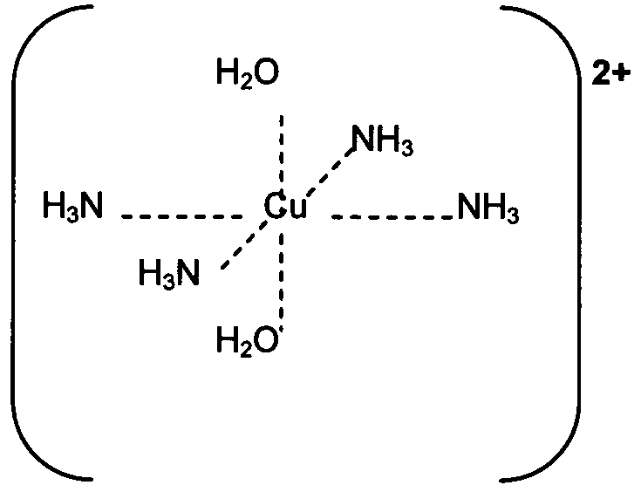 | 2 marks
- multiple oxidation states |  | 1 mark

Question 8 (6 marks)
- The atoms of elements across a period have the same outermost occupied shell.  For the atoms of the elements in the 1st period, the 1st shell is filling  This shell only contains the 1s subshell, which can only hold a maximum of 2 electrons, and this is why this period only contains 2 elements. | 1 mark
- After removal of the first electron from an atom, the atom has a net charge of +1. The remaining electrson are therefore more tightly bound and it requires more energy to remove the second electrons, as it will need to be pulled away from a positively charged particle. | 1 mark
- As the core charge increases across the period it becomes harder to remove an electron so the metallic character decreases. | 2 marks
- i. Na₂O (s) + 2 HNO₃ (aq) → 2 NaNO₃ (aq) + H₂O (l) | 1 mark
ii. SO₃ (g) + 2 KOH (aq) → K₂SO₄ (aq) + H₂O (l) | 1 mark

