Lisachem
2006
CHEMISTRY
Unit 3 Exam

Section A – Multiple Choice

Question 1
A basic solution is titrated with an acid using methyl orange indicator. The indicator colour changes from yellow when the pH drops below 4.4 and turns red when the pH drops below 3.1. Between 4.4 and 3.1, the indicator displays its orange ‘endpoint’ colour. By what factor does the [H₃O⁺] in the titration flask change at the end point?
- decrease by 1.3
- decrease by 20
- increase by 1.3
- increase by 20

Question 2
Haemoglobin, a protein in red blood cells, carries O₂ from the lungs tot eh body’s cells. Iron, present as iron(II) ions, makes up 0.33%, by mass, of haemoglobin. If the molar mass of haemoglobin is 6.8 × 10⁴ g mol⁻¹, how many Fe²⁺ ions are present in one haemoglobin molecule?
- 1
- 4
- 2.2 × 10²
- 2.4 × 10²⁴

Question 3
Ozone reacts with nitrogen(II) oxide according to the equation
NO (g)+ O₃ (g) → NO₂ (g) + O₂ (g)
If 0.893 g of NO (g) was mixed with 1.08 g O₃ (g) and the reaction allowed to proceed to completion, the maximum volume of NO₂ (g) produced at zero °C and 100 kPa would be
- 0.510 L
- 0.555 L
- 0.675 L
- 0.750 L

Question 4
A 0.954 g sample of a diprotic acid was allowed to react completely with NaOH (aq). If 36.04 mL of 0.509 M NaOH was required to react with all of the acid, what is the molar mass, in g mol⁻¹ of the acid?
- 116
- 104
- 58
- 52

Question 5
Consider the delivery of twenty mL of solution by a single calibration mark twenty mL pipette and twenty mL of solution by a burette during a volumetric analysis.
The approximate errors, in the volumes delivered, for the pipette and burette are
- pipette – 0.04 mL, burette – 0.01 mL
- pipette – 0.01 mL, burette – 0.01 mL
- pipette – 0.01 mL, burette – 0.04 mL
- pipette – 0.04 mL, burette – 0.04 mL

Question 6
A polyester is formed by reaction between the two monomers shown below:
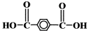 | HO – CH₂ CH₂ – OH
The percentage, by mass, of carbon in the polyester is
- greater than in the monomers
- less than in the monomers
- the same as in the monomers
- equal to the percentage by mass of oxygen in water
Question 7
An aqueous solution of oxalic acid, H₂C₂O₄ (aq), is oxidised to CO₂ by acidified potassium permanganate solution, KMnO₄ (aq). The unbalanced chemical equation for the reaction is
___ H₂C₂O₄ (aq) + ___ MnO₄– (aq) + ___ H⁺ (aq) → ___ CO₂ (g) + ___ Mn²⁺ (aq) + ___ H₂O (l)
1 mol of CO₂ will be produced by this reaction if
- 1 mol H₂C₂O₄ reacts
- 0.2 mol MnO₄– reacts
- 2 mol H₂C₂O₄ reacts
- 2 mol MnO₄– reacts

Question 8
Natural rubber is an addition polymer of 2-methyl-1,3-butadience which has the molecular formula C₅H₈.
Synthetic rubber is an addition polymer produced when styrene, C₈H₈, and butadiene, C₄H₆, combine in a 1:3 ratio sot that the repeating unit in the polymer has the chemical formula C₂₀H₂₆.
Analysis of an ‘unknown’ rubber sample shows that is contains 10.3%, by mass, hydrogen and 89.7%, by mass, carbon.
The chemical analysis suggests that the sample is
- pure synthetic rubber
- a mixture of synthetic rubber and natural rubber, with a greater proportion of synthetic rubber
- a mixture of synthetic rubber and natural rubber with a greater proportion of natural rubber
- pure natural rubber

Question 9
Carbon monoxide reacts with hydrogen gas at elevated temperatures to form methanol according to the equilibrium
CO (g) + 2 H₂ (g)  CH₃OH (g)
0.80 mol of CO and 0.60 mol of H₂ are added to an empty 2.0 L container and allowed to reach equilibrium. When equilibrium has been established, analysis shows that the concentration of CH₃OH is 0.060 mol L⁻¹. What is the value of the equilibrium constant, K_{c}?
- 0.42 M⁻²
- 0.98 M⁻²
- 1.7 M⁻²
- 5.4 M⁻²

Question 10
A total mass of products formed during the complete combustion of 22.8 g of octane is
- 135 g
- 103 g
- 70.4 g
- 32.4 g

Question 11
Three chemical equilibrium systems, represented by the chemical equations below, were established in separate gas syringes.
1. N₂ (g) + 3 H₂ (g)  2 NH₃ (g)
2. H₂ (g) + I₂ (g)  2 HI (g)
3. N₂O₄ (g)  2 NO₂ (g)
The plunger of each of the three syringes was then pushed in, reducing the volume of the gas mixture.
When equilibrium is reached, after the volume change, how would the position of equilibrium have shifted compared to the original equilibrium for each system?
- 1. moved left; 2. moved right; 3. not changed
- 1. moved right; 2. not changed; 3. moved left
- 1. not changed; 2. moved left; 3. moved right
- 1. not changed; 2. not changed; 3. not changed

Question 12
A sample of a motor vehicle fuel is to be analysed using gas chromatography, and the relative amounts of each of the compounds present in the sample determined from the data collected. Which of the following measurements would be most useful in determining the amount of a particular component in the fuel?
- The distance moved by the compound through the stationary phase.
- The height of the compound’s peak on the recorder output.
- The time taken for the compound to pass through the instrument.
- The area under the compound’s peak on the recorder output.

Question 13
The lung disease emphysema reduces the capacity of a sufferer’s lungs to exhale CO₂ (g).
CO₂ levels in the body are controlled through the equilibria:
1. CO₂ (g)  CO₂ (aq)
2. CO₂ (aq) + H₂O (l)  H₂CO₃ (aq)
3. H₂CO₃ (aq) + H₂O (l)  HCO₃– (aq) + H₃O⁺ (aq)
According to these equilibria, emphysema will cause
- Blood pH to rise
- All three equilibria to move to the left
- Blood pH to fall
- Less CO₂ to be dissolved in the blood

Question 14
Temperature and pressure are key factors in the production of common chemicals via equilibrium reactions. The data below shows the relationships between percentage yield of product, temperature and pressure for the industrial production of a particular chemical.
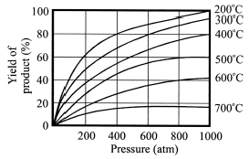
According to this data
- The forward reaction is exothermic, and the produce is on the side with fewer particles.
- The forward reaction is endothermic, and the produce is on the side with more particles.
- The forward reaction is exothermic, and the produce is on the side with more particles.
- The forward reaction is endothermic, and the produce is on the side with fewer particles.

Question 15
Hydrochloric acid reacts with zinc metal to produce a zinc chloride solution and hydrogen gas.
The ionic equation for the reaction is:
Zn (s) + 2 H⁺ (aq) → Zn²⁺ (aq) + H₂ (g)
Suppose some hydrochloric acid was added to a sample of zinc granules in a test tube. Which of the following factors is least likely to significantly increase the rate of reaction?
- Increasing the temperature
- Adding a suitable catalyst
- Adding more hydrochloric acid
- Using powdered zinc rather than zinc granules

Question 16
Vinegar is acidic because of the presence of ethanoic acid. In a simple practice exercise, the pH of a 0.10 M aqueous solution of ethanoic acid was measured before and after the addition of a small amount of potassium hydroxide solution.
Which of the following sets of data most likely represents the initial and final pH of the ethanoic acid solution?
- Initial – 7.1 Final – 4.9
- Initial – 2.8 Final – 5.7
- Initial – 9.5 Final – 3.4
- Initial – 1.0 Final – 8.3

Question 17
In the experimental determination of the concentration of an aqueous solution of hydrochloric acid, HCl (aq), a student uses the acid to titrate 20.0 mL aliquots of an aqueous solution of the primary standard sodium carbonate, Na₂CO₃ (aq).
The sodium carbonate solution used was to be prepared by dissolving a known mass of Na₂CO₃ in deionised water in a 250 mL volumetric flask. However during he preparation of this solution the student used a 200 mL volumetric flask which had been mistakenly labelled as 250 mL.
Assuming all other aspects of the procedure were error free, use of the incorrectly labelled flask would cause
- the volume of HCl (aq) required to reach the endpoint to be larger and its calculated concentration to be greater than the true value
- the volume of HCl (aq) required to reach the endpoint to be larger and its calculated concentration to be lower than the true value
- the volume of HCl (aq) required to reach the endpoint to be smaller and its calculated concentration to be greater than the true value
- the volume of HCl (aq) required to reach the endpoint to be smaller and its calculated concentration to be lower than the true value

Question 18
In a petroleum refinery, crude oil is subjected to fractional distillation. In this process
- the crude oil is separated into groups of chemicals, each boiling within a selected temperature range
- high molecular mass molecules are converted into lower molecular mass unsaturated molecules
- low molecular mass molecules vaporise first and condense near the bottom of the tower
- alkanes and alkenes are separated according to their boiling temperatures.

Question 19
Consider the list of chemical formulae given below
CH₃CH₂CH₂CH₃ H₂SO₄ NaCl C₄H₈ SO₂ CO₂ HSO₄– O₂
Which of the following is not present in this list?
- an acid-base conjugate pair
- a strong oxidant when hot and concentrated
- an acid-base primary standard
- a substance with on other isomer

Question 20
A sealed container is filled with oxygen at 300 kPa pressure, whilst another sealed container of the same volume is filled with ozone at 100 kPa pressure.
If the temperatures of the gas samples in the two containers are the same, which of the following statements best describes the relationship between the two gas samples?
- The mass of the oxygen sample is three times that of the ozone sample.
- There are twice as many atoms I the oxygen sample as there are in the ozone sample.
- The number of mole of ozone present is 1.5 times the number of mole of oxygen present.
- Oxygen molecules are larger than ozone molecules and so exert greater pressure.

Section B – Short Answer Questions

Question 1
The ‘Kjeldahl test’ is an analytical method for the determination of the amount of nitrogen in particular organic compounds.
The sample being analysed is treated to convert the organically bound nitrogen to ammonium ions, NH₄⁺ (aq), which are converted to NH₃ (aq) by reaction with NaOH (aq). The NH₃ is then distilled into an aqueous solution of hydrochloric acid where it reacts according to
NH₃ (g) + HCl (aq)I → NH₄⁺ (aq) + Cl– (aq)
The excess hydrochloric acid is then titrated with a standard solution of sodium hydroxide.
HCl (aq) + NaOH (aq) → NaCl (aq) + H₂O (l)
When a 0.2515 g sample of grain was analysed for nitrogen content, the ammonia produced was distilled into 50.00 mL of 0.1010 M HCl (aq).
The excess acid required 19.30 mL of 0.1050 M NaOH (aq) to reach the endpoint.

- Determine
(i) the number of moles of HCl in 50.00 mL of 0.1010 M HCl (aq).

1 mark
(ii) the number of moles of HCl (aq) remaining after reaction with NH₃ (g)

1 mark
(iii) the number of moles of HCl (aq) reacting with the ammonia

1 mark
(iv) the number of moles of NH₃ produced from the grain sample

1 mark
(v) the percentage, by mass, of nitrogen atoms in the grain sample

2 marks
- Assuming the grain sample was accurately weighed and recorded, suggest two potential errors in experimental technique which could lead to a lower than true calculated percentage of nitrogen in the grain.

2 marks
Total 8 marks
Question 2
The use of spectral data to identify and quantify substances is essential to modern chemical analysis.
Instruments based on absorption spectra are more common than those based on emission spectra. Two such instruments are an atomic absorption spectrometer (AAS) and a UV-Visible spectrometer. For these two instruments

- Describe the light source used in an atomic absorption spectrometer, and explain its link to the emission and absorption of light.

2 marks
- Describe the key characteristics of the light source used in a UV-Visible spectrometer.

1 mark
- Describe how the sample being analysed is introduced into each instrument.

2 marks
- Describe the role of the monochromator in a spectrometer.

1 mark
- In the analysis of the amount of chlorophyll, a green pigment, in leaf extract, what are wavelengths in the green region of the spectrum not used?

1 mark
- How does measuring absorbance in an AAS or UV-vis spectrometer lead to accurate concentration values for the species being analysed?

1 mark
- What is the basis of the separation of the different components of a mixture during analysis by chromatograph?

2 marks
Total 10 marks
Question 3
Consider the flowchart of organic reaction sequences shown below.
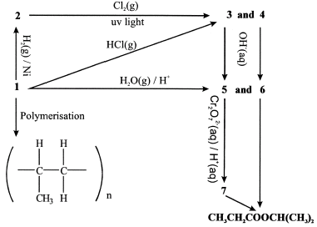

- Write the name of the compound represented by the chemical formula CH₃CH₂COOCH(CH₃)₂.

1 mark
- Give the names and semi-structural formulae of the compounds labelled 1. to 7. respectively.
1. ______________________________________________________________________________________________
2. ______________________________________________________________________________________________
3. ______________________________________________________________________________________________
4. ______________________________________________________________________________________________
5. ______________________________________________________________________________________________
6. ______________________________________________________________________________________________
7. ______________________________________________________________________________________________
7 marks
- What type of chemical reaction occurs in the conversion of
  - 1. to 3.
  - 5. to 7.
2 marks
Total 10 marks

Question 4
- Shown below is a concentration-time graph for the equilibrium system
Fe³⁺ (aq) + SCN– (aq)  Fe(NCS)²⁺ (aq)
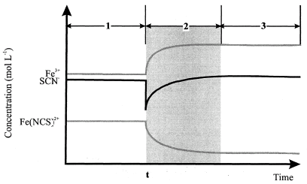
(i) What change was imposed on the system at time t?

(ii) How and why did the system respond to this change?

2 marks
- The concentration-time graph below show the effect of a temperature change on the equilibrium system
Fe³⁺ (aq) + SCN– (aq)  Fe(NCS)²⁺ (aq)
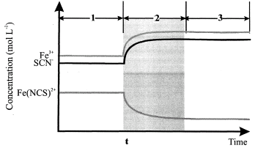
The temperature of the equilibrium mixture was lowered at time t. Explain how the information on the concentration-time graph helps determine whether the reaction Fe³⁺ (aq) + SCN– (aq)  Fe(NCS)²⁺ (aq) is exothermic or endothermic.

2 marks
- Consider the concentration-time graph given for the equilibrium system
N₂O₄ (g)  2 NO₂ (g)
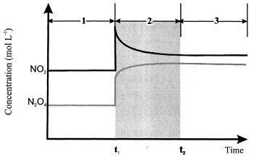
(i) At time t₁ the volume of the gas syringe containing the equilibrium mixture was changed.
How does the concentration time graph show whether it increased or decreased?

1 mark
(ii) Why do the concentrations of NO₂ and N₂O₄ change during section 2 of the graph?

2 marks
(iii) At time t₂, when the system returns to equilibrium after the imposed volume change, the c(NO₂) is greater than it was initially, but how does the m(NO₂) present compare to the m(NO₂) present before the volume change? Explain your answer.

2 marks
Total 9 marks

Question 5
The diagram below represents some of the steps in the industrial production of sulfuric acid.
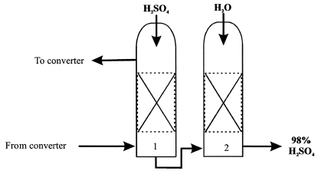
- Write a balanced chemical equation for the reaction occurring in the converter.

1 mark
- What is the thermochemical nature of the reaction occurring in the converter and what impact does this have on the conditions used to maximise the yield of product?

3 marks
- What substances are recycled back to the converter from the reaction vessel labelled 1?

1 mark
- Write balanced chemical equations for the reactions occurring in reaction vessels 1 and 2.
1.

2.

2 marks
- Write a balanced equation describing the production of ethene from pentane by cracking.

1 mark
- Both the production of sulfuric acid, and the production of ethene, utilise low pressures in the equilibrium gas mixtures. Is this consistent with Le Chatelier’s principle in both cases?

2 marks
Total 10 marks

Question 6
Niacin, also known as nicotinic acid, C₅H₄NCOOH, is recognised as having cholesterol lowering properties.
Nicotinic acid is a weak acid with K_{a} = 1.40 × 10⁻⁵ at 25°C.
In an analysis to determine the amount of niacin in a breakfast cereal, the niacin in a 5.00 g sample of the cereal was extracted and dissolved in deionised water to make 50.0 mL of solution at 25°C. The pH of this solution was measured to be 4.60.

- Write a balanced equation for the ionisation of nicotinic acid in aqueous solution.

1 mark
- Determine the [H₃O⁺] in the aqueous solution produced by dissolving niacin in deionised water.

1 mark
- The aqueous solution of niacin prepared during the analysis is very dilute. In very dilute solutions, the hydrolysis of weak acids will be quite extensive. In this case, the ‘assumption’ that the concentration of the acid is the same at equilibrium as it was initially is not valid. Keeping this in mind, determine the concentration of the 50.0 mL solution formed with respect to niacin.

2 marks
- Determine the mass of niacin present in 100 g of the cereal.

2 marks
Total 6 marks

Question 7
Shown below is an energy profile for combustion of methane according to:
CH₄ (g) + 2 O₂ (g) → CO₂ (g) + 2 H₂O (g)
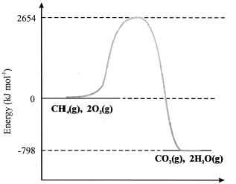

- Explain how the energy profile enables you to decide whether the reaction between methane and oxygen is exothermic or endothermic?

2 marks
- What is the value of the activation energy, in kJ mol⁻¹, for the reaction?

1 mark
- Show, on the diagram, the energy profile for the reaction ½ CH₄ (g) + O₂ (g) → ½ CO₂ (g) + H₂O (g).
2 marks
- In terms of the molecules involved, what is the key factor in determining whether a mixture of methane and oxygen reacts?

1 mark
Total 6 marks

END OF QUESTION AND ANSWER BOOKLET

