STAV
2006
UNIT 4 CHEMISTRY

SECTION A – Multiple-choice questions

Question 1
The main energy conversion that occurs in a fuel cell is
- chemical energy to electrical energy
- thermal energy to electrical energy
- electrical energy to mechanical energy
- mechanical energy to electrical energy

Question 2
The combustion of ethane can be represented by
2 C₂H₆ (g) + 7 O₂ (g) → 4 CO₂ (g) + 6 H₂O (g) ΔH = –3120 kJ mol^{–1}
The formation of 1.0 mol of ethane from carbon dioxide and water vapour involves
- absorption of 3120 kJ of energy
- absorption of 1560 kJ of energy
- release of 3120 kJ of energy
- release of 1560 kJ of energy

Question 3
A solution calorimeter was inadvertently calibrated with just 95 mL of water instead of 100 mL and then used to determine the heat of reaction of powdered magnesium in 100 mL of HCl (aq). Compared with the values calculated from this information
- the correct calibration factor should be lower and the heat of reaction should be lower
- the correct calibration factor should be higher and the heat of reaction should be higher
- the correct calibration factor should be lower and the heat of reaction should be higher
- the correct calibration factor should be higher and the heat of reaction should be lower

Question 4
Which of the following factors affect the amount of metal formed from its molten salt during electrolysis?
- The amount of current used.
- The charge on the metal ion.
- The period of time the current is used.
- I only
- I and II only
- I and III only
- I, II and III

Question 5
The table shown below gives the heat of combustion, in kJ g^{–1}, for four different fuels.

Fuel | Heat of Combustion  (kJ g^{–1})
methanol | 22.7
ethanol | 29.6
propan-1-ol | 33.6
octane | 47.8

If the heat of combustion, in kJ mol^{–1}, for one of these fuels was calculated as 2016 kJ mol^{–1}, what was the fuel?
- methanol
- ethanol
- propan-1-ol
- octane

Question 6
The oxidation number of beryllium in the ion BeF₄²⁻ is
- –2
- 0
- +2
- +6

Question 7
The equations listed represent the electrolytic production of the elements: Al, Na, Cl₂ and O₂.
Al³⁺ + 3 e– → Al
Na⁺ + e– → Na
2 Cl– → Cl₂ + 2 e–
2 H₂O → 4 H⁺ + O₂ + 4 e–
If one mole of electrons is passed through a suitable electrolytic cell, the substance produced in the greatest mass is
- Al
- Na
- Cl₂
- O₂

Question 8
Rutile is composed of titanium and oxygen. A trial electrolytic plant, running at 100 percent efficiency, applied a potential difference of 4.0 volts and used 463.2 kJ of electrical energy to produce 14.37 g of titanium metal.
The chemical composition of rutile is
- Ti₂O
- TiO
- Ti₂O₃
- TiO₂

Question 9
The diagram represents the electrochemical cell: Fe(s) | Fe²⁺ (aq)||Cu²⁺ (aq) | Cu (s)
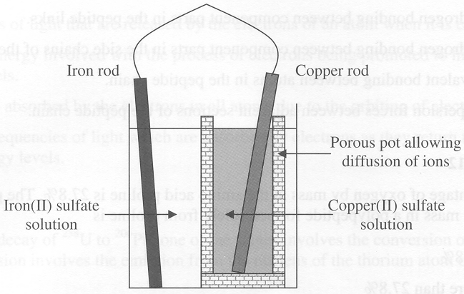
The particles, I, II, III, and IV, involved in this electrochemical cell are listed.
- copper atoms
- iron atoms
- copper (II) ions
- iron (II) ions
The particles that move towards the site of reduction are
- I only
- II only
- I and III
- III and IV
Question 10
Which of the following does not describe a reaction of glucose?
- Glucose reacts with oxygen exothermically to produce carbon dioxide and water.
- Glucose molecules react exothermically to produce cellulose and water.
- Glucose reacts exothermically to produce carbon dioxide and ethanol.
- Glucose molecules react endothermically to produce starch and water.

Question 11
The structure in proteins can be classified as primary, secondary and tertiary.
The secondary structure is due to
- hydrogen bonding between component parts in the peptide links
- hydrogen bonding between component parts in the side chains of the peptide chain
- covalent bonding between atoms in the peptide chain
- dispersion forces between adjacent sections of the peptide chain

Question 12
The percentage of oxygen by mass in the amino acid proline is 27.8%. The percentage of oxygen by mass in a polypeptide formed solely from proline is
- 27.8%
- more than 27.8%
- less than 27.8%
- unable to be determined without further information

Question 13
Antioxidants are added to foods high in fats and oils
- to enhance the emulsification of the food components
- to reduce the degree of unsaturation of the lipid components
- to reduce the oxidative deterioration of the lipid components
- to increase the rate of hydrolysis of lipids by dispersing these food components

Question 14
The chemical link joining the monomers of a glycogen molecule can be represented by
A. | –C–O–C– | B. | 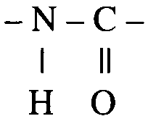 | C. | 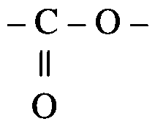 | D. | –C–O–O–C

Question 15
An absorption spectrum consists of dark lines on a coloured background. The dark lines correspond to
- the energies of light that are released by the electrons of an atom when it is excited
- quanta of energies involved with the process of electrons being promoted to higher energy levels
- light that is absorbed by the electrons in all atoms due to the orbiting of electrons
- different frequencies of light which are absorbed by electrons as they return to more stable energy levels

Question 16
In the radioactive decay of ²³⁸U to ²⁰⁶Pb, one of the stages involves the conversion of ^{234Th} to ²³⁴Pa. This conversion involves the emission from the nucleus of the thorium atom of
- a neutron
- an electron
- an alpha particle
- a positron

Question 17
Consider the properties of all of the Period 2 elements (including lithium and neon).
When moving across Period 2 from left to right (lithium to neon) there is an increase in the
- electronegativity of the elements
- ionisation energy of the elements
- atomic radius of the elements
- metallic nature of the properties of the elements

Question 18
Manganese is a transition element. The evidence below which best supports its position in the Periodic Table is
- it forms cations with a +2 and +3 charge
- it has a relatively low density
- it has a relatively low melting point
- it reacts with dilute sulfuric acid to form hydrogen

Questions 19 to 20 refer to the following information.

The electron configurations of the elements I, II, III and IV are shown.
- 1s²2s²2p⁴
- 1s²2s²2p⁶3s¹
- 1s²2s²2p⁶3s²3p⁶4s¹
- 1s²2s²2p⁶3s²3p⁶3d¹⁰4s²

Question 19
Selecting from the elements I to IV, identify any element(s) likely to form a 2– ion.
- I
- II
- II, III and IV
- IV

Question 20
Selecting from the elements I to IV, identify any element(s) that is likely to react as a reductant.
- I
- II
- II, III and IV
- IV

SECTION B – Short-answer questions

Question 1
Write concise explanations for the following observations.

- Platinum rather than iron is used as an electrode in the standard Fe³⁺/Fe²⁺ half cell.
_______________________________________________________________________________________
_______________________________________________________________________________________
_______________________________________________________________________________________
_______________________________________________________________________________________
_______________________________________________________________________________________
- The electrolytic cell used in the production of sodium uses a molten mixture of sodium chloride in calcium chloride rather than a concentrated aqueous solution of sodium chloride.
_______________________________________________________________________________________
_______________________________________________________________________________________
_______________________________________________________________________________________
_______________________________________________________________________________________
_______________________________________________________________________________________
- Versions of the Periodic Table published prior to Mendeleev’s version showed the element iodine (I) placed before tellurium (Te) while modern versions reverse this order.
_______________________________________________________________________________________
_______________________________________________________________________________________
_______________________________________________________________________________________
_______________________________________________________________________________________
_______________________________________________________________________________________
- The transition element zinc forms colourless compounds while most ionic compounds of the transition elements are coloured.
_______________________________________________________________________________________
_______________________________________________________________________________________
_______________________________________________________________________________________
_______________________________________________________________________________________
_______________________________________________________________________________________
2 + 2 + 2 + 2 = 8 marks
Suggested time = 10 minutes

Question 2
The energy stored in biomass, such as wood, can be released in several ways. Two of these are direct combustion or conversion to ethanol. For each of these two methods, give one advantage and one disadvantage.

- Direct combustion
Advantage
_______________________________________________________________________________________
_______________________________________________________________________________________
_______________________________________________________________________________________
Disadvantage
_______________________________________________________________________________________
_______________________________________________________________________________________
_______________________________________________________________________________________
- Conversion to ethanol
Advantage
_______________________________________________________________________________________
_______________________________________________________________________________________
_______________________________________________________________________________________
Disadvantage
_______________________________________________________________________________________
_______________________________________________________________________________________
_______________________________________________________________________________________
2 + 2 = 4 marks
Suggested time: 4 minutes

Question 3
A group of hikers are trying to calculate how much fuel they will need to take for a weekend hike in the Victorian Alps. They intend to use snow as their source of water and they have determined that 334 J of energy is required to melt 1.0 g of snow. The hikers intend to use methylated spirits as their fuel. This fuel is mainly ethanol, CH₃CH₂OH, which releases 1364 kJ mol^{–1} no complete combustion.

- Write a balanced chemical equation for the complete combustion of ethanol.
_______________________________________________________________________________________
- The hikers estimate that they will require 1.0 kg of water per person per meal.
i. What mass of fuel will be needed to melt 1.0 kg of snow?
Quote your answer to the appropriate number of significant digits.

ii. Methylated spirits is sold by volume rather than mass. If the density of methylated spirits is 0.793 g mL^{–1}, what volume of methylated spirits would be required to melt 1.0 kg of snow?
Quote your answer to the appropriate number of significant digits.

- On the trip, the hikers found that they had insufficient methylated spirits for their needs, even though they did not require more than 1 kg of water per meal. Suggest one assumption made in the calculations in part b.
_______________________________________________________________________________________
_______________________________________________________________________________________
_______________________________________________________________________________________
- The complete oxidation of ethanol can also be carried out in a fuel cell.
For the fuel cell reaction in an acidic electrolyte write the half equations for the
i. Oxidation process
__________________________________________________________________________________
ii. Reduction process
__________________________________________________________________________________
2 + [3 + 1] + 1 + [1 + 1] = 9 marks
Suggested time: 10 minutes

Question 4
When 1.650 g of solid potassium hydroxide is dissolved in 200 g of water, 1.62 kJ of energy is released. The initial temperature of the water was 25.00°C.

- Calculate the final temperature of the water after the potassium hydroxide was added.

- Calculate the magnitude and sign of ΔH for the process:
KOH (s) + aq → K⁺ (aq) + OH– (aq)

2 + 3 = 5 marks
Suggested time: 6 minutes

Question 5
A food company wishes to determine the energy content of a new cereal. Their chemists choose to use a combustion or ‘bomb’ calorimeter.

- Draw a clearly labelled diagram of a ‘bomb’ calorimeter.

- Initially the calorimeter must be calibrated. The calibration factor for the calorimeter is 484 J °C^{–1}. When 0.158 g of the cereal is ignited and completely burned in the calorimeter a temperature rise of 5.52 K is observed. What is the energy content, in kJ g^{–1}, of the cereal?

- Why is the energy content of the cereal not quoted in kJ mol^{–1}?
_______________________________________________________________________________________
_______________________________________________________________________________________
_______________________________________________________________________________________
3 + 2 + 1 = 6 marks
Suggested time: 6 minutes

Question 6
Triglycerides are important biochemical molecules. They are formed within human cells from one or more fatty acids and another molecule that is common to all triglycerides.

- Give the semi-structural formula and name the molecule that is common in the formation of all triglycerides.

- Stearic acid is a saturated fatty acid with eighteen carbon atoms.
Draw the semi-structural formula for a molecule of stearic acid.

- Linoleic acid is an essential fatty acid known as omega-6. This fatty acid is found in linseed oil and fish oil.
i. Linoleic acid, C₁₈H₃₂O₂, is an unsaturated fatty acid. State how many carbon to carbon double bonds a molecule of linoleic acid contains. Explain your response.
__________________________________________________________________________________
__________________________________________________________________________________
__________________________________________________________________________________
__________________________________________________________________________________
ii. Stearic acid has a melting point of +69.6°C and linoleic acid has a melting point of –11.0°C. Explain the difference in melting points of these fatty acids in terms of their structure.
__________________________________________________________________________________
__________________________________________________________________________________
__________________________________________________________________________________
__________________________________________________________________________________
2 + 1 + [1 + 1] = 5 marks
Suggested time: 5 minutes

Question 7
Molecules A to H are listed using semi-structural or molecular formula.

A | B | C | D
CH₃CH₂COOH | C₆H₁₂O₆ | C₁₂H₂₂O₁₁ | NH₃
E | F | G | H
NH₂CH₂COOH | CO(NH₂)₂ | C₃H₈O₃ | CH₃(CH₂)₁₅COOH

- Identify the molecule or molecules from those listed above that could have been formed in the digestion by hydrolysis of the following three types of biomolecules. Circle the letter(s) corresponding to your responses.
Protein | A | B | C | D | E | F | G | H
Fat | A | B | C | D | E | F | G | H
Carbohydrate | A | B | C | D | E | F | G | H
- Identify a molecule from the above set that is the main waste product formed within liver tissue from amino acids. Circle the letter corresponding to your response.
Waste product | A | B | C | D | E | F | G | H
- Amino acids are important biomolecules.
i. Draw the structural formula of alanine, and, on your diagram, circle the two functional groups typically found in amino acids and label these as (1) and (2).

ii. Name the two functional groups you have circled on your diagram in part c. i.
Functional group (1): _________________________________________________________________
Functional group (2): _________________________________________________________________
iii. Draw the structural formula of alanine in a solution of pH 11.

3 + 1 + [3 + 1 + 1] = 9 marks
Suggested time: 10 minutes

Question 8
A sample of the element nickel was analysed by mass spectrometry.
The spectrum obtained is shown below.
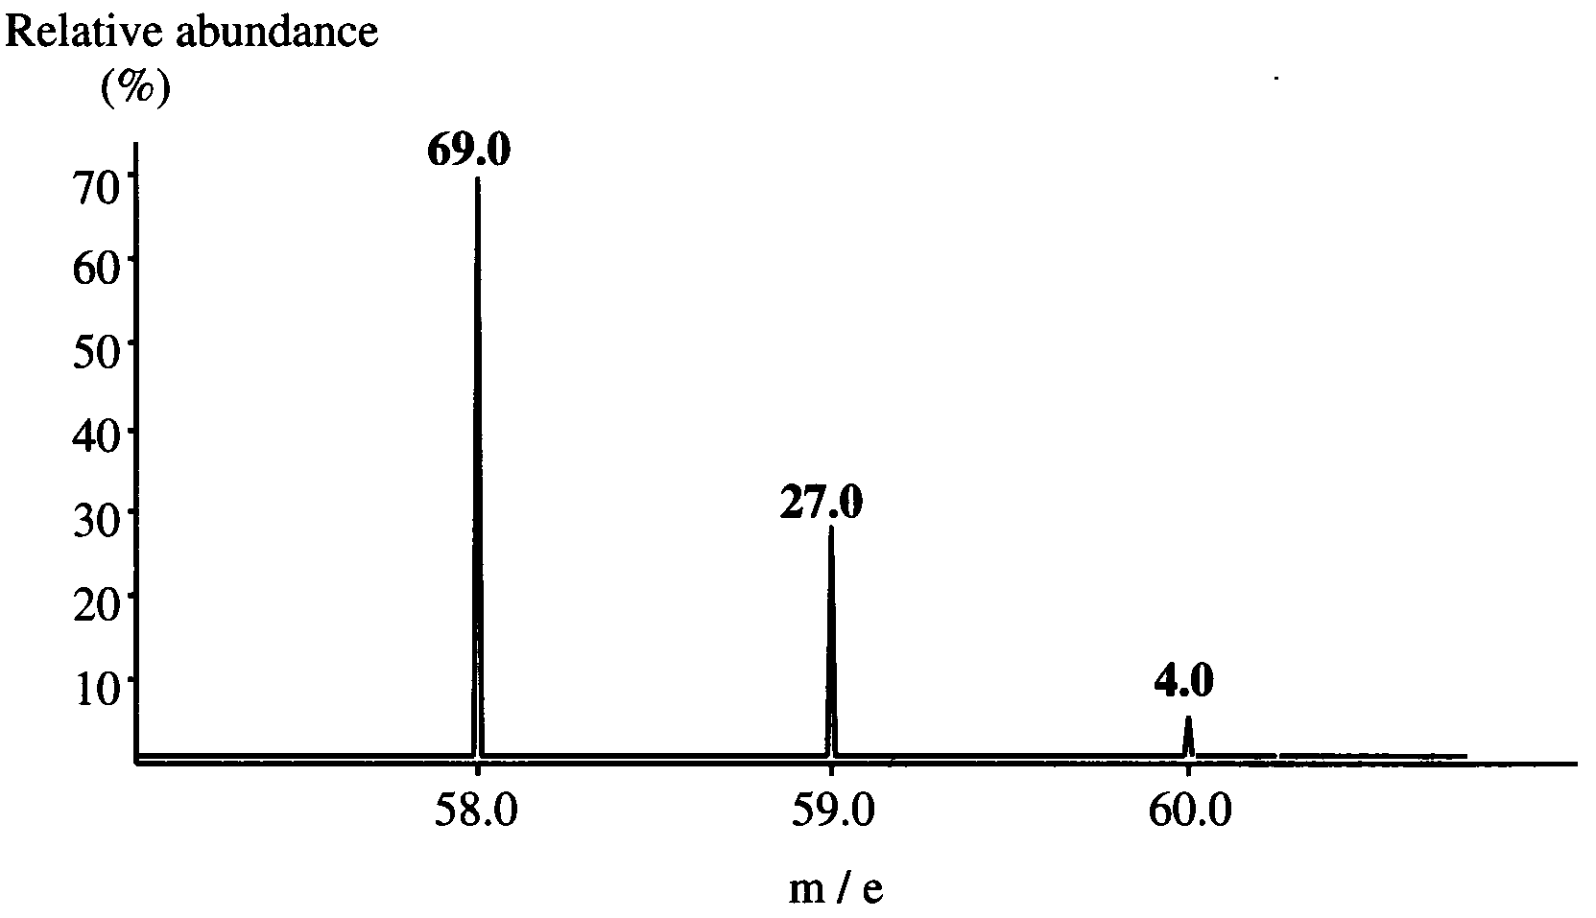

- Use the data to calculate the relative atomic mass of nickel. (Show your working)

_______________________________________________________________________________________
- i. Write the full isotopic symbol (nuclide representation) for the
species that is least deflected in the mass spectrometer?
ii. Write the symbol for the species that would produce a peak in
the mass spectrum of nickel at m/e of 58.0.
iii. What causes the ions to be deflected in the mass spectrometer?
__________________________________________________________________________________
__________________________________________________________________________________

- i. Write the ground state electron subshell configuration of nickel.
__________________________________________________________________________________
ii. Write the ground state electron subshell configuration of the Period 3 element which has five electrons in the outermost shell.
__________________________________________________________________________________
iii. Which element would you expect to have the higher electronegativity, nickel or the element referred to in part ii.? Give a reason for your choice.
__________________________________________________________________________________
__________________________________________________________________________________
__________________________________________________________________________________
__________________________________________________________________________________
2 + [1 + 1 + 1] + [1 + 1 + 1] = 8 marks
Suggested time: 9 minutes

Question 9
Consider the following data
VO₂⁺ (aq) + 2 H⁺ (aq) + e–  VO²⁺ (aq) + H₂O (l) E⁰ (volts) = + 1.02
VO²⁺ (aq) + 2 H⁺ (aq) + e–  V³⁺ (aq) + H₂O (l) E⁰ (volts) = + 0.34
V³⁺ (aq) + e–  V²⁺ (aq) E⁰ (volts) = – 0.25

- Name the element which has the chemical symbol V.
_______________________________________________________________________________________
- i. Of the ions listed, give the species containing the element V in its highest oxidation state.
__________________________________________________________________________________
ii. What is the oxidation state of the element V in the ion you have selected?
__________________________________________________________________________________
iii. What is the highest oxidation state expected fort he element V?
Explain your answer.
__________________________________________________________________________________
- Give the electron configuration of the ion, V³⁺.
_______________________________________________________________________________________
- Which, if any, of the four species, V²⁺ (aq), V³⁺ (aq), VO²⁺ (aq) and VO₂⁺ (aq) should be chosen to convert iodide ion to iodine in aqueous solution? Explain your answer.
_______________________________________________________________________________________
_______________________________________________________________________________________
_______________________________________________________________________________________
1 + [1 + 1 + 1] + 1 + 2 = 7 marks
Suggested time: 8 minutes

