Australian Education Academy
2004

MATHEMATICAL METHODS

TRIAL EXAMINATION 1

Reading time: 15 minutes
Writing time: 1 hour 30 minutes

Student’s name: ______________________________________

Directions to students
This examination has two parts:
Part I (Multiple-choice questions) and Part II (Short-answer questions).

Answer all questions in Part I on the multiple-choice answer sheet provided.
There are 27 marks available for this part.

Part II consists of seven questions. Answer all questions in Part II in the spaces provided. There are 23 marks available for this part.

There are 50 marks available for this task.
A formula sheet is attached.

These questions have been written and published to assist students in their preparations for the 2004 Mathematical Methods Examination 1. The questions and associated answers and solutions do not necessarily reflect the views of the Victoria Curriculum and Assessment Authority. The Association gratefully acknowledges the permission of the Authority to reproduce the formula sheet.

© Australian Education Academy Pty Ltd 2004
This Trial Examination is licensed to the purchasing school or educational organization with permission for copying within that school or educational organization. No part of this publication may be reproduced, transmitted or distributed, in any form or by any means, outside purchasing schools or educational organizations or by individual purchases without permission.

Published by Australian Education Academy Pty Ltd
ABN: 18 104 474 893
105, Normanby Drive, Greenvale, Vic 3059
Ph: (03) 9333 2392 Fax: (03) 9333 4865
Email: dilshan@aol7.com.au

Mathematical Methods

Part I (Multiple-choice questions)

Question 1

The graph shown could be that of a function f whose rule is

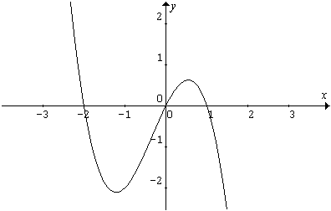
A. $f(x)=x(x−1)(x+2)$
B. $f(x)=x(x−1)(x−2)$
C. $f(x)=x(x+1)(x+2)$
D. $f(x)=x(1−x)(x−2)$
E. $f(x)=x(1−x)(x+2)$

Question 2
The inverse of the function $y=\frac{x−1}{x}$is
A. $y=\frac{1}{x−1}$ B. $y=\frac{1}{x+1}$ C. $y=\frac{x}{x−1}$ D. $y=\frac{x}{x+1}$ E. $y=\frac{1}{1−x}$

Question 3

The exact solution of the equation$5^{2x−1}={\text{25}}^{−x}$ is

A. 4 B. $\frac{1}{4}$ C. $\frac{1}{2}$ D . $\frac{1}{\text{16}}$ E. 2

Question 4

If ${\text{log}}_{e}x=a$ then $e^{3a}+3e^{2a}−2e^{−a}$ is equal to
A. $x^{3}+3x^{2}−\frac{2}{x}$ B. $a^{3}+3a^{2}−\frac{2}{a}$ C. $3{\text{log}}_{e}a+6{\text{log}}_{e}a−\frac{2}{{\text{log}}_{e}a}$
D. $3{\text{log}}_{e}x+6{\text{log}}_{e}x−\frac{2}{{\text{log}}_{e}x}$ E. $e^{3}+3e^{2}−\frac{2}{e}$

Question 5

The graph of the function with equation $y=f(x)$ is shown.
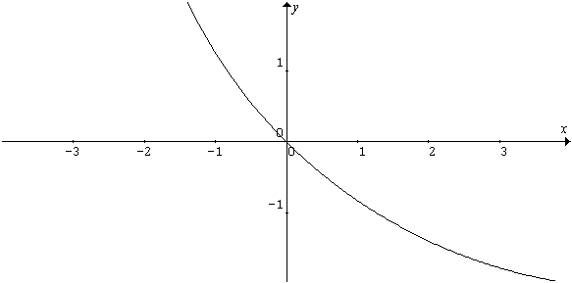
Which one of the following is most likely to be the graph of the inverse function?
A B.
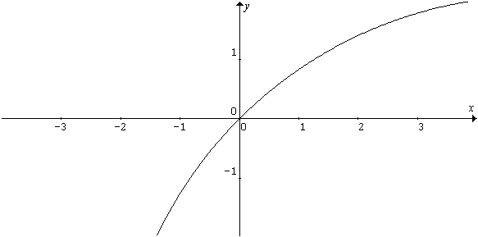
C. D.
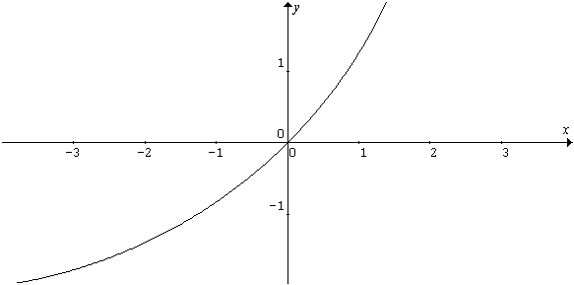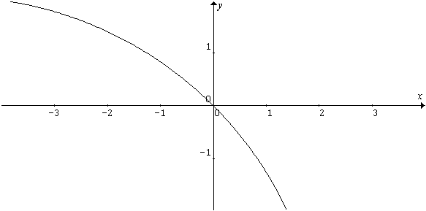

E.
. 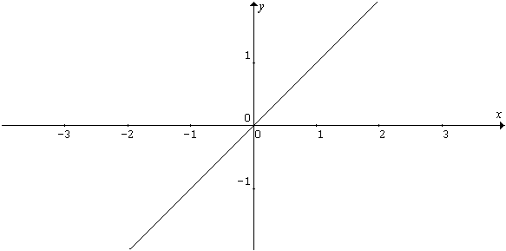

Question 6

The graph of the function with equation $y=f(x)$ is shown here.
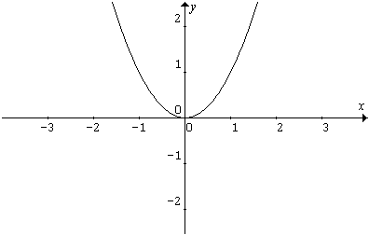
Which one of the following is most likely to be the graph of the $y=f(x+1)−1$?
A. B
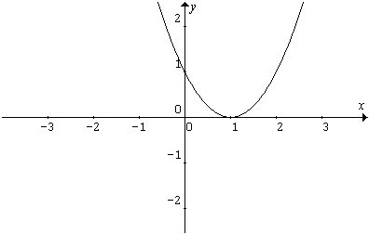

C. D.

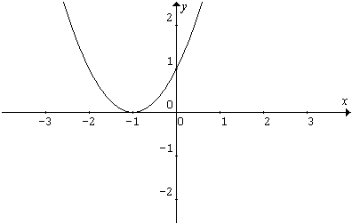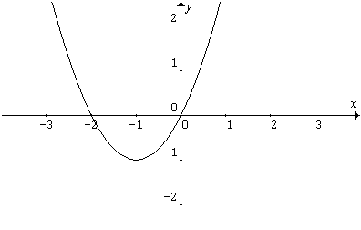
.
E.
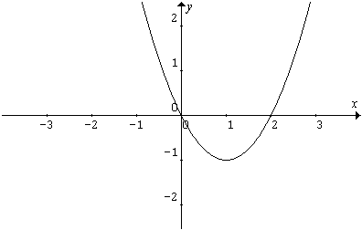

Question 7
The function given by $f(x)=2+\frac{1}{x−3}$ has domain and range given by
A. R \ {-3} and R \ {-2} B. R \ {3} and R \ {-2} C. R \ {3} and R \ {2}

D. R \ {2} and R \ {3} E. R \ {3} and R \ {3}

Question 8

If $P(x)=x^{3}+3x^{2}−3x+6$, when $P(x)$ is divided by $x+1$ the remainder is

A. –1 B. 0 C. 1 D. 11 E 12

Question 9

The linear factors of the polynomial $x^{4}−\text{10}x^{2}+9$ are

A. $x−1$,$x+3$,$x^{2}+3$ B. $x+1$,$x−3$,$x^{2}+3$ C.$x−3$,$x+3$, $x^{2}+1$

D. $x−1$, $x−1$,$x−3$,$x+3$ E. $x−3$, $x+3$,$x−1$,$x+1$

Question 10

The graph of the function f is shown here. The rule for f is most likely to be
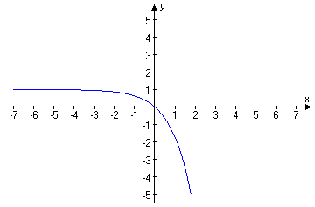

A. $f(x)=1−e^{x}$ B. $f(x)=1−e^{−x}$ C. $f(x)=e^{x}−1$

D. $f(x)={\text{log}}_{e}x+1$ E. $f(x)={\text{log}}_{e}(x+1)$

Question 11

The diagram shows one cycle of the graph of a circular function. The amplitude, period and range of the function are respectively

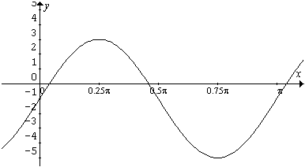
amplitude period range
A. 2 π/3 [0, π]
B. 3 π/2 [-5,3]
C. 3 π [-5,3]
D. 4 π [-5,3]
E. 4 π/2 [-1,3]

Question 12

The solution(s) to the equation $\sqrt{3}\text{sin}2x=\text{cos}2x$, $0≤x≤2π$ are

A. $π/{\text{12}}, \text{13}π/{\text{12}}$ B. ${−π}/{\text{12}}, 7π/{\text{12}}$

C. $π/{\text{12}}, 7π/{\text{12}}, \text{13}π/{\text{12}}, \text{19}π/{\text{12}}$ D. $π/{\text{12}}, 7π/{\text{12}}$ E. $\text{13}π/{\text{12}}, \text{19}π/{\text{12}}$

Question 13

The function . $f:R→R$, $f(x)=a\text{sin}(\text{bx})+c$, where a, b and c are positive constants. The amplitude, period and range of f are

amplitude period range
A. b a c
B. a 2π/b [c-a,c+a]
C. c 2π/b a
D. a 2π [c,c+a]
E. a π/b [c-a,c+a]

Question 14

The graph of $y=\text{cos}x$ is transformed into the graph $y=3\text{cos}2x$ by

- a dialation in the y-direction by a scale factor of 3 units and translation in x-direction of 2 units.
- a dialation in the y-direction by a scale factor of 2 units and translation in x-direction of 1/2 units.
- a dialation in the y-direction by a scale factor of 2 units and dialation in x-direction of 3 units.
- a dialation in the y-direction by a scale factor of 3 units and translation in x-direction of π units.
- a dialation in the y-direction by a scale factor of 3 units and dialation in x-direction of 1/2 units.

Question 15

The graph of y as a function of x is given below.
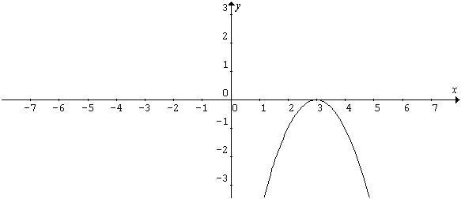
The corresponding graph of $\frac{\text{dy}}{\text{dx}}$ is

A. B.
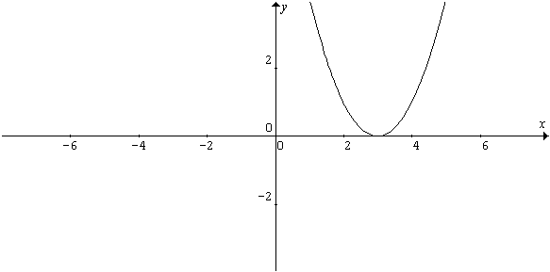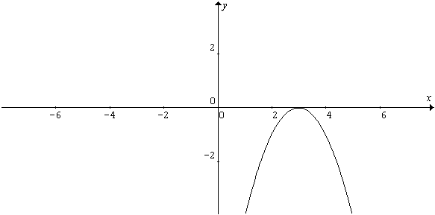

- D.
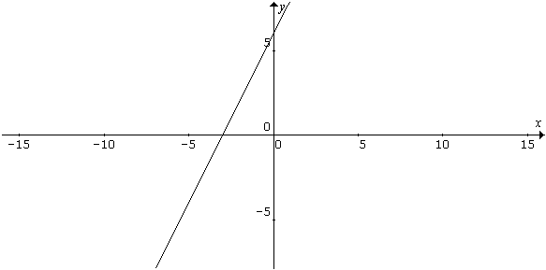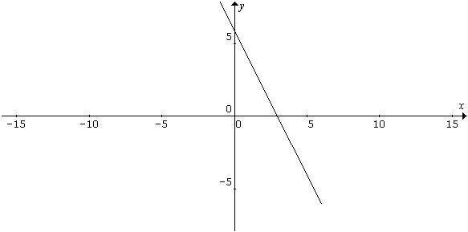

E.
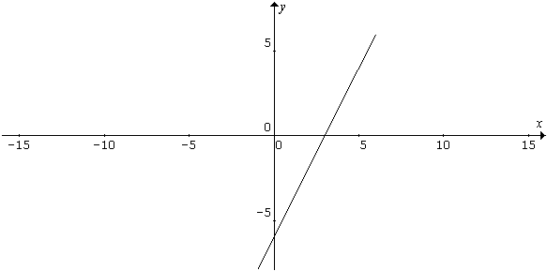

Question 16

If $f(x)=\frac{x^{2}−1}{x^{2}+1}$then $f'(x)$ is
A. $f(x)=\frac{2x}{(x^{2}+1)^{2}}$ B. $f(x)=\frac{x^{2}−1}{2x}$ C. $f(x)=\frac{4x}{x^{2}+1}$

D. $f(x)=\frac{4}{(x^{2}+1)^{2}}$ E. $f(x)=\frac{4x}{(x^{2}+1)^{2}}$

Question 17

If $y=\frac{\text{sin}x}{x}$then $\frac{\text{dy}}{\text{dx}}$is

A. $\frac{x\text{cos}x−\text{sin}x}{x^{2}}$ B. $\frac{x\text{cos}x+\text{sin}x}{x^{2}}$ C. $\frac{\text{sin}x−x\text{cos}x}{x^{2}}$

D. $x\text{cos}x−\text{sin}x$ E. $\text{cos}x$

Question 18

The graph of the function $f(x)=x^{3}−3x^{2}+3x−1$ has

- no stationary point.
- exactly one stationary point, which is a point of inflexion.
- Exactly one stationary point, which is a minimum point.
- Exactly one stationary point, which is a minimum and a point of inflexion.
- Exactly three stationary points.

Question 19

The concentration of a drug in the bloodstream t hours after injection is given approximately by $C(t)=4\text{.}\text{28}e^{−t}$, $0≤t≤6$.Where $C(t)$ is concentration in milligrams per milliliter. What is the rate of change of concentration after 4 hours?

- The concentration is decreasing at the rate of $\frac{4\text{.}\text{28}}{e^{4}}$mg/ml/hr.
- The concentration is increasing at the rate of $\frac{4\text{.}\text{28}}{e^{4}}$mg/ml/hr
- The concentration is decreasing at the rate of $4\text{.}\text{28}$mg/ml/hr

- The concentration is increasing at the rate of $4\text{.}\text{28}$mg/ml/hr

- The concentration is decreasing at the rate of $\frac{8\text{.}\text{56}}{e^{4}}$mg/ml/hr.

Question 20

$\int{e^{x}\left(1−\frac{e^{−x}}{x^{2}}\right)}\text{dx}$ is equal to

A. $e^{x}−\frac{1}{x}+C$ B. $e^{−x}−\frac{1}{x}+C$ C. $e^{−x}+\frac{1}{x}+C$ D. $e^{x}+\frac{1}{x}+C$

E. $e^{x}−\frac{1}{x^{2}}+C$

Question 21

Given that the derivative of $x\text{sin}2x$ is equal to $2x\text{cos}2x+\text{sin}2x$, which of the following statement is true?

A.$\int{x\text{cos}2\text{xdx}=−\frac{x}{2}}\text{sin}2x+\frac{1}{4}\text{cos}2x+C$ B. $\int{x\text{cos}2\text{xdx}=\frac{x}{2}}\text{sin}2x−\frac{1}{4}\text{cos}2x+C$

C. $\int{x\text{cos}2\text{xdx}=\frac{x}{2}}\text{sin}2x+\frac{1}{4}\text{cos}2x+C$ D. $\int{x\text{sin}2\text{xdx}=\frac{x}{2}}\text{cos}2x+\frac{1}{4}\text{sin}2x+C$

E.$\int{x\text{sin}2\text{xdx}=\frac{x}{2}}\text{cos}2x−\frac{1}{4}\text{sin}2x+C$

Question 22

If $\frac{\text{dy}}{\text{dx}}=\frac{1}{x^{2}}$ and $y=1$ when $x=1$ then

A. $y=\frac{1}{x}$ B. $y=−\frac{1}{x}$ C. $y=1−\frac{1}{x}$ D. $y=2−\frac{1}{x}$ E. $y=2+\frac{1}{x}$

Question 23

The probability distribution for the random variable X is given by

X=x | 1 | 2 | 3 | 4 | 5 | 6
P(X=x) | k | k/2 | k/3 | k/4 | k/5 | k/6

The value of k is

A. $\frac{\text{40}}{\text{49}}$ B. $\frac{\text{20}}{\text{49}}$ C. $\frac{\text{10}}{\text{49}}$ D. $\frac{5}{\text{49}}$ E. $\frac{1}{\text{49}}$

Question 24

In the expansion of $(1+x)^{n}$ in ascending powers of x, the coefficient of $x^{3}$and $x^{4}$are equal. The value of n is

A. 3 B.4 C.5 D.6 E.7

Question 25

A fair cubical die is rolled 10 times and the number of sixes is counted. The probability of obtaining at least one six is

A. $1−{\left(\frac{5}{6}\right)}^{\text{10}}$ B. $1−{\left(\frac{1}{6}\right)}^{\text{10}}$ C. ${\left(\frac{5}{6}\right)}^{\text{10}}$ D. ${\left(\frac{1}{6}\right)}^{\text{10}}$ E. $C_{1}\left(\frac{1}{6}\right){\left(\frac{5}{6}\right)}^{\text{10}}$

Question 26

An urn contains 4 blue balls and 3 green balls. Two balls are chosen at random from the urn simultaneously. The probability of obtaining one ball of each color is

A. $\frac{1}{\text{12}}$ B. $\frac{2}{7}$ C. $\frac{4}{7}$ D. $\frac{5}{7}$ E. $\frac{6}{7}$

Question 27

The length of life of a certain make of tyre is Normally distributed about a mean 25000 km with a standard deviation of 2500km.The proportion of such tyres will need replacing before they have traveled 20,000 km is

A. P(Z<-2) B. P(Z>-2) C. P(Z<2) D. P(Z>2) E. P(-2<Z<2)

Part II (Short Answer Questions)

Question 1

A recent study found that X ,the number of passengers per car entering a city on the freeway on a working morning, is

X=x | 0 | 1 | 2 | 3 | 4 | 5
Pr(X=x) | 0.40 | 0.30 | 0.15 | 0.10 | 0.03 | 0.02

a. Compute E(X), the mean number of passengers per car.

[1 mark]

b. Compute Variance of X and hence standard deviation of X.

[1 mark]
c. Find Pr($μ−2σ≤X≤μ+2σ$) where $μ$ and $σ$ denote the mean and standard
deviation respectively.

[1 mark]
[Total 3 marks]

Question 2

The height of a certain population of adult males is normally distributed with mean 174 cm and standard deviation 8 cm.

a. Find the probability that the height of a randomly selected individual will exceed 190 cm.

[1 mark]

b. If two individuals are selected at random, find the probability that both of their heights will exceed 190 cm.

[1 mark]
[Total 2 marks]

Question 3

A recreational swimming lake is treated periodically to control harmful bacteria growth. Suppose t days after a treatment, the concentration of bacteria per cubic centimeter is given by
$C(t)=\text{30}t^{2}−\text{240}t+\text{500}$, $0≤t≤8$

a. How many days after a treatment will the concentration be minimal?

[1 mark]

b. What is the minimum concentration?

[1 mark] [Total 2 marks]

Question 4

The function f is defined by$f:[a,∞)→R$, $f(x)=(x−2)^{2}+1$

a. Find the smallest value of a such that f is one-to-one.

[1 mark]
b. With this value of a, state the range of f.

[1 mark]

c. Sketch the graph of f
[1 mark]

d. Find the inverse function of f

[2 marks]
[Total 4 marks]

Question 5
A function f given by $f:R→R$,$f(x)=k\text{sin}2x+2$, passes through the point with coordinates $(\frac{π}{4},−2)$.
a. Find the value of k

[1 mark]
- Determine the minimum and the maximum values of $f(x)$.

[1 mark]

- Find the solutions of the equation$f(x)=0$ in the interval

[2 marks]
[Total 4 marks]

Question 6

The graph of the function f with domain [-6,6) is shown below.
- On the set of axes below, sketch the graph of the derivative function $f^{'}$.
[2 marks]
- State the domain of the derivative function $f^{'}$.

[1 mark]
[Total 3 marks]

Question 7

a. Find the x coordinates of the points of intersection of the line with equation $y=2x+4$and the parabola with equation $y=x^{2}+1$.

[1 mark]

b. Sketch the two graphs on the same set of axes.
[1 mark]

c. Use calculus to find the area of the region bounded by the line with equation $y=2x+4$ and the parabola with equation $y=x^{2}+1$.

[3 mark]
[Total 5 marks]

