Questions from Previous VCE Exam Papers - DC Motors

Question 1 (1992)
Two students, Giovanna and Kim, dismantle an operational low voltage DC motor. They find a rectangular armature of 50 turns which is shown below.
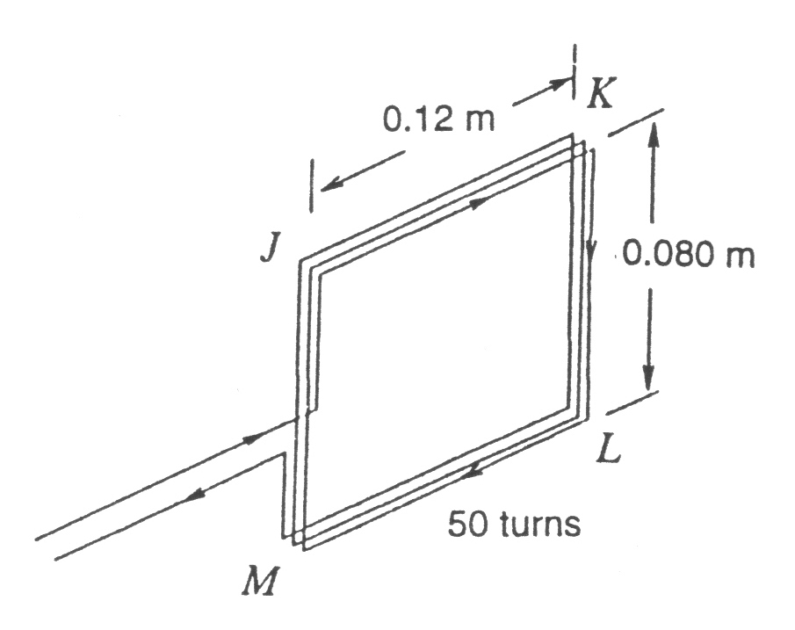
Figure 1
The armature is placed in the field of a two pole magnet. This is basically an electromagnet producing a field. This is shown in Figure 2 below. The field goes from N to S. The armature windings and the field coils are connected in series. When the motor is operating, the current flowing in the armature is 1.5 A.
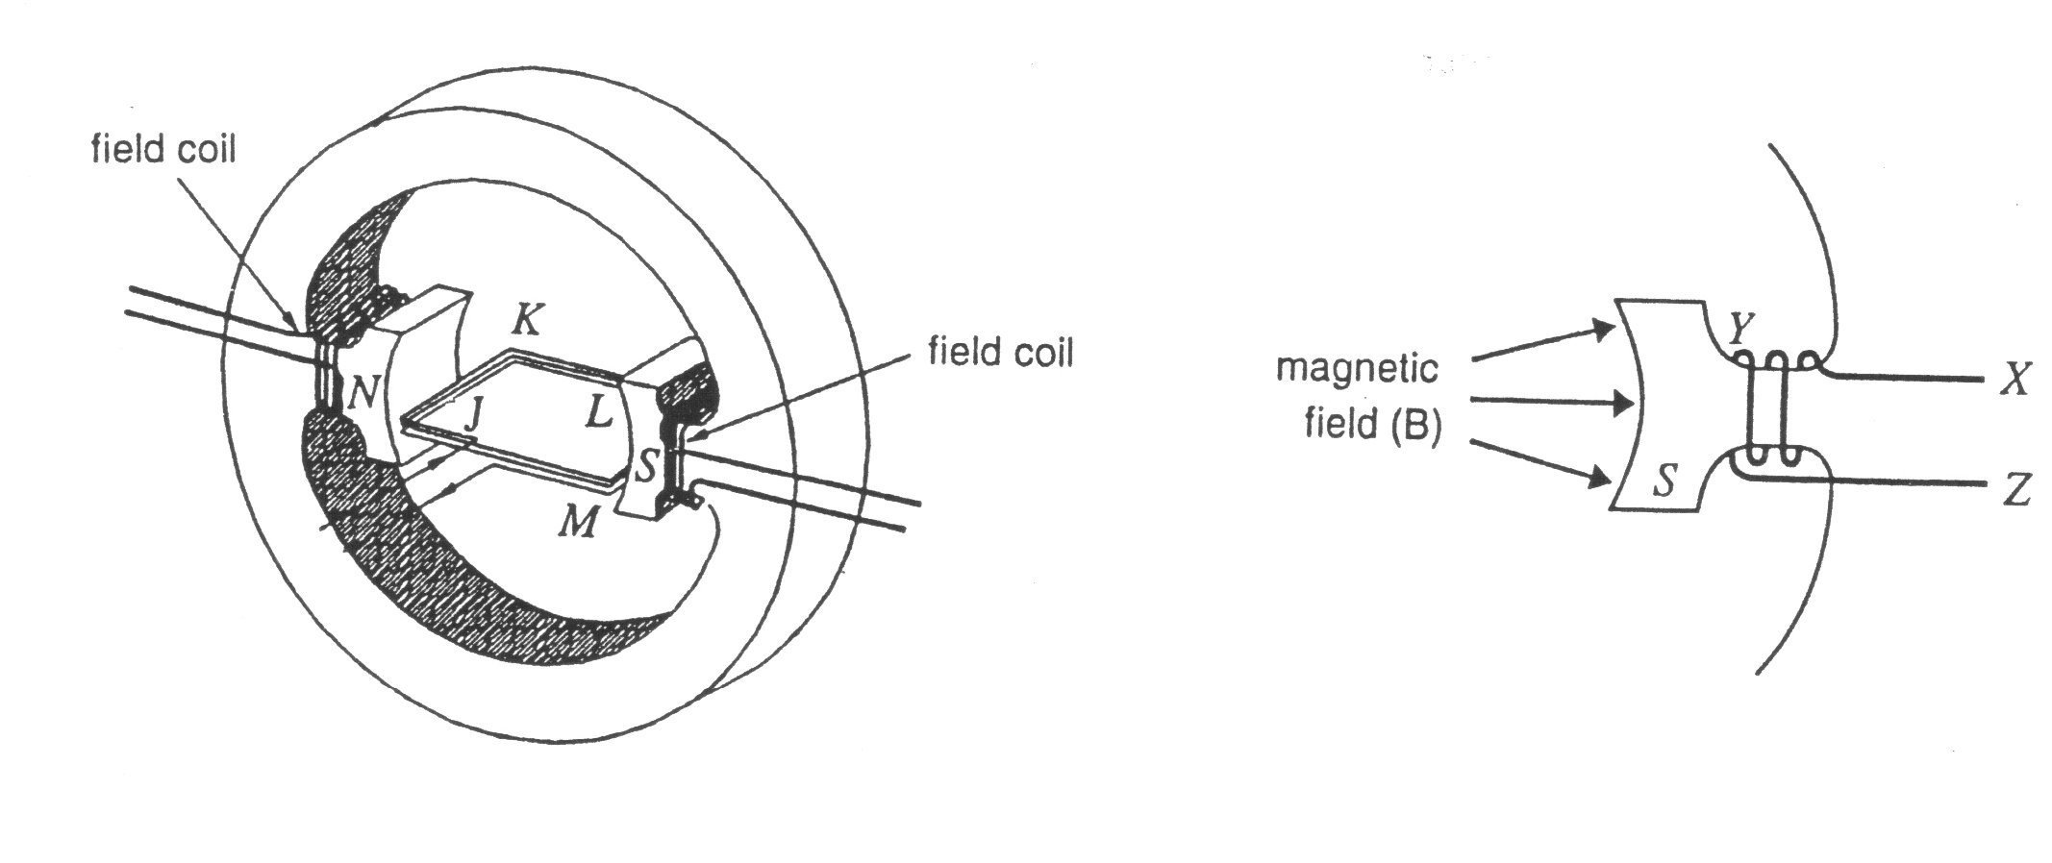
Figure 2: Armature inside field magnet Figure 3: Detail of field coil

(a) In which direction must the current flow in the field coils to produce the field direction indicate in Figure 3?
A: in the direction XYZ, B: in the direction ZYX,
C: in no fixed direction - the current is alternating, D: it is mot possible to tell.

(b) What is the magnitude of the force on the side LM of the armature when it is placed in the field of the two pole magnet, as shown in Figure 2? The side LM is 0.080 m long and has a current of 1.65 A flowing in it. The magnetic field in the region is 0.10 T.

(c) The armature is at rest in the position shown in Figure 2.
Which of the following alternatives best describes its motion when he current starts flowing and the motor is operating normally.
A: It will start rotating clockwise
B: It will start rotating anticlockwise
C: It will start rotating, but we cannot say in which direction
D: It will remain at rest.

(d) The current in the motor is doubled to 3.0 A. This increases the magnetic field by a factor of 2. Which of the following best describes the effect this will have on the force on the side LM?
A: increased by a factor of two B: increased by a factor of four
C: reduced to half D: reduce to one quarter
E: remain the same.

Question 2 (1993)
Figure 4 shows a model DC motor. The students connected a battery between x and y (see Figure 4). The coil is now rotated continuously in the same direction.
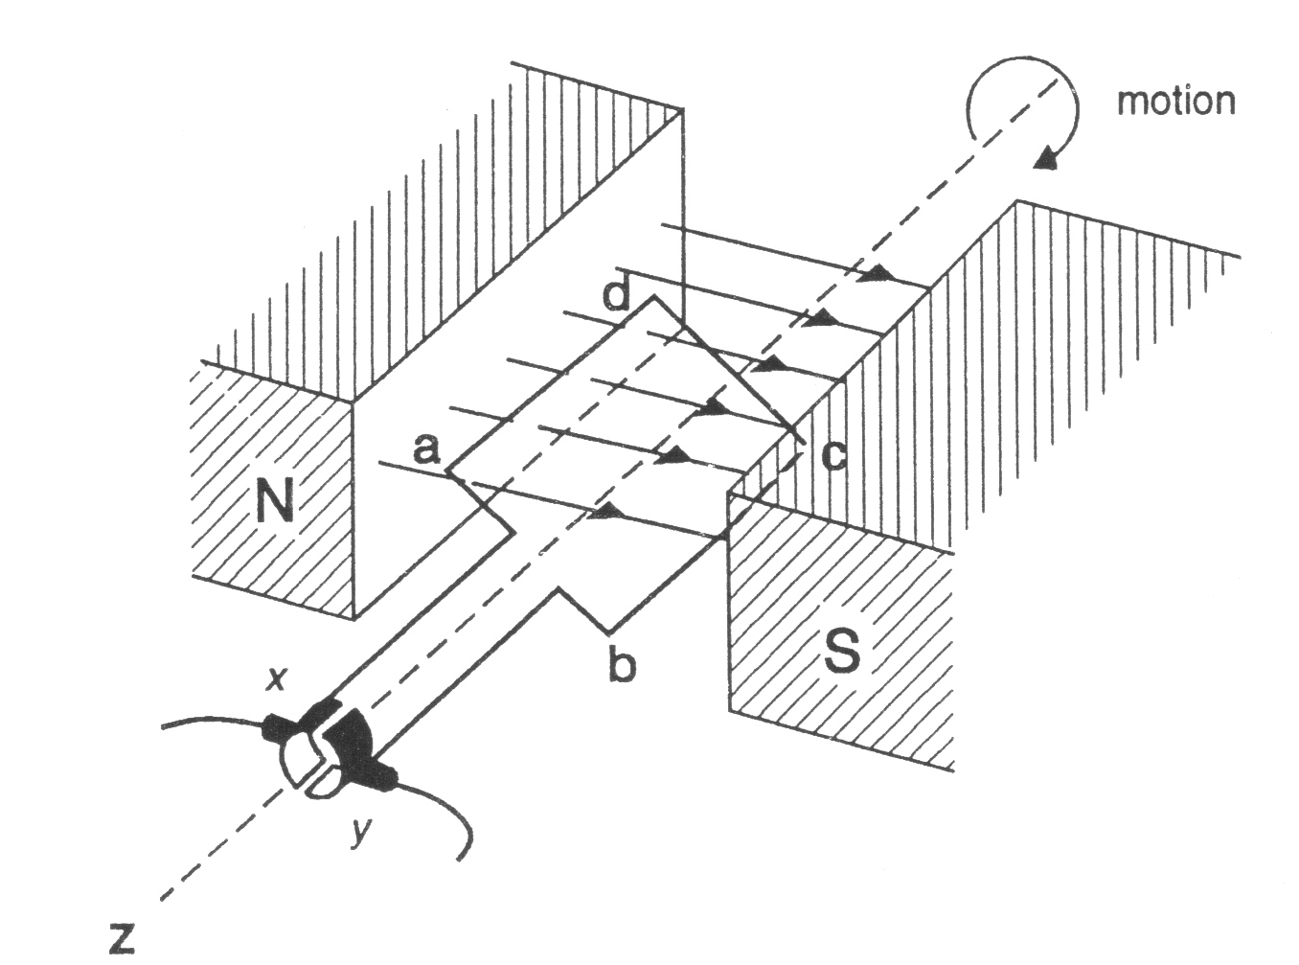
Figure 4

(a) Explain how the split ring commutator enabled the coil to rotate always in the same direction.
(2 marks)
(b) How should the terminals of the battery be connected to x and y (see Figure 1) to make the coil rotate clockwise as viewed from Z?
(1 mark)

Question 3 (1994)
A student built a model DC motor. The motor is shown in Figure 5. The arrows show the direction of the magnetic field.

The coil of the motor was formed from 50 turns of wire. Each turn was rectangular, having length 0.050 m (sides WX and YZ) and width 0.030 m (sides XY and WZ). The magnetic field can be assumed to be uniform and have a value of 0.048 T.

The student mounted the coil to allow it to rotate freely and placed it between the poles of the magnet. When the terminals of the coil were connected to a battery the coil began to rotate.
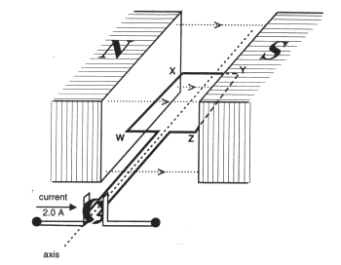
Figure 5

(a) Draw arrows to show the direction of the force on sides WX and XY of the coil when the plane of the coil is parallel to the magnetic field and the current direction is as shown. If the force on either side is zero, then label that side 'zero force'.
1 mark

(b) What is the magnitude of the force on the side YZ of the 50-turn coil when the coil is in the orientation shown in Figure 5 and the current in the coil is 2.0 A?
1 mark

Several orientations of the coil, as viewed along the axis, are shown in Figure 6.
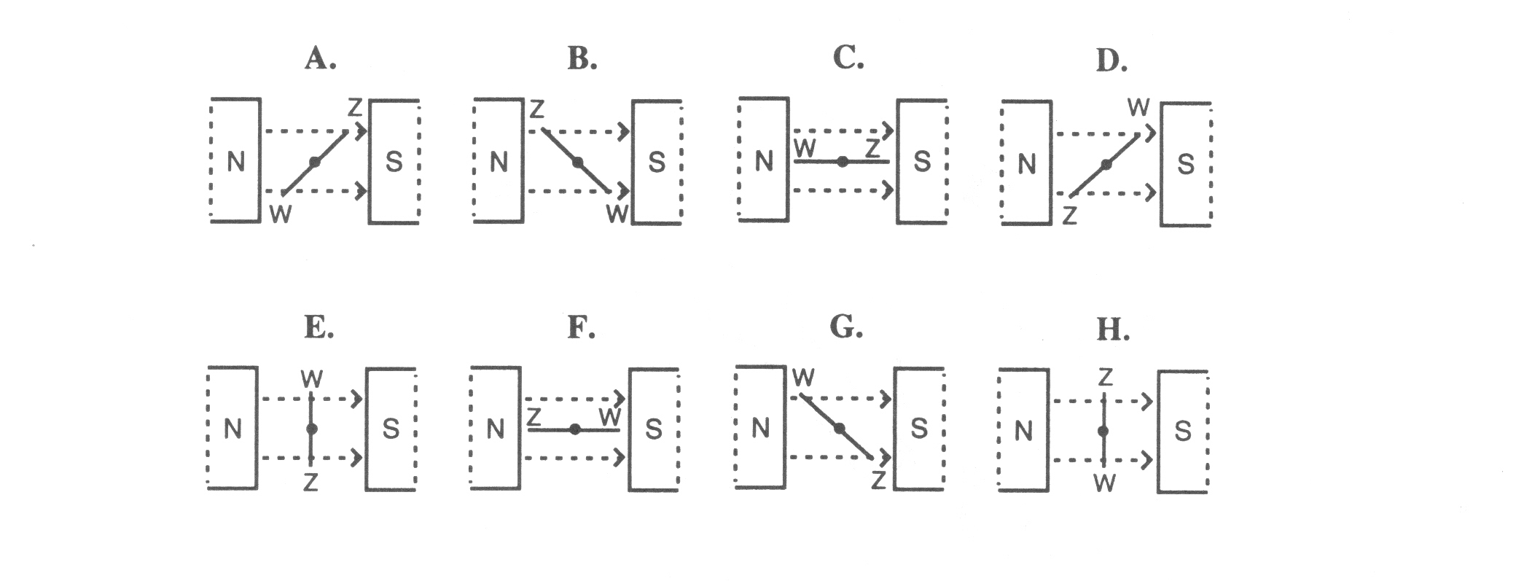
Figure 6
(c) In which one or more orientations (A-H above) does the magnitude of the Torque experienced by the coil have its maximum value? Justify your answer. You may find it helpful to draw diagrams to assist your explanation. 2 marks

You are asked to design another motor, of the same type, in which the coil will experience a greater maximum Torque. You may make any changes you wish.

(d) Describe two changes you would make and explain why each of these changes would increase the maximum torque on the coil.
2 marks
Question 4 (1995)
A student has pulled apart a small DC motor to observe how it operates. Although the motor looks complicated, the motor can be drawn in simple form as shown in Figure 45 below. In this simple model the square coil, attached to the commutator, rotates in a uniform magnetic field of strength 0.50 T. A current of 500 mA flows through the coil. Each side of the coil is 3.0 cm long.
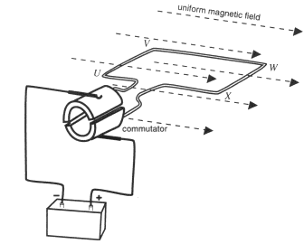

Figure 45
a) With the coil oriented as in Figure 45, what is the magnitude of the force on side VW of the coil? (1 mark)

b) Describe the principles of operation of the simple motor shown in Figure 45. In your answer discuss the direction of rotation, the purpose of the commutator, and the way the torque depends on the coil orientation. (3 marks)

Question 5 (1996)

A DC electric motor is illustrated below in Figure 7
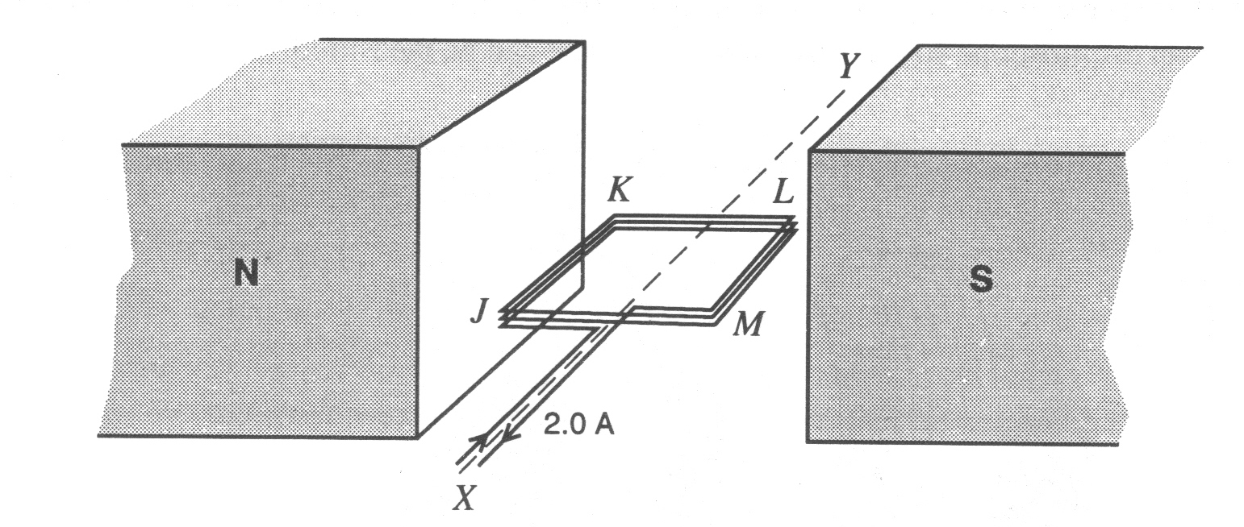
Figure 7

The permanent magnet shown in Figure 7 produces a uniform magnetic field of 3.0 x 10⁻² T between the pole pieces. The coil JKLM, wound on a square armature of side 0.50 m consists of 20 turns of wire. There is a current of 2.0 A in each turn of the coil. The armature can rotate about the axis XY.

(a) For the coil oriented horizontally, as shown in Figure 7, calculate the magnitude of the total force exerted on the 20 turns of side JK.

(b) For the coil oriented horizontally, as shown in Figure 7, calculate the magnitude of the total force exerted on the 20 turns of side KL.

Curving the pole pieces of a magnet produces the magnetic field shown below in Figure 8. Maximum value of the field is 3.0 x 10⁻² T. This magnetic field will provide a greater average torque on coil JKLM, with the same coil current, than the magnetic field shown above in Figure 7.
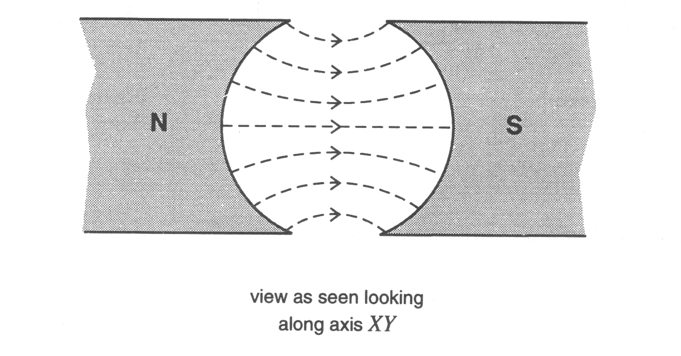
(c) Explain why such pole pieces lead to a greater average torque on the coil.

Question 6 (1997)
Figure below shows four positions (A, B, C, D) of the coil of a DC motor. The coil can be assumed to be a single wire which is in a uniform magnetic field parallel to the coil when in the orientation shown in diagram A. The coil is attached to a commutator, to which current is passed by brushes (not shown in the figure).
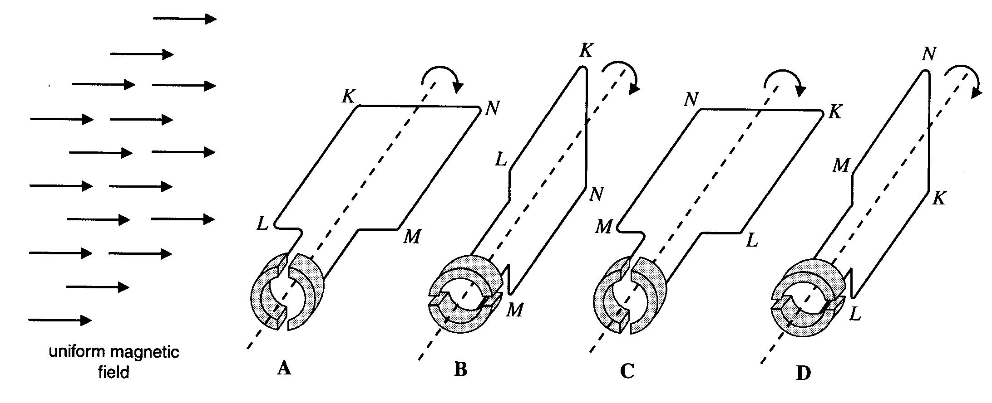
(a) For the coil shown in orientation A of the above figure, in which direction is the current flowing in the side KL? (1 mark)

Side KL of the coil is 0.10 m long, and a magnetic force of 0.60 N acts on it.
(b) If the magnetic field has a magnitude of 1.5 T, what is the magnitude of the current in the coil?
(1 mark)
Consider two cases:
i) The coil is at rest with the orientation shown in diagram A of the above figure.
ii) The coil is at rest with the orientation shown in diagram B of the above figure.
(c) Explain what would happen, in each case, if current is allowed to flow in the coil. Your answer should discuss the forces on each side of the coil, and their net effect. (2 marks)

Question 7 (1986)
The essential features of a small DC electric motor are shown in the diagram below. The rotating coil of the motor is connected to a DC supply whose polarity is marked on the diagram. The direction of the magnetic field is also shown on the diagram
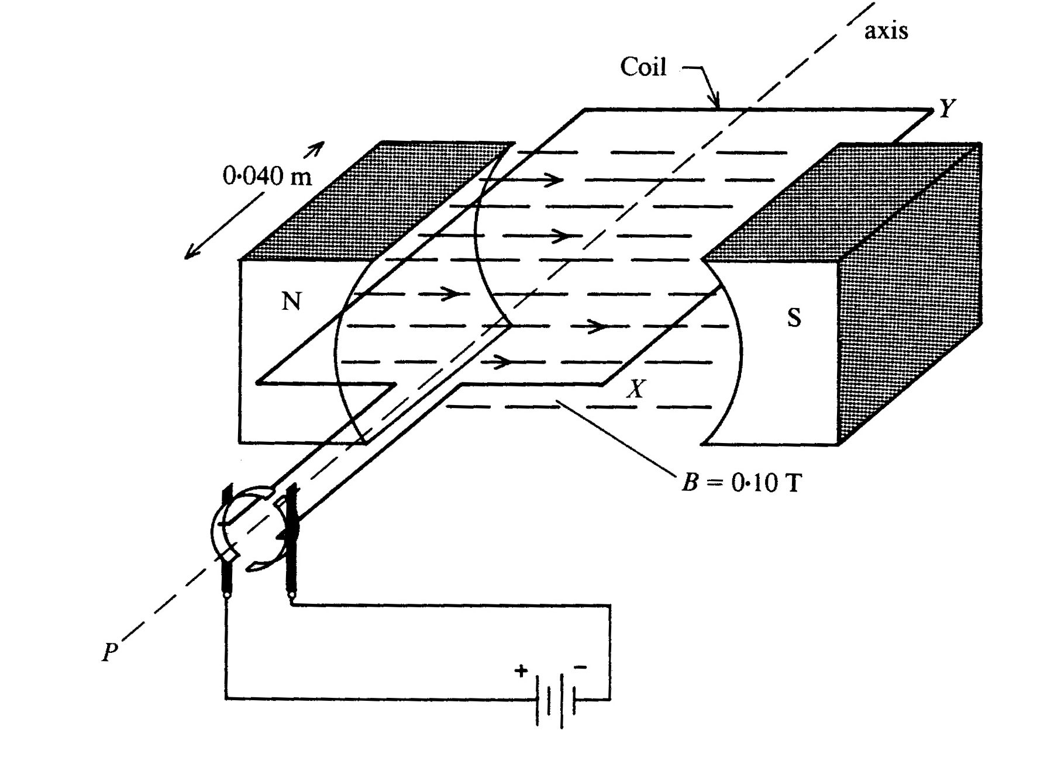
(a) With the coil in the position shown in the diagram which of the following (A - C) shown the direction of rotation of the coil? (1 mark)
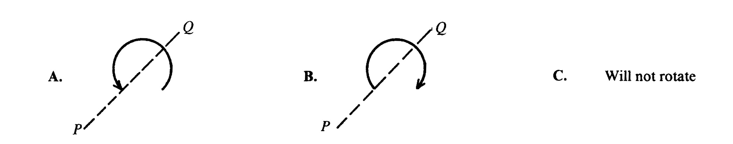
The strength of the motor's magnetic field is 0.10 T and the length of the conductors in the field is 0.040 m.
(b) What is the maximum force that will act on the segment XY (marked on the diagram), if a current of 5.0 A flows in the coil? (1 mark)

Solutions
Question 1
(a) B Using hand grip rule, the magnetic field inside the coil is to the right, the direction of the current is down the front
(b) 0.90N F = nBIl = 50 x 0.10 x 1.5 x 0.12 = 0.90 N
(c) B Current is from L to M, direction of magnetic field is left to right, so direction of force is up, producing anticlockwise current.
(d) B Field is doubled, current is doubled, so the force is quadrupled.

Question 2
(a) The split ring commutator reverses the current (1), twice every cycle (1), when the coil is at right angles to the magnetic field (1)
(b) Clockwise means force on ad is up, since the magnetic field is from left to right (N --> S), so using your hand rule the current is from d to a, which means the positive of the battery is connected to y and the negative to x.

Question 3
(a) Force on WX is down, Force on YZ is up
(b) 0.24 N Force = nBIl = 50 x 0.048 x 2.0 x 0.050 = 0.24 N
(c) C, F The forces on WX and YZ do not change in direction. Torque is a maximum when the lines of the action of these two forces are the furthest apart. This occurs when the coil is parallel to the field.
(d) Stronger magnetic field will result in stronger force and therefore torque. Larger current will result in a larger force, etc. More turns will results in a larger force, etc. A longer length, WX and YZ will results in a larger force, etc. A larger separation between WX and YZ will result in the forces being further apart, etc.

Question 4
(a) Using F = BIl, but current is parallel to the magnetic field so Force = zero.
(b) The direction of the force on UV is UP and the force on WX is down. This produces a clockwise rotation. The torques depends of the separation of the lines of action of the two forces, which is a maximum in Figure 6 and is zero when the coil perpendicular to the field. If the coil without a commutator turns beyond the perpendicular the forces are unchanged in direction and the torque will return the coil to the perpendicular. A commutator is needed to change the direction of the current when the coil is perpendicular to the field, so that as the coil moves past the perpendicular the forces reverse direction and the torque continues to turn the coil for 180⁰ when the commutator changes the direction of the current again.

Question 5
(a) 0.060 N Force = nBIl = 20 x 3.0 x 10⁻² x 2.0 x 0.050 = 6.0 x 10⁻² N
(b) Zero Current is parallel to the field, so the force is zero.
(c) In Figure 3, as the coil rotates 90⁰, the size of the torque reduces from a maximum to zero because even though the forces are unchanged, the distance between their lines of action gets smaller, equaling zero after 90⁰. Whereas in Figure 4, because of the shape of the filed the force will always at right angles to the coil, giving a constant separation between the lines of action, fixed at the maximum value, at least while the coil is inside the magnetic field.

Question 6
(a) K to L Using the hand rule, Field is to right, Force is up, so current is K to L.
(b) 25 A Using Force = nBIl , I = 1.5 / (0.60 x 0.10) = 25 Amp.
(c) For i) the force on KL is up and the force on MN is down, as their lines of action are on either side of the axis, there is a net torque and the coil rotates. For ii) the answer depends on the design of the commutator and brushes. There may be a complete break in the circuit, leading to zero current and so no force or torque. It is possible that the current may short through the commutator from brush to brush without going through the coil and so burn out the motor. It is also possible that current flows through the coil producing forces on KL and MN. The forces will be in opposite direction, but because their lines of action pass through the axis, there is no torque and the motor does not turn.

Question 7
(a) A The current flows from Y to X in the coil. Using the hand rule, the force on the left side of the coil is down, while the force on XY is up. So the coil rotates in an anticlockwise direction.
(b) 0.020 N Using F = nBIl, F = 0.10 x 5.0 x 0.040 = 0.020 N

