Questions from Previous VCE Exam Papers - Photoelectric Effect

Question 1 1999
Experimental work was carried out to investigate the photoelectric effect by shining light onto a particular metal surface. Measurements were made of the number and maximum kinetic energy of the emitted electrons from this particular metal surface for different frequencies and intensities of light.

a) Which one of the following (A - D) was not one of the findings?
A. The ability to eject electrons from this metal depended only on the frequency of light.
B. At frequencies below the 'threshold frequency' no electrons were ejected from the metal no matter how high the intensity was.
C. The 'stopping potential' for the photoelectrons was independent of the light intensity.
D. The maximum kinetic energy of the photoelectrons depended only on the intensity of the light.

The apparatus shown below was set up to investigate the photoelectric effect.
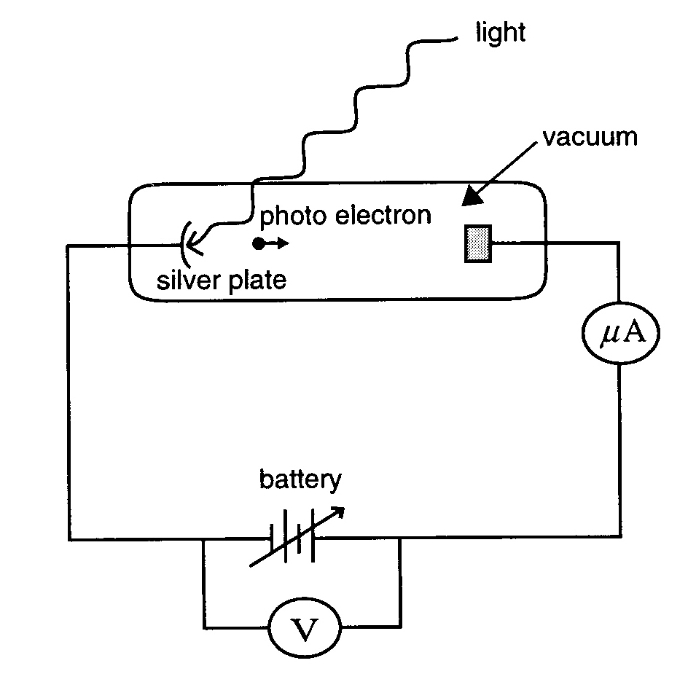
Using this apparatus it is found that light of wavelength 254 nm (2.54 x 10⁻⁷ m) ejects photoelectrons from a silver plate. The work function of the silver surface is 4.7 eV.

b) Calculate the energy, in eV, of a single photon of light of wavelength 254 nm (2.54 x 10⁻⁷ m).

c) What is the kinetic energy, in eV, of the fastest moving photoelectrons ejected by light of 254 nm?

Question 2 1996
An experiment is carried out to investigate the photoelectric effect. Light of various single frequencies shines onto a clean metal plate inside an evacuated glass tube as shown below.
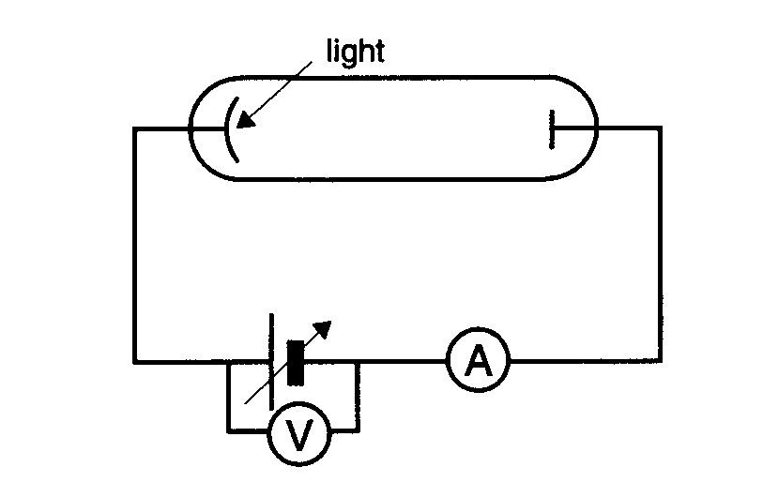
The maximum kinetic energy of the photoelectrons is measured for the different frequencies, giving the results shown below.
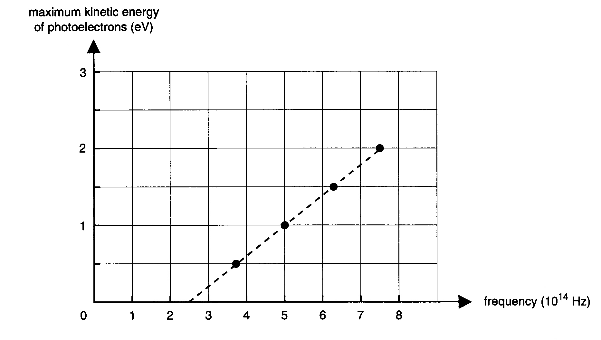
a) From this graph calculate the value of Planck's constant, h, in the units eV s. You must show your working.

b) Calculate the minimum retarding voltage needed to prevent an electron of kinetic energy
4.8 x 10⁻¹⁹ J from crossing the evacuated glass tube.

c) Which one of the plotted lines (A - E) in the graph below would be obtained for the same metal plate for light of double the intensity.
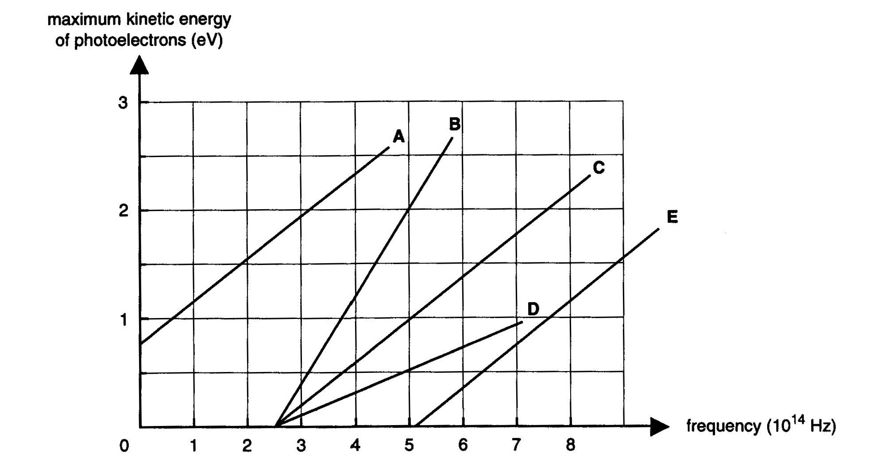
Newton proposed a particle model for light and Huygens proposed a wave model for light.

d) Explain, giving reasons, how Einstein's interpretation of the photoelectric effect supported a wave or a particle model.

Question 3 1995
In early experiments to investigate the photoelectric effect, a beam of light of a single frequency was directed at a clean surface of potassium metal. The maximum kinetic energy of electrons which were ejected from the metal was measured.

When the experiment was repeated with different frequencies of light the maximum kinetic energy of electrons depended on the frequency of the light as shown below.
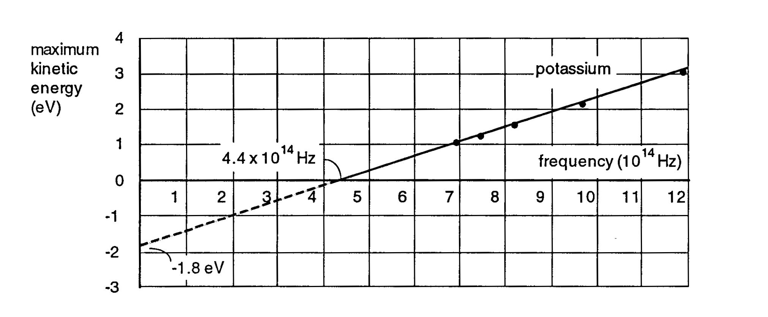
a) What is the minium energy of a light photon that can eject an electron from potassium metal? (Answer in units of eV)

The graph above shows that electrons ejected by light of frequency 6.0 x 10¹⁴ Hz have a maximum kinetic energy of 0.7 eV. The maximum kinetic energy of electrons ejected by light of frequency
1.2 x 10¹⁵ Hz is 3.2 eV

b) Explain why the maximum kinetic energy of electrons ejected by light of a higher frequency is greater than the maximum kinetic energy of electrons ejected by light of a lower frequency.

The minimum photon energy required to eject electrons from copper is approximately double the value for potassium.

c) Which of the graphs below would best describe the results if the experiment were repeated with copper instead of potassium? Explain your choice, commenting on the slope of the lines for potassium and copper and the points where the lines cross the frequency axis.

(The potassium results have been included for comparison.)
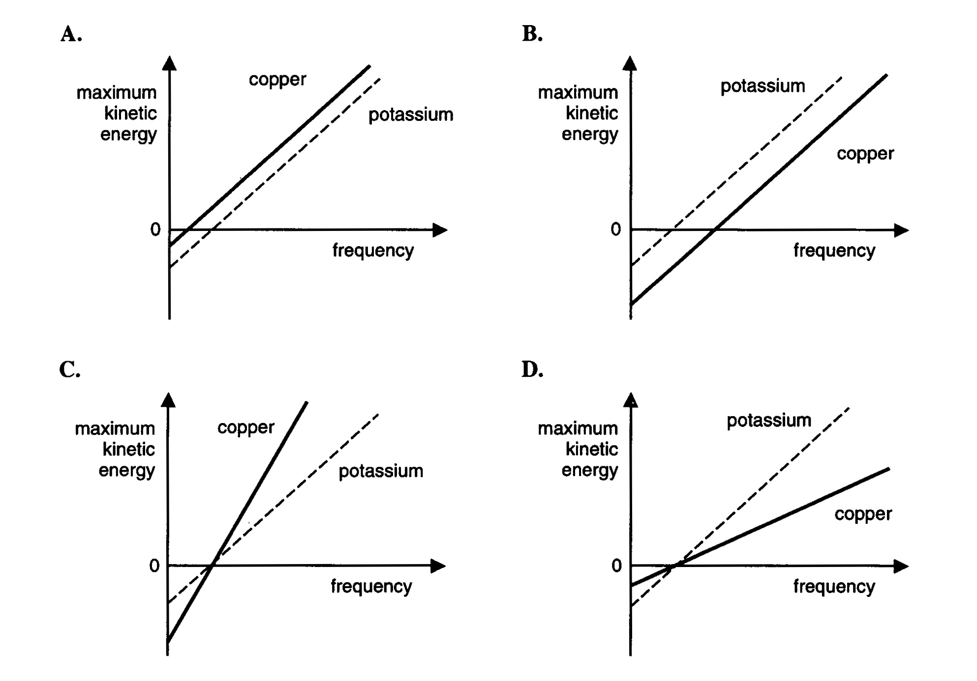

Question 4 1990 (8 min)
The photo-electric effect was one of the most important pieces of experimental evidence concerning the nature of light radiation. Einstein won the Nobel prize for his interpretation of the data.

The apparatus shown below on the left allows the kinetic energy of the most energetic electrons (KE_{e}) emitted from the metal to be measured when light of different frequencies, f, is shone onto the metal surface. The results of such measurements are sketched below on the right.
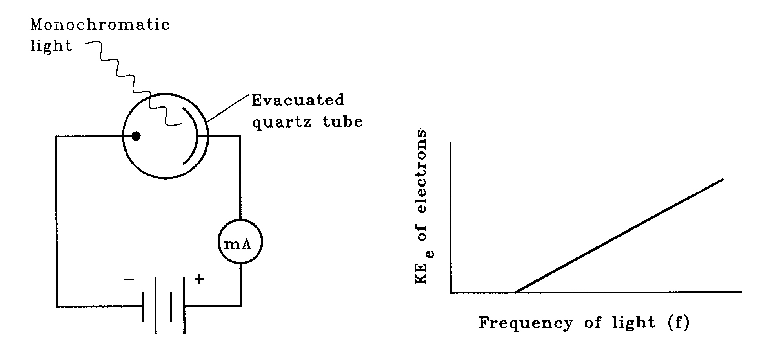
Discuss the results shown in the figure on the right, and show how they relate to Einstein's famous equation (KE = hf - ϕ). You should mention the physical significance of the terms 'hf' and 'ϕ' in the equation.

The results shown in the figure are independent of the intensity of the light used in the measurement. Explain what this fact implies about the nature of light.
Question 5 1988
The light meter of a particular camera consists of a circuit using a photoelectric cell as shown below.
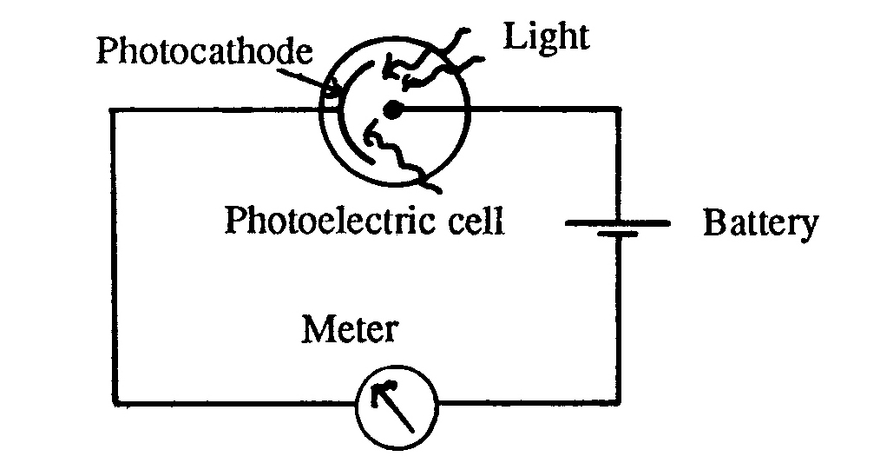
The material of the photocathode has a cut-off potential versus frequency relationship as shown below.
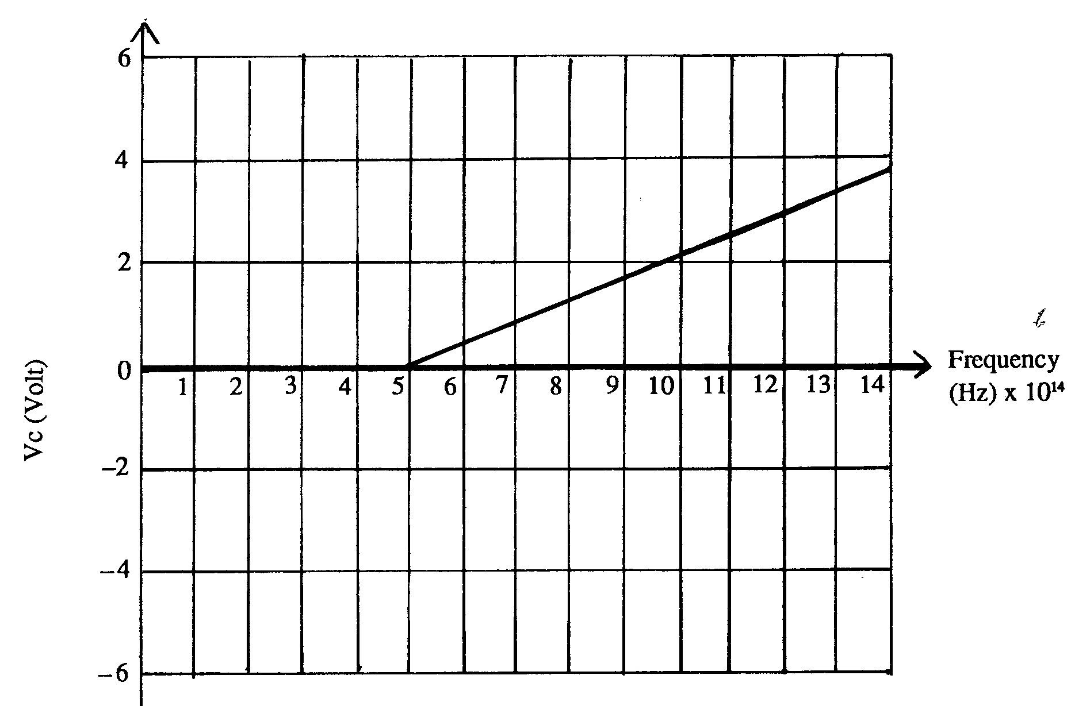
a) What is the work function (in eV) of the cathode material?
b) What is the maximum kinetic energy (in eV) of an ejected electron when light of frequency 7 .0 x 10¹⁴ Hz falls on the photocathode.

Question 6 1987
The diagram below shows part of the circuit for a burglar alarm.
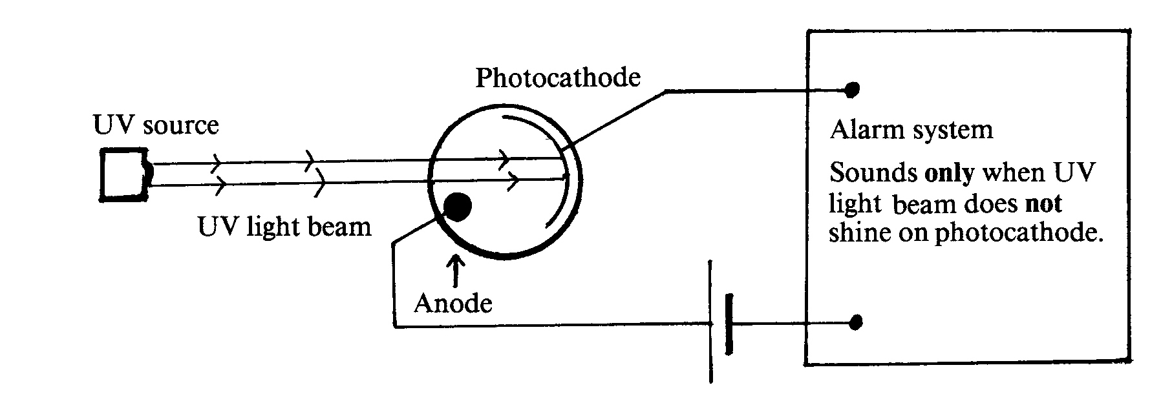
The alarm system is arranged in such a way that, when ultra-violet (UV) light shines on the photocathode, the alarm does not sound but when the UV light beam is broken the alarm will start to sound.

a) Which of the statements (A-D) below is the best explanation of the effect of shining UV light on the photocathode?
A The UV light photons eject electrons from the photocathode causing an electric current to flow in the circuit.
B The UV light photons eject positive charges from the photocathode causing an electric current to flow in the circuit.
C The UV light prevents electrons from being ejected from the photocathode, hence the alarm sounds only when the beam is broken.
D The UV light deflects electrons which normally flow from the photocathode to the anode.

The ultra-violet light source is now replaced by a source of red light.

b) Which of the statements (A-E) below best describes the result of this replacement?
A The alarm will definitely operate as normal.
B The alarm will now ring whether or not the light beam is broken.
C The alarm will now ring when the light beam is shining but will stop when the beam is broken.
D The alarm will only operate normally if the light beam is directed at the anode rather than the photocathode.
E Whether or not the alarm will operate normally depends on the value of the work function of the photocathode material.

The material of the photocathode has a work function of 2.0 eV, and with UV light shining on it the ejected electrons have a maximum kinetic energy of 3.0 eV.

c) What is the frequency, in hertz, of the UV light photons?

Question 7 1986
When ultraviolet light falls on a potassium surface, electrons are emitted from the surface of the metal.
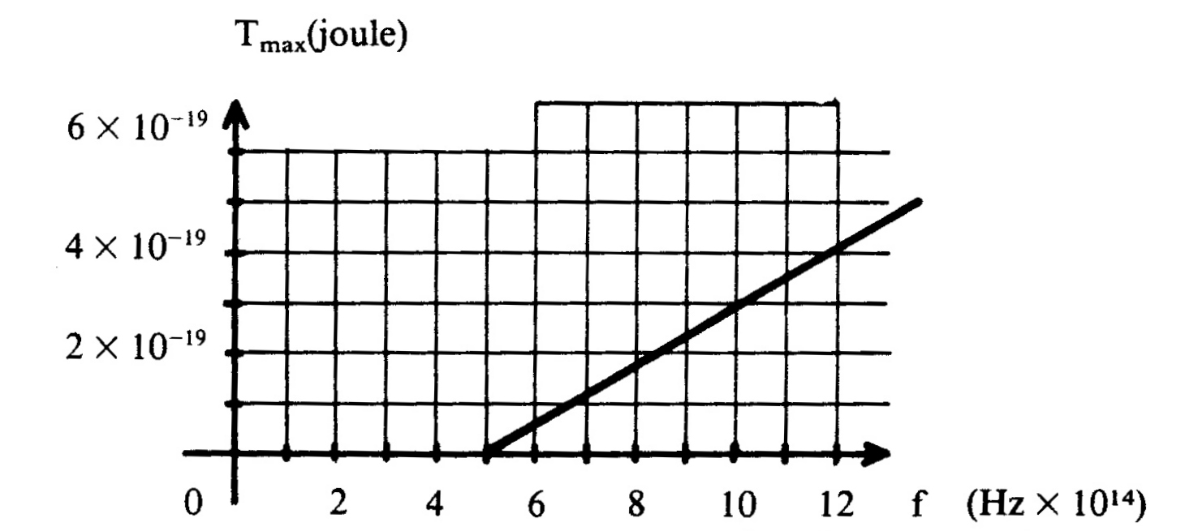
The kinetic energy, T_{max}, of the mots energetic electrons emitted is found to be dependent upon the frequency, f, of the radiation used, as shown in the graph above.

a) Which of the graphs below A - E below represents the result if the intensity of the light were doubled?

b) Which one of more of the graphs A - E below, could represent the result if the potassium were replaced by another metal?
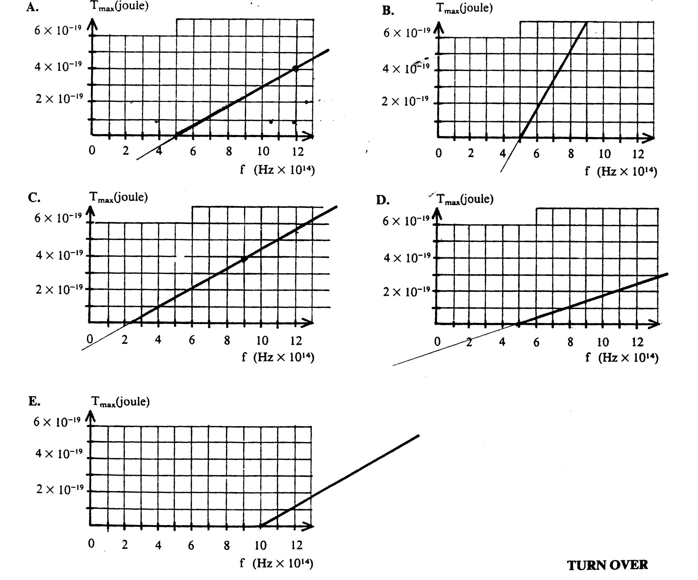

Question 8 1985
An apparatus to investigate the photoelectric effect is set up as shown below. The ammeter measures the current I in the circuit, and the voltmeter measures the potential V_{ee} of the collector relative to the emitter.

V_{ee} may be made positive or negative as shown.
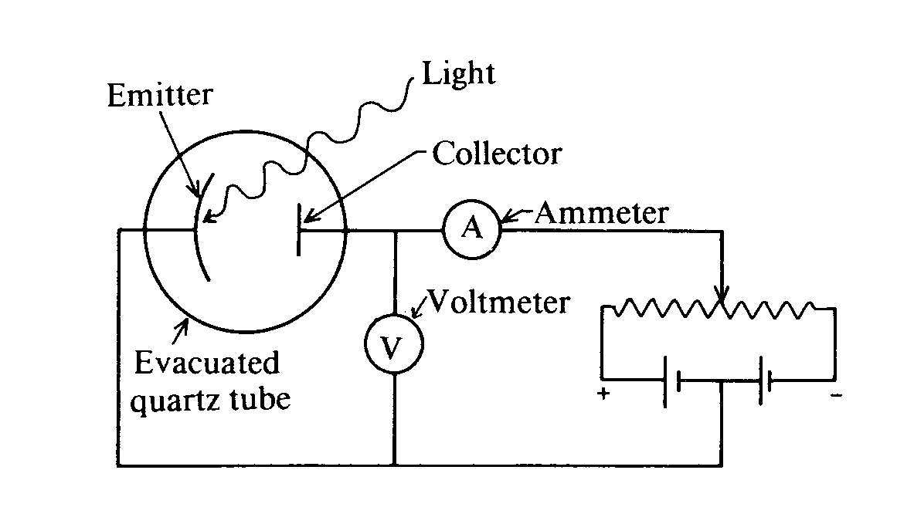
For an emitter made of a particular material and illuminated with light of a fixed intensity an frequency, the following graph of I as a function of V_{ee} is obtained. I₀ is the current obtained for a very large value of V_{ee}.
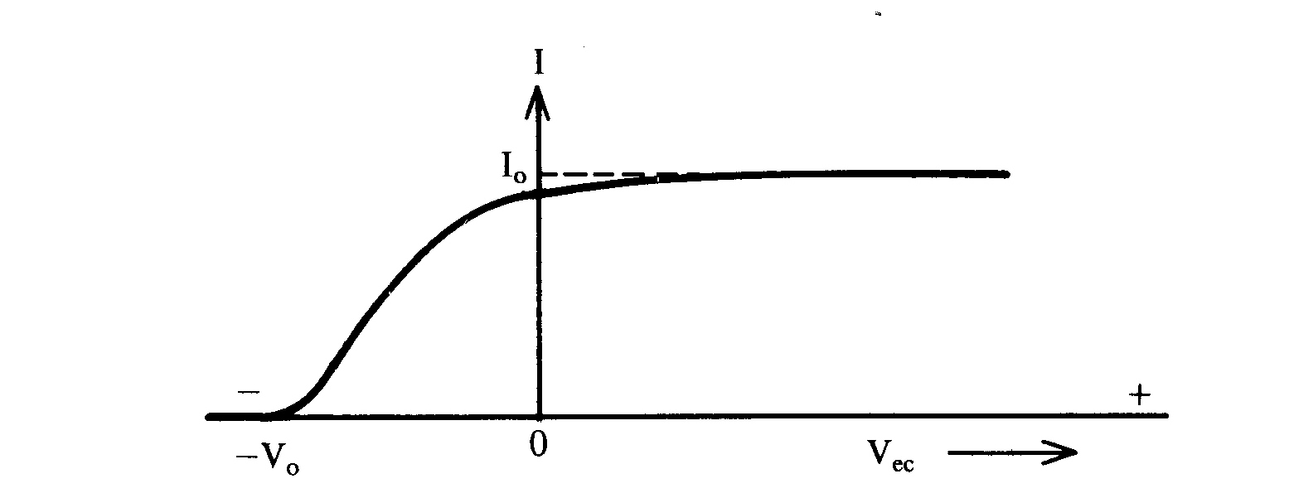
a) Which graph (A - F) below best represents the results expected if the intensity of the light were doubled, using the same emitter and the same frequency of light?
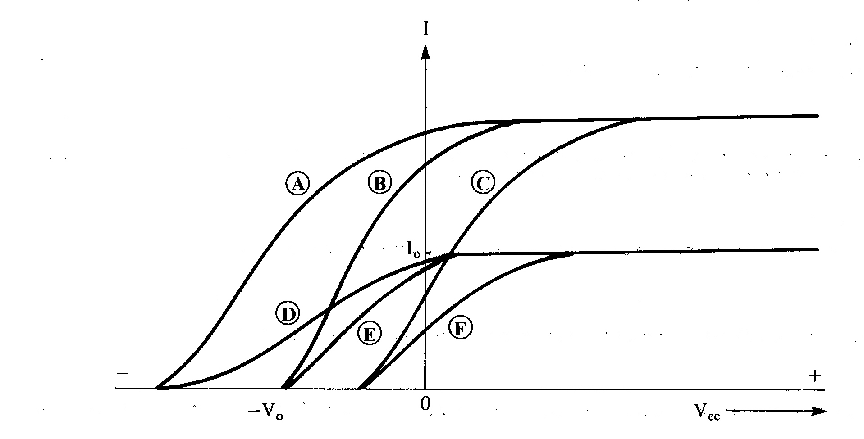

The experiment is repeated using the same emitter of light, but light of a higher frequency. The intensity is such that the same number of photons per second falls on the emitter as originally, when obtaining the original results.

b) Which of the graphs (A - F) best represents the results obtained?

c) Which one or more of the statements (A - D) below concerning the quantities measured in the original experiment is correct?
A V₀ is the kinetic energy of the most energetic electrons as they leave the emitter.
B eV₀ is the kinetic energy of the most energetic electrons as they leave the emitter (e being the charge on the electron).
C V₀ / I₀ is the internal resistance of the emitter (its work function).
D I₀ is proportional to the number of electrons per second released from the emitter.

Question 9 1984
The emission of electrons from a metal surface when light falls on it is called the photo-electric effect.

Which of the following statements gives the best explanation of the effect?
A Because light cannot penetrate far into the metal, the light energy heats up the surface so that electrons are boiled off.
B The metal expands because of the light energy absorbed, leaving insufficient room for all of the electrons, so that some of them are forced out of the surface.
C Photons excite the metal atoms near the surface to higher energy states; the atoms then drop back to the ground state by emitting electrons.
D When a photon strikes the metal it may lose some of its energy to electrons near the surface. If enough photons collide with an electron it may eventually gain sufficient energy to be freed from the metal.
E When a photon collides with an electron near the surface of the metal, its energy is acquired by the electron which may then escape from the metal.

Question 10 1966
The maximum kinetic energy of electrons ejected from a particular metal surface by monochromatic light of frequency υ is measured by several different values of υ. The straight line in the following diagram is the line of best fit to the experimental points.
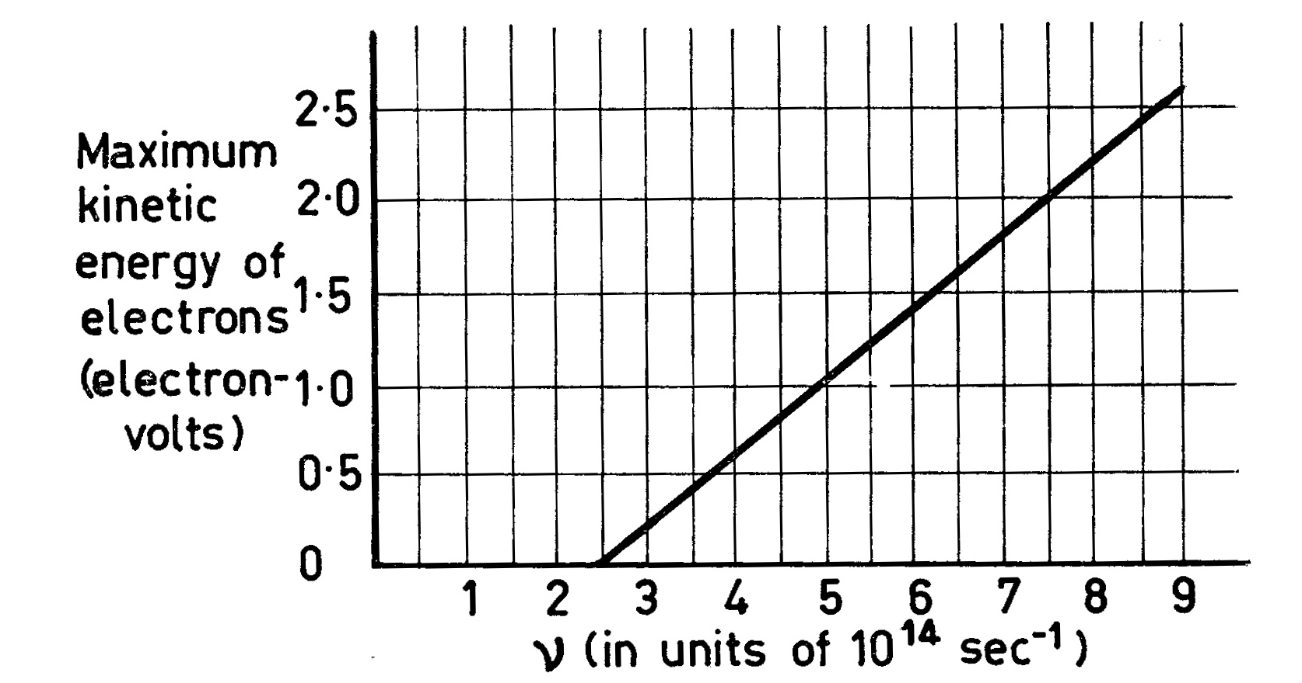
a) What is the value of Planck's constant (in eV-sec) as calculated from the graph?
b) What is the minimum energy (in electron-volts) required to extract an electron from this metal surface?
Question 11 1983
The figure below on the left shows an evacuated quartz-glass envelope containing two electrodes. These can be connected to a voltage V the magnitude and sign of which may be varied.

When ultra-violet light is shone on to the cathode a current may flow. The figure on the right shows the current as a function of ultra-violet light frequency for a given positive voltage V. Curves X and Y in the figure on the right are obtained for different cathode materials.
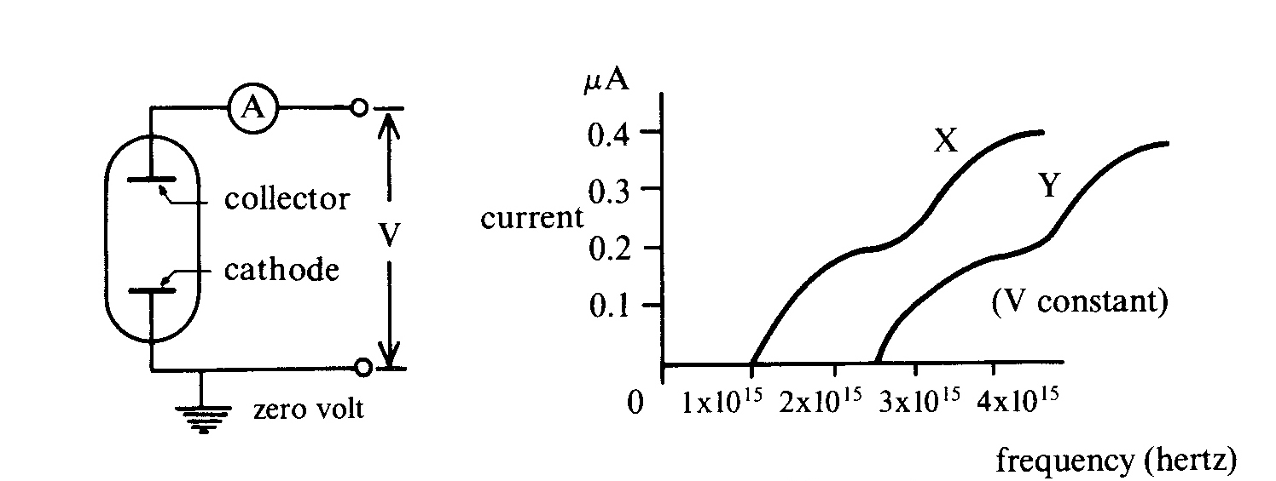

a) What is the longest wavelength of light for which electrons are emitted from the cathode of material X?
b) How much energy is needed to remove an electron from the surface of material X?
c) Light of frequency 3·0x 10¹⁵ Hz is shone on to a cathode of material Y. What value of V (sign and magnitude) must be applied to the collector to just prevent electrons from reaching it?
d) Under certain conditions a particular current is flowing in the circuit; which of the following is the best way to halve this current?
A halve the applied voltage V
B halve the wavelength of the light
C halve the distance between the cathode and collector
D halve the intensity of the light

Data
Speed of light c = 3.00 x 10⁸ ms⁻¹
Planck's constant h = 6.63 x 10⁻³⁴ J s = 4.14 x 10⁻¹⁵ eV s
charge of electron e = 1.6 x 10⁻¹⁹ C

Solutions
Question 1
a) D A, B and C are all true.
b) 4.9 eV E = hc/λ = 4.14 x 10⁻¹⁵ x 3.00 x 10⁸ / (2.54 x 10⁻⁷) = 4.9 eV
c) 0.2 eV Max KE = photon energy - work function = 4.9 - 4.7 = 0.2 eV

Question 2
a) 4.0 x 10⁻¹⁵ eV Planck's constant = gradient = 1 / ((5 - 2.5) x 10¹⁴) = 4.0 x 10⁻¹⁵ eV
b) 3.0 V electron energy in eV = 4.8 x 10⁻¹⁹ / 1.6 x 10⁻¹⁹ = 3.0 eV, so retarding voltage = 3.0 V
c) C Changing the intensity has no effect on the photon energy and so no effect on the graph.
d) The PE Effect supports the particle model. For the wave model: i) increasing the intensity means increasing the amplitude of the wave, so the ejected electrons should have more energy (WRONG), ii) changing the frequency of the wave does not change its energy, so ejected electrons will have same energy (WRONG) and will be ejected regardless of frequency or intensity (WRONG), iii) for low intensity, ejected electrons will not be emitted immediately. For the particle model: i) increasing the intensity means more photons, so there will be more ejected electrons with the same energy (CORRECT), ii) increasing the frequency, gives each photon more energy, so ejected electrons will have more energy (CORRECT) and will be ejected regardless of how low the intensity is (CORRECT).

Question 3
a) 1.8 eV E = hf, where f = threshold frequency. E = 4.14 x 10⁻¹⁵ x 4.4 x 10¹⁴ = 1.82 eV
b) Einstein's explanation of the PE Effect was that light consisted of packets of energy called photons, with the amount of energy in each packet proportional to the frequency of the light and that when these photons interacted with electrons they gave all their energy to just one electron. Light of a higher frequency will consist of photons with greater energy to give to each electron. According to the graph for this metal, electrons use a minimum of 1.8 eV of energy escaping from the surface. So light of a higher frequency will produce electrons with a greater max KE.
c) B Copper has twice the work function as Potassium and so twice the y-intercept for the graph, but still parallel to the Potassium graph.

Question 4
The graph is of the form y = mx + c which means the KE is proportional to the frequency, but there is a negative off set as the graph does not pass through the origin. The equation can be written as KE = hf - ϕ , with KE on the y - axis, frequency on the x - axis. The factor in front of the frequency represents the gradient of the graph and the constant is the y - intercept.

The equation can be interpreted as an energy equation. The KE of the electron equals the photon energy, given by hf, minus the minimum energy to escape the metal, the work function given by ϕ .

The fact that the graph is independent of the intensity of the light implies for the particle model of light, that increasing the intensity increases the number of photons, each with the same energy. So there is more energy due to more photons and more electrons will be ejected, but each will still have the same maximum kinetic energy.

Question 5
a) 2.1 eV Extrapolate the graph and find the y - intercept, or use the threshold frequency,
ϕ = hf₀ =5.0 x 10¹⁴ x 4.14 x 10⁻¹⁵ = 2.07 eV
b) 1.0 eV From graph find voltage for frequency = 7.0 x 10¹⁴ Hz, gives about 1.0 V, so KE = 1.0 eV. By calculation using the threshold frequency,
E = (7 -5) x 10¹⁴ x 4.14 x 10⁻¹⁵ = 0.83 eV

Question 6
a) A B, C and D are wrong.
b) E If the photon energy for red light exceeds the work function, then there will be a current, however in practice, this is unlikely, so B would be a realistic answer.
c) 1.2 x 10¹⁵ Hz Photon energy = 2 + 3 = 5 eV, so frequency, f, = E / h = 5.0 / 4.14 x 10⁻¹⁵
f = 1.2 x 10¹⁵ Hz

Question 7
a) A No change to gradient or intercepts.
b) C, E Same gradient, different intercepts

Question 8
a) B Greater intensity means more photons producing more electron giving a larger starting current. Same frequency means the same stopping voltage, so B.
b) D Same in initial current, but higher frequency means a greater stopping voltage as the electrons now have more energy, so D.
c) B, D A and C are wrong.

Question 9
a) E A - D are all wrong.

Question 10
a) 4.0 x 10⁻¹⁵ eVs Planck's constant = gradient = 1.0 / ((5 - 2.5) x 10¹⁴) = 4.0 x 10⁻¹⁵ eVs.
b) 1.0 eV Work function = hf₀ = 4.0 x 10⁻¹⁵ x 2.5 x 10¹⁴ = 1.0 eV

Question 11
a) 300 nm Threshold frequency for X = 1.0 x 10¹⁵ Hz, so wavelength = 3 x 10⁸ / 1.0 x 10¹⁵
l = 3.0 x 10⁻⁷ m = 300 nm.
b) 4.14 eV Work function = hf₀ = 4.14 x 10⁻¹⁵ x 1.0 x 10¹⁵ = 4.14 eV
c) 2.12 eV Using threshold frequency of 2.5 x 10¹⁴ Hz,
Max KE in eV = (3.0 - 2.5) x 10¹⁵ x 4.14 x 10⁻¹⁵ = 2.12 eV.
d) D Only reducing the intensity will reduce the current.

