**Sample Written examination # 2 – By Jack Graffeo**

**November 2023**

**Reading time: 15 mins**

**Writing time: 2 hours**

**QUESTION AND ANSWER BOOK**

**Structure of the exam**

|  |  |  |  |  |  |
| --- | --- | --- | --- | --- | --- |
|  | *Section* | *Number of questions* | *Number of questions to be answered* | *Number of marks* |  |
|  | A | 11 | 11 | 60 |  |
|  | B | 4 | 1 | 20 |  |
|  |  |  |  | Total 80 |  |

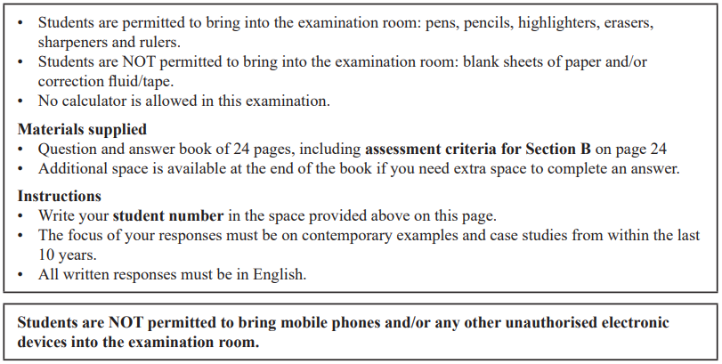

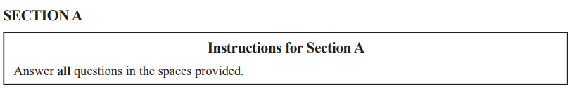

**Question 1** (2 marks)

Describe one aim of the state in global politics.

|  |
| --- |
|  |
|  |
|  |
|  |
|  |
|  |

**Question 2** (3 marks)

Explain one way the International Criminal Court (ICC) promotes multilateralism.

|  |
| --- |
|  |
|  |
|  |
|  |
|  |
|  |
|  |
|  |
|  |

**Question 3** (4 marks)

Explain how one legal non-state actor engages in global governance.

|  |
| --- |
|  |
|  |
|  |
|  |
|  |
|  |
|  |
|  |
|  |
|  |
|  |
|  |

**Question 4** (6 marks)

Analyse the extent to which the United Nations (UN) supports states in pursuing security and stability.

|  |
| --- |
|  |
|  |
|  |
|  |
|  |
|  |
|  |
|  |
|  |
|  |
|  |
|  |
|  |
|  |
|  |
|  |
|  |
|  |

**Question 5 (15 marks)**

One of the following Asia-Pacific states must be used as the focus of all responses to Question 5: Australia, China, Indonesia, Japan or the United States of America.

Selected Asia-Pacific state: ____________________________________________________

1. Describe one way in which pragmatism has influenced this Asia-Pacific state’s use of the military as a foreign policy instrument. (3 marks)

|  |
| --- |
|  |
|  |
|  |
|  |
|  |
|  |
|  |
|  |
|  |

1. Explain how aid has been used by this Asia-Pacific state in an attempt to achieve national security. (4 marks)

|  |
| --- |
|  |
|  |
|  |
|  |
|  |
|  |
|  |
|  |
|  |
|  |
|  |
|  |

1. Evaluate the success of this Asia-Pacific state in achieving regional relationships. (8 marks)

|  |
| --- |
|  |
|  |
|  |
|  |
|  |
|  |
|  |
|  |
|  |
|  |
|  |
|  |
|  |
|  |
|  |
|  |
|  |
|  |
|  |
|  |
|  |
|  |
|  |
|  |

**Question 6** (4 marks)

From the list below, select one ethical issue that you have studied this year:

**You must respond to the same ethical issue in Question 6 and 7.**

• human rights

• people movement

• development

• arms control

Ethical issue: _______________________________________________________________

Explain how a global actor's response to this ethical issue was guided by a particular ethical perspective.

|  |
| --- |
|  |
|  |
|  |
|  |
|  |
|  |
|  |
|  |
|  |
|  |
|  |
|  |

**Question 7** (5 marks)

Using one specific ethical debate, discuss how this ethical issue can transcend specific states, regions and continents.

**You must respond to the same ethical issue as Question 6.**

|  |
| --- |
|  |
|  |
|  |
|  |
|  |
|  |
|  |
|  |
|  |
|  |
|  |
|  |
|  |
|  |
|  |

**Question 8** (6 marks)

Select another ethical issue that you have studied this year. The ethical issue selected must be **different** from the one selected in Question 6 and 7.

Ethical issue ________________________________________________________________

Evaluate the extent to which one global actor’s response to this ethical issue reflects obligations outlined in one international law.

|  |
| --- |
|  |
|  |
|  |
|  |
|  |
|  |
|  |
|  |
|  |
|  |
|  |
|  |
|  |
|  |
|  |
|  |
|  |
|  |
|  |

**Question 9** (4 marks)

From the list below, select one global crisis that you have studied this year:

**You must respond to the same global crisis in Question 9 and 10.**

• climate change

• armed conflict

• terrorism

• economic instability

Global crisis: _______________________________________________________________

Explain how one global actor’s response to this global crisis has exacerbated the crisis.

|  |
| --- |
|  |
|  |
|  |
|  |
|  |
|  |
|  |
|  |
|  |
|  |
|  |
|  |

**Question 10** (5 marks)

Analyse one cause of this global crisis.

**You must respond to the same global crisis as Question 9.**

|  |
| --- |
|  |
|  |
|  |
|  |
|  |
|  |
|  |
|  |
|  |
|  |
|  |
|  |
|  |
|  |
|  |

**Question 11** (6 marks)

Select another global crisis that you have studied this year. The global crisis selected must be **different** from the one selected in Question 9 and 10.

Global crisis ________________________________________________________________

To what extent have unilateral responses been evident in response to this global crisis?

|  |
| --- |
|  |
|  |
|  |
|  |
|  |
|  |
|  |
|  |
|  |
|  |
|  |
|  |
|  |
|  |
|  |
|  |
|  |
|  |

**SECTION B**

Write an essay on one of the following questions in the space provided.

Your response will be assessed according to the assessment criteria set out on the back page.

**Question 1** (20 marks)

‘The power of the state is being increasingly challenged in global politics.’ Discuss

**OR**

**Question 2** (20 marks)

Don’t do this question, unless you want to do bad on this exam.

**OR**

**Question 3** (20 marks)

‘In ethical debates, the cosmopolitan perspective is not accepted universally.’ Discuss with reference to at least one ethical issue.

**OR**

**Question 4** (20 marks)

Analyse the impact of the key aspects related to one global crisis.



|  |
| --- |
|  |
|  |
|  |
|  |
|  |
|  |
|  |
|  |
|  |
|  |
|  |
|  |
|  |
|  |
|  |
|  |
|  |
|  |
|  |
|  |
|  |
|  |
|  |
|  |
|  |
|  |
|  |
|  |
|  |
|  |
|  |
|  |
|  |
|  |
|  |
|  |
|  |
|  |
|  |
|  |
|  |
|  |
|  |
|  |
|  |
|  |
|  |
|  |
|  |
|  |
|  |
|  |
|  |
|  |
|  |
|  |
|  |
|  |
|  |
|  |
|  |
|  |
|  |
|  |
|  |
|  |
|  |
|  |
|  |
|  |
|  |
|  |
|  |
|  |
|  |
|  |
|  |
|  |
|  |
|  |
|  |
|  |
|  |
|  |
|  |
|  |
|  |
|  |
|  |
|  |
|  |
|  |
|  |
|  |
|  |
|  |
|  |
|  |
|  |
|  |
|  |
|  |
|  |
|  |
|  |
|  |
|  |
|  |
|  |
|  |
|  |
|  |
|  |
|  |
|  |
|  |
|  |
|  |
|  |
|  |
|  |
|  |
|  |
|  |
|  |
|  |
|  |
|  |
|  |
|  |
|  |
|  |
|  |
|  |
|  |
|  |
|  |
|  |
|  |
|  |
|  |
|  |
|  |
|  |
|  |
|  |
|  |
|  |
|  |
|  |
|  |
|  |
|  |
|  |
|  |
|  |
|  |
|  |
|  |
|  |

**END OF SECTION B**

**Extra space for responses.**

**Clearly number all responses in this space.**

|  |
| --- |
|  |
|  |
|  |
|  |
|  |
|  |
|  |
|  |
|  |
|  |
|  |
|  |
|  |
|  |
|  |
|  |
|  |
|  |
|  |
|  |
|  |
|  |
|  |
|  |
|  |
|  |
|  |
|  |
|  |
|  |
|  |
|  |
|  |
|  |
|  |
|  |
|  |
|  |
|  |
|  |
|  |
|  |
|  |
|  |
|  |
|  |
|  |
|  |
|  |
|  |

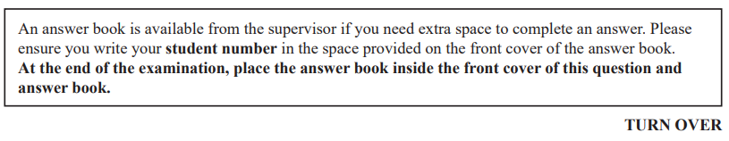

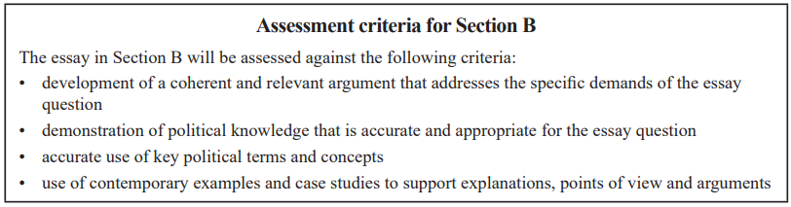

**END OF QUESTION AND ANSWER BOOK**

