Sample Written examination # 2 – By Jack Graffeo
November 2023
Reading time: 15 mins
Writing time: 2 hours

QUESTION AND ANSWER BOOK

Structure of the exam
 | Section | Number of questions | Number of questions to be answered | Number of marks
 | A | 11 | 11 | 60
 | B | 4 | 1 | 20
 |  |  |  | Total 80

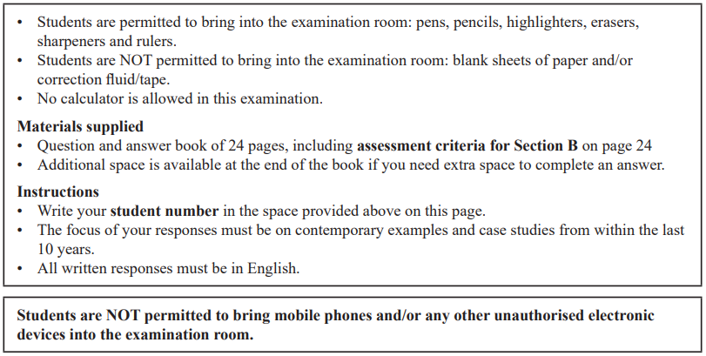

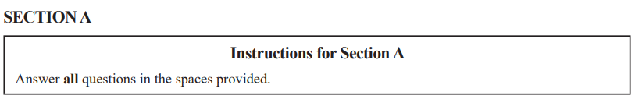

Question 1 (2 marks)
Describe one aim of the state in global politics.

Question 2 (3 marks)
Explain one way the International Criminal Court (ICC) promotes multilateralism.

Question 3 (4 marks)
Explain how one legal non-state actor engages in global governance.

Question 4 (6 marks)
Analyse the extent to which the United Nations (UN) supports states in pursuing security and stability.

Question 5 (15 marks)
One of the following Asia-Pacific states must be used as the focus of all responses to Question 5: Australia, China, Indonesia, Japan or the United States of America.

Selected Asia-Pacific state: ____________________________________________________

- Describe one way in which pragmatism has influenced this Asia-Pacific state’s use of the military as a foreign policy instrument. (3 marks)

- Explain how aid has been used by this Asia-Pacific state in an attempt to achieve national security. (4 marks)

- Evaluate the success of this Asia-Pacific state in achieving regional relationships. (8 marks)

Question 6 (4 marks)
From the list below, select one ethical issue that you have studied this year:
You must respond to the same ethical issue in Question 6 and 7.
• human rights
• people movement
• development
• arms control

Ethical issue: _______________________________________________________________

Explain how a global actor's response to this ethical issue was guided by a particular ethical perspective.

Question 7 (5 marks)
Using one specific ethical debate, discuss how this ethical issue can transcend specific states, regions and continents.
You must respond to the same ethical issue as Question 6.

Question 8 (6 marks)
Select another ethical issue that you have studied this year. The ethical issue selected must be different from the one selected in Question 6 and 7.

Ethical issue ________________________________________________________________

Evaluate the extent to which one global actor’s response to this ethical issue reflects obligations outlined in one international law.

Question 9 (4 marks)
From the list below, select one global crisis that you have studied this year:
You must respond to the same global crisis in Question 9 and 10.
• climate change
• armed conflict
• terrorism
• economic instability

Global crisis: _______________________________________________________________

Explain how one global actor’s response to this global crisis has exacerbated the crisis.

Question 10 (5 marks)
Analyse one cause of this global crisis.
You must respond to the same global crisis as Question 9.

Question 11 (6 marks)
Select another global crisis that you have studied this year. The global crisis selected must be different from the one selected in Question 9 and 10.

Global crisis ________________________________________________________________

To what extent have unilateral responses been evident in response to this global crisis?

SECTION B
Write an essay on one of the following questions in the space provided.
Your response will be assessed according to the assessment criteria set out on the back page.

Question 1 (20 marks)
‘The power of the state is being increasingly challenged in global politics.’ Discuss

OR

Question 2 (20 marks)
Don’t do this question, unless you want to do bad on this exam.

OR

Question 3 (20 marks)
‘In ethical debates, the cosmopolitan perspective is not accepted universally.’ Discuss with reference to at least one ethical issue.

OR

Question 4 (20 marks)
Analyse the impact of the key aspects related to one global crisis.



END OF SECTION B

Extra space for responses.
Clearly number all responses in this space.
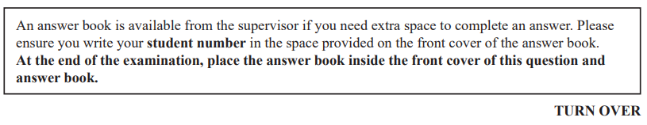

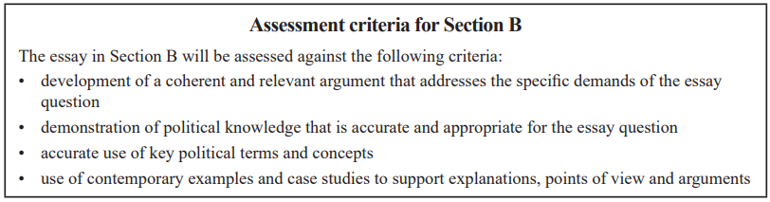

END OF QUESTION AND ANSWER BOOK


