Sample Written examination # 5 – By Jack Graffeo
November 2023
Reading time: 15 mins
Writing time: 2 hours

QUESTION AND ANSWER BOOK

Structure of the exam
 | Section | Number of questions | Number of questions to be answered | Number of marks
 | A | 10 | 10 | 60
 | B | 4 | 1 | 20
 |  |  |  | Total 80

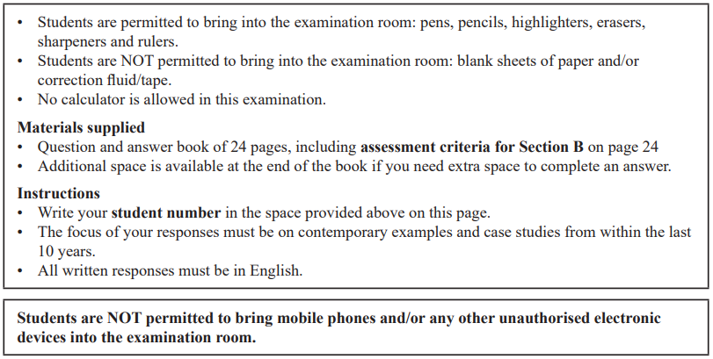

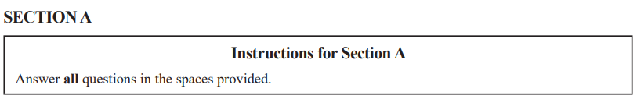

Question 1 (4 marks)
- Identify one aim of a Transnational corporation (TNC) in global politics. (1 mark)

- Explain one limitation to the ability of this TNC to achieve this aim. (3 marks)

Question 2 (4 marks)
Explain how one terrorist non-state actor has challenged the sovereignty of a state.

Question 3 (7 marks)
Compare and contrast the power of two Intergovernmental Organisations (IGOs) in global politics.

Question 4 (15 marks)
One of the following Asia-Pacific states must be used as the focus of all responses to Question 4: Australia, China, Indonesia, Japan or the United States of America.

Selected Asia-Pacific state: ____________________________________________________

- Describe the diplomatic power held by this Asia-Pacific state. (2 marks)

- Evaluate the effectiveness of this Asia-Pacific state’s use of soft power to pursue regional relationships. (5 marks)

- Analyse the influence of idealism and pragmatism on this Asia-Pacific state’s pursuit of national security. (8 marks)

Question 5 (3 marks)
Using an example, explain the term ‘realism’ as it relates to the study of global politics.

Question 6 (6 marks)
From the list below, select one ethical issue that you have studied this year:
• human rights
• people movement
• development
• arms control

Ethical issue: _______________________________________________________________

Analyse the success of one international law in supporting the resolution of this ethical issue.

Question 7 (6 marks)
Select another ethical issue that you have studied this year. The ethical issue selected must be different from the one selected in Question 6.

Ethical issue ________________________________________________________________

Discuss how a global actor’s perspective may determine their view on how justice can be achieved in relation to this ethical issue.

Question 8 (2 marks)
From the list below, select one global crisis that you have studied this year:
You must respond to the same global crisis in Question 8 and 9.
• climate change
• armed conflict
• terrorism
• economic instability

Global crisis: _______________________________________________________________

Describe one key aspect related to this global crisis.

Question 9 (5 marks)
Analyse how globalisation has exacerbated this global crisis.
You must respond to the same global crisis as Question 8.

Question 10 (8 marks)
Select another global crisis that you have studied this year. The global crisis selected must be different from the one selected in Question 8 and 9.

Global crisis ________________________________________________________________

Assess the extent to which responses from global actors have addressed the causes of this global crisis.
SECTION B
Write an essay on one of the following questions in the space provided.
Your response will be assessed according to the assessment criteria set out on the back page.

Question 1 (20 marks)
‘Transnational corporations present the most significant challenge to the power of the state.’ To what extent do you agree?

OR

Question 2 (20 marks)
Don’t do this question, unless you want to do bad on this exam.

OR

Question 3 (20 marks)
‘States have an obligation to pursue cosmopolitanism in regards to ethical issues.’ Discuss with reference to at least one ethical issue.

OR

Question 4 (20 marks)
Evaluate the effectiveness of the responses from global actors to one global crisis that you have studied this year.



END OF SECTION B

Extra space for responses.
Clearly number all responses in this space.
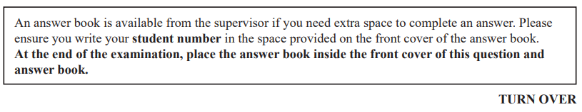

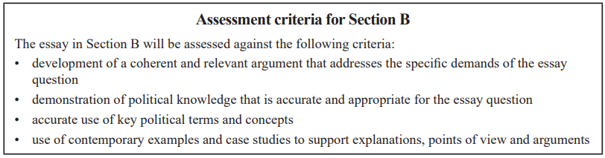

END OF QUESTION AND ANSWER BOOK


