**LABEL ME!!**

Differences between point mutations and Block mutations:

**Chromosomal (Block) Mutations:** A mutation involving a long segment of DNA or a section of a chromosome

**Deletion:**

**Duplications:**

**Inversion:**

**Translocation:**

**Chromosomal Abnormalities**

**Aneuploidy Polyploidy**

Define: Define:

Difference: Difference

**Point Mutations:** *mutation affecting only one or very few nucleotides in a gene sequence.*

**Silent Mutation:**

**Nonsense mutation:**

**Missense mutation:**

What happens to the resulting peptide in each case??

Silent Nonsense Missense



Similarities between point mutations and Block mutations:

**Key knowledge 10: Changes in the genetic makeup of a population**

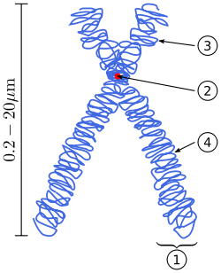

**Allele frequency**: *the relative frequency of an allele (variant of a gene) at a particular locus in a population.*

**What is the Allele frequency equation??**

Frameshift Mutations (Insertions and deletions):

**Selection pressure examples:**

**How are gene pools manipulated through selective breeding?**

**What is Darwin’s theory of evolution by natural selection?**

**Define Selective breeding**

**How are gene pools manipulated through selective breeding?**

**What is Speciation?**

**How do fragmented populations cause speciation?** *Hint – how does the combination of selection pressures and restricted gene flow result in a new species*

**What are the biological consequences of genetic diversity?**

**Increased Decreased**

**Why does genetic drift have a greater effect on smaller populations?**

**Define the following and explain how they ‘drive’ Natural Selection?**

**Phenotype:**

**Environmental Selection Pressures:**

**Gene Flow:**

**Genetic Drift:**

**Bottle Neck: Founder Effect:**

**How does mutation affect the process of evolution??**