|  |  |  |
| --- | --- | --- |
| **Cell Organelles** | | |
| **Organelle** | **Function** | **Illustration** |
| Nucleus |  |  |
| Mitochondria |  |  |
| Ribosome |  |  |
| Golgi Apparatus |  |  |
| Cell wall |  |  |
| Rough ER |  |  |
| Smooth ER |  |  |
| Lysosome |  |  |
| Cytoskeleton |  |  |

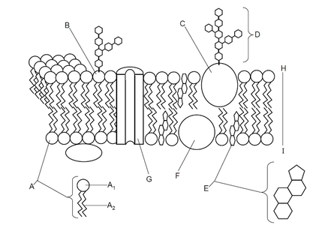

**Prokaryotic Vs Eukaryotic**

What is cell compartmentalisation and what benefit(s) does it provide eukaryotic cells with?

Key Knowledge 1:

The Plasma Membrane

What are the three types of Endocytosis & what molecules do they take into the cell?



Why are vesicles able to fuse with the plasma membrane?

**Active Membrane Transport**

Explain each process & use an illustration

**Active Transport:**

**Endocytosis**

**Exocytosis**

Give examples of molecules which use each type of transport

**Passive Active**

**Passive Membrane Transport**

Explain each process & use an illustration

**Diffusion**

**Facilitated Diffusion**

**Osmosis**

**Label Me!**

Hydrophillic Vs Hydrophobic

How does the fluid mosaic model allow for membrane transport?

Explain how the term fluid mosaic model describes the structure of the plasma membrane?