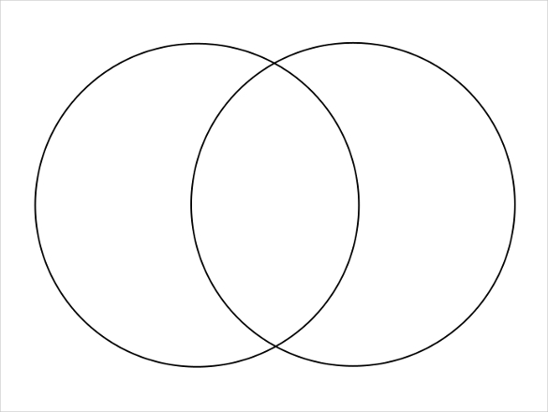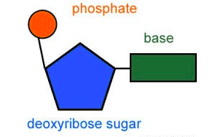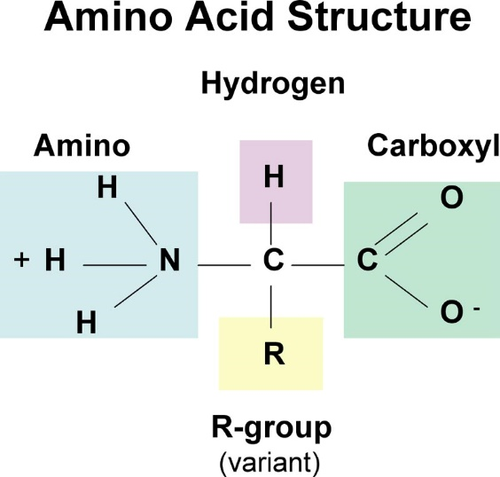

**RNA**

**DNA**

**Transcription; RNA Processing; Translation**

Draw and describe each process

Define the following

Codon:

Triplet:

Proteome:

**Complete the Venn Diagram comparing DNA and RNA**

**Protein Hierarchy**

Describe & illustrate the key events in protein hierarchy

|  |
| --- |
| **Primary** |
| **Secondary** |
| **Tertiary** |
| **Quaternary** |

Key Knowledge 2:

Nucleic Acids & Proteins

**RNA**

|  |  |  |  |
| --- | --- | --- | --- |
|  | **tRNA** | **mRNA** | **rRNA** |
| **Role in cell** |  |  |  |
| **Diagram** |  |  |  |

**Describe the roles of the following protein categories.**

|  |  |
| --- | --- |
| Structural Proteins | Hormones |
| Defensive proteins | Enzymes |
| Storage Proteins | Receptor Proteins |
| Transport Proteins | Contractile Proteins |

**Label this nucleotide!**

**DNA Structure:**

Why is DNA organised into chromosomes?

Why is it referred to as the universal code?

What is the relationship between histone proteins and DNA?

**Condensation Polymerisation Reactions**

During condensation reaction, two molecules combine to form a single molecule with the loss of a small molecule; in dehydration reaction, this lost molecule is water.

**Give examples of molecules which are formed from this reaction?**

**DNA Degeneracy**

Explain ‘degenerate triplet code’:

What are the advantages of degeneracy?

**Describe the relationship between DNA and protein structure**

|  |  |  |  |
| --- | --- | --- | --- |
| **Nitrogenous Bases** | | | |
| *Base* | *Pairs with* | *Purines or Pyrimidines* | *DNA or RNA* |
| Adenine |  |  |  |
| Thymine |  |  |  |
| Cytosine |  |  |  |
| Guanine |  |  |  |
| Uracil |  |  |  |