**Structural gene Vs Regulatory gene**

**Describe the following processes (use a diagram if necessary)**

1. **Transcription**
2. **RNA Processing**
3. **Translation**

**Genes**

What is a Gene?

What are the two primary types of genes?

Difference between Eukaryotic and Prokaryotic gene structure

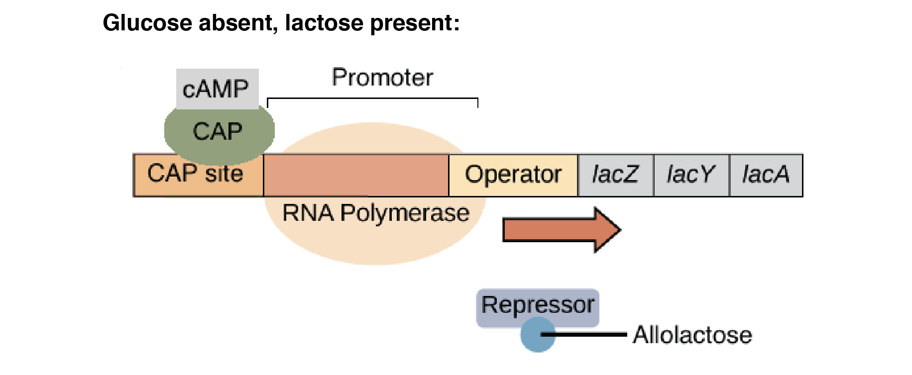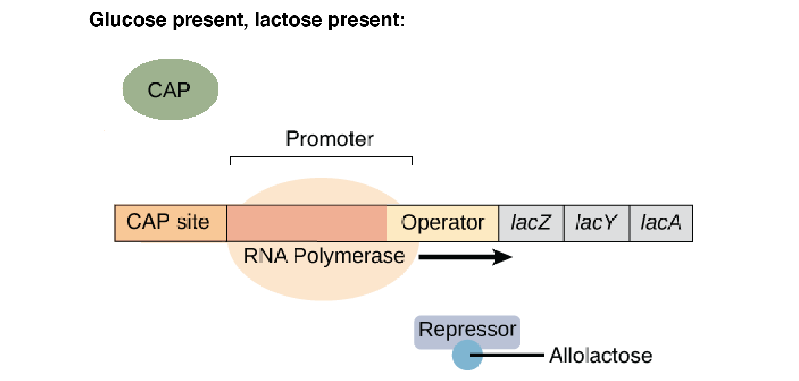

**Key Knowledge Three:**

**Gene Structure & Regulation**

What is the Lac Operon Model used to demonstrate?

What does it require?

What does it produce?

Describe what is occurring in the following two pictures

What are transcription factors?

What role do they play in Gene structure and function?

**Eukaryotic Gene Structure**

**Promotor Region**

**Exon**

**Intron**