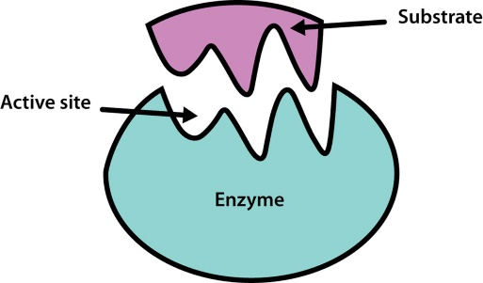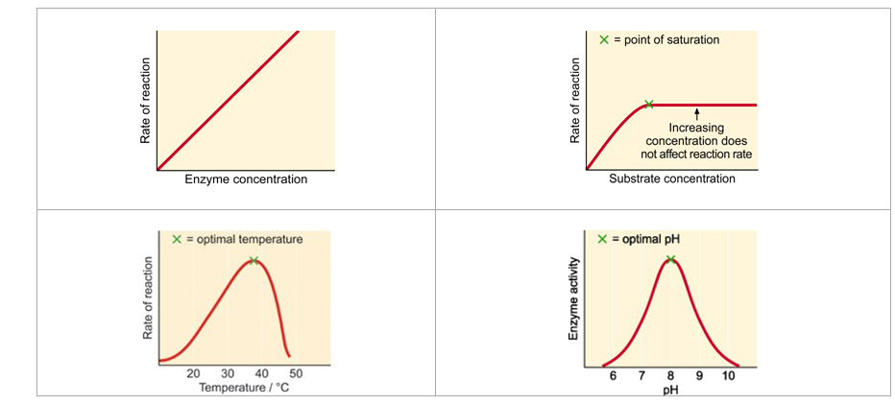

What is the difference between denatured and deactivated?

What is the difference between anabolic and catabolic reactions?

Give examples:

**Label me!!**

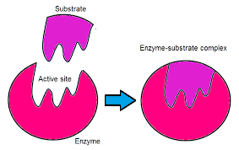

How does temperature affect enzyme reactions?

How does pH affect enzyme reactions?

How does enzyme concentration affect reaction rates?

How does substrate concentration affect reaction rates?

Describe the cycling of the following coenzymes & what biochemical processes are they involved in?

**ATP**

**NADH**

**NADPH**

What is the difference between a coenzyme and a co factor?

**Draw and describe the lock and key enzyme hypothesis**

**Draw and describe the induced fit enzyme hypothesis**

What is enzyme inhibition?

In what situations is it permanent?

In what situations is it reversible?

Key Knowledge Four

Structure and Regulation of Biochemical Pathways

What is an enzyme controlled biochemical pathway?

**Label the following enzyme graphs:** (pH, Enzyme concentration, substrate concentration and Temperature)

How do the following terms relate to enzymes?

Specific:

Catalyst:

Active site:

Substrate:

How do enzymes catalyse reactions?