|  |  |  |
| --- | --- | --- |
| **The Chloroplast** | | |
| **Structure:** | **Definition** | **Process’ which occurs here** |
| Membranes |  |  |
| Thylakoid |  |  |
| Grana |  |  |
| Chlorophyll |  |  |
| Stroma |  |  |
| Nucleoid |  |  |
| Ribosome |  |  |
| Starch Granule |  |  |

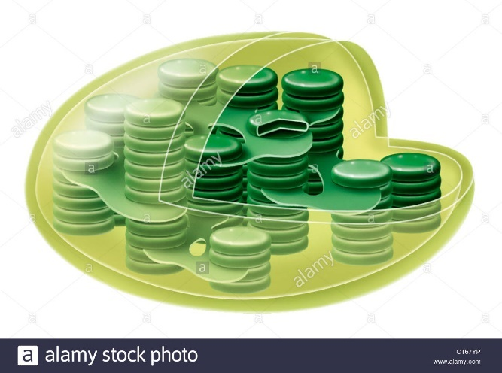

What is the relationship between photosystem 1 and photosystem 2?

**Key knowledge 5 –**

**Photosynthesis**

**Give 5 examples of evidence for chloroplasts having bacterial origin**

**Light Dependent Stage:**

Location:

Inputs:

Outputs:

Define the process:

**Word equation for Photosynthesis**

**Chemical Equation for Photosynthesis:**

**Label me**

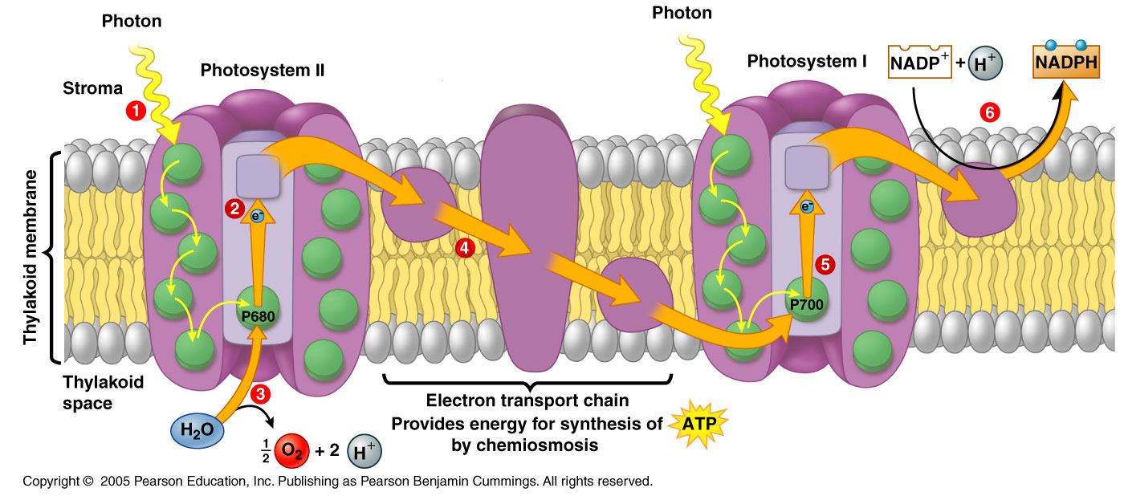

**Describe how the following factors affect the rate of photosynthesis (& which stage(s) the affect**

**Temperature Light availability CO2 availability O2 availability**

Relationship between the light dependent and light independent stage of Photosynthesis

**Light Independent Stage:**

Location:

Inputs:

Outputs:

Define the process:

Describe what is occurring at stages 1 – 6 in the image on the left:



What is the role of ATP synthase in Photosynthesis?