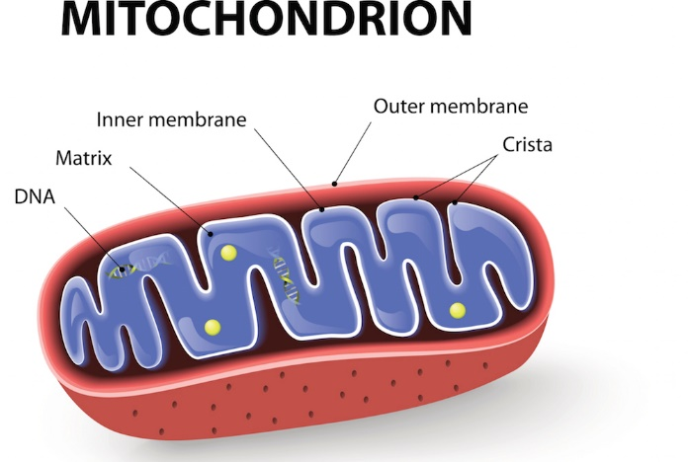

**Situations where anaerobic respiration is used**

**Aerobic Respiration**

**Advantages Disadvantages**

**Anaerobic Respiration**

**Advantages Disadvantages**

**Anaerobic Respiration:**

Type 1:

Organisms which undertake this process:

ATP yield:

Word Equation:

Type 2:

Organisms which undertake this process:

ATP yield:

Word equation:

Word Equation for aerobic respiration

Chemical equation for aerobic respiration

What is the difference between Acetyl CoA and Glucose?

Key Knowledge 6 –

Cellular Respiration

What is the difference between Glycolysis and Pyruvate oxidation?

Give reasons as to why Photosynthesis & cellular respiration are not ‘opposite’ cellular processes

Describe how the following factors affect the rate of cellular respiration

**Glucose availability Temperature Oxygen Concentration**

What role do enzymes play in cellular respiration

What is the function of the following structures?

**Give 5 examples supporting the endosymbiosis theory of mitochondria**

**Electron Transport Chain**

Location:

Inputs:

Outputs:

Net ATP Yield:

**Krebs Cycle**

Location:

Inputs:

Outputs:

Net ATP Yield:

**Glycolysis:**

Location:

Inputs:

Outputs:

Net ATP yield: