Discuss the major components & roles of the Lymphatic system

What are MHC & what are their role(s) in the immune response?

**Describe Fever**

**What is the difference between interferons and a compliment system**?

Draw a flow chart showing inflammation response

**Fill the blanks**

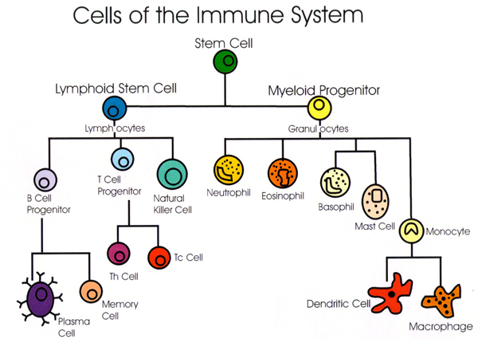

Humoral Vs Cell Mediated

Describe the mechanisms in the **first line** of defence

What is the relationship between the first line & second line of defence?

Key Knowledge 8

Responding to Antigens

Describe the mechanisms in the **second line** of defence

Describe the mechanisms in the **third line** of defence

**Define and draw & classify as cellular or non-cellular**

|  |  |  |
| --- | --- | --- |
| Virus | Bacteria | Fungi |
| Worms | Prion | Protozoa |

Allergen Vs Non-self antigen

Self antigen Vs Non-self antigen

**Label me**

