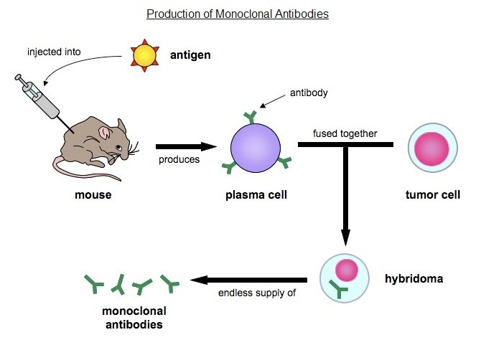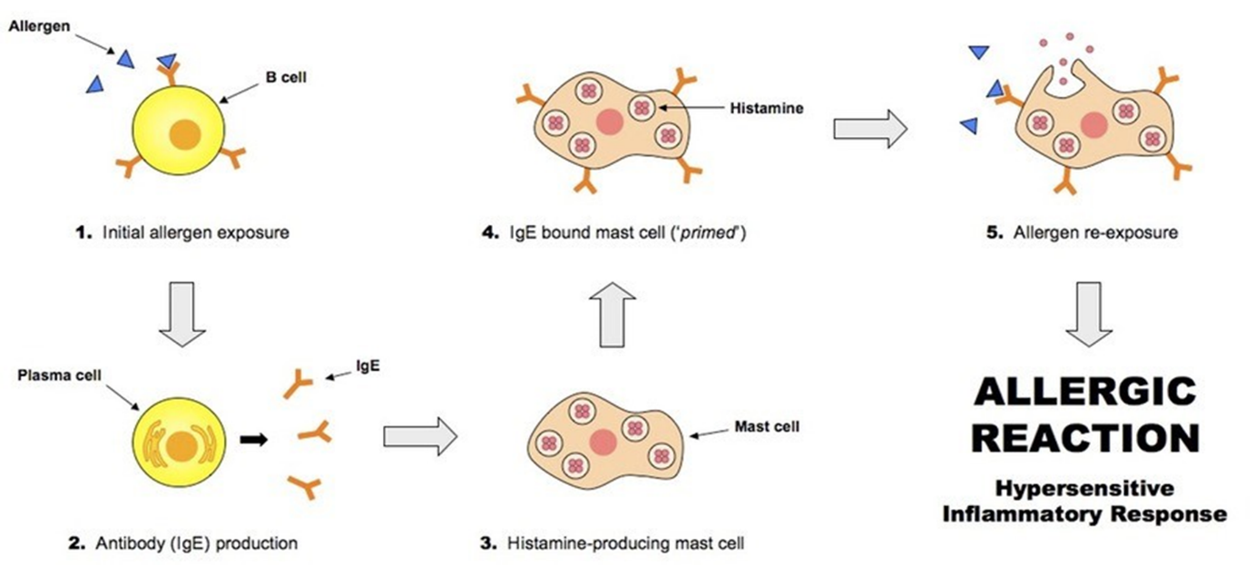

How does HIV affect the body?

How does multiple sclerosis affect the body?

List 5 diseases currently vaccinated for in Australia

**Label the diagram of monoclonal antibody production**

**Define Immunity:**

|  |  |
| --- | --- |
| **Vaccination type** | **Characteristics** |
| Live attenuated vaccines |  |
| Killed vaccine |  |
| Toxoid vaccine |  |
| Component vaccine |  |

|  |  |  |
| --- | --- | --- |
|  | **Natural** | **Artificial** |
| **Active** |  |  |
| **Passive** |  |  |

How does an autoimmune disease differ from an immunodeficiency disease?

What is herd immunity?

How can herd immunity limit the spread of disease?

Key Knowledge 9

Immunity

What is occurring in dot points 1 – 5

Label the graph with: *Initial exposure; primary response; secondary exposure; secondary response*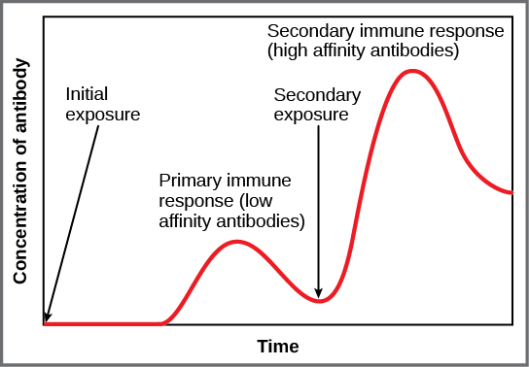

**Describe what is occurring:**

**Compare and contrast:**

**Natural Immunity Vs Artificial Immunity**

**Active Immunity Vs Passive Immunity**