**UNIT 2 BIOLOGY**

**AOS 2 Workbook**

**How is inheritance explained?**

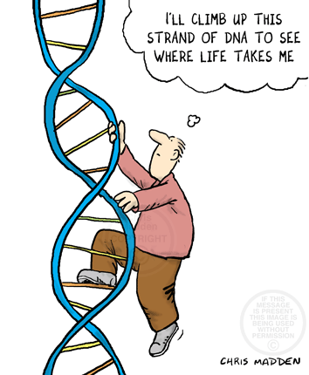

**Name: _____________________**

**Teacher: ____________________**

**Unit 2 AOS 2: Study Design**

**Outcome 2**

On completion of this unit the student should be able to apply an understanding of genetics to describe patterns of inheritance, analyse pedigree charts, predict outcomes of genetic crosses and identify the implications of the uses of genetic screening and decision making related to inheritance.

**Key knowledge:**

**Genomes, genes and alleles**

* The distinction between a genome, gene and allele
* The genome as the sum total of an organism’s DNA measured in the number of base pairs contained in a haploid set of chromosomes
* The role of genomic research since the Human Genome Project, with reference to the sequencing of the genes of many organisms, comparing relatedness between species, determining gene function and genomic applications for the early detection and diagnosis of human diseases.

**Chromosomes**

* The role of chromosomes as structures that package DNA, their variability in terms of size and the number of genes they carry in different organisms, the distinction between an autosome and a sex chromosome and the nature of a homologous pair of chromosomes (one maternal and one paternal) as carrying the same gene loci
* Presentation of an organism’s set of chromosomes as a karyotype that can be used to identify chromosome number abnormalities including Down’s Klinefelter’s and Turner’s syndromes in humans.

**Genotypes and phenotypes**

* The use of symbols in the writing of the genotypes for the alleles present at a particular gene locus
* The distinction between a dominant and recessive phenotype
* The relative influences of genetic material, environmental factors and interactions of DNA with other molecules (epigenetic factors) on phenotypes
* Qualitative treatment of polygenic inheritance as contributing to continuous variation in a population, illustrated by the determination of human skin colour through the genes involved in melanin production or by variation in height.

**Pedigree charts, genetic cross outcomes and genetic decision-making**

* Pedigree charts and patterns of inheritance including autosomal dominant, autosomal recessive, X-linked and Y-linked traits
* The determination of genotypes and prediction of the outcomes of genetic crosses including monohybrid crosses, and monohybrid test crosses
* The inheritance of two characteristics as either independent or linked, and the biological consequence of crossing over for linked genes
* the nature and uses of genetic testing for screening of embryos and adults, and its social and ethical implications.

**Chapter 10-Key terms**

|  |  |  |  |  |
| --- | --- | --- | --- | --- |
| Adenine | Alleles | Antiparallel | Autosomes | Base |
| Centromere | Chromatid | Chromosomes | Complementary base pair | Complete dominance |
| Cytosine | Diploid | DNA | DNA sequencing | Dominance |
| Dominant phenotype | Double helix | Epigenetics | Gene | Genome |
| Genotype | Guanine | Haploid | Hemizygous | Hereditary |
| Heterogametic | Heterozygous | Histones | Homogametic | Homologous chromosomes |
| Homozygote | Homozygous | Human Genome Project | In vitro fertilisation (IVF) | Karyotype |
| Locus | Nucleosome | Phenotype | Ploidy | Polygene |
| Polygenic inheritance | Polypeptide | Pre-implantation genetic diagnosis (PGD) | Protein | Purines |
| Pyrimidines | Recessive phenotype | Reprogramming | Sex chromosomes | Somatic cell |
| Thymine | Trait |  |  |  |

**Chapter 11-Key terms**

|  |  |  |  |  |
| --- | --- | --- | --- | --- |
| Autosome | Carrier | Chiasma | Chromatid | Co-dominance |
| Cross | Crossing over | Dihybrid cross | DNA amplification | DNA polymerase |
| DNA profiling | DNA sequencing | Dominant | F1 generation | F2 generation |
| Gel electrophoresis | Gene mapping | Genetic screening | Genetic testing | Genome |
| Heterozygous | Homozygous hybrid | Law of Independent Assortment | Law of Segregation | Linkage |
| Locus | Monohybrid cross | Mutant | Nucleotide | Pedigree analysis |
| Recessive | Recombinant | Sex-linked inheritance | Spontaneous mutation | Testcross |
| Wild type | X-linked | Y-linked |  |  |

**Textbook summaries (optional)**

10.1, 10.2, 10.3, 10.4, 11.1, 11.2, 11.3, 11.4

**Biozones**

|  |  |  |  |  |  |  |  |  |  |  |
| --- | --- | --- | --- | --- | --- | --- | --- | --- | --- | --- |
| 187 | 188 | 189 | 190 | 191 | 192 | 197 | 198 | 200 | 203 | 204 |
| 205 | 206 | 208 | 209 | 211 | 212 | 213 | 214 | 215 | 216 | 217 |
| 218 | 219 | 220 | 221 | 222 | 223 | 224 | 225 |  |  |  |

**Activity #1: DNA**

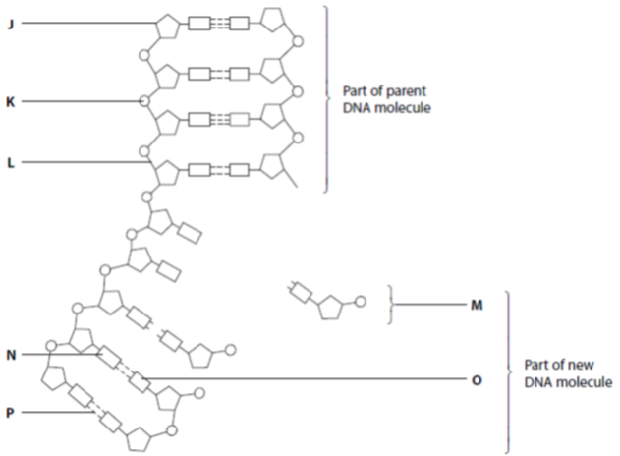

1. **Name the structures/components of the DNA molecule above.**

|  |  |  |
| --- | --- | --- |
| **Label** | **Structure/component** | **Additional information** |
| J |  |  |
| K |  |  |
| L |  |  |
| M |  |  |
| N |  |  |
| O |  |  |
| P |  |  |

**2.** **Nucleotides are composed of the same three components. Name the molecule represented by:**

**P:** ____________________________

**S:** ____________________________

**A, T, C, G:** ____________________________

**3. The nucleotide sequence below in figure 2.25 is part of the human β-haemoglobin gene.**

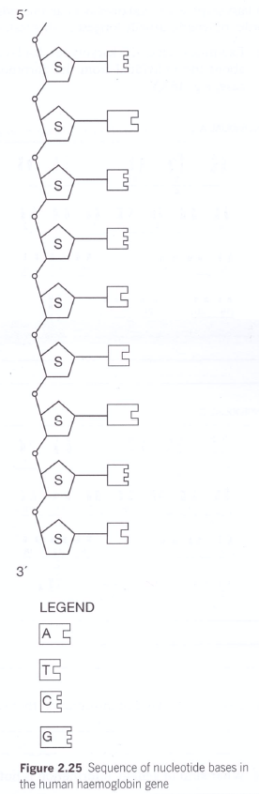**a) Use coloured pencils to colour-code the nucleotide bases in the legend.**

**b) Use appropriate symbols and colour-coding to draw the complementary DNA strand against this template strand.**

**4. Look carefully at the details of your double-stranded DNA. Describe 2 features of DNA that ensure complementary base-pairing occurs.**

**Feature 1:** ______________________________________________________

______________________________________________________

______________________________________________________

**Feature 2:**

______________________________________________________

______________________________________________________

______________________________________________________

**4**. **Distinguish between DNA, genome, gene and allele.**

___________________________________________________________________________________________________________________________________________________________________________________________________________________________________________________________________________________________________________________________________________________________________________________________________________________________________________________

**Activity #2: The Human Genome Project**

**1.** **What was the original goal of the Human Genome Project?**

______________________________________________________________________________________________________________________________________________________________________________

**2. Reorder the following statements that describe the process of DNA sequencing in order from first to last.**

|  |  |
| --- | --- |
| A chromatogram is produced |  |
| DNA is replicated and the test tube mixture ends up with a range of fragments of DNA of different sizes (lengths) |  |
| DNA is added to a mixture containing DNA polymerase, nucleotides, and terminating nucleotides that are tagged with fluorescent markers |  |
| Gel from gel electrophoresis is read by computers |  |
| Terminating nucleotides fluoresce as they pass through a laser beam |  |

**Activity #3: Chromosomes**

1. **Using the terms chromosome, histone, DNA and nucleosome, describe how DNA is packaged into a cell nucleus.**

_______________________________________________________________________________________________________________________________________________________________________________________________________________________________________________________________________________________________________________________________________________________________________________________________________________________________

1. **Label the parts on the chromosome using the following terms:**

**Centromere gene chromatid sister chromatids**

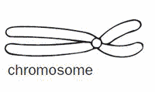

**3. Distinguish between the following terms:**

**a) autosome and sex chromosome**

_____________________________________________________________________________________________________________________________________________________________________________________________________________________________________________________________________

**b) sex chromosome and homologues**

_____________________________________________________________________________________________________________________________________________________________________________________________________________________________________________________________________

**4. Circle 5 pairs of homologous pairs in the picture below using a different coloured pencil for each pair.**

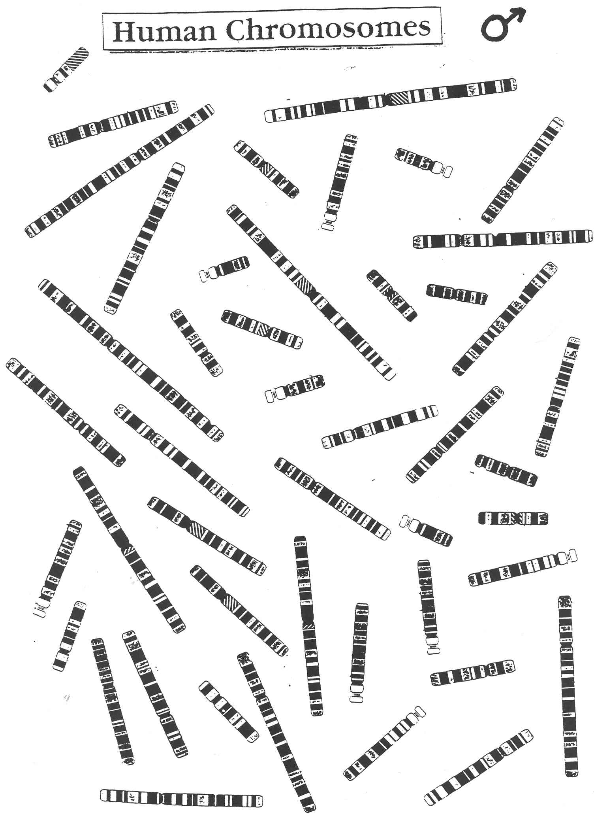

**5. Explain which features you used to match the chromosomes.**

____________________________________________________________________________________________________________________________________________________________________________________________________________________________________________________________________________________________________________________________________________________________

**Activity #4: Karyotyping**

**1. For each of the conditions listed below, state which chromosome is affected and whether the chromosome is in excess or missing**

**a) Down syndrome:** ______________________________________________________________________

**b) Turner syndrome:** _____________________________________________________________________

**c) Klinefelter syndrome:** __________________________________________________________________

**2. Examine each of the karyotypes displayed. In the space below each, write information that can be determined about the individual from the chromosomal information provided. Include the general genotype in each case, e.g. 46XY.**

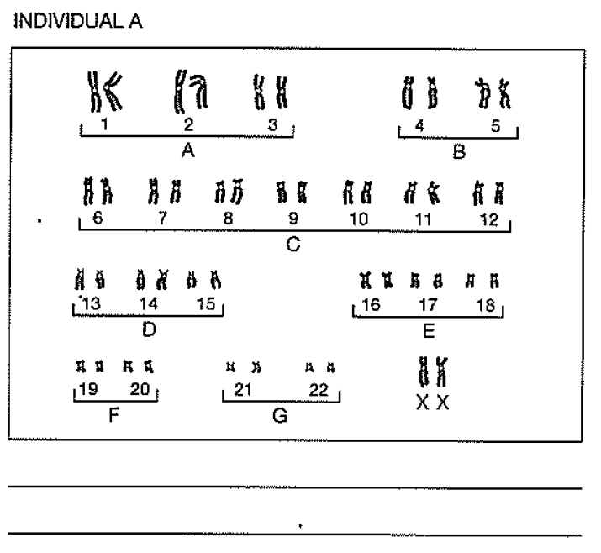

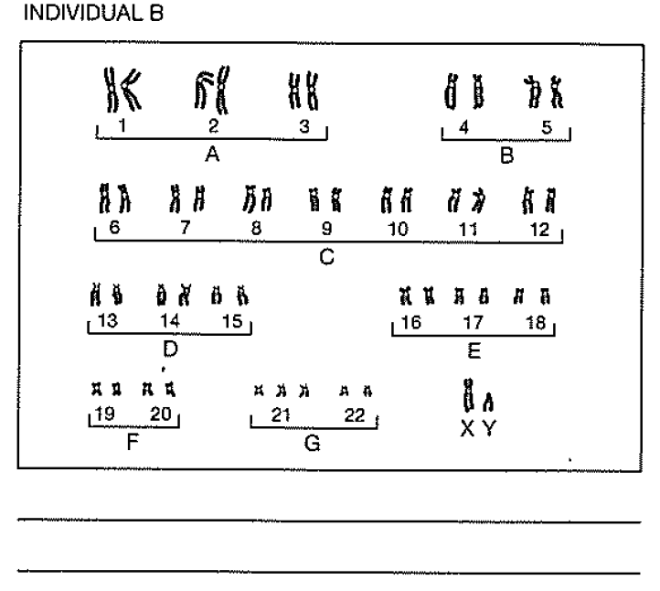

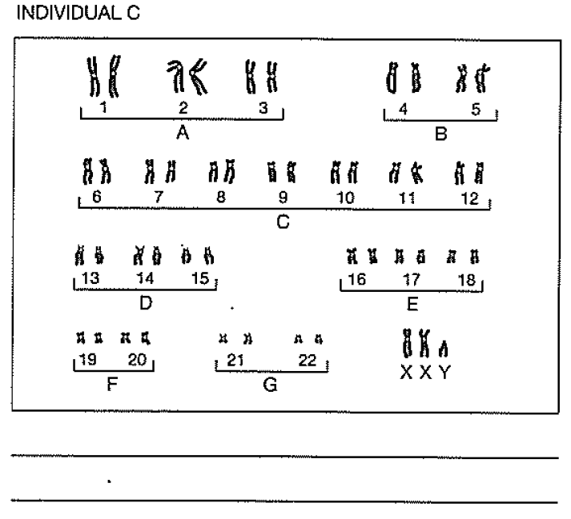

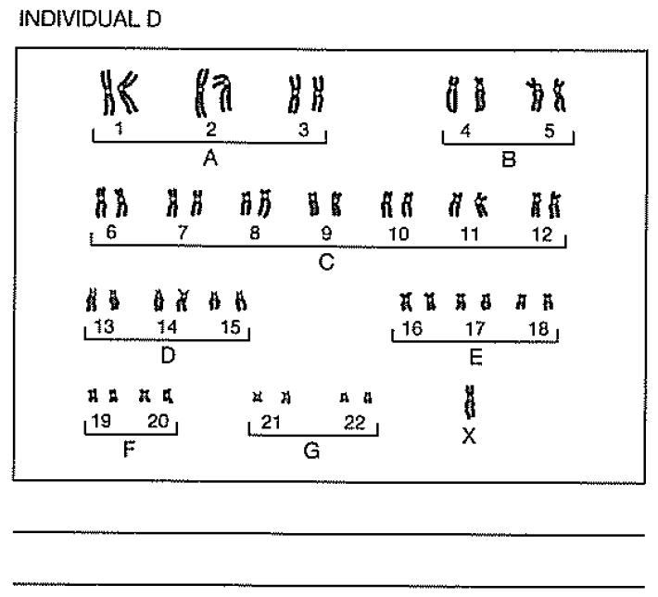

**3. Describe the kind of information that karyotyping provides about an individual.**

______________________________________________________________________________________________________________________________________________________________________________

**4. What kind of genetic information is not available from karyotyping analysis?**

______________________________________________________________________________________________________________________________________________________________________________

**Activity #5: Crossword- genotypes and phenotypes**

Complete the crossword puzzle to help you check your knowledge and understanding of key terms and processes related to genotypes, phenotypes and genetic crosses.

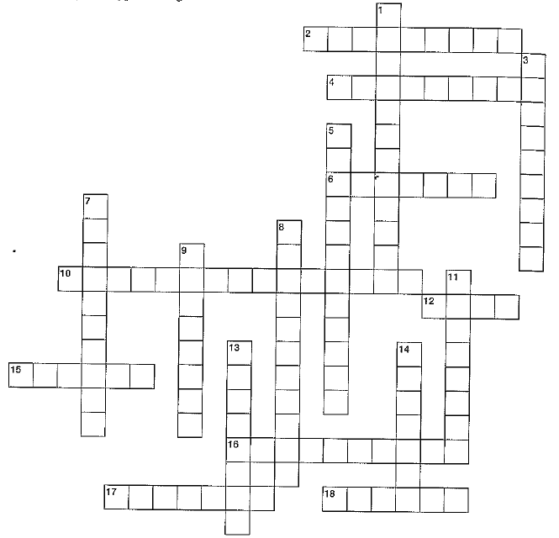

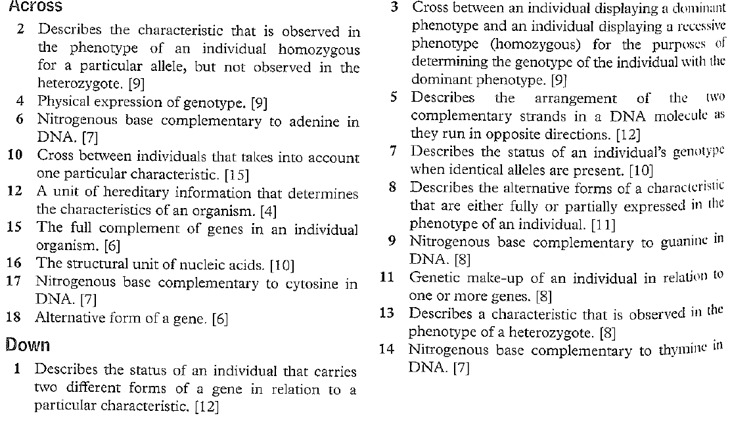

**Activity #6: Genotypes and phenotypes**

Use the following traits to determine the genotypes and phenotypes.

|  |  |  |  |  |
| --- | --- | --- | --- | --- |
| **Trait** | **Dominant** | **Allele** | **Recessive** | **Allele** |
| Ear lobes | Free ear lobes | E | Attached ear lobes | e |
| Hair type | Curly | C | Straight | c |
| Dimples | Dimples | D | No dimples | d |
| Thumb | Straight thumb | T | Curved thumb | t |
| Eyelashes | Long | L | Short | l |

**1. Write out the GENOTYPE(S) for these people:**

* 1. Heterozygous long eyelashes ______
  2. Homozygous straight thumb ______
  3. Dimples ______
  4. Straight hair ______
  5. Hybrid free ear lobes ______
  6. Homozygous curved thumb ______
  7. Hybrid curly hair ______
  8. Straight thumb ______

**2. Write out the PHENOTYPES for these people:**

1. Ee ______________________________________
2. cc ______________________________________
3. DD _____________________________________
4. Dd _____________________________________
5. Tt ______________________________________
6. ll ______________________________________
7. Ll ______________________________________
8. CC _____________________________________
9. LL _____________________________________
10. Cc _____________________________________

**Activity #7: Review questions 1**

1. **What is the difference between the alleles of a gene?**
2. Their locus on the chromosome
3. Their amino acid sequence
4. The type of sugar on the nucleotides
5. The sequence of bases

**2. What was the aim of the Human Genome Project?**

**A.** to identify human infectious diseases

**B.** to make improvements to the human genome

**C.** to allow transfer of genes from other species to humans

**D.** to sequence genetic information in humans

**3. What does a nucleosome consist of?**

1. DNA and histones
2. DNA and chromatid
3. Chromatid and nucleotides
4. RNA and histones

**4. Which of the following correctly identifies the relationship between alleles, chromosomes and genes?**

1. Genes contain chromosomes and alleles
2. Chromosomes contain genes but not alleles
3. Alleles are found in chromosomes but not in genes
4. Genes are parts of chromosomes and have different alleles

**5. The term ‘genome’ applies best to all the**

1. Genes present in a cell
2. Organelles present in a cell
3. Proteins produced by a cell
4. Metabolites produced by a cell

**6. Chromosomes from eukaryotic cells are made of**

1. carbohydrates
2. phospholipids and proteins
3. nucleic acids and fatty acids
4. nucleic acids and proteins

**7. In leaf cutting ants, a male develops from an unfertilised egg and a female from a fertilised egg. It is reasonable to assume that**

1. sperm produced by a particular male are genetically identical
2. males can be either homozygous or heterozygous at any gene locus
3. unfertilised eggs from a particular female develop into identical males
4. homologous pairs of chromosomes are found in both male and female ants

**8. The following karyotype is from a human baby with a genetic defect.**

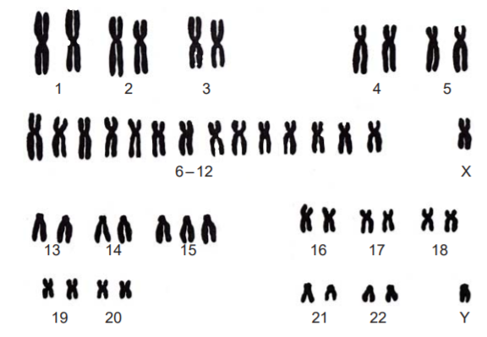

**The condition indicated by the karyotype is an example of**

1. monosomy
2. polyploidy
3. inversions
4. trisomy

**9. The number of autosomes in the karyotype below is:**

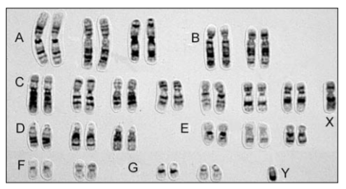

1. 22
2. 23
3. 44
4. 46

**10. Examination of the karyotype reveals that the baby**

1. Is a male
2. Has a defective allele
3. Has an extra X chromosome
4. Has three number 13 chromosomes

**11. What is the genotype of pure breeding plants?**

1. heterozygous
2. homologous
3. homozygous
4. monohybrid

**12. Identical twins have the same genotype. Why are there small differences between the phenotypes of identical twins?**

1. Some genes are not co-dominant
2. Environment affect the expression of genes
3. Both parents are homozygous for those phenotypes
4. Chromosomes segregate independently during meiosis

**13. Scientists have been studying the amount of vitamin E in a corn plant. The amount of vitamin E in hundreds of different plant seeds that were tested is summarised in the following graph.**

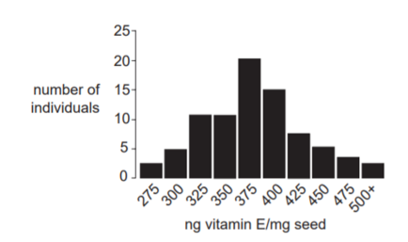

**It is reasonable to conclude that the vitamin E phenotype of corn plants is a result of:**

1. cloning
2. asexual reproduction
3. polygenic inheritance
4. discontinuous variation

**14. State the number of autosomes and homologous chromosomes in a human**

**a) Female somatic cell** _______________________________________________________________

**b) Male somatic cell** _______________________________________________________________

**15. In mice, coat colour is controlled by a single gene. Black coat colour is dominant to white coat colour.**

**a) Assign allele symbols for the gene responsible** _____________________________________________

**b) How many genotypes are possible with respect to these alleles? State the genotypes and phenotypes.**

______________________________________________________________________________________________________________________________________________________________________

___________________________________________________________________________________

**16. The diagram below shows a pair of chromosomes during meiosis to form a human sperm. The position of the alleles of some of the genes is shown.**

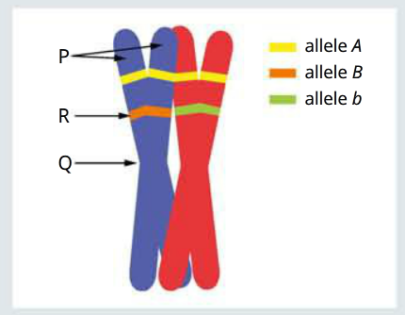

**a) Identify the chromosome structures labelled P and Q.**

**P:** _______________________________________________

**Q:** _______________________________________________

**b) Suggest with reasons, whether the chromosomes are:**

**i- sex chromosomes or autosomes** ______________________________________________________________________________________________________________________________________________________________________________

**ii- homologous or non-homologous**

______________________________________________________________________________________________________________________________________________________________________________

**iii- homozygous, hemizygous or heterozygous with respect to the B gene locus**

______________________________________________________________________________________________________________________________________________________________________________

**Activity #8: Monohybrid crosses**

**1. Freckles are an inherited trait which results in the formation of spots on fair skin. It is found on chromosome 4 and shows a dominant inheritance pattern.**

**a) State the type of inheritance (autosomal/sex-linked/dominant/recessive)**

_______________________________________________________________________________________

**b) Complete the Punnett square to show how a mother and father, who have freckles, can have a child that does not have freckles. State the probability for the child not to have freckles.**

|  |  |  |
| --- | --- | --- |
| **Parents** |  |  |
|  |  |  |
|  |  |  |

**Probability for the child not to have freckles =** _________________________________________________

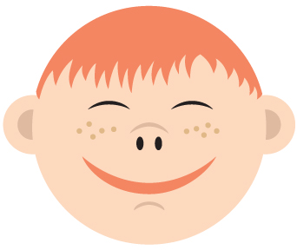

**2. Robert has blood type A and Lee has blood type B. Is it possible for them to have a baby of blood type O? What is the probability of this occurring? Use the Punnett square below to help explain your answer.**

|  |  |  |
| --- | --- | --- |
| **Parents** |  |  |
|  |  |  |
|  |  |  |

______________________________________________________________________________________________________________________________________________________________________________

**3. The figure below shows the inheritance of haemophilia in a family. Haemophilia is a recessive X-linked inheritance.**

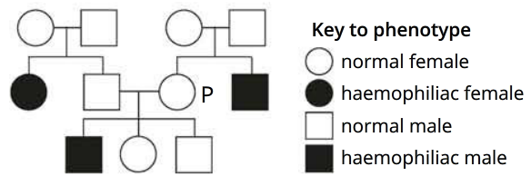

**a) What is the genotype of individual P? Show your working using a Punnett Square and appropriate symbols.**

|  |  |  |
| --- | --- | --- |
| **Parents** |  |  |
|  |  |  |
|  |  |  |

**Genotype of individual P =** _________________________________________________________________

**4. What type of inheritance is shown in the pedigree below? Give three reasons for your choice of inheritance pattern?**

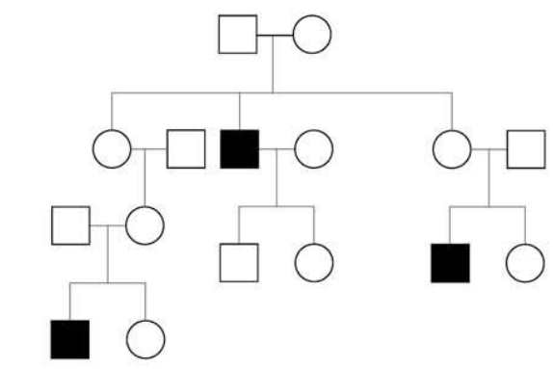

____________________________________________________________________________________________________________________________________________________________________________________________________________________________________________________________________________________________________________________________________________________________

**Activity #9: Puzzling pedigrees- analysing family histories**

|  |  |
| --- | --- |
| **Genotype** | **Phenotype** |
| $$I^{A}I^{A}$$ | A |
| $$I^{A}i$$ | A |
| $$I^{B}I^{B}$$ | B |
| $$I^{B}i$$ | B |
| $$I^{A}I^{B}$$ | AB |
| $$ii$$ | O |

The ABO blood group of an individual can be determined by identifying the kinds of proteins (antigens) that are present on the surfaces of red blood cells. The single gene locus that codes for the production of these antigens has three alleles $(I^{A}, I^{B}and i)$. The genotypes and phenotypes of respective individuals are shown in the table below.

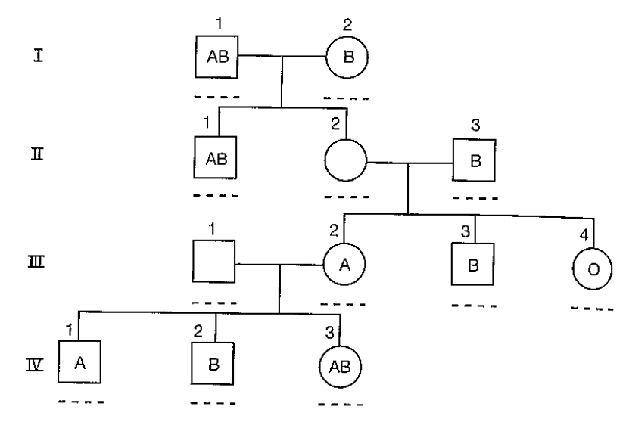

**1. The pedigree above indicates the blood type for some individuals. Use your understanding of inheritance and the alleles above to assign genotypes and blood types to individuals II-2 and III-1.**

**2. Outline the relationship between the phenotypic expression of the $I^{A}, I^{B}$ and $i$ alleles.**

______________________________________________________________________________________________________________________________________________________________________________

**Activity #10: Royal blood**

**The pedigree below represents part of the family tree for a European royal family. It also tracks the inheritance of haemophilia, a blood disorder that leaves sufferers without an important clotting factor, leading to uncontrolled bleeding after even minor injury. Today, haemophiliacs are successfully treated with blood transfusions, but in the past individuals born with this disorder usually did not survive childhood.**

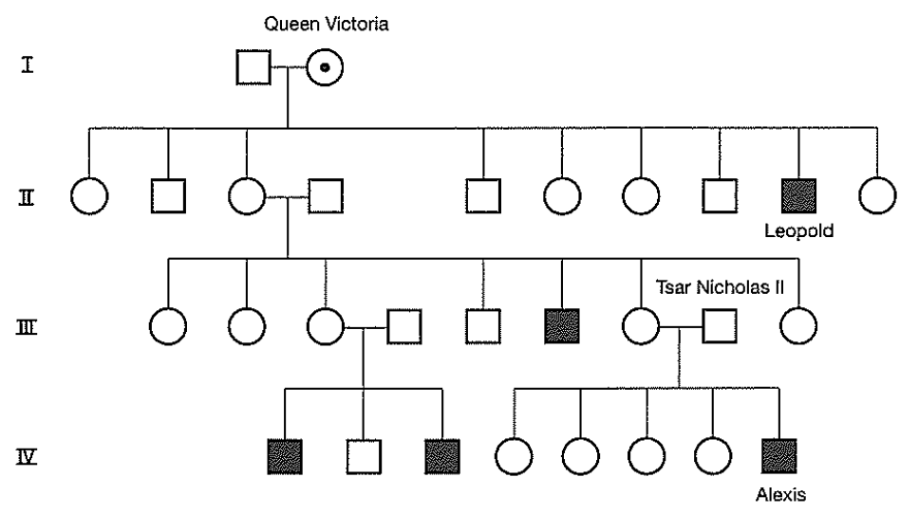

**1. Suggest why only males in this family tree are affected by haemophilia.**

_____________________________________________________________________________________________________________________________________________________________________________________________________________________________________________________________________

**2. Queen Victoria’s son, Leopold, was the first person in the family’s history to have been diagnosed with the condition. The cause of the disease in this family is attributed to a mutation that occurred early in the embryological development of Queen Victoria or in a germ-line cell from one of her parents. Describe the evidence from this family tree that points to Queen Victoria as the origin of haemophilia in the family, and not her son Leopold.**

_____________________________________________________________________________________________________________________________________________________________________________________________________________________________________________________________________

**3. In the pedigree, Queen Victoria’s status as a carrier is denoted by the dot symbol. Use the same notation to identify all of the other carriers of haemophilia in this family.**

**Activity #11: Pedigree analysis- Scenario 1**

The pedigrees in Figures 2.32 and 2.33 show the inheritance pattern of earlobe shape in two different families. ‘Free lobes’ are dominant to ‘attached lobes’, which are recessive. The gene responsible for earlobe shape has two alternative alleles represented by E (free lobes) and e (attached lobes).

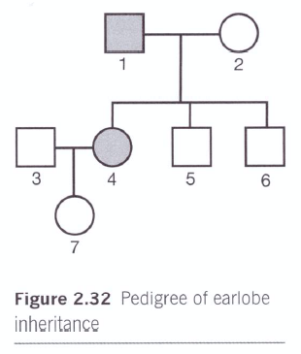

**1. Assign genotypes to as many individuals as possible in Figure 2.32**

**Activity #11 continued: Pedigree analysis- Scenario 1**

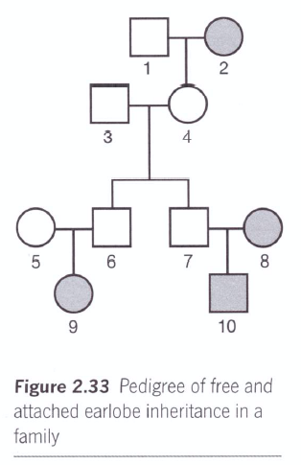

**2. Examine the pedigree in Figure 2.33. Assign genotypes to as many individuals as possible.**

**3. Why is it difficult to do this with confidence for individuals 1 and 3?**

_____________________________________________________________________________________________________________________________________________________________________________________________________________________________________________________________________

**4. How can you be sure of the genotypes of individuals 6 and 7?**

_____________________________________________________________________________________________________________________________________________________________________________________________________________________________________________________________________

**Activity #12: Pedigree analysis- Scenario 2**

Known family histories are also useful to geneticists in establishing the mode of inheritance for particular genetic diseases. Pedigree analysis for families that show such diseases is also important so that genetic counselling can be provided to families about the likelihood of future children being affected or carrying the allele in question. Figure 2.34 illustrates the inheritance of Huntington’s disease in 2 unrelated families. Huntington’s disease is a neurological disorder that leads to gradual, permanent deterioration of nerve and muscle control with eventual complete dependence on care. Death results after some years. The onset of the symptoms does not occur until at least the mid to late thirties.

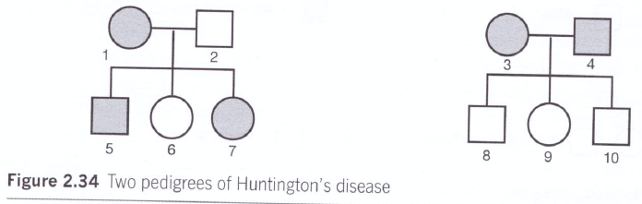

**1. Assign genotypes to each person in both pedigrees.**

**2. Name the mode of inheritance for Huntington’s disease. Explain your choice.**

_____________________________________________________________________________________________________________________________________________________________________________________________________________________________________________________________________

**Individuals 7 and 8 are engaged to be married. Both individuals are keen to raise a family.**

**3. What are the chances of any children from this union developing Huntington’s disease? Show your working.**

_____________________________________________________________________________________________________________________________________________________________________________________________________________________________________________________________________

**4. Suggest options that a genetic counsellor might discuss with such a couple.**

_____________________________________________________________________________________________________________________________________________________________________________________________________________________________________________________________________

**Activity #13: Pedigree analysis- Scenarios 3 and 4**

**People with galactosaemia are unable to digest milk sugar (galactose).**

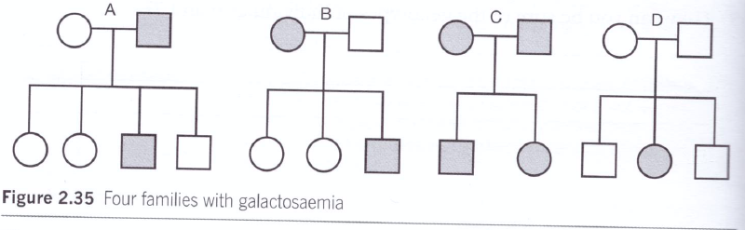

**1. From the evidence of the pedigrees should in Figure 2.35, suggest which pedigree shows beyond doubt that galactosaemia is inherited as an autosomal recessive condition. Explain your reasoning.**

_____________________________________________________________________________________________________________________________________________________________________________________________________________________________________________________________________

**Red-green colour blindness is a relatively common condition, inherited as an X-linked recessive trait. Figure 2.36 shows the pedigrees of 3 families in which this condition occurs.**

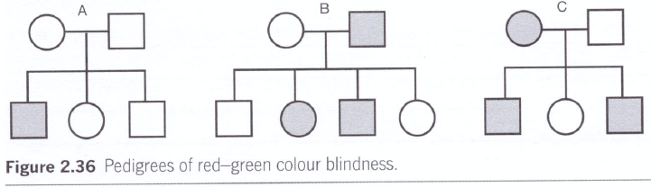

**2. Which of the three pedigrees best establishes the mode of inheritance for this trait? Explain your reasoning.**

_____________________________________________________________________________________________________________________________________________________________________________________________________________________________________________________________________

_______________________________________________________________________________________

**Activity #14: Linked genes and crossing over**

**1. For each of the following statements, circle whether it is true or false.**

* Genes are linked when the percentage of recombinant gametes falls below 50%

TRUE FALSE

* Recombinant gametes are observed in the offspring

TRUE FALSE

* If A and B loci are very close together, the probability of a random cross over event is very low.

TRUE FALSE

**2. Sheep blowfly chromosome 5 carries genes for resistance to the insecticide dieldrin (gene D). The same chromosome carries a gene called furrowed eyes (F).**

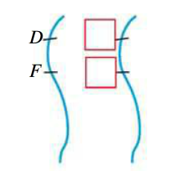**a) Complete the allele symbols for a fly that is heterozygous at both loci.**

**b) If no crossing over occurs in meiosis, the gametes will carry either DF or df alleles. What combinations of alleles will be present in gametes if crossing over does occur?**

______________________________________________________________________________________________________________________________________________________________________________

**c) Complete the Punnett square below for a cross between the fly shown above (genotype DdFf) (after recombination has occurred in meiosis) and a homozygous recessive fly (ddff).**

|  |  |  |
| --- | --- | --- |
| **Parents** |  |  |
|  |  |  |
|  |  |  |

**Activity #15: Linkage and pedigrees- a summary**

**Make a selection from the list to fill in the missing words in each summary statement.**

|  |  |  |  |  |
| --- | --- | --- | --- | --- |
| X-linked | Gene complex | Continuous | Pedigree | Sex linkage |
| Polygenic | Linkage | Crossing over | Stud books | Y-linked |
| Discontinuous | Recombinant | Dominant | Recessive |  |

* When 2 or more genes are located on the same chromosome they are referred to as a _______________ group. The more closely such genes are situated on a given chromosome, the greater the likelihood that they will be inherited together.
* _________________ gametes are formed as a result of __________________________ at a chiasma during prophase I in meiosis.
* Genes that are so closely linked on a chromosome that crossing over between them is a rare event are referred to as ________________ ____________________.
* _______________ _________________ refers to the presence of genes on either of the sex chromosomes. In this case, the inheritance of characteristics is linked to the sex of the individual.
* Colour-blindness is an example of an _________________ characteristic. The mode of inheritance for this condition is X-linked recessive. Transmission is typically from a female parent to male offspring. X-linked characteristics appear less often in females because there are two X-chromosomes. When one X-chromosome is carrying the affected allele, it may be masked by a normal allele on the second X-chromosome. Male are more often affected because the allele is present on their only X-chromosome.
* _________________ inheritance shows a pattern of transmission from father to son. Characteristics that follow this mode of inheritance are never observed in females.
* _______________ analysis is a strategy that allows geneticists to track the pattern of inheritance of particular characteristics. This provides important information about the mode of inheritance of characteristics and can be useful in calculating the likelihood of genetic diseases occurring in families.

**Activity #15 continued: Linkage and pedigrees- a summary**

**Make a selection from the list to fill in the missing words in each summary statement.**

|  |  |  |  |  |
| --- | --- | --- | --- | --- |
| X-linked | Gene complex | Continuous | Pedigree | Sex linkage |
| Polygenic | Linkage | Crossing over | Stud books | Y-linked |
| Discontinuous | Recombinant | Dominant | Recessive |  |

* Animal breeders looking to breed desirable characteristics avoid inbreeding and maintain genetic variation by keeping records called ____________ ____________ to track breeding stock over generations.
* When alternative forms of a particular characteristic can be clearly placed into non-overlapping groups, _______________ variation is said to exist. Such characteristics are typically governed by single genes.
* _________________ variation describes the kinds of characteristics that show wide variation across a range. Such characteristics are typically governed by a number of genes and are referred to as ______________________ traits.
* Characteristics that appear in the phenotype of a heterozygote are described as ___________________.
* Characteristics that do not appear in the phenotype of the heterozygote are described as ___________________.

**Activity #16: What am I?**

1. I am a cross between two individuals with different alleles at a single locus.

**What am I? _____________________________________________________________________________**

2. I am a type of inheritance that refers to a dominant trait that is passed on to offspring via an autosomal gene.

**What am I? _____________________________________________________________________________**

3. I am a type of inheritance in which both alleles are expressed in varying degrees in the phenotype of the heterozygous individuals.

**What am I? _____________________________________________________________________________**

4. I am a type of inheritance where phenotypes are inherited through genes on sex chromosomes.

**What am I? _____________________________________________________________________________**

5. I am a type of inheritance where the traits are predominantly expressed in males because males carry only one X chromosome.

**What am I? _____________________________________________________________________________**

6. I am a type of inheritance where a trait is passed from father to son and never observed in females.

**What am I? _____________________________________________________________________________**

7. I am a type of inheritance that is likely if two parents do not have a particular phenotype but one or more of their offspring does.

**What am I? _____________________________________________________________________________**

8. I am a type of inheritance that is likely if both parents show the trait but one or more of their offspring do not show the trait.

**What am I? _____________________________________________________________________________**

**Activity #17: Review questions 2**

**1. Why might the results of a monohybrid cross differ from the expected ratio of 3:1? Select the correct answer.**

1. mutations
2. alleles not segregating
3. chance
4. incomplete meiosis

**2. The figure below shows part of a family pedigree. If individual III-3 was shaded, which of the following best describes the trait?**

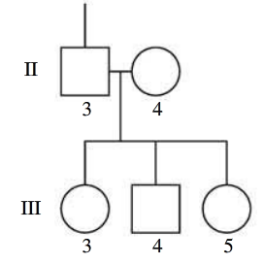

1. dominant
2. sex-linked
3. recessive
4. co-dominant

**3. If individual III-5 was shaded, what would the genotypes of the parents be? Choose from options A-D and draw a Punnett Square to show your reasoning.**

|  |  |  |
| --- | --- | --- |
| **Parents** |  |  |
|  |  |  |
|  |  |  |

1. BB, BB
2. Bb, Bb

$X^{B}X^{B}, X^{B}Y$

$X^{B}X^{B}, X^{b}Y$

**4. What does ‘carried on the X-chromosome’ and ‘occurs more in males than females’ suggest?**

1. A monohybrid cross
2. A dihybrid cross
3. Mendel’s experiments
4. Sex-linked inheritance

**5. Which pedigree represents an X-linked dominant trait?**

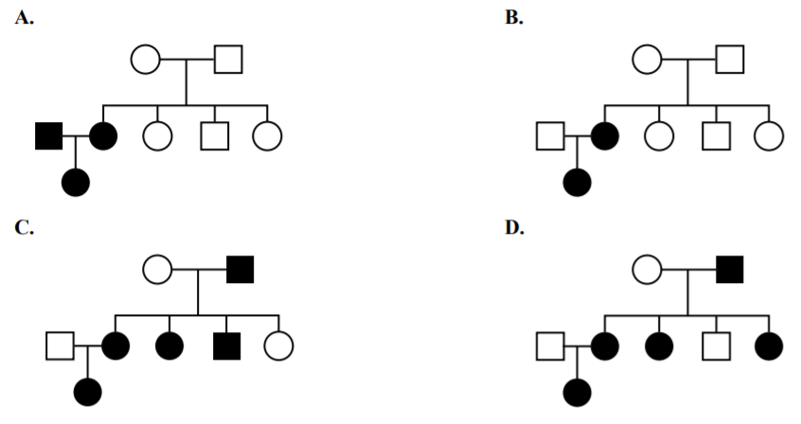

**6. In the following pedigree, shaded individuals have a particular genetic trait.**

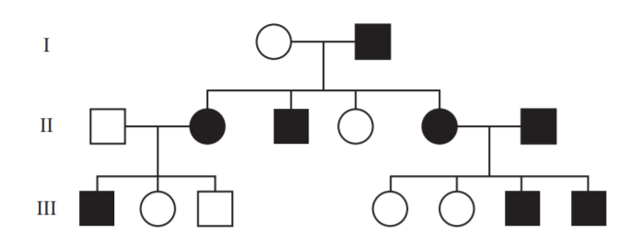

**The mode of inheritance of the trait is:**

1. X-linked dominant
2. X-linked recessive
3. Autosomal recessive
4. Autosomal dominant

**7. A family tree is shown.**

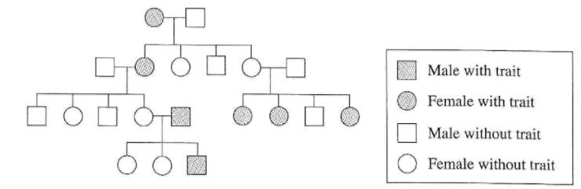

**What is represented by this family tree?**

1. Sex-linked inheritance
2. Polygenic inheritance
3. Inheritance of a recessive trait
4. Inheritance of a dominant trait

*Use the following information to answer questions 8 and 9.*

**Examine the following pedigree.**

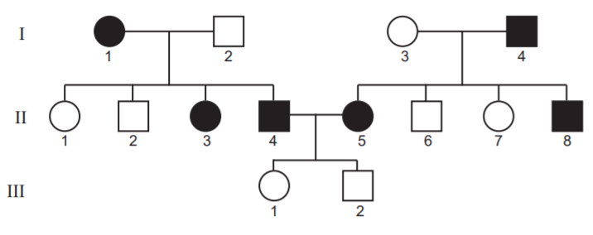

**8. The mode of inheritance of the trait shown in the pedigree is**

1. X-linked recessive
2. X-linked dominant
3. Autosomal recessive
4. Autosomal dominant

**9. If individuals II-2 and II-7 married, the chance that their first child would have the trait is**

1. zero
2. one in two
3. one in three
4. one in four

*Use the following information to answer questions 10 and 11.*

**In humans, the ABO blood group has a single autosomal gene locus with three possible alleles. There are four different blood group types. The different blood group types and their genetic makeup are shown in the following table.**

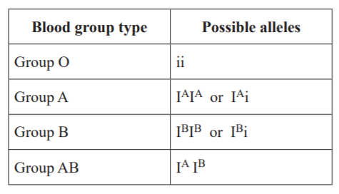

**10. A woman of blood group A, whose genotype is unknown, and a man of blood group O have a child. Genetically, this is an example of a**

1. self cross
2. test cross
3. dihybrid cross
4. sex-linked cross



**11. Examine the following pedigree, which shows the phenotype with respect to the ABO gene locus of each individual.**

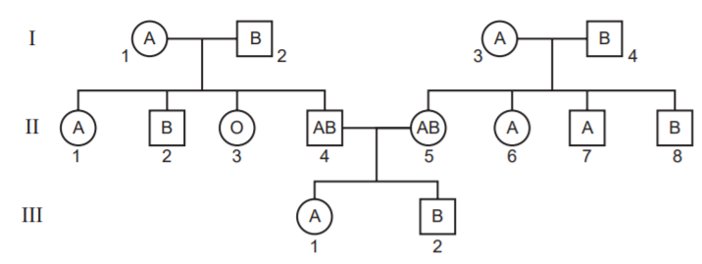

**Individuals that would be homozygous at the ABO gene locus include**

1. I-3
2. II-2
3. II-6
4. III-2

**12. Red-green colour blindness is an X-linked recessive trait with the alleles:**

$$X^{R}=normal colour vision$$

$$X^{r}=red-green colour vision$$

**Examine the following pedigree**

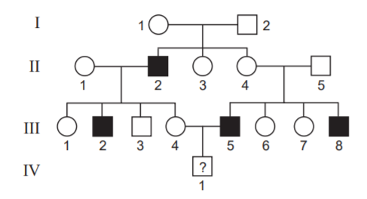

**With respect to this gene, it is reasonable to predict that individual**

1. II-3 must be $X^{R}X^{R}$
2. III-4 must be $X^{R}X^{r}$
3. II-4 has a two in three chance of being $X^{R}X^{R}$
4. IV-1 has a one in four chance of being colour blind

**The following pedigree shows the inheritance of an X-linked dominant trait in a family.**

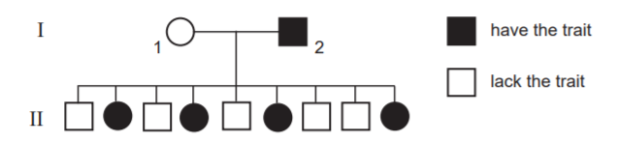

**13. It is reasonable to assume that the**

1. Mother of I-1 had the trait
2. Father of I-1 had the trait
3. Mother of I-2 had the trait
4. Father of I-2 had the trait

**14. A pedigree is shown.**

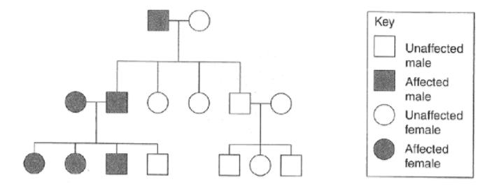

**What type of inheritance is shown in the pedigree?**

1. Sex-linked inheritance
2. Sex-linked dominant
3. Non sex-linked recessive
4. Non sex-linked dominant

**15. Cystic fibrosis is an autosomal recessive trait that affects many parts of the body, particularly the lungs and other organs. Parents who show none of the characteristics of cystic fibrosis have an affected child. The chance that their next child will be phenotypically normal is**

1. Three in four
2. One in four
3. One in two
4. Zero

**16. The presence of freckles is a dominant characteristic. A child’s mother has no freckles and its father is heterozygous for freckles. What is the probability that this child will have freckles?**

1. 25%
2. 50%
3. 75%
4. 100%

**17. In humans, brown eye colour is dominant and blue eye colour is recessive. A brown-eyed boy and a blue-eyed girl have a blue-eyed mother. What eye colour does the father have and why?**

1. Brown because the gene for brown eye colour is sex-linked
2. Brown because at least one of the parents must have brown eyes
3. Blue because at least two other members of the family have blue eyes
4. Blue because at least one of the parents must be heterozygous for eye colour

**18. Two genes for coat colour in dogs have the following alleles.**

|  |  |
| --- | --- |
| **Gene 1** | **Gene 2** |
| B: black | S: solid colour |
| b: brown | s: white spotting |

**It is reasonable to conclude that a dog with the genotype**

1. **BB Ss** would be black with white spotting
2. **Bb Ss** would be brown with white spotting
3. **bb SS** would be a solid brown colour
4. **bb ss** would be a solid black colour

**19. In cats, coat colour and fur length are inherited characteristics. The two genes involved are on different chromosomes and have the following alleles.**

|  |  |
| --- | --- |
| **Coat colour** | **Fur length** |
| B: black | S: short |
| b: brown | s: long |

**A breeder, Joyce, obtained a cat, Felix, which has short black fur. Joyce wanted to determine if Felix was heterozygous or homozygous at the two gene loci.**

**To do this, it is best that Joyce carries out a test cross between Felix and a female cat with the genotype:**

1. Bb Ss
2. Bb ss
3. bb ss
4. bb Ss

**20. The shape of a human earlobe is determined by a single autosomal gene. Free lobe is dominant to attached lobe.**

**a) Write appropriate allele symbols for this gene**

_______________________________________________________________________________________

**b) How many genotypes are possible with respect to these alleles? How many phenotypes are possible?**

______________________________________________________________________________________________________________________________________________________________________________

**c) A homozygous man with free lobes married a heterozygous woman. Show the genotypes and phenotypes possible in their children.**

_____________________________________________________________________________________________________________________________________________________________________________________________________________________________________________________________________

**d) Can two people with free lobes have a child with attached lobes? Explain your answer.**

_____________________________________________________________________________________________________________________________________________________________________________________________________________________________________________________________________

**e) Two parents heterozygous for earlobe shape have a child. What is the probability that the child has attached lobes? Write your answer as a percentage and as a ratio.**

______________________________________________________________________________________________________________________________________________________________________________

**21. What is the most likely mode of inheritance for each of the diseases shown in the following pedigrees? Explain your choices.**

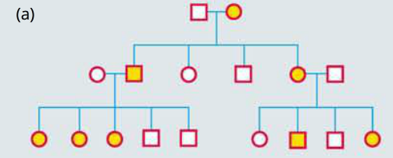

_____________________________________________________________________________________________________________________________________________________________________________________________________________________________________________________________________

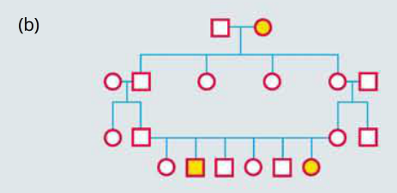

_____________________________________________________________________________________________________________________________________________________________________________________________________________________________________________________________________

**22. The following pedigree shows the inheritance of albinism.**

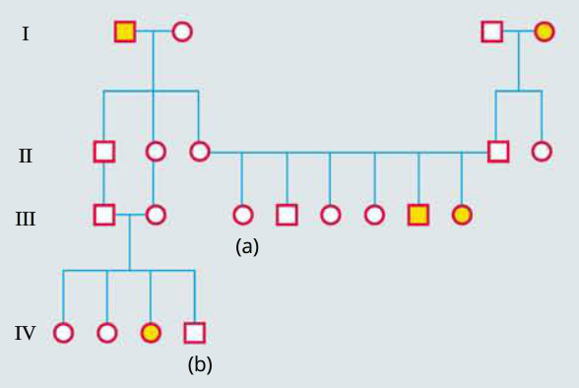

**a) What is the most likely mode of inheritance of the condition? Explain.**

_____________________________________________________________________________________________________________________________________________________________________________________________________________________________________________________________________

**b) If III-(a) and IV-(b) were to have offspring, what would you need to know about these individuals to calculate the chances of their offspring having albinism?**

______________________________________________________________________________________________________________________________________________________________________________