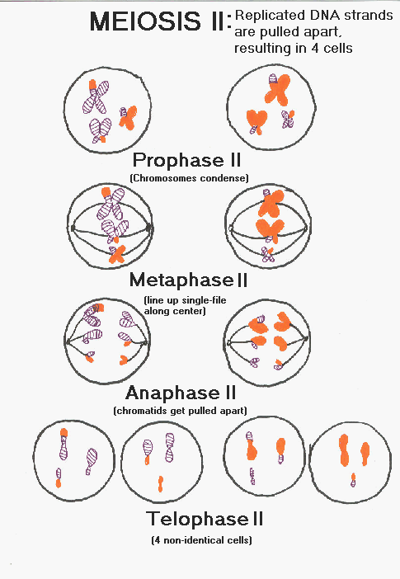Meiosis Activity: Arrange the following diagrams and words in a flow diagram illustrating the events of meiosis from a diploid somatic cell to haploid gametes. Submit to your teacher

DNA Replication

**Prophase II**

**Telophase I (cytokinesis)**

**Anaphase II**

**Prophase I**

**Gametes**

**G1 of Interphase**

**Metaphase II**

**Metaphase I**

**Anaphase I**

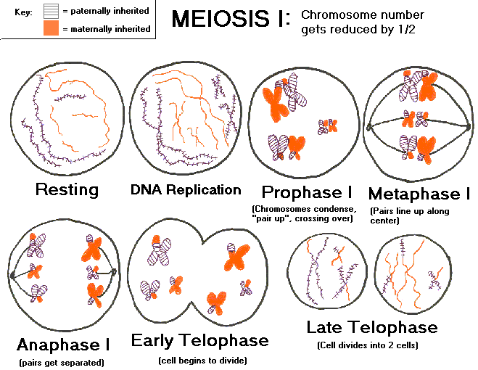

**G2 of Interphase**