# 

# ECONOMICS

# Practice SAC 2.1.1-

# UNIT 2 - OUTCOME 2

**You will have 80 minutes to complete this task.**

The SAC is a Structured Questions Test

The total SAC is worth **10%** of your Unit 1 grade.

**Conditions and restrictions**

* Students are permitted to bring into the room for this task: pens, pencils, highlighters, erasers, sharpeners and rulers
* Students are NOT permitted to bring into the room for this task: blank sheets of paper and/or white out liquid/tape.

**Materials supplied**

* Question and answer book of 15 pages

**Instructions**

* Print your name in the space provided on the top of the front page.
* All written responses must be in English.

Student name ____________________________________________

**Grade/Score: ____/___40 Satisfactory Completion? S/N: ______**

**(Provisional)**

--------------------------------------------------------------------------------------

**Assessment Criteria**

This assessment task was developed using the Outcome 1 key knowledge and skills in Unit 2 VCE Economics:

|  |
| --- |
| **Key knowledge**  • the nature and meaning of trade-offs in economics  • aggregate demand and its components  • aggregate supply  • the meaning and measurement of economic growth using real Gross Domestic Product (GDP) and real GDP per capita  • the economic benefits of economic growth such as growth in material living standards, employment opportunities, economic development and non-material living standards  • the limitations associated with using GDP per capita to measure changes in living standards  • aggregate demand and aggregate supply factors that may influence economic growth  • factors that might affect future rates of economic growth such as an ageing population and labour force participation  • the meaning of both long-term economic prosperity and environmental sustainability  • economic and environmental costs of economic growth such as climate change, depletion of natural resources and deterioration of common access resources  • trade-offs and compatibility between economic growth and environmental sustainability  • alternative economic indicators of living standards  • the effect of policy response used to address environmental effects of economic growth such as market-based approaches, direct actions and regulation.  **Key skills**  • define key economic concepts and terms and use them appropriately  • access and synthesise information gathered from a range of sources and draw conclusions  • identify trends, patterns, similarities and differences in economic data and other information  • gather, interpret and analyse statistical and graphical data  • evaluate the potential costs and benefits associated with economic activity. |

**SECTION A – Multiple Choice**

**Instructions for Section A**

Answer **all** questions.

Choose the response that is **correct** or that **best answers** the question.

A correct answer scores 1, an incorrect answer scores 0.

A mark will not be awarded if more than one response is chosen for a question.

**Question 1**

The level of economic activity refers to:

1. All production and expenditure by businesses
2. Any activity by individuals, businesses and government that generates production, income, employment and expenditure
3. Consumption and expenditure on goods and services by households
4. The activities of the government in the economy

**Question 2**

Which of the following is not used as an indicator of changes in non-material living standards?

1. The crime rate
2. The level of greenhouse gas emissions
3. The quantity of goods and services a person is able to purchase
4. The rate of urban sprawl

**Question 3**

Which of the following aggregate supply factors would tend to slow down economic activity?

1. A reduction in interest rates on business loans and overdrafts
2. A fall in the real unit labour costs
3. A rise in the cost of imported raw materials used by local businesses
4. A rise in the participation rate

**Question 4**

The government’s goal of strong and sustainable economic growth is a rate around 3 – 3.5% per annum. This is considered to be an appropriate level of growth in order to avoid all of the following except:

1. Rising levels of unemployment
2. Increased levels of spending by households
3. Jeopardising future living standards
4. Depletion of environmental resources

**Question 5**

Which of the following factors is likely to have an effect on Consumption Expenditure (C) which is different from that of the other three factors?

1. An increase in the savings ratio
2. A decrease in the rates of personal income tax
3. A decrease in the level of consumer confidence
4. An increase in the level of unemployment

**SECTION B – Written responses**

**Instructions for Section B**

Answer **all** questions in the spaces provided.

**Question 1 (6 marks)**

**a. Explain** one economic cost and one environmental cost associated with unsustainable economic growth.

4 marks

|  |
| --- |
|  |
|  |
|  |
|  |
|  |
|  |
|  |
|  |
|  |
|  |
|  |
|  |
|  |
|  |
|  |

**b. Describe** the trade-off between economic growth and environmental sustainability.

2 marks

|  |
| --- |
|  |
|  |
|  |
|  |
|  |
|  |
|  |
|  |
|  |
|  |

**Question 2 (4 marks)**

**Explain** one direct and one market-based policy response used by the government to address the environmental effects of economic growth.

|  |
| --- |
|  |
|  |
|  |
|  |
|  |
|  |
|  |
|  |
|  |
|  |
|  |
|  |
|  |
|  |
|  |
|  |
|  |
|  |

**Question 3 (5 marks)**

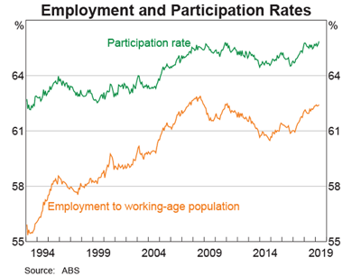

**a. Describe** the trend in Australia’s Labour Force Participation Rate over the past two years.

2 marks

|  |
| --- |
|  |
|  |
|  |
|  |
|  |
|  |
|  |
|  |
|  |

**b. Explain** how the trend in the Labour Force Participation Rate is likely to influence the aggregate supply curve and future rates of economic growth.

3 marks

|  |
| --- |
|  |
|  |
|  |
|  |
|  |
|  |
|  |
|  |
|  |
|  |
|  |
|  |
|  |

**Question 4 (8 marks)**

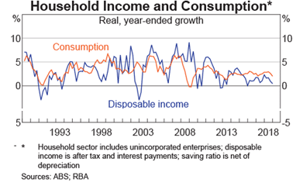

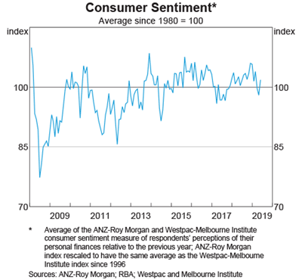

**Analyse** how the trend in both disposable income and consumer confidence is likely to influence the Aggregate Demand curve and:

* Economic growth
* Employment opportunities
* Living standards

|  |
| --- |
|  |
|  |
|  |
|  |
|  |
|  |
|  |
|  |
|  |
|  |
|  |
|  |
|  |
|  |
|  |
|  |
|  |
|  |
|  |
|  |
|  |
|  |
|  |
|  |
|  |
|  |
|  |
|  |
|  |

**Question 5 (6 marks)**

The table below includes the chain volume of goods and services for Nation H over 2018 and 2019:

|  |  |  |
| --- | --- | --- |
|  | **2018** | **2019** |
| Chain volume of goods and services | 100 | 103 |

**a. Calculate** the change in Real Gross Domestic Product over 2018 and 2019.

1 mark

|  |
| --- |
|  |

**b. Explain** one economic benefit of economic growth.

2 marks

|  |
| --- |
|  |
|  |
|  |
|  |
|  |
|  |
|  |
|  |
|  |

**d. Explain** the impact of an improvement in economic growth on economic development and living standards.

3 marks

|  |
| --- |
|  |
|  |
|  |
|  |
|  |
|  |
|  |
|  |
|  |
|  |
|  |
|  |
|  |
|  |

**Question 6 (6 marks)**

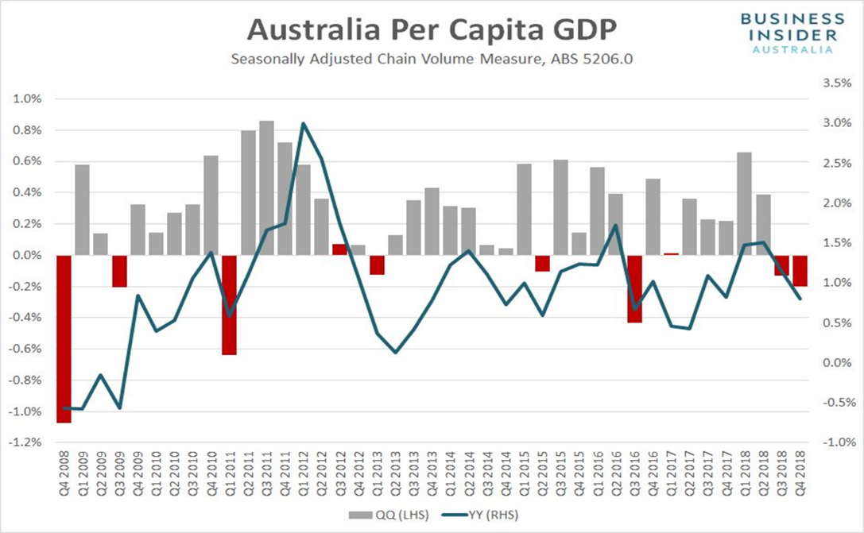

|  |
| --- |
| “Officially the two consecutive quarters of negative growth means that Australia has officially entered a GDP per capita recession” |

**a. Explain** one reason that has influence the trend movement of Australia’s GDP per capita and the impact on material living standards.

2 marks

|  |
| --- |
|  |
|  |
|  |
|  |
|  |
|  |
|  |
|  |

**b. Explain** one limitation of using real GDP per capita to measure living standards.

2 marks

|  |
| --- |
|  |
|  |
|  |
|  |
|  |
|  |
|  |
|  |
|  |

**d. Explain** one alternative economic indicator to measure living standards.

2 marks

|  |
| --- |
|  |
|  |
|  |
|  |
|  |
|  |
|  |
|  |
|  |

**Extra writing space**

**(clearly label all responses)**

|  |
| --- |
|  |
|  |
|  |
|  |
|  |
|  |
|  |
|  |
|  |
|  |
|  |
|  |
|  |
|  |
|  |
|  |
|  |
|  |
|  |
|  |
|  |
|  |
|  |
|  |
|  |
|  |
|  |
|  |
|  |