|  |  |
| --- | --- |
|  | |
| **Topic:** **“We’re a nation of Peeping Toms.” To what extent does Hitchcock endorse this idea in ‘Rear Window’?** | |
| Introduction **Context:**  **Source/Text Information:**  **Main contention:**  **Summary of arguments:**   * **Hitchcock endorses both voyeurism and the male gaze.** * **Hitchcock questions the 1950s society morality of watching through a ‘rear window’ of an apartment** * **Hitchcock provides a social commentary on the absurdity of the McCarthy period, and ultimately mocks the paranoia of the anti-communist uprising.**   **Directors message on the theme:** | |
| Body Paragraph 1 - AGREE | |
| Topic sentence | Throughout the film ‘Rear Window’ Hitchcock resentfully endorses aspects of the 1950s voyeuristic culture. |
| Explanation  Evidence  (interchangeable) 🡪 Jeff is a hero | Jeff’s occupation as photojournalist encompasses the new values of the time period and the support for voyeurism and viewing as an everyday American past-time and profession. Jeff’s apartment is surrounded by photographs of different scenes from war torn countries to car crashes and even a stack of magazine with a photograph one might suspect to be his love interest Lisa Freemont – suggesting that not only is this his professional but that he ultimately has made a lucrative career of this observation of viewing rather than partaking in everyday life. |
| Explanation  Evidence  (interchangeable)  🡪 Male Gaze | From the beginning of the film through to the ends conclusion the viewers see Jeff become obsessive about proving that Mr. Thorwald has in fact killed his wife. This suspicion occurs after Jeff has a fevered sleep one hot evening waking early in the morning to the echo of a female scream through the urban Greenwich apartment block. The morning afterwards Jeff laments to Stella that it is “hard to figure” what is happening in the “salesman(s)” apartment due to the suspicious activity occurring in his apartment. After their conversation Jeff peers out of the window to see Mr. Thorwald looking out of his apartment in “not an ordinary” manner and views this as enough evidence to begin his thorough investigations. To a contemporary audience this would be seen as an inadequate reason to invade someone’s privacy and become a vigilante, however for the 1950s viewer this would be consider enough grounds and a form of civic duty. |
| Explanation  Evidence – literary device  (interchangeable) | Hitchcock also endorses the privilege that men have to treat women as sexual objects by showing his support of the male gaze. From the distance of his apartment Jeff sits and gazes as the those around him, especially the scantily clad Miss Torso who repetitive dances in front of the window. Throughout the course of the film his lens grows bigger and bigger as his intrigue grows surrounding the Thorwald case, but also as he becomes more and more aroused by Miss. Torso’s love life and erotic movements. Thus his lens’ can be seen as a psychoanalytic representation of a phallic symbol and therefore insinuating that her body makes him feel like a ‘man’ and therefore aroused. Even Doyle stops and stares at her American beauty from the comfort of Jeff’s apartment and her idolized imagine, her long blonde hair, ample bust and tanned body makes her the ideal woman for the American man. Hitchcock never punishes Jeff, Doyle or even the viewer for perving of the semi-naked body frame and if anything encourages us that intrusive looking at these sexualised women is entirely appropriate and innately connected to what it means to be a man. |
| Linking Sentence | Furthermore, Hitchcock does endorse aspects of voyeurism suggesting to cinemagoers that not all forms of voyeurism is negative but does so begrudgingly before offering a more cynical view of a paranoiac society. |
| Body Paragraph 2- CHALLENGE | |
| Topic sentence | Hitchcock questions the 1950s society morality of watching through a ‘rear window’ of an apartment |
| Explanation  Evidence  (interchangeable) |  |
| Explanation  Evidence  (interchangeable) |  |
| Explanation  Evidence – literary device  (interchangeable) |  |
| Linking Sentence |  |
| Body Paragraph 3- MESSAGE | |
| Topic sentence | **Hitchcock provides a social commentary on the absurdity of the McCarthy period, and ultimately mocks the paranoia of the anti-communist uprising..** |
| Explanation  Evidence  (interchangeable) |  |
| Explanation  Evidence  (interchangeable) |  |
| Explanation  Evidence – literary device  (interchangeable) |  |
| Linking Sentence |  |
| Conclusion | |
| * **Clearly refer to the topic** and provide a concise response to it * **Restate your contention,** but avoid repeating the same words as your introduction * **Briefly** summarise your arguments * Include one or two **strong, general statements about the text’s significance,** rather than simply summarising the examples (great place to incorporate views and values, use the sentence stem sheet I gave you last Friday) * Furthermore, Shakespeare’s dramatic play ‘Macbeth’ exposes the dangers associated with allowing ones “vaulting ambition” to consume our thoughts encourage us, the audience, to monitor our selfish “desires” and monitor our motivations for seeking fulfilment. * Therefore, Shakespeare’s social commentary ‘Macbeth’ outlines that the seventeenth century in England was quite restrictive and condemning of men and women who did not adhere to gender roles, particularly the stereotypical view of what it means to be a ‘man’. * Throughout Shakespeare’s confronting play ‘Macbeth’ the audience is exposed to the satanic and dangerous nature of the “weird sisters” and other “instruments of darkness” encourage the Elizabethan audience to stray from temptation and follow the Protestant Reformation ideals. | |

Suggestions

|  |  |
| --- | --- |
| **we must consider  alternatively  juxtaposed against  disappointingly  is a realistic outlook  correspondingly  coupled with  foremost  embodiment  simultaneously  formidable  admittedly difficult  emotionally charged  it is significant that  advocates/proponents claim that  conversley  autonomous  sanction  abstract  cognizant  succinct  respite** | **notable  shrewd  astute  articulated  demean  myriad  extol  this is illustrated by   we could interpret this in two ways  the prevailing attitude  infinitely smaller (greater)  constantly changing background  recurring images  account for  assess  The character of ... embodies  innate  brevity  plethora  antithesis  formidable  augment  evocative** |

**Powerful Verbs for Essays:**

The following verbs are helpful as a means of showing how an example or quote in literature supports an idea or interpretation.

EXAMPLE + VERB + EXPLANATION/SIGNIFICANCE

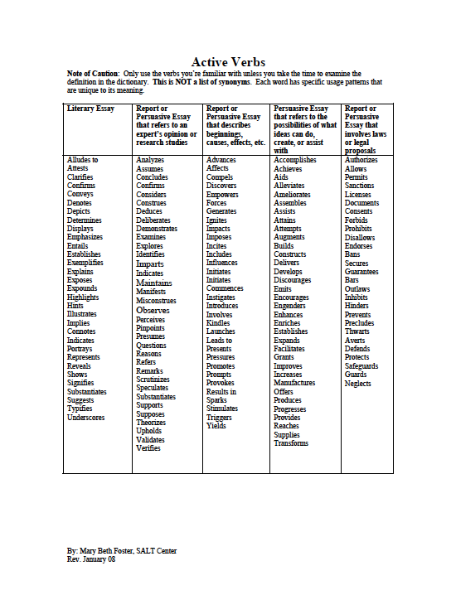Macbeth’s hallucinations suggest that his sanity is unstable after he orders Banquo to be killed.