Unit 3 Further Maths SAC 2 Revision

Recursion and Financial Modelling

**Question 1**

A car is purchased by a company for $42 000. It is depreciated by a flat rate of 6% of its purchase price each year.

1. It is depreciated by a flat rate of 6% of its purchase price each year. Write a recursion relation that models the depreciation of the car.

|  |
| --- |
|  |

2 marks

1. Hence what will its value be after 5 years?

1 mark

1. If it is depreciated at a flat rate of 7.2% per year, what will its value be after 5 years?

1 mark

1. If it is depreciated by 20 cents per kilometer (unit cost depreciation), write a rule for the value of the car after *n* km

|  |
| --- |
|  |

1 mark

1. Hence how many kilometres will it have been driven when its value reaches $10 000?

2 marks

**Question 2**

1. An amount of $12 000 is invested in an account that earns 4% simple interest calculated annually.

Using a recurrence relation find what the investment is worth after 3 years?

2 marks

1. If the $12 000 had been invested in an account that earned 4% per annum, compound interest calculated annually.

Using a recurrence relation find what the investment is worth after 3 years?

2 marks

1. Discuss which option you would invest your $12 000 and why?

1 mark

**Question 3**

An amount of $64 000 is invested in an annuity at 6% per annum compound interest compounded monthly.

1. Regular monthly payments of $2 000 are to be made to the investor. How long will this annuity last? Express your answer in months to the nearest whole month.

1 mark

1. If the investor wanted the annuity to last for 5 years, what would be the monthly payment to the investor?

1 mark

**Question 4**

A couple borrow $180 000 when they take out a reducing balance loan. The interest rate charged on this loan is 5.2% per annum compounding quarterly. They can completely repay the loan over a 10 year period.

If they completely repay the loan over a 10 year period, their quarterly repayments will be

$5 799.49.

1. If the couple choose to completely repay the loan over a 10 year period, how much will they still owe on the principal after 5 years?

1 mark

1. If the couple change their mind and decide to completely repay the loan over a 15 year period, what will their quarterly repayments be?

1 mark

1. How much interest will the couple save by completely repaying the loan over a 10 year period instead of a 15 year period?

2 marks

**Question 5**

A new website is set up to sell discounted concert tickets. Let *Sn* be the number of tickets predicted to be sold in the *n*th month after it has been set up. The recurrence relation that defines *Sn* is



1. Find the number of tickets predicted to be sold in the fourth month.

1 mark

1. In order for this recursion equation to predict growth in the monthly sales of concert tickets, the number of tickets sold in the first month must exceed 4 000. Explain why this is the case using appropriate working.

2 marks

**Question 6**

Peter has 3 cars for his business. Using flat rate depreciation, after 5 years of use the total value of the cars is $55 775. If the annual depreciation is $6 845

**a.** What was the original total cost price of the three cars?

1 mark

**b.** What was the percentage rate of depreciation for the cars in the first year? Give your answer to one decimal place

2 marks

**c.** When the total value of the cars first reaches less than $30 000, Peter sells the cars and buys new cars. How many years will he have the cars before he sells them?

1 mark

**Question 7 (continued on from question 6)**

Peter’s accountant, Gemma, suggests that he should use reducing balance depreciation

of 12% per annum instead.

**a.** Write a rule for the value of the cars, $V_{n}$, after *n* years.

1 mark

**b.** What would be the value of the cars at the end of 5 years if Peter took Gemma’s advice?

Give your answer to the nearest dollar.

1 mark

**c.** At what rate would Peter need to depreciate the cars, using a reducing balance depreciation, if he wanted them to be worth $39 934 at the end of five years? Give your answer to the nearest whole number.

2 marks

**Question 8**

Peter knows that he will have to spend more money in his business in 6 years’ time.

For this reason he puts $30 000 into different accounts.

**a.** $12 000 is invested at 5.2% simple interest. What is the value of this investment at the end of 6 years?

1 mark

**b.** $12 000 is invested at 4.8% per annum compounding every 6 months. How much interest will Peter have earned on this investment at the end of 6 years? Give your answer to the nearest cent.

2 marks

1. Peter invests the rest of the $30 000 at 5.0% per annum compounding monthly. He also deposits $500 into this account just after the interest has been paid each month. What is the total value of this investment at the end of 6 years. Give your answer to the nearest cent.

1 mark

**d.** What is the total final value of the investment? Give your answer to the nearest dollar.

1 mark

**e.** How much interest would Peter have received on all three investments by the end of the six years? Give your answer to the nearest dollar.

1 mark

**f.** If Peter wanted the final value of his investments at the end of the 6 years to be $100 000, how much should he pay into the $12 000 investment that is compounding every six months, just after the interest has been paid? Give your answer to the nearest dollar.

2 marks

**Question 9**

Phillip has borrowed some money from the bank to build a cooking school building in his backyard. The amortisation table for this loan, showing the first 5 monthly payments on the reducing-balance loan, is shown below. The letters *A*, *B* and *C* represent values from the table that are missing.

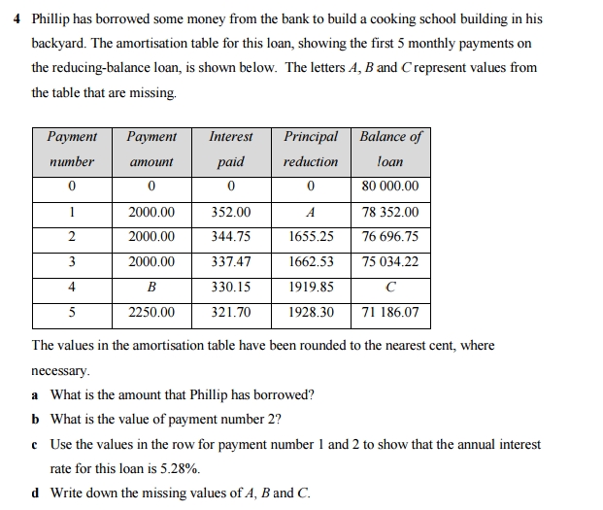

The values in the amortisation table have been rounded to the nearest cents, where necessary.

1. What is the amount that Phillip has borrowed?

1 mark

1. What is the value of payment number 2?

1 mark

1. Use the values in the row for payment number 1 and 2 to show that the annual interest rate for this loan is 5.28%

1 mark

1. Write down the missing values of *A*, *B* and *C*.

3 marks

Phillip will continue to repay the loan with monthly payments of $2 250.

1. Use a financial solver to determine the total number of payments Phillip must make in order to fully repay this loan, to the nearest month.

2 marks

1. If Phillip had borrowed the money with an interest only loan for five payments, how much extra interest would he have paid after five months?

2 marks

1. After the fifth payment, the interest rate was increased to 5.32% per annum, compounding monthly. If Phillip will increase his monthly payment so that he will fully repay the loan in the same period, what will his new payments be? Round your answer to the nearest cents.

2 marks

**Question 10**

A school needs to consider which method of depreciation to report to the school board and its finance committee.

One option is a **reducing balance** model. If the value of the bus is to be depreciated from its purchase price of $33 000 to a scrap value of $8 000 over 5 years

1. Calculate the **reducing balance** rate of depreciation as a percentage correct to one decimal place.

2 marks

1. What is the book value of the bus after 2 years (to the nearest dollar)?

1 mark

1. Another method is to depreciate using the Unit Cost Depreciation method. If in the 5 years it is expected to have travelled 80 000 kilometres, calculate the rate of depreciation if it will be depreciated from $33 000 down to $8 000. Give your answer in cents per 100 kilometres.

2 marks

1. With the $8 000 from the sale of the bus after it is scrapped, a scholarship fund is to be set up. A scholarship amount of $1 200 is to be paid annually from the $8000 and will be set up with the local bank offering a guaranteed interest rate of 4% p.a. compounded annually. For how many years will the scholarship be able to be granted before the funds are exhausted, to the nearest year?

1 mark

**Question 11**

Carlos set up a compound interest investment to pay his employee on retirement. He will deposit an initial $15 000 and add $240 to the investment every month. Interest will be paid at the rate of 4.85% per annum, compounding monthly.

1. Carlos’ employee will retire in 18 years time. Use a financial solver to determine the amount of money that will be paid to the employee upon retirement. Write your answer correct to the nearest cent.

1 mark

1. After 10 years, Carlos will increase his monthly payments so that his employee will retire with $140000. What monthly payments will Carlos need to make? Write your answer correct to the nearest dollar.

2 marks

Upon retirement, the employee invests the $140 000 superannuation fund into an annuity that earns interest at the rate of 6.75% per annum, compounding monthly. He will receive monthly payments of $1000. The amortisation table for the first three payments of this investment is shown below.

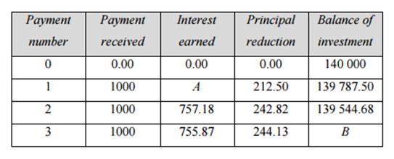

1. Use the information in the amortisation table to
2. Determine the interest earned after one month (the value of *A*).

2 marks

1. The balance of the investment after three months (the value of *B*).

1 mark

**Question 12**

Holly investigated a reducing balance loan of $48 000 for landscaping at the hospital. Interest is charged monthly at 5.3% per annum. Holly considers two options to fully repay this loan.

*Option 1*: Equal monthly repayments of $1450 and one final repayment of less than $1450.

*Option 2*: Equal monthly repayments of $1700 and one final repayment of less than $1700.

Calculate the difference in the number of repayments required for option 1 and the number of repayments required for option 2.

1. Calculate the number of repayments required for option 1 rounded to the nearest month

1 mark

1. Calculate the number of repayments required for option 2 rounded to the nearest month

1 mark

1. Hence calculate the difference in the number of repayments required for option 1 and the number of repayments required for option 2.

1 mark

**Question 13**

Lucky has won $355 000 in a lottery. He wants to secure his future and retire in 5 years so he is considering a number of financial options.

1. Lucky considers putting the $355 000 into a compound interest account earning 4.25% per annum compounding monthly. If he chooses this option, what will be the balance of his account after 5 years?

1 mark

1. Lucky knows that the compound interest option won’t give him enough to retire. He wants to have $1 000 000 in 5 years. If he keeps working and invests the $355 000 into the compound interest account earning 4.25% per annum compounding monthly how much will he need to add to the account at the end of every month so that he has $1 000 000 in 5 years?

1 mark

Lucky cannot afford the amount needed to add to the account each month to get him to $1 000 000 in 5 years. Instead, he invests the $355 000 into a compound interest account earning 4.25% per annum compounding monthly and adds $1200 each month. After 2 years, the interest rate changes to 5.5% per annum and at the same time he is able to increase his monthly payment to $1400.

1. How much will he have at the end of 5 years?

2 marks

**Question 14**

Laura is buying a new car. The total cost is $39990. She does not have any savings.

She has 2 loan options to consider.

Option 1: The dealership offers her finance on the full price at 7.2 % p.a. repaid quarterly over 10 years.

Option 2: A bank offers her finance on the full price at 7.25 % p.a. repaid monthly over 10 years.

1. If Laura takes the dealership’s offer, what is the total amount that she will pay for her new car?

Calculate payment amount

Calculate the total cost of the car by using $number of payments× payment amount$

Calculate interest paid over the life of the loan by using $total cost- loan amount$ so that it can be used to see which loan has the most /least interest

1. How much would the total amount repaid if she decides to take the loan from her bank?
2. Should Laura go with option 1 or 2? Justify your answer.

You will now investigate changes made to option 2, the bank loan.

Compare each individual change stated in parts d. to g. to the original option 2

1. What would be the effect on the bank loan (option 2) if Laura decided to make fortnightly payments over the 10 years?
2. What would be the effect on the bank loan (option 2) if Laura increases the monthly payment to the bank by an extra $50 per month? Where applicable round answers to the nearest month.

As this question does not state over 10 years the effect will be that the loan is paid off quicker so find N and round to the nearest month as stated, so normal rounding. After finding the number of payments calculate the total cost and interest as per the hints for part a

1. For option 2 the bank changes the interest rate to 7.5% after 2years. Investigate the effect this will have on the loan, if it is still to be repaid over 10 years.

The loan is still over 10 years so investigate the extra cost of the rate increase by;

1. Work out how much more each payment is after the change
2. Payments left after the change 🞭 answer to step 1
3. 3 years after taking out the **original** bank loan (option 2) and making the scheduled monthly payments, Laura has $3000 saved and decides to make a lump sum payment. If she continues with the same monthly payments, how much time and money does she save by making this lump sum payment. Where applicable round answers to the nearest month.

**End of Revision**