* concepts of health and wellbeing (including physical, social, emotional, mental and spiritual dimensions) and illness, and the dynamic and subjective nature of these concepts

**Health**: Complete state of physical, mental and social wellbeing not just merely the absence of disease or infirmity.

**Wellbeing**: a complex combination of all dimensions of health, characterised by an equilibrium in which the individual feels happy, healthy, capable and engaged.

**Health and wellbeing** explained:

* relates to the state of a person’s physical, social, emotional, mental and spiritual existences
* relates to how a person feels about their life.
* is characterised by an equilibrium where the individual feels healthy, happy, capable and engaged.
* is a state of complete physical, social, emotional, mental and spiritual wellbeing, and not merely the absence of disease or infirmity.

**Illness**: the state of feeling unwell.

**Disease**: Physical or mental disturbance involving symptoms, disfunction or tissue damage, while illness is a more subjective concept related to a personal experience of disease.

**Health** **Status**: an individual’s or a population’s overall health taking into account carious aspects such as life expectancy, about on disability and levels of disease risk factors.

**HEALTH** = dynamic and subjective

Dynamic nature - changing or moving continually in response to the environment and experiences.

Subjective nature - influenced by personal opinions and feelings

**DIMENSIONS**

**Physical**: Relates to the functioning of the body and it's systems; includes the physical capacity to perform daily activities or tasks

* Appropriate body weight for height (BMI)
* Level of fitness
* Functioning of organ and systems
* Healthy eating/tobacco use/alcohol consumption
* Having adequate levels of energy

**Mental**: Mental health is the current state of well-being relating to the mind or brain and it relates to the ability to think and process information and respond constructively to situations

* Using good coping mechanisms for stress
* Forming opinions
* Coping with day-to-day demands
* Feeling good and accepting yourself
* Design making

**Social**: The ability to form meaningful and satisfying relationships with others and the ability to manage or adapt appropriately to different social settings

* Having meaningful relationships
* Managing conflict effectively
* Obeying laws and rules of society
* Accepting responsibility
* Being an active family member

**Emotional**: Emotional health related to the ability to express emotions in a positive way

* Feeling in control of emotions
* Feelings of accomplishment
* Expressing empotions
* Resilience
* Aware of emotions/self-aware

**Spiritual**: Not material in nature but relates to ideas, beliefs, values and ethics that arise in the minds and conscience of human beings

* Seeking the meaning of life
* Having a guiding sense of purpose, meaning and value
* Sense of belonging
* Seeking happiness and fulfilment
* Peace and harmony

• benefits of optimal health and wellbeing and its importance as a resource individually, nationally and globally

**Individual benefits**

* Reduces there risk of premature death, disease and disability
* Increases the ability to concentrate on activities that can improve the quality of life (example: education, socialising, meaningful work)
* Children can go to school —> more employable —> stable income —> food security
* Decreases feelings of stress and anxiety
* Improved physical health and wellbeing and quality of relationships <—>increased energy to participate in health promoting behaviours such as exercise

— low levels of individual health and wellbeing can reduce the length and quality of life —

**National benefits**

Economic

* Higher average incomes, greater work productivity and lower rates of absenteeism (staying away from school/work for no good reason) higher GDP and GNI
* Reduced healthcare and associated caring costs meaning the money saved can be used for other ares (school, housing, transport)

Social

* Improved life expectancy means personal resources are maintained within the community
* Lower levels of stress in the community which could reduce levels of violence
* Increased participation in community areas such as volunteering

**Global benefits**

* Increased global income
* increased universal access to healthcare
* Risk of global disease outbreak reduces
* Morbidity and mortality is reduced
* Governments can focus on other issues (climate change, education)
* More countries move into the high income category
* Nations can work together to combat/help other countries and eradicate poverty and achieve sustainable development goals
* World peace and security
* More sustainable living

• prerequisites for health as determined by the WHO including peace, shelter, education, food, income, a stable eco-system, sustainable resources, social justice and equity

(**P**eople, **S**hould, **E**at, **F**ood, **E**veryday, **I**ncluding, **S**ome, **S**ustainable, **S**alad)

(**P**eace, **S**helter, **E**quity, **F**ood, **E**ducation, **I**ncome, **S**table ecosystem, **S**ustainable resources, **S**ocial justice)

| WHAT | DEFINITON | ADVANTAGE |
| --- | --- | --- |
| Peace | More than just the absence of war or conflict, includes access to essential services - education, health and essential services.  living with others on a basis of tolerance, respect and mutual understanding | * reduces the risk of premature death and injury * People can access essential services - education and work * People can develop and maintain social connections * Reduced mental health issues |
| Shelter | More than just a roof, relates to adequate ate privacy, space, security, structural stability, water-supply, sanitation and waste management | Provides/allows   * protection and safety * Place to study * Socialise * Relax and do hobbies |
| Equity | addressing the causes of inequality and providing strategies to ensure fairness.  Not about treating everyone equally but rather providing what individuals or groups require for health and wellbeing. | - everyone reaches the same outcome —> fairness and impartiality |
| Food | Fundamental right to ensure everyone has access to proper nutrients from all five food groups | * good nutrition —> less illness and good functioning of body systems * Need adequate ate nutrients to grow properly and think and learn * Food can provide a social connection * Good food —> healthy —> high self esteem |
| Education | Access to literacy and numeracy skills by attending school | * increases employability —> increases SES * Helps to mould a person’s values, morals and beliefs * Contributes to self purpose * Helps to develop and maintain relationships * Health literacy —> better health choices —> less chronic illnesses fewer infectious diseases |
| Income | Stable financial state | * allows people (**individuals**) to buy essential items (food, shelter, water, clothes, sanitary items, education) * Can recover from natural disasters * **National** and global economic growth —> reduced poverty |
| Stable ecosystem | Harmony between all living and non-living organisms | * crops and livestock can grow and flourish * Basic resources can be regenerated (food, water, air, less pollution) * Less chance of natural disaster |
| Sustainable resources | Meets the needs of the present without compromising the needs of the future. | * soil fertility * Over fishing * Energy use |

DOT POINT 4 (quizlet)

DOT POINT 5 (textbook summary pages)

* the contribution to Australia’s health status and burden of disease of smoking, alcohol, high body mass index and dietary risks (under-consumption of vegetables, fruit and dairy foods; high intake of fat, salt and sugar; low intake of fibre and iron).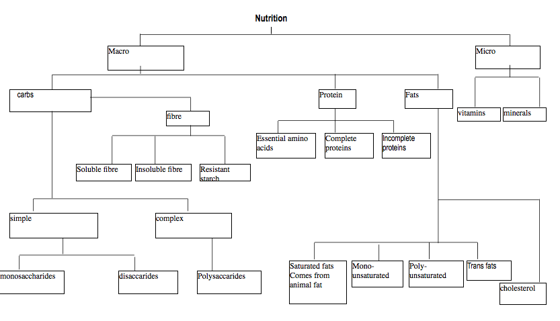

**SMOKING**

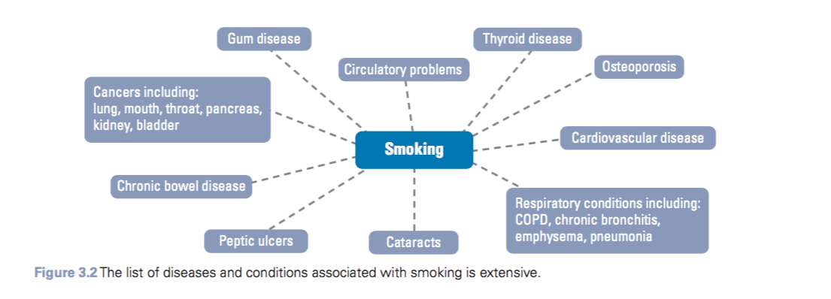

* Cigarettes have carcinogens (cancer-causing chemicals) and the smoke itself is a carcinogen
* Reduces the ability of the blood to carry oxygen, increases heart rate and basal metabolic rate
* Narrows blood vessels
* Smoking harms nearly every organ in the body, including the heart, blood vessels, lungs, eyes, mouth, reproductive organs, bones, bladder and digestive organs

**SMOKING (tobacco) AND CVD**

* Coronary hear disease and stroke
  + Damages the lining of the arteries, leading to a build-up of plaque (atheroma), which narrows the artery
* Carbon monoxide causes less oxygen to be carried around the body in the blood stream so the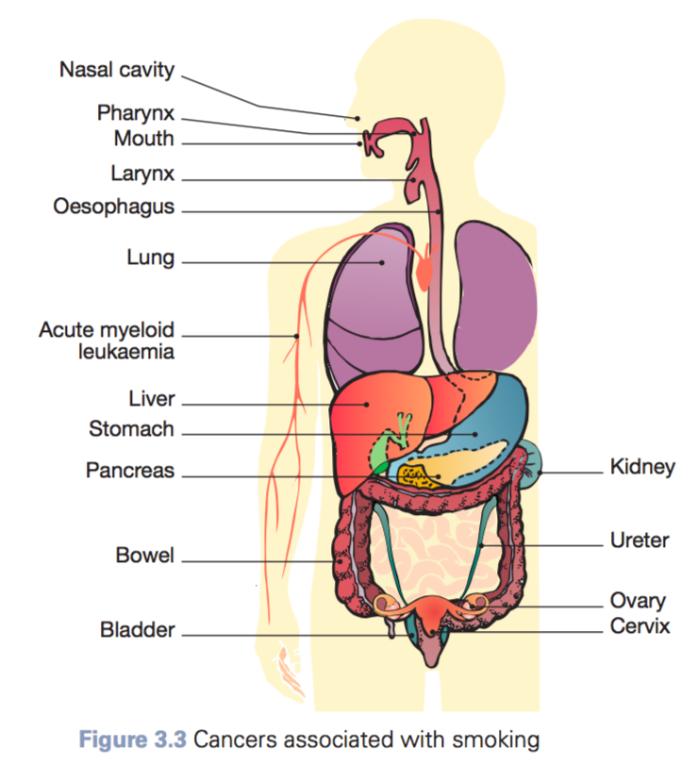 heart has to pump harder to supply the same amount of oxygen
* Nicotine in cigarettes makes the heart pump faster and results in high BP
* Blood clots are also more common in smokers which can cause stroke

**SMOKING (tobacco) AND CANCER**

* Tobacco smoke has an inflammatory effect, this results in the body producting more hormoes, white blood cells and other substances to appear in the damaged area (example. Lung) this inflammation can be the driver of cancer.

**SMOKING (tobacco) AND OTHER HEALTH CONCERNS**

* Respiratory problems,
  + coughing
  + phlegm
  + wheezing
  + chest colds
  + shortness of breath
* Passive smoking at young age increases the risk of developing eye and ear infections
* Smoking during pregnancy
  + miscarriages
  + low birthweight
  + impaired foetal development,
  + premature births
  + stillborn births
  + New born baby is also more susceptible to SIDs

**Variation in population groups (tobacco smoking)**

* More males (but most for females and males in age group 24-49 and 40-49)
* People in rural and remote areas are more likely to smoke tobacco (in very rural areas risk is 1.8 times more)
* Lower SES groups are 3 times more likely to smoke than people in the highest SES group
  + Smoking during pregnancy is more common in low SES groups
* Indigenous are 2.8 more likely to smoke
  + Almost half of the indigenous population over the age of 15 smoke

**Smoking of illicit drugs**

* Cannabis

**ALCOHOL**

* Factors influencing the impact of alcohol
  + Sex
  + Body size and composition
  + Age
  + Genetics
  + Nutrition
  + Metabolism

**ALCOHOL AND INJURIES**

* In 2013 more than 1 in 5 of recent drinkers put themselves or others at risk of harm while under the influence of alcohol in the previous 12 months (for example, by driving a vehicle, or verbally  
  or physically abusing someone or undertaking some other risky activity). (AIHW, 2016)
* Alcohol’s toll
  + 30% road accidents
  + 44% of fire injuries
  + 34% falls and drowns
  + 16% of child abuse cases
  + 12% of suicides
  + 10% industrial accidents

**ALCOHOL AND OBESITY**

* Alcohol adds kilojoules to the normal diet and may increase energy intake and fat storage further by increasing appetite.

**ALCOHOL AND CVD**

* Long-term use of excessive amounts of alcohol can cause high blood pressure, some types of cardiac failure, stroke and other circulatory problems.

**ALCOHOL AND CANCER**

* Alcohol is carcinogenic, and is related to cancers of the mouth, pharynx, larynx, oesophagus, liver and colorectum.

**OTHER**

* Long term
  + Liver
  + Mental health
  + Foetal defects
* Short term
  + Nausea
  + Loss of balance
  + Stress
  + Loss of productivity

**Variation in population groups (alcohol consumption)**

* For example, people in the low-SES group had a lower rate of lifetime risky drinking of alcohol. These adults were less likely to exceed alcohol consumption guidelines than adults in the high-SES group.
* Aboriginal and Torres Strait Islander people aged 15 and over were 1.1 times as likely to have exceeded the guidelines for single-occasion risk than non-Indigenous Australians
* People in very remote areas were likely to drink excessive of the guidelines once a week compared to urban city areas

**HIGH BMI**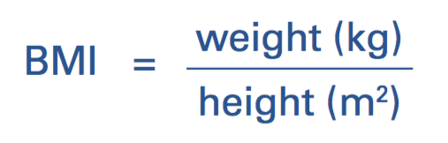

* Factors influencing body weight
  + Genetics
  + Metabolism
  + Hormone control
  + Diet
  + Physical activity
* Body types
  + Ectomorph
  + Endomorph
  + Mesomorph
* In 2014–15, 63 per cent of Australians aged 18 years and over were overweight or obese

**HIGH BMI AND DIABETES**

* Excess body fat seems to trigger the release of certain proteins from fat cells that negatively affect the secretion of insulin (a hormone that metabolises blood sugar in order to keep it at healthy levels). This may eventually overwork the pancreas and increase blood sugar, leading to type 2 diabetes.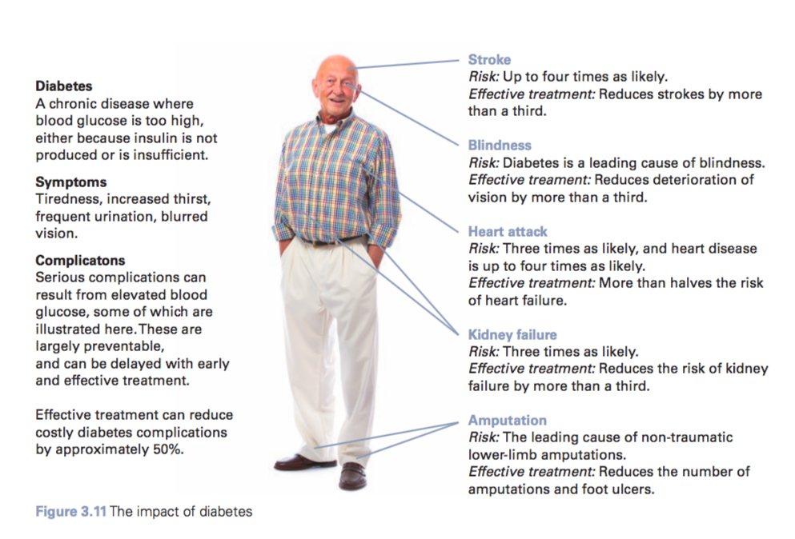

**HIGH BMI AND OTHER HEALTH CONCERNS**

* CVD
* High BP
* Some cancers
* Osteoarthritis
* Muskulo skeletal issues
* Respiratory issues
* Sleep apnea
* Gall bladder disease
* Hernia
* reproductive disorders
* Urinary incontinence
* Fatty liver
* Mental health issues
  + Depressions
* Metabolic disorders
* Life expectancy
  + if you have a BMI of 30–35 instead of a healthy BMI (between 18.5 and 25), your life expectancy is reduced by two to four years, and having a BMI of 40–45 reduces it by eight to 10 years.

Variations in population groups (high BMI)

* 71% of males had a high body mass in comparison to 56% of females.
* Low-income populations were also more likely to have a high body mass at 66% in comparison to high-income populations with a lower prevalence of 58%.
* A high body mass is more common among Indigenous populations in comparison to non- Indigenous populations with a prevalence during adulthood of 43% and 27% respectively.

**VEGETABLES**

TYPES OF VEGETABLES

* **gourd vegetables –** pumpkin and cucumber
* **root and tuber vegetables** – carrots, yams   
  and potatoes
* **allium vegetables** – onion, garlic and shallot
* **leafy green vegetables** – spinach, lettuce,   
  silver beet
* **members of the crucifer family** – broccoli,   
  cabbages, Brussels sprouts
* **edible plant stems** – celery and asparagus.
* Vegetables provide phytochemicals - bioactive chemical compounds  
  found in plants; also known as antioxidants.
* In 2014–15, 93 per cent of adults did not eat the recommended serves of vegetables each day
* Majority of adults only consume half the recommended serving

**VEGETABLES AND CANCER**

* Phytochemicals found I vegetables are a protective factor against cancer
  + carotene-rich vegetables (yellow, orange and red) and the cruciferous vegetables (broccoli, cauliflower, Brussels sprouts and cabbage) are highly recommended as a preventative measure against colon cancer.

**VEGETABLES AND CVD**

* Cholesterol becoming oxidised in the blood vessels near the heart, which can deposit to form plaque in the arteries, causing blockages can cause CVD issues but phytochemical (like vitamin E and C) reduce the risk of cholesterol build up

**VEGETABLES AND DIABETES**

* Adequate consumption of vegetables is a protective factor against obesity and hence Type 2 diabetes

**FRUIT**

* High in fibre (carbohydrate)
* Closely linked to vegetables
* Wide range of vitamins and minerals
* More people consume the correct amount of fruit compared to vegetables

**FRUT AND CVD**

* Recommended consumption of fruit reduces risk of coronary heart disease and stroke
* Fruit with reduced fat dairy products can reduce the risk if high BP (hypertension)

FRUT AND OBESITY

**Variation in population groups**

* 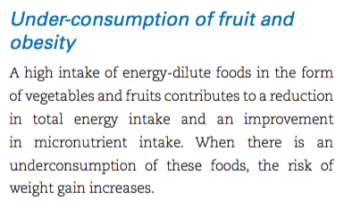Low SES and Indigenous and rural (ALL) but mainly SES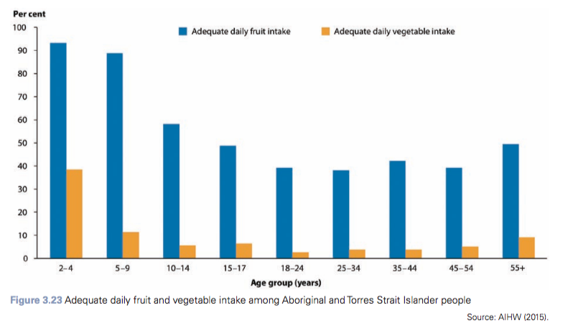

**DAIRY**

* 1 in 10 people are meeting the recommended dairy intake recommended by ADG
* Lactose intolerance is relatively high in Australia and is often experienced by those of Asian descent (80–90% of people) and is also common in those of Aboriginal and Torres Strait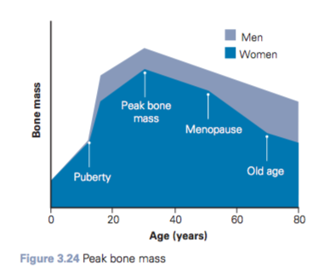 Islander descent (80 per cent of people).
* Calcium works with phosphorus and vitamin D

**DAIRY AND OSTEOPEROSIS**

* Osteoporosis is a decrease in bone density and strength that results in increased susceptibility to bone fractures. Osteoporosis literally means ‘porous bones’.
* Typically effects wrists, hip and spine
* Bones become brittle and fragile
* Calcium: main purpose is the construction and maintenance of bones and teeth
* Underconsumption of calcium in early years of life and youth can stop bones reaching peak bone mass (genetic potential of bone density)

**Intake of dairy between population groups**

Males vs Females

* Males consume slightly more dairy foods that females during adolescence and adulthood, although the difference in consumption is not considered to be very significant.
* Women consume less during menopause as they don’t want to put on weight

Indigenous vs Non-Indigenous

* Indigenous populations on average consume less dairy foods than non-Indigenous populations.
  + This could be due to higher rates of lactose intolerance in Indigenous communities

**FAT**

37Kj per gram

more difficult and take more time to break down (catabolise) than carbohydrates in order to be a useable energy source in the form of glucose.

Should only contribute to 15-30% of daily energy intake

**FATS**

**saturated fats**

* animal fats
* Increases LDL
* Solid at room temp
* No double bonds

**monounsaturated fats**

* plant based (olive, peanut, canola …)
* Avocados and other healthy fats
* LOWERS LDL does not lower HDL
* Healthiest source of fat

**polyunsaturated fats**

* vegetable oils
* Omega 3 and 6 fatty acids
  + Required to fight diseases
  + lower the risk of cardiovascular disease. Omega-3 fats have a role in regulating blood pressure and blood clotting and helping to maintain a healthy immune system; they also assist in brain and spinal cord function.

**trans fats.**

* increases LDL and lowers HDL

Trans fats are formed when monounsaturated or polyunsaturated vegetable oils are hydrogenated (hydrogen added) and hardened to form margarines, or the even harder vegetable shortening used by the food industry.Trans fatty acids also occur naturally in small quantities in some meats, butter and dairy products. (Better Health Channel, 2016)

• cardiovascular disease

• type 2 diabetes

• colorectal cancer

• musculoskeletal conditions – impacting the joints.

**FAT AND OBESITY**

* High or regular consumption of fat will result in build up of fat tissue (adipose tissue) in body

**FAT AND TYPE 2 DIABETES**

* Saturated fats can raise cholesterol and triglyceride levels in the blood, increasing the likelihood of an increase in body fat.
* Being over- weight or obese is a precursor of type 2 diabetes.
* Individuals with diabetes have a higher than average risk of coronary heart disease,
* A high saturated-fat intake has been associated with a higher risk of impaired glucose tolerance, and higher fasting glucose and insulin levels. Higher proportions of saturated fatty acids in serum lipid or muscle phospholipid have been associated with lower insulin sensitivity and a higher risk of type 2 diabetes. (WHO, 2003)
* Insulin is like the key that allows sugar to become energy and enter the cell

**FAT AND CARDIOVASCULAR DISEASE**

* Cardio = heart, vascular = blood vessels
* Atherosclerosis
  + The blood vessels inner walls of the arteries become narrow due to a build-up of plaque, which consists of fats, cholesterol, cellular waste products, calcium and other substances.
  + Blood flow through arteries can reduce significantly
  + Plaque build up can rapture —> this results in blood clots
  + Blood clots can block vessels that lead to the heart —> heart attack OR to the brain —> stroke
* hypertension (High BP)
  + Can cause other CVDs such as stroke and heart failure

**FAT AND COLORECTAL CANCER (colon or rectum)**

* colon and rectum are part of the digestive system that remove nutrients from food and store waste until it passes out of the body. The colon is the large intestine. It begins where the small intestine ends and ends where it connects to the rectum.
* Cancer is the abnormal growth of cells. (keep diving and create a tumour - benign (non-cancerous) or malignant (cancerous)) cancer cells destroy the tissue around them

**Intake of fats between population groups**

rural/remote vs inner city

* Those living outside of major cities are more likely to have a high intake of fats than those living within major cities.
* A contributing factor may be differences in the availability of foods,
  + low-fat versions of dairy foods and meat products (more likely to be available in major cities)

**CHOLESTEROL**

WHAT IS CHOLESTEROL REQUIRED FOR:

* Essential to all the body cell membranes
* Production of some hormones
* High density in brain and nervous system
* Absorption of fat from foods

**LIPOPROTIENS**

* Lipoproteins transport fats around the body
* Made up of:
  + A protein
  + A lipid (fat molecule)
* Lipoproteins contain different fats, one is cholesterol
* Two types of lipoproteins
  + Low density lipoproteins (LDL)
    - Can’t effectively carry cholesterol so deposits it on artery walls
  + High density lipoproteins (HDL)
    - Carry cholesterol to the liver where it is disposed of

**SALT**

* Regulation of blood pressure and blood volume
* Maintains body water distribution
* Mineral (salt) is reabsorbed by kidneys when there are low intakes

**SALT AND CVD**

* High sodium and low potassium increases hypertension (blood pressure - pressure on artery walls)
  + High BP is a risk factor for heart disease and other blood-vessel diseases

**SALT AND OSTEOPEROSIS**

* More consumption of salt results in excretion of calcium in urine
* Reduced bone density
* porous bones can develop and a greater incidence of fractures may occur. A low-sodium intake will help to ensure that the calcium balance in bones is optimal.

**Intake of salt between population groups**

rural/remote indigenous population vs inner city

* around 83 per cent of Aboriginal and Torres Strait Islander people aged 12 years or older living in remote areas reported ‘sometimes’ or ‘usually’ adding salt after cooking, compared with 66 per cent of those living in non-remote areas, indicating a high risk for high blood pressure and cardiovascular disease.

**SUGAR**

* Sugar is a type of carbohydrate (macronutrient, two types simple - sugars and complex -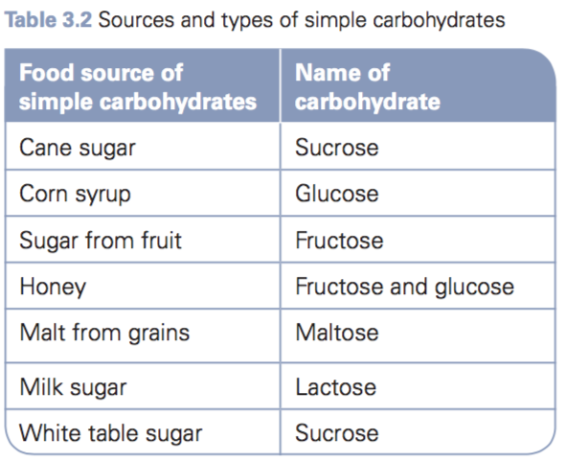 starches)
* Monosaccharides and disaccharides

**SUGAR AND OBESITY**

* an increase in fat storage in the body in the form of adipose tissue.
* Foods that are low in sugar can potentially be a protective factor against weight gain, as they take longer to release glucose into the bloodstream.
* Obesity links to CVD (especially if adipose tissue is collected around upper abdominal area) and type 2 Diabetes

**SUAGR AND DIABETES**

* In type 2 diabetes, the body may produce enough insulin but its action may be blocked because of excess fat around the cells
* the insulin receptor sites of the body becoming hyposensitive and lose the ability to respond to insulin.
* The body compensates for the resistance to the action of insulin by producing even more insulin.
* As the amount of insulin in the blood increases, side-effects of its excess become evident, such as fluctuating blood sugar and damage to the pancreas.
* Diabetes can also cause or increase risk of blindness, kidney failure, foot ulceration, which may lead to amputation, risk of infections, coronary heart disease and stroke.

**SUGAR AND CVD**

* blood triglyceride levels increase —> higher risk of cardiovascular disease.

**Intake of sugar between population groups**

Male vs Female

* Males are more likely than females to consume have a high sugar intake, and in particular consume higher amounts of sugary drinks.
* This is particularly the case for males aged 9 to 18 years.

**FIBRE**

Fibre is the edible parts of plants and is a type of carbohydrate that the body does not digest

Two types: soluble and insoluble

Soluble fibre - pectins, gums and mucilage (plant cells)

* decrease the absorption of dietary cholesterol, therefore helping to lower blood cholesterol levels

Insoluble fibre - cellulose, hemicelluloses and lignin (part of cell walls)

* adds bulk to faeces and promotes regular bowel movements
* Prevents haemorrhoids

**FIBRE AND COLORECTAL CANCER**

* Polyps (**polyp** An abnormal growth of tissue (tumour) projecting from a mucous membrane such as the intestine.) start as begin tumours and then can become malignant (risk increases as size increases)
* Approximately 75 per cent of deaths from colorectal cancers are thought to be preventable through a healthy diet.

**FIBRE AND OBEISITY**

* High fibre food makes you feel satiety (full) during a meal so less quantity of food is consumed low fibre food does not fill you as much and hence results in overeating

**FIBRE AND CVD**

* low-fibre intake can increase blood cholesterol levels, a risk factor for cardiovascular disease – specifically coronary heart disease, stroke and high BP
* Fibre helps remove cholesterol from blood stream

**FIBRE AND DIABETES**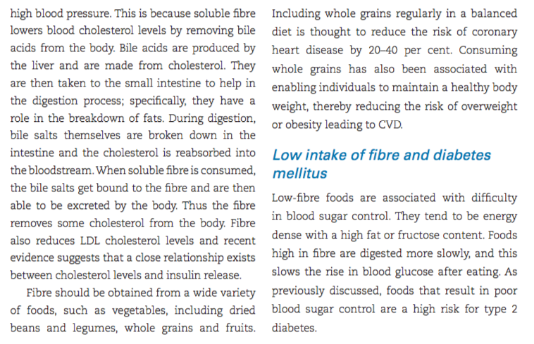

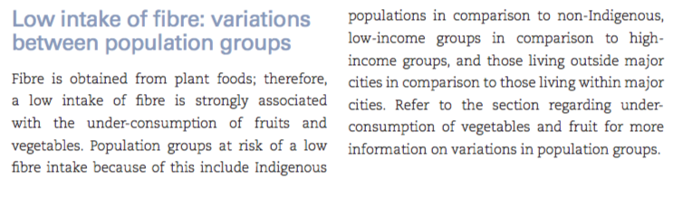

**IRON**

* Iron is an essential component of haemoglobin (a type of protein) in red blood cells and myoglobin in muscles. Haemoglobin transports oxygen in the blood from the lungs to the tissues, which need oxygen to maintain basic life functions.

**IRON AND ANAEMIA**

* insufficient haemoglobin in the red blood cells to carry oxygen to meet the body’s needs.
* This means the red blood cells have to work harder to get oxygen around the body

**Intake of iron between population groups**

Male vs Female

* Low iron intake is more common in females
* Anaemia
  + 1 in 5 menstruating women
  + 1 in 2 (half) of pregnant women
* SYMPTOMS: fatigue, weakness and breathlessness. A drop in blood pressure when standing from a sitting or lying position (orthostatic hypotension). This may happen after acute blood loss, like a heavy period.

Low Income

* May not be able to afford iron rich/dense foods like red meat

Obesity and diabetes

- if there is fat around organs then insulin can’t get to the cells to allow glucose to enter meaning cells don’t get energy