* improvements in Australia’s health status since 1900 and reasons for these improvements, focusing on policy and practice relating to:
  + - * ‘old’ public health
      * the biomedical approach to health and improvements in medical technology
      * development of ‘new’ public health including the social model of health and Ottawa Charter for Health Promotion
      * the relationship between biomedical and social models of health

Barriers to accurately reporting health-related data changes

* Research/health-related knowledge has improved —> diseases are more accurately understood and new disease groups have been identified
* ICD = International. Classification of Diseases identifies codes for different diseases that are used to record data about the causes of death
* In 1907 = 189 diseases recorded: in 200 = 2850 diseases recorded
* Need to use age standardised rates rather than the actual incidence or prevalence as a number.
  + - * Age standardised rate takes into account increase in population growth.

Population grows, life expectancy grows —> illness also increases

**DEATH RATES**

* Continuing decline in death rates in Australia between 1907 and 2013
  + - 71% for males
    - 76% for females
    - Death rates have typically always been higher for men but over time the gap is closing.
* Reduced death rates can be attributed to:
  + - Control of infection diseases
    - Better hygiene
    - Improved nutrition
    - Control of viruses and parasites
    - Better understanding of dehydration
    - Improvement in prevention detection and treatment of non-communicable diseases such as CVD
    - Road safety improvements
    - Education
    - Reduced smoking rates
    - Decline in death rates of diarrhoea (dramatic)
      * + 1900’s 7000 male children and 5800 female children per 1000000 died (age 1-4)
        + 2000 - 2 deaths per 1000000

**DISEASES EXPLAINED:**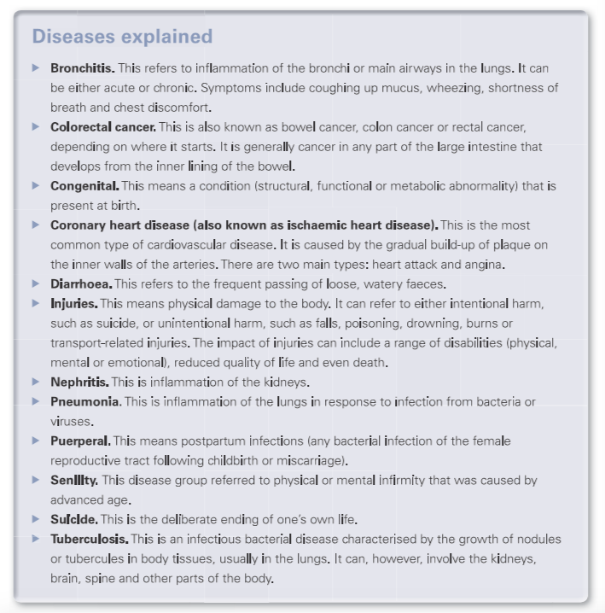

**LIFE EXPECTANCY**

| Year | Life expectancy | |
| --- | --- | --- |
|  | Males | Females |
| **1900** | 53.8 | 57.5 |
| **2014** | 80.3 | 84.4 |

Two main periods of change

1902-1962 (improved by 14.1 years for males and 16.7 years for females)

1972-2002

Result of increasing life expectancy: ageing population in Australia and a decline in birth rates, fewer citizens under 30 and more elderly.

**DEATH RATES BY BROAD CAUSE**

*Circulatory diseases (aka CVD)*

* mortality rates are decreasing
* Still the leading cause of death over the past 100 years
* Peaked in 1968 (830 deaths per 100,000)
* 2013 - 154 deaths per 100,000
* Males have higher rates

*Cancer*

* has not declined like most other diseases over the past 100 years
* Incidence rate for all cancers is predicted to increase by 22 per cent
  + 383 new cases per 100 000 population in 1982 TO 467 per 100 000 in 2016.
    - * Can be attributes to the ageing population, increased population, improvements in the diagnosis of cancer
* Although more people are being diagnosed with cancer the survival rate has increased

*Respiratory disease - affect the lungs and breathing*

* + COPD
  + Asthma
  + Pneumonia
  + Influenza
* 1907 - 320 deaths per 100,000 males; 263 deaths per 100,000 females
* 2013 - 67 deaths per 100,000 males; 37 deaths per 100,000 females
  + Brief spike in 1918-1919 as a result of Spanish Influenza pandemic

*Injury and poisoning*

* + Motor vehicles
  + Suicide
  + Assault
  + Poisonings
  + Drownings
  + Burns
  + Falls
  + Complications from medical care or surgery
* since 1907 death rate due to injury or poisoning has nearly halved
* Death rate between males and females was a big gap which has also narrowed

*Infectious/communicable diseases*

* + Tuberculosis
  + Septicaemia (blood poisoning)
  + Hepatitis
  + Small pox
  + Polio
  + Whooping cough
  + STD/STIs
    - HIV/AIDS
    - Syphilis
* in 1907 infectious/communicable diseases were the leading cause of death (13% of all deaths - 301.4 deaths per 100,000)
* In 1984 - 3.3 deaths per 100,000 (decline in more than 98%)
* 2000 - 11 deaths per 100,000 males; 7 per 100,000 females
  + - Increase was due to AIDS, hepatitis, septicaemia
* **Vaccinations (**the process of providing immunity [orally or via injection] against infections diseases) - introduced in 1932
  + - Death from vaccine-preventable infectious diseases have declined by 99% (even though population has grown disgnificantly)
    - Several diseases are non-existent or very rare
      * + Diphtheria (inflammation of mucus membrane in throat - rustics breathing and swallowing, can affect heart and blood)
        + Poliomyelitis (disease that effects CNS and can cause paralysis)

*Diabetes*

* chronic condition in which the body does not produce insulin, makes too little or does not use it properly. —> increases blood glucose —> damages heart, blood vessels, eyes, kidneys and nerves
  + 3 types
    - Types 1 (lifelong autoimmune disease - typically diagnosed in childhood or adolescents)
    - Type 2 (caused largely by lifestyle factors - typically occurs in adulthood and is preventable
    - Gestational (when higher than normal blood levels are detected during pregnancy)
* Diabetes can result in other health issues:
  + - Heart attack
    - Stroke
    - Blindness
    - Limb amputation
    - CVD
    - Kidney issues
* prevalence of diabetes has increased
  + - Overall increase in type 2 diabetes
    - Increased public awareness —> more pope diagnosed
    - Increased survival rates (people live longer with diabetes)
    - An ageing population
* Morality due to diabetes is hard to compare as the understanding of it has changed significantly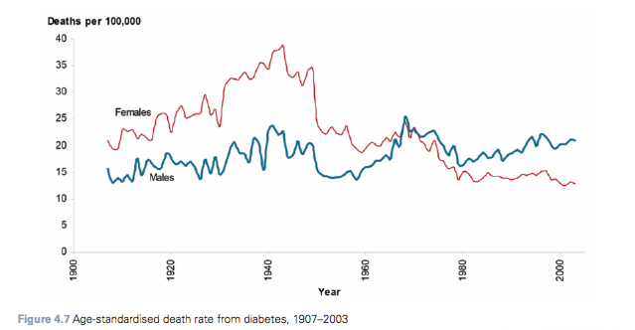

**MORE RECENT CHANGES IN HEALTH STATUS**

| Health status | Males | Females |
| --- | --- | --- |
| Life expectancy | 1998 = 75.9  2012 = 80.3 | 1998 = 81.5  2012 = 84.3 |
| Health adjusted life expectancy  Born in the year stated | 1998 = 58  2012 = 62.4 | 1998 = 62.1  2102 = 64.5 |
| Premature death (risk of dying before 75) | 1997 = 43%  2013 = 34% | |

**LEADING CAUSES OF DEATH CHANGES**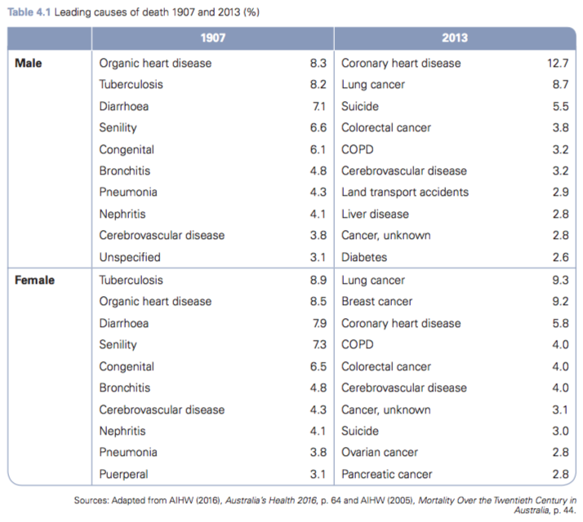

**CHANGES IN DEATH RATES BY AGE**

*Infant Mortality*

* Rates have decreased significantly for both males and females over the past 100 years
* Males: 1912 - 80 deaths per 1000 —> 2015 - 3.3 deaths per 1000
* Females: 1912 - 63 deaths per 1000 —> 2015 - 2.7 deaths per 1000
* In 1907 deaths in the 0–4 age group accounted for 26 per cent of all deaths compared with less than 1 per cent in 2013.
* The decline in infant deaths can be attribute to:
  + - Improved access to neonatal care
    - Improved quality of neonatal care
    - Increased community awareness
    - Improved sanitation and hygiene
    - Reduction in vaccine preventable diseases due to immunisation programs

*Child and youth mortality*

* Higher in males consistently than females
* Males (0-4): 1907 - 2604 deaths per 100,000—>2013 - 90.9 deaths per 100,000
* Females (0-4): 1907 - 2214 deaths per 100,000 —> 81.4 deaths per 100,000
* Leading cause of death
  + - 1907: diarrhoea and perinatal conditions (total accounted for 25% of deaths)
    - 2000: perinatal conditions and congenital conditions, injury and poisoning, and SIDS
      * Death from diarrhoea is very uncommon

*Adult Mortality (25-44)*

* Traditionally experience good health
  + Trend is increasing over the past century
* Males: 2012- 104 per 100,000 <— 1907 - 578 per 100,000
* Women: 2012 - 54 per 100,000 <— 1907 - 555 per 100,000
* 2012: made up 29% of the population made only 3.5% of deaths, men twice as likely to die
  + Main reason for the decline in mortality rates for this group are the reduction in deaths from *circulatory disease* and *respiratory conditions* as well as *tuberculosis* rates dropped (135 per 100,000 nearly last century to 0 by 2000)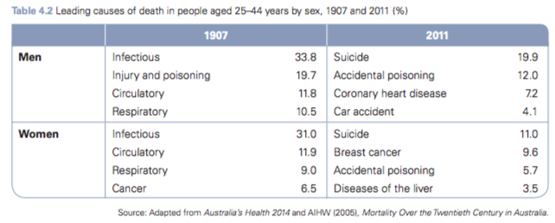

**SUMARY OF IMPROVEMENTS**

* A lot has changed since 1900 where most people would die from pneumonia, in uenza, tuberculosis, gastrointestinal infections, heart disease and strokes.
* In 2013 the leading causes of death were coronary. Heart disease, dementia (incl Alzheimers), cerebrovascular disease and lung cancer.
* Life expectancy has increased - death rates have decreased
* Not just living longer but living more years free of disability
* Significant decline in infant and child mortality rates (decrease in deaths from injury, poisoning and infectious diseases)
* Cancer diagnosis and death rates reduced
* Decline in deaths from respiratory disease (293 per 100 000 in 1907 to 45.1 in 2013) and circulatory disease (410.2 per 100 000 in 1907 to 154.1 in 2013).
* One of the most influential may be improved understanding of health, disease prevention and treatment of disease and injury

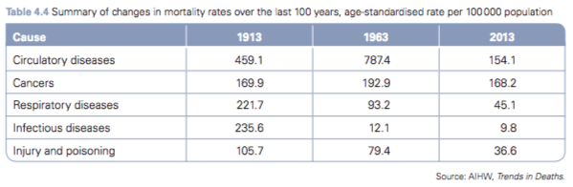

**DEFINING PUBLIC HEALTH**

* Public health: the organised response by society to protect and promote health, and to prevent illness, injury and disability. It involves identifying public health issues, problems and priorities, and designing and implementing interventions targeted at the population as a whole, or population sub-groups rather than individuals. (textbook)
* AIHW (2016): Activities aimed at bene tting a population, with an emphasis on prevention, protection and health promotion as distinct from treatment tailored to individuals with symptoms.
* Focus is more on promoting health and preventing illness rather than treatment
* Improving health has many benefits
  + - * SOCIAL
      * ECONOMIC
        + Reduced demand on health services in the future
* Initiatives that the Australian government has done
  + - Improve and protect water quality
    - Improve sanitation, sewerage and waste management
    - Improve the level of immunisation of the population
    - Campaigns to stop the spread of HIV/AIDS
    - Encourage healthy eating and physical exercise
    - Implement screening programs for diseases such as breast cancer
    - Implement anti-smoking education campaigns.
* Public health activities
  + - **Public health intelligence**
      * + information that identifies trends of ill-health and health in the population and information about the factors
    - **Public health programs**
      * + development of policy and the planning of strategies that aim to prevent, protect and promote health
    - **Public health infrastructure**
      * + including administrative, legislative, information, research and program-delivery systems, and the workforce to implement them.

**THE ‘OLD’ PUBLIC HEALTH**

* Dates back to the British settlement
  + Australia had few infections diseases prior to British settlement - due to isolated geographic location
  + Once the British arrived from the boats they had many diseases due to the lack of water, sanitation, malnourishment and overcrowding resulted in spread of diseases such as tuberculosis and smallpox.
* British colonisation resulted in establishment of the public hospital system in NSW
  + A few basic hospitals were set up in the 1830s
  + Government also introduced a period of sanitary reform
  + *Public Health Acts*  were implemented in each state
    - * Adequate sanitation
      * Reliable clean water supply
      * Sufficient housing
      * Vaccinations against smallpox
      * Quarantine control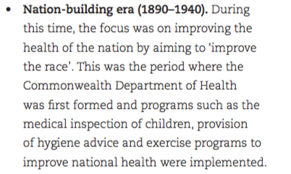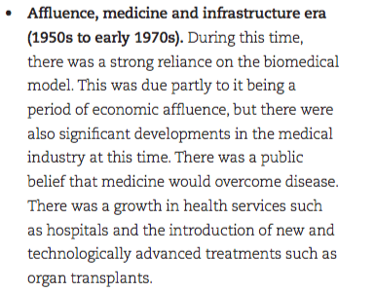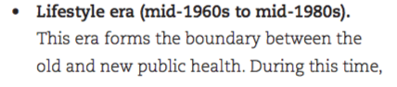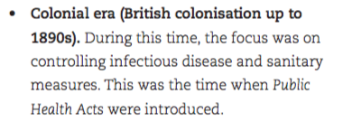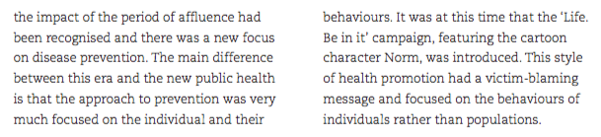

1.

2.

3.

4.

**THE BIOMEDICAL APPROACH TO HEALTH**

* **Biomedical model of health** Focuses on the physical or biological aspects of disease and illness. It is a medical model of care practised by doctors and health professionals, and is associated with the diagnosis, cure and treatment of disease.
* By the early 1900s the state governments had taken responsibility for public healthcare with a focus on public hospitals
  + Simply identify symptoms and disease and treat
  + Biomedical model at this time viewed the body in isolation from the environment, and focused on the role of bacteria and symptoms of the individual.
  + Minimal emphasises on the relationship between physical and mental health (good health was considered - freedom from disease, pain and disability)
  + The strong focus on disease took the focus off the environment, sanitation and water supply.
  + Reliance on hospitals grew
  + Even though vaccines and antibiotics was developing diseases like
    - * Poliomyelitis
      * Whooping cough
      * Tuberculosis
      * Smallpox
      * Diphtheria
* the expectation was that there would be a ‘fix it’ solution to every health problem
* Post WWII there was an increase in: heart disease, cancer and smoking
* Government put a focus n finding a cure for cancer and while doing this developed many new technologies (such as organ transplants , new drugs) and hospitals grew

Today

* we still use the biomedical approach is still used for example
  + - Blood tests
    - S-rays
    - Bypass surgeries
    - Chemotherapy

**ADVANCES IN MEDICAL TECHNOLOGY**

- preventive, promotive, curative, rehabilitative -

**Examples**

***Diagnostic tools and equipment***

Use of electromagnetic radiation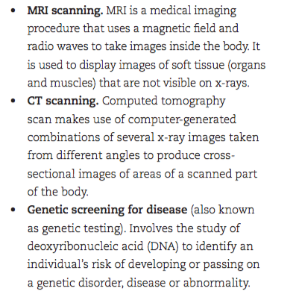

***Pharmaceuticals***

* new pharmaceuticals and vaccines are developed every year all around the world
* Recent developments include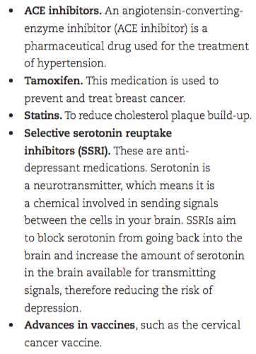

***Medical procedures***

Developing rapidly with the help of technology

examples:

* organ transplants
* hip/knee replacements
* Laparoscopic burger (keyhole surgery)
* Phase cataract removal
* Robotic surgery
* Development of artificial organs
* Gene therapy
* Tissue engineering such as spray on skin
* IVF/reproductive technology

**THE ‘NEW’ PUBLIC HEALTH (aka second revolution in public health)**

* lifestyle factors were taken into consideration and understood better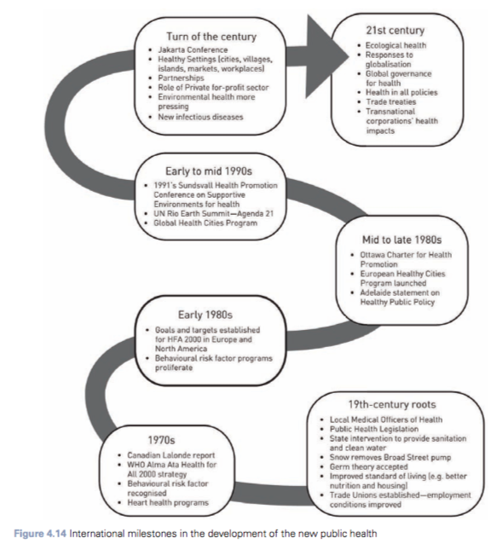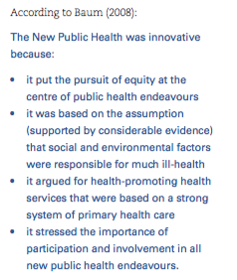
* New public health is distinguished by its extensive understanding of the ways in which lifestyles and living conditions determine health status, and a recognition of the need to have equity in access to resources and make well-planned investments in policies, programs and services that create and protect health by supporting healthy lifestyles.
  + - New public health era (mid 1990 - 21st century) continues to build on this understanding but takes into account global social and economic factors
* WHO: Role of public health is to promote health, prevent disease and prolong life through the organised efforts of society
* The strategies that have been developed by the government and health-related organisations has led to individuals being encouraged to take more responsibility for their own health through lifestyle changes
* In addition to this, society has a role to play in working to reduce inequities and recognising that inter-sectoral action is vital as the medical profession is only one profession contributing to improvements in health.
* In 1970 WHO played key role in the development and promotion of the new public health, and current public health practice in Australia reflects the WHO’s Health for All policy. The WHO adopted the Global Strategy for Health for All by the Year 2000 in 1981, and this was the turning point in the way the world looked at healthcare and understood health and its factors.
* The knowledge that environmental factors can influence heath was not new (ex. In 1800’s there was a sanitary reform) BUT it was the recognition of the influence of social factors, and in the need for inter-sectorial action to address them
* Ottawa charter and Social Model of Health are key developments of the new public health - hi-light the importance of achieving equity in relation to access to healthcare
* One focus of public health in Australia: universal access to healthcare
  + - To achieve this a national tax-funded healthcare system known as Medibank was introduced in 1975
    - Replaced by Medicare in 1984 (after a change of government)
    - Commonwealth government played an important role in the development of policies to improve public health as well as providing funding to implement them
* WHO’s Health For All by 2000 strategy —> Australia responded and paid more attention to public health strategies
  + - * Development of many national initiatives
        + National Drug Strategy
        + National HIV/AIDS strategy
        + BreastScreen Australia
        + National Cervical Screening
* The Heart Foundation, Cancer Council and other non-government organisations have also played an important role in health pro- motion and in educating the public about the prevention of major health concerns.
* MAJOR DIFFERENCE BETWEEN ‘OLD PUBLIC HEALTH’ and ‘ NEW PUBLIC HEALTH’
  + - Old public health focused on specific medical interventions to read illness and narrowly on public health initiatives
    - New public health recognises that health is complex, that a broader range of social factors influence health and that inter-sectorial action and policy change is required to address them
* **According to Baum:** The New Public Health is the totality of the activities organised by societies collectively (primarily led by governments) to protect people from disease and to promote their health. It seeks to do this in a way that promotes equity between different groups in society.They will also ensure that social, physical, economic and natural environments promote health.The new public health is based on a belief that the participation of communities in activities to promote health is as essential to the success of those activities as is the participation of experts.The new public health works to ensure that practices of the government and private sector (including the health sector) do not detract from health and where ever possible promote health.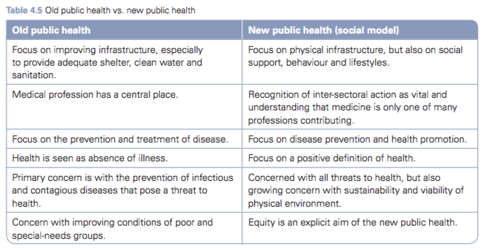

**SOCIAL MODEL OF HEALTH**

**-** Social model of health A conceptual framework within which improvements in health and wellbeing are achieved by directing effort towards addressing the social, economic and environmental determinants of health. The model is based on the understanding that in order for health gains to occur, social, economic and environmental determinants must be addressed.

* + - evolved in the 1970s was heavily influenced by the Alma-Ata Declaration in 1978
* the social model of health moves away from the biomedical approach of treatment to directing effort towards addressing the social and economic and environmental factors that impact health.
  + Social
    - * Education
      * SES
      * Employment
      * Culture
      * Social connectedness
  + Environmental
    - * Shelter
      * Food
      * Water supply
* it does not work in isolation or replace the biomedical or preventative approach it works in conjunction with both of these.
* Guiding principles of the social model of health
  + **A**  - **A**ddress broader determinants of health

These two are harder to control

* + - * Biological
      * Sociocultural
      * Environmental
  + **R** - **R**educe social inequalities
    - * Example: regardless of SES anyone should be able to access vaccinations —> provides support for those who need it most
  + **E** - **E**mpowers individuals and communities
    - * Empowerment through
        + Skils
        + Knowledge
        + Resources
        + Confidence
      * enables people to be aware and make better decision for their health (ex. Quit smoking)
  + **A** - **A**cts to enable healthcare
  + **S** - involves inter- **S**ectorial collaboration
    - Working with government sector, private sector and health sector to create better health outcomes

**OTTAWA CHARTER FOR HEALTH PROMOTION**

**-enable, mediate, advocate-**

**Ottawa Charter for Health Promotion** An approach to health-promotion development by the World Health Organisation that attempts to reduce inequalities in health. The Ottawa Charter for Health Promotion was developed from the social model of health and defines health promotion as ‘the process of enabling people to increase control over, and to improve, their health’ (WHO, 1998). The Ottawa Charter identifies three basic strategies for health promotion: enabling, mediating and advocacy.

**Health Promotion:** The Process of enabling people to increase control over and improve their health (WHO 1998)

1. **Enable:** means to support people with the information, opportunities, resources and skills that they need to make choices that support good health.

2. **Mediate**: Optimal health cannot be ensured by the health sector alone, and health promotion requires coordinated action by all levels of government, the health sector, non- government organisations, industry and the media.

3. **Advocate**: Health promotion aims to make the necessary political, economic, social, cultural, environmental, behavioural and biological factors favourable to support good health and wellbeing. It is about promoting and supporting initiatives that promote health on behalf of the whole community, and protecting health as a resource and important determinant in relation to the quality of life.

Within these **three basic strategies** for health promotion, the Ottawa Charter for Health Promotion also outlines **five elements or priority actions** that are deemed **important in achieving health for all:**

1. *Build healthy public policy.*
2. *Create supportive environments.*
3. *Strengthen community action.*
4. *Develop personal skills.*
5. *Reorient health services.*

* *Build healthy public policy*
  + - Decisions that are made by governments and organisations in relation to healthcare policy, legislation, taxation, rules and regulations.
      * Examples

Cigarette smoking banned in public areas

Tex on cigarettes

Ban on commercial sun tanning beds

Reducing speed limit on roads near schools

* *Creative supportive environments*
  + Involves building links between individuals and heir environments (economic, physical and social) through taking care of one another , communities and natural resources
  + Also involves promoting environments that encourage safe, stimulating and enjoyable living and working conditions so an individual can reach their full potential
  + It encourages individuals to support and help each other to make healthy choices - both now and in the future
    - Examples
      * Ensuring children’s playgrounds are a safe and stimulating environment with adequate shade
      * Ensuring roads are safe
      * Provision of social support groups such as mothers groups
* *Strengthen community action*
  + Working together to set priorities, make decisions, and plan and implement strategies that will help them to achieve better health.
  + Communities can include large community settings such as the total Australian community or much smaller settings such as an individual school or workplace community
    - * Examples:

Transport ads run by - Transport Accident Commission (TAC), state governments and VicRoads

Worksafe ads

* *Develop personal skills*
  + Gaining of life skills and information through health promotion and education <— desired outcome of many health promotion programs
  + Allows the individual to make choices that will enhance their health and to take control over their own health
    - * Examples

How to protect yourself from cyber-bullying

How to check your body for breast/skin cancer

How to eat a healthy diet

These must be a combined effort of schools, workplace, government and voluntary organisations

* *Reorient health services*
  + Idea is for groups to work together to support healthcare professionals moving beyond biomedical services to treat and cure illness —> places a strong emphasis on health promotion
  + Focus must be on the whole person
    - Examples
      * + Doctor talking to a smoker about cancer asthma
        + Doctor encouraging women to have regular pap smears and mammograms
        + Medical professionals discussing the importance of physical activity and healthy eating to reduce obesity, type 2 diabetes and CVD

**Live lighter relation to Ottawa Charter**

* + Live lighter is a campaign launched in Victoria in 2014 with mass media advertising
    - Social media
    - Online
    - Printed
    - Television ads
      * Often graphic and confronting
  + Creare supportive environments
    - * Has compiled many resources on a website
  + Strengthen community action
    - * Promotes interaction between the Cancer Council and the Heart Foundation and the Vic Government
  + Develop personal kills
    - * Public awareness campaigns and factsheets on the website
  + Reorient health services
    - * ‘health professionals’ section on the website—> LL provides access to campaign materials and presentations so that health professionals can promote health promotion messages.

**THE RELATIONSHIP BETWEEN BIOMEDICAL AND SOCIAL MODELS OF HEALTH**

Example of the difference between the two models: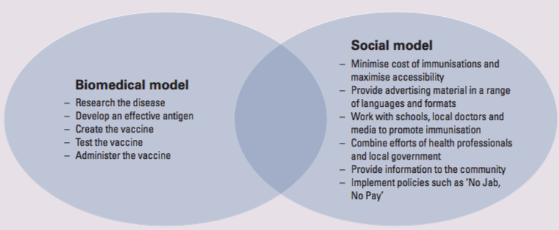

* Both work together to achieve better health outcomes
* Immunisations - one of the most effective and successful health-prevention strategies [social model of health]
  + - Success can be attributed to Immunisation Australia Project (funds the purchase of vaccinations to protect Australians from vaccine- preventable diseases) AND the ‘no jab, no play’ policy (requires children of all ages to meet immunisation requirements to be eligible to receive the Family Tax Benefit)
    - Providing information in a variety of languages to overcome language barriers
    - Media to promote childhood immunisations
    - Doctors, local health centres and governments to run immunisation clinics
    - 90% immunisation rate by the time children start school
    - Without the biomedical approach to health - vaccinations would not exist (antigens to use as vaccine)
* cancer screening
* Sanitation
* Safe birthing practices
* Maternal and child health services
* Workplace safety
* Better food and water supply

**STRENGTHS AND LIMITATIONS**

|  | STRENGTHS | LIMITATIONS |
| --- | --- | --- |
| BIOMEDICAL | * provides treatment for many medical conditions * Helps us learn about diseases and illnesses * Enables us to improve the health status of the population * Can reduce the amount of time people spend in ill-health | * can be expensive * Does not always promote equity * Does not promote or encourage good health * It treats the body and illness in isolation to the environment * There is not a cure/treatment or every illness or disease |
| SOCIAL | * aims to improve the situation before it occurs - prevention * Focusses on population rather than the individual * Focuses on collaboration to improve effectivenesss * Focuses on promoting good health * It is sustainable * Cost effective * Indiaiduals are empowered to promote their own health * Promotes equity | * may be less effective for some people * Not all illnesses or conditions can be prevented * It relies on individuals making good choices * It does not address the needs of the imdividual |

**Initiatives to address**

|  | Biomedical | Social |
| --- | --- | --- |
| Lung cancer | * development of treatment to treat lunch anger (chemo + radiation) * GP consultations to treat lunch cancer * Development of tools and equipment to   + Test and diagnose   + Treat | * increased taxation on tobacco (policy changes) * Media campaigns   + Provide info   + Empower   + Reduce inequity * Banning smoking in public areas * Increasing the legal age to 18 |
| Type 2 diabetes | * development of personal blood glucose meters * Development of insulin tablets/injections * Medical consultation for diagnosis * Blood test for diagnosis | * health promotion initiative   + Life, be in it   + Health star rating   + Australian guide to healthy eating   + Empower individuals and communities - prevent/manage type 2 diabetes * including insulin on Pharmaceutical Benefits Scheme to remove cost as a barrier to accessing insulin   + Reducing social inequities |
| Road traffic accidents/ injury/ poisoning | * surgical procedure to rest injuries * Research into the best ways to treat brain injuries * Rehabilitation for people suffering road trauma | * changes in legislation   + Compulsory wearing of seatbelts   + 0.05 BAC   + Reducing speed limits (school areas, residential areas, pedestrians etc..)   + Fence pools * Creating safer roads and addressing accident black spots * Changing rules for P-plate drivers (only one passenger) * Introducing 120 hours of driving for L-plate (empowerment) |
| Infection and disease rate | * development of vaccines such as varicella chick pox vaccine * New treatments to treat infectious diseases * GP consultations to diagnose conditions * Development of tests to help diagnose diseases | * immunise Australia Program   + Reduce social inequities - removes the cost as a barrier to vaccination   + Covers healthcare visits through medicare rebates * Australian Childhood Immunisation   + Keeps records of children immunisations and sends reminders (empowers and makes info easily accessible)   - ‘No jab no play’ policy by federal government (1st Jan 2016) - requires all children to meet immunisation requirements in order to be eligible to receive Daily Tax Benefits. (development of social policy) |