• Australia’s health system, including Medicare, private health insurance, the Pharmaceutical Benefits Scheme and the National Disability Insurance Scheme, and its role in promoting health in relation to funding, sustainability, access and equity

**Medicare**: Australia’s universal healthcare system, which aims to improve the access to healthcare for all Australians and to provide access to adequate healthcare at little or no cost to all Australians in need of treatment, regardless of age or income.

**Healthcare system:** All the activities whose primary purpose is to promote, restore and/or maintain health. And identifies that an effective healthcare system is one that is able to deliver quality healthcare services to all people when and where they are required.

**Average daily facts**

* 616,000 subsidised prescriptions dispensed
* 381,000 visits to a general practitioner (GP)
* 246,000 pathology tests
* 79,000 visits to a specialist
* 27,000 hospitalisations – 59 per cent in the public sector
* 27,000 allied health services provided
* 24,000 contacts made at community mental healthcare services
* 20,000 presentations to public hospital emergency departments – 30 per cent end up being admitted to hospital
* 1900 people admitted for elective surgery in public hospitals – 9 per cent for cataract surgery.
* Due to our ageing population and an increase in the number of people suffering from chronic disease, our healthcare system is getting busier each year. Australia’s health expenditure per person was $5060 in 2013–14. Our GPs are seeing more patients, more prescriptions are being written and our hospitals are being stretched to their limits.

**Australia's healthcare system**

**Primary Healthcare:** Refers to an individual’s first contact with the healthcare system

Includes

* Health promotion

Primary healthcare - **reflects the social model of health (prevention)**, also provide patient centred care that is community based.

* Prevention initiatives
* Early detection
* 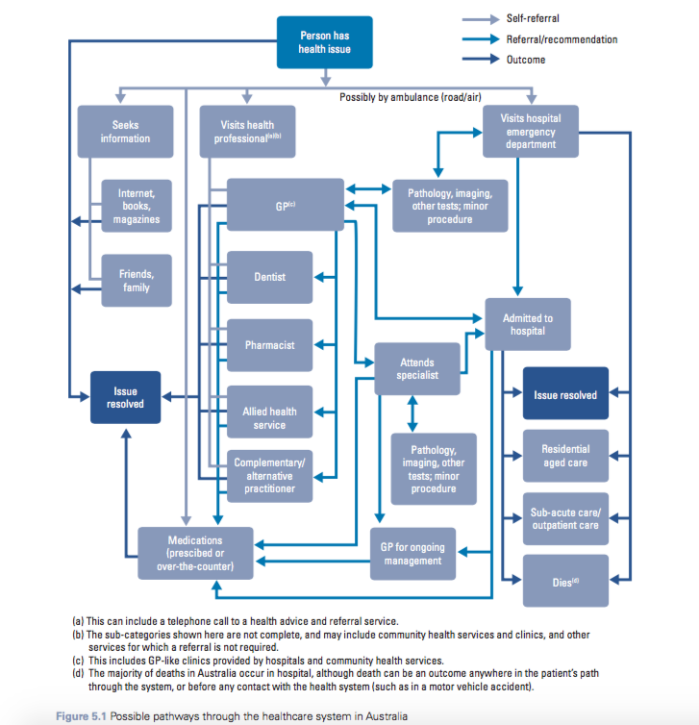Early intervention
* Treatment of illness
* Management of chronic conditions (ex. Diabetes)

Not usually hospital care but local clinics or community health centres (Gps, nurses, allied health professionals, dentists, midwives, pharmacists)

Operates with secondary care

**Secondary care:** Includes health services and medical care provided by specialists after  
a referral from a primary healthcare professional.

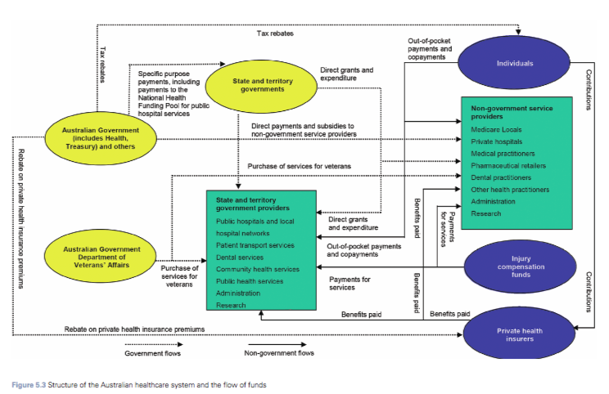

**Responsibilities of each level of government**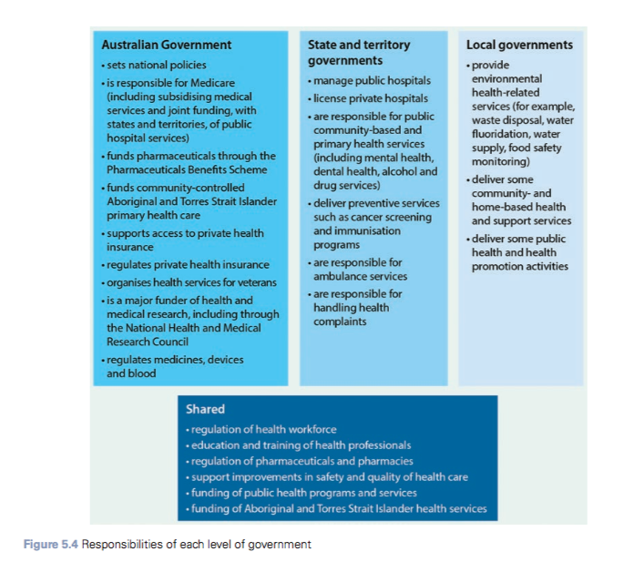

**Funding the healthcare system**

* in 2013-2014 approximately 9.8% of Gross Domestic Product (GDP) was used for healthcare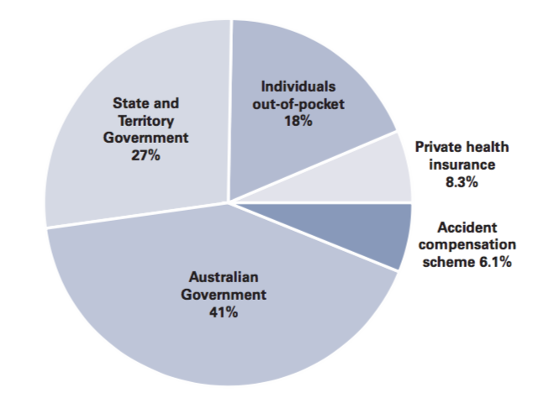 ($155 billion)
  + - 68% was by governments
      * 41% commonwealth government
      * 27% state and territory government
    - 18% individual pockets
    - 8.3% private health insurance
    - 6.1% accident compensation schemes
* Most was spent on hospitals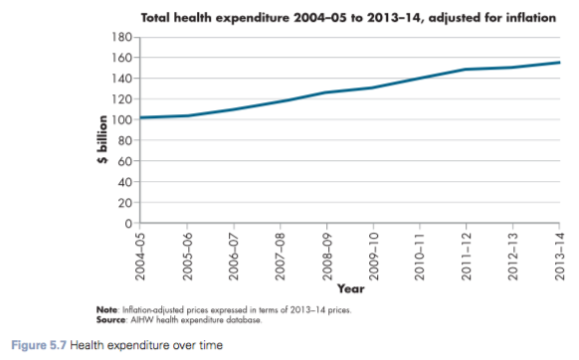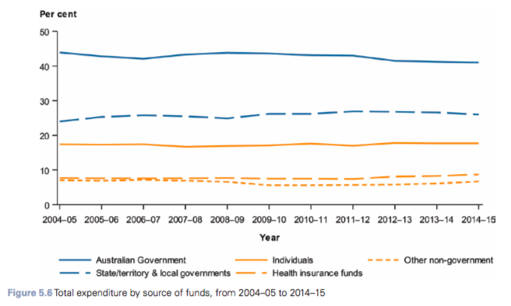

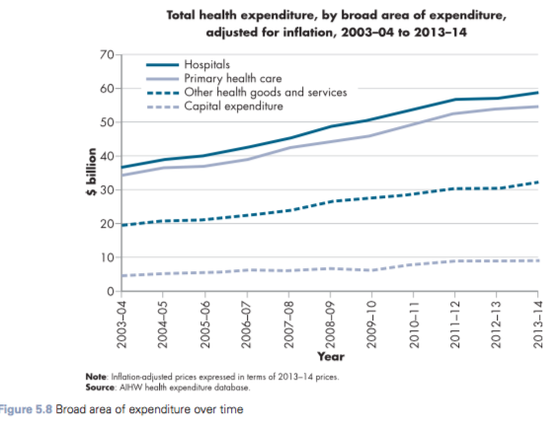

**Medicare**

**3 objectives:**

* to make healthcare more **affordable** for all Australians
* to give all Australians access to healthcare services with **priority** according to clinical need
* to provide a **high quality** of care.

Funded by Commonwealth Government partly through contributions made to the healthcare system through a 2% Medicare levy (paid by most taxpayers who earn over a certain amount and based on taxable income)

*How does Medicare work*

* covers in hospital and out of hospital services
* free/subsidied treatment by general practitioners and optometrists (as well as diagnosis tests)

OUT OF HOSPITAL CARE

* can be treated by own GP —> reimbursed
* part of the doctor’s fee by Medicare
* depending on the billing options of the doctor.

Coverage: depended on Medicare Benefits Schedule (MBS - set by federal government)

* medicare will cover 100% of GP visit and 85% of specialist visit
* Schedule fee (set for service by commonwealth government)
* practitioners would chose to charge more than schedule fee and patients would have to pay the difference out of pocket.
* Bulk-billing —> charges straight from medicare as full payment (no cost to patient)

*Medicare Safety net*

* **Medicare safety net** An additional rebate scheme introduced by the federal government for the benefit of patients, covering a range of doctor’s visits and tests received out of hospital. It provides for reimbursement of 100 per cent of the MBS fee for out-of-hospital services once the relevant threshold has been reached.

The dot points are what is covered by medicare out of hospital care

* + - Includes
      * + Doctors and specialist consultations
        + Ultrasounds
        + X-rays
        + Blood tests
        + Optometrist eye tests
        + Most procedures performed by GPs
* **gap amount** The difference between the Medicare benefit and the schedule fee.
* **out-of-pocket costs** The difference between the Medicare benefit and what the doctor charges

*In hospital care covered by Medicare*

* Treatment and accomodation as a public patient in a public hospital by a doctor appointed by the hospital as a result of an emergency or after referral from a doctor
* 75 per cent of the Medicare Schedule fee for services and procedures for a private patient in a public or private hospital (which doesn’t include accommodation in hospital or items such as theatre fees or medication).

*WHAT IS NOT COVERED*

* General/most dental exams and treatments (THERE ARE EXCEPTIONS)
* Ambulance services
* Home nursing
* Most allied health services
  + - Physiotherapy
    - Speech pathology
    - Occupational therapy
    - Chiropractic services
    - Podiatry
    - Psychology (THERE ARE EXCEPTIONS)
  + Hearing aids, contact lenses and glasses
  + Medicines (except PBS)
  + Overseas medical costs (HAS EXCEPTIONS)
  + Medical examinations for employment   
    purposes, life insurance or superannuation
  + Medical exams that are not clinically necessary
  + Private hospital costs other than treatment - accomodation, theatre fees, medicines
  + Acupuncture (unless referred by doctor)

EXCEPTIONS

* Dental care —> children aged 2-17 may receive basic dental care through family tax benefits
* Allied health services (psychology) —> people with chronic medical conditions (a condition that has been present for at least six months, is likely to be present for six months or is terminal.) may be entitles to receive a medicare benefit
  + GP Management plan
  + Team Care Arrangement Plan
* Overseas treatment —> Australia has reciprocal healthcare arrangements with
  + New Zealand
  + United Kingdom
  + Ireland
  + Sweden
  + Netherlands
  + Finland
  + Italy
  + Belgium
  + Malta
  + Slovenia
  + Norway

*Funding for Medicare*

* federal government
* Raises revenue from taxpayers
* Contributions made to the healthcare system through the 2% medicare levy (most taxpayers pay this levy

*Role of Medicare in promoting health*

***SUSTAINABILITY***

* *meeting the needs of the present without compromising the ability of future generations to meet their own needs.*
* Medicare in the long term is aimed at reducing cost of treatment by improving overall health outcomes
* Medicare only covers essentials (not elective surgeries and allied health services)
  + Provides what is necessary without extra expenses
    - Helps to meet the current needs but also ensure that financially Australia will able to continue to support the health needs of future generations.

***ACCESS***

* *Being able to make use of the service regardless of*
  + - *Location*
    - *Knowledge*
    - *Time*
    - *Cost*
  + Services provided are financially accessible which increases early detection and treatment
    - Helps to reduce the impact of the disease and promote health
  + Medicare serves people in hospitals based on need (someone with heart attack would be treated before someone with a broken arm)
    - Aim of reducing mortality rates and increasing life expectancy
  + Provides rebates for a range of in-hospital and out-of-hospital services across the country (including those in remote areas)
    - Improves physical access —> treatment sooner—> better health outcomes
  + Medicare allows people to select their own doctor
    - Makes services more accessible (can chose in their local area)
    - People can chose according to their social and cultural needs
      * More people will feel comfortable seeking healthcare —> improves health outcomes

***EQUITY***

* linked to fairness and social justice —> ensures everyone reaches the same outcome
  + Provides extra support to those who need it
* includes a safety net to protect those who experience higher costs of healthcare, those who have concession cards and big families from large out-of-pocket costs for healthcare services, thus providing extra support to those who need it most.
* Medicare is available to all Australian citizens and it does not discriminate on the basis of age, gender, race, location, income or health status.

**Pharmaceutical Benefits Scheme (PBS)**

An Australian Government program the provides subsided prescription medication to Australian residents, as well as foreign visitors covered by Reciprocal Health Care Agreement.

* introduces in 1948 (before medicare was implemented) as a limited scheme that provided free medication for pensioners; 139 other medicines were also made free to other members of the community
* NOW: provides timely, reliable and affordable access to necessary medicines for Australians
* AIM: subsidise the cost of a wide range of prescription medications, providing Australians with vital medications at affordable prices —> ensure optimal health outcomes and economic objectives are achieved
* The price an individual pays for a medication covered by the PBS is called a co-payment, and it depends on their situation. From 1 January 2017, general patients pay up to $38.80 for medication covered by the PBS and concession card-holders pay $6.30, with the Commonwealth Government paying the balance. This gure is updated on 1 January each year. If a medication is not listed on the PBS, then the individual needs to pay the full price of the medication. In some cases the cost of medication not covered by the PBS may be reimbursed by an individual’s private health insurer. If an individual is provided with medications as a public patient in a public hospital, these are usually provided to the patient free of charge as part of their hospital treatment. As of 1 January 2016, pharmacists have been able to choose to discount the PBS co-payment by up to $1; this discount is totally at the discretion of the pharmacist.

| Advantages | Disadvantages |
| --- | --- |
| * It provides access to essential medication at a subsidised rate or in some cases no cost. | * Places a significant financial burden on the Commonwealth Government. |
| * Enables access to medications from local pharmacies and does not require medications to be purchased from specialised services. | * Does not generally cover all medicine |
| * Includes the PBS safety net and the RPBS to further protect people from the high cost of medication. | * For most Australians, there is still a  co-payment of $38.80. |
| * Available to all Australian citizens, regardless of their age or income. |  |
| * Provides additional support to those with concession cards by having lower co-payments. |  |

***Funding for PBS***

* Funded by the Commonwealth Government through taxes.
  + - Doctor prescribes medication PBS approved —> patient pays subsidised amount, government pays the rest
  + In 2013–14, government spending on medications on the PBS and RPBS totalled $10.1 billion for the 223 million subsidised medications dispensed
  + Through funding some essential medications, the PBS aims to improve health by giving people with long-term chronic conditions access to the medication they need. This can reduce the stress and anxiety associated with having to cover the high cost of medication and therefore improve mental health. Improving access to essential medication can also improve physical health, as the medication can play an important role in the treatment and control of illness.

*Role of PBS in promoting health*

***SUSTAINAIBILITY***

* by subsiding medication and making it affordable so they can meet their health needs
* Aims to be economically sustainable by adding only medicine that is more efficient at treating conditions than exisiting treatment
  + Reduces the cost of the wider health system
  + Preventing development of serious conditions
  + Reducing the need tofu hospital stays or other demands on the healthcare system
* Adds only trialled and test reliable medication to the PBS promoting sustainability and hence meeting the current needs and improving the health of future generations as people are less likely to require ongoing treatment.
* The PBS includes a Prescription Shopping Programme (PSP) to protect its integrity. Prescription shopping is when a patient unknowingly or knowingly gets more medicine than they medically need by visiting many doctors without telling them about their other consultations. The PSP helps health professionals identify and reduce the number of patients who get more PBS-subsidised medicines than they need. This helps to ensure the nancial sustainability of the program by not spending more on medications than necessary, which means the government is still able to meet the health needs of the current generation but will also be more able to provide medications for future generations to help them treat illness.

***ACCESS***

* people can get medication without having to travel
* Financially affordable also improves access

***EQUITY***

* added a closing the cap PBS co-payment program in 2010
  + Reduces the cost of medication fo Indigenous and Torres strait Islander people (same price as concession)
  + Indigenous are more likely to get medicine they need such as insulin
* Also provides a safety net for those who suffer chronic illnesses
* PBS serves everyone regardless of age, gender, race, location, income or health status.
  + Makes it equitable

**Private health insurance**

| Benefits | Disadvantages |
| --- | --- |
| * choice of being **treated in a private hospital** | * Costly for individuals and families to pay for private health cover |
| * **choose the hospital** in which they are treated | * There can still be out of pocket cost for some services in some policies |
| * **choose the doctor** that treats them in hospital | * There might still be a qualifying or waiting period for some procedures |
| * entitle them to their **own room in hospital** | * Individuals may feel like they are paying for a service they don’t use |
| * Reduced waiting period for some non- emergency procedures in private hospitals |  |
| * more choice about the timing of non-emergency procedures in hospital |  |
| * covers a wider range of services than Medicare |  |
| * option of extras cover to subsidise a broader range of out-of-hospital services. |  |
| Benefits towards the wider community   * It helps the government to address the increasing costs of Medicare * Supports and ageing Australia * Support the public health system and all Australians |  |

*Private Health insurance incentive schemes - rebate, levy surcharge, lifetime cover*

* Fewer people were starting to take out private health insurance so extra pressure was placed on the public healthcare system
  + The federal government introduced and updated a number of incentive schemes through the Fairer Private Health Insurance Incentives Act 2012. The purpose of these schemes is to reduce the cost of private health insurance to make it more affordable, and also to lighten the load on public hospitals.

**Private health insurance rebate**

* introduced in 1999 by commonwealth government
  + With this most Australians received rebate from the government to help cover the cost if premiums
  + Rebates depending on age and income

**Medicare levy surcharge**

* introduced in 1984
  + Currently at 2% of taxable income to help cover the costs of medicare
  + 1997 — additional surcharge of between 1 and 1.5 per cent charged for higher-income earners who do not have private hospital health insurance
    - This is to encourage people to take up private health insurance and reduce demands on Medicare system

**Lifetime health cover**

* implemented in July 2000
  + To encourage people to stay with private health insurance
    - * Under this scheme, anyone who does not have private hospital insurance with a registered health fund in Australia before 1 July following their 31st birthday, and then decides to take out cover later in life, will pay an additional 2 per cent loading on their premium for each year over the age of 30 when they join, with a maximum loading of 70 per cent. This means that if you take out private hospital insurance at age 45, you will pay an additional 30 per cent more each year than someone who first took out hospital cover before they turned 30.

*Funding for private health insurance*

* generally funded by members and supported by medicare

*Role of private health insurance in promoting health*

***Sustainability***

* helps to meet the heal care needs of the present b placing less pressure on the public system
* Meets the needs of the future by implement incentive schemes to mace access to private health insurance more affordable —> decreasing demand on public system as out ageing population continues to grow
  + Less demand on public system means more people can get treated faster —> better health outcomes

***Access***

* through introducing the private health insurance rebate scheme the government has tried to make private health insurance more affordable/financially accessible
* People have access to their doctors that they choose (who best meet their needs)
* Also improves access for people without private health insurance as reduces the waiting time in public hospitals —> more people can access treatment sooner

***Equity***

* promotes equity through private health insurance incentives
* Earn more—> pay more for private health insurance as they get less/no rebate
* Levy also helps those who earn less to pay less levy if they can’t afford PHI - higher income earners are encouraged to take out PHI
* Elderly use healthcare system the most so the incentives encourage and make it easier for elderly to take out PHI and rely less on Medicare

**National Disability Insurance Scheme**

* laughed in July 2013 (commonwealths new way of providing support to Australians with disability and their parents/carers to receive full access to the support the need)
* 460,000 Australians receive support through the NDIS (under 65 with a remnant and significant disability where support is needed to live an ordinary life)
* It was introduced slowly over 3 years to ensure it was sustainable
* Helps people wiht a disability to
  + Access mainstream services and supports, including healthcare, education, public housing, aged care and the justice system
  + access community services and supports, including sporting clubs, libraries, charities and community groups
  + maintain informal support arrangements, including the unpaid help they get from family and friends that is part of most people’s lives
  + receive reasonable and necessary funded support, such as the financial support the NDIS will offer that is related to their disability and required for them to live an ordinary life.

*Funding for NDIS*

* commonwealth gov

*Role of NDIS in promoting health*

***SUSTAINABILTY***

* NDIS has been introduced over time not all at once in order to ensure that it is sustainable
* It is aimed at providing support long term (for the duration of their life)
* The extra 0.5% Medicare levy added by Commonwealth government is to support NDIS and make it financially sustainable

***ACCESS***

* aims to ensure Australians receive reasonable and necessary minded support required for them to financially access services they need to live an ordinary life

***EQUITY***

* supports those who need it most —> promotes equity