• the role of health promotion in improving population health, focusing on one of: smoking, road safety, or skin cancer, including:

–  why it was/is targeted

–  effectiveness of the health promotion in improving population health

–  how the health promotion reflects the action areas of the Ottawa Charter for Health Promotion

**Health promotion:** represents a comprehensive social and political process, it not only embraces actions directed at strengthening the skills and capabilities of individuals, but also action directed towards changing social, environmental and economic conditions so as to alleviate their impact on public and individual health. Health promotion is the process of enabling people to increase control over the [factors] of health and thereby improve their health. Participation is essential to sustain health promotion action. (WHO 1998)

**Health promotion (WHO 1984):**

• involves the population as a whole in the context of their everyday life, rather than focusing on people at risk for specific diseases – it enables people to take responsibility and have control over their own health. This requires full access to health related information.

* is directed towards action on the factors ... or causes of health – this relies on co-ordination of services beyond health services to address a wide range of health issues. Local, state and federal governments have an important role in ensuring that the physical and social environment (including that which is beyond the control of an individual) is suitable to promote good health.
* combines diverse, but complementary methods or approaches including communication, education, legislation, fiscal measures, organisational change, community development and spontaneous local activities against health hazards.
* aims particularly at effective and concrete public participation – this requires clear problem definition and development of life skills including problem solving among individuals and within communities.
* is basically an activity in the health and social fields, and not medical service; health professionals (especially those in primary health care) still have an important role  
  in nurturing and enabling health promotion. Health professionals have an important contribution in relation to education and health advocacy.

**Examples of health promotion**

* Social marketing
* Education
* Legislation
* Regulations (aim to change social, political and physical environment in order to promote behaviours)
* People need to be able to control their own health - to be in a position to make healthy lifestyle choices, There is a need for political action across sectors and regions and highlight the role of good governance and health literacy in improving health as well as the critical role played by city authorities and communities. (WHO 2016 - ninth conference)
* Ottawa charter - health is seen as a resource not as the objective of living
  + Health is a positive concept emphasising social and personal resources as well as physical capacities
    - * So health is not only the responsibility of the health sector but foes beyond healthy lifestyle and wellbeing

In 2013–14, 1.4 per cent of Australia’s total health expenditure, or $2.2 billion, was spent on prevention, and on the promotion of public health activities.

**ROLE OF HEALTH PROMOTION IN REDUCING THE IMPACT OF SMOKING**

* Tobacco cigarettes have more than 4000 chemicals in it
  + - Many are associated with increasing the risk of cancer
* According to AIHW - smoking is the single most important preventable cause of ill-health and death in Australia
  + - Tobacco smoke is inhaled —> spread through the body via lymphatic system
  + Most people start as teenagers —> get addicted by adulthood
    - * Health promotion targets young people before they start smoking
        + Young people usually smoke to: look mature, fit it, manage their weight and experiment
        + Adults usually smoke to: reduce stress/pressure (economic/personal) and feel good
      * Others try to quite but it is a strong addiction and difficult habit to break

*Health promotion for young people to prevent smoking over time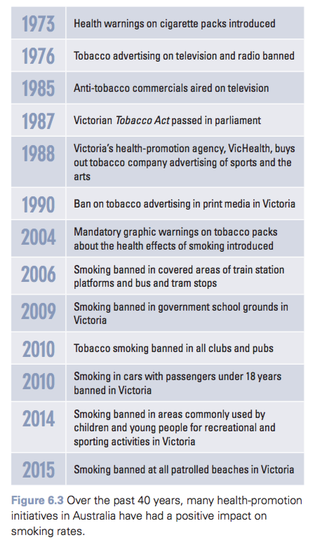*

**WHY IS SMOKING TARGETED**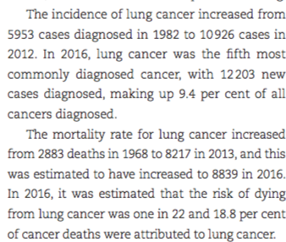

* Increases the risk of
  + - Cancers
    - CVD
    - Diabetes
    - Rheumatoid arthritis
    - Fractures
    - Reproductive issues for women
  + Second hand/passive smoking can also has repercussions
  + In 2011 tobacco smoking was the leading risk factor contributing to death and disease in Australia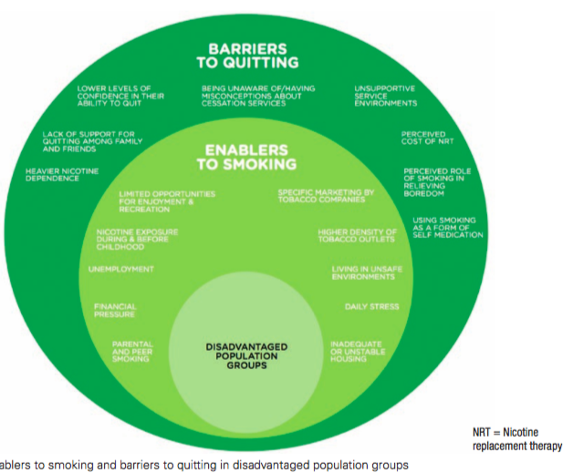
    - * responsible for 9% of all BOD and injury
    - Further increases inequity in health status experienced by population groups
    - SMOKING RATES ARE: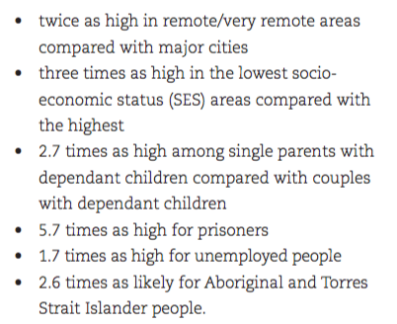
* Modifiable risk factors —> Australian community can collectively reduce it
  + Goal: 2025 - reduce smoking rate to 5%

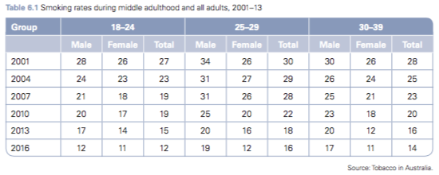

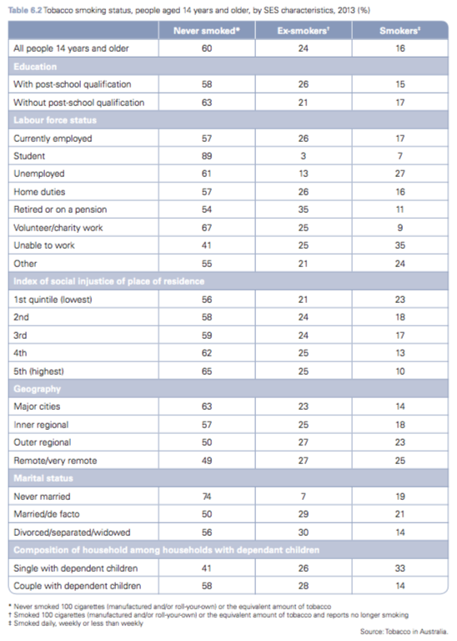

**HEALTH PROMOTION INITIATIVES**

***QUIT***

* Program run by Cancer Council Victoria
* Began in 1985 when a ministerial review of health promotion identified tobacco as the most significant health priority in the state
* National Heart Foundation joined later in
* Committee provides advice to the Minister for Health on legislation and policy aimed at reducing prevalence of smoking in Victoria
* 1987 the Tobacco Act was passed
  + Introduced a levy on the sale of tobacco
* QUIT is currently funded by: cancer Council, National Heart Foundation, VicHealth and Department of Health
* Purpose: encourage, support and promote people to quit smoking for preventative health reasons as well as the economic impacts that smoking can have on both the individual and the healthcare costs borne by the Australian Government.
* Initiatives
  + - Quitline
    - QUIT Coach
    - QUIT media campaigns
    - QUIT learning hub for health professionals
    - supporting the development of Critics Choice resources.

How the QUIT program reflects the Ottawa Charter

* **Build health public policy**
  + - In conjunction with the Victorian Government QUIT has assisted in the implementation of a range of policies and laws aimed at reducing the impact of smoking on the health of Victorians. These include the banning of tobacco advertising, the banning of smoking in public places, changes to tobacco taxation, the introduction of plain packaging on tobacco products via the *Tobacco Plain Packaging Act 2011*, increasing the age at which people can legally purchase tobacco and banning the display of tobacco in retail outlets.
* **Strengthen community action**
  + - QUIT has worked with a range of groups within the community to increase the success of its program and initiatives. These include working with the state government to change legislation, working with community health- promotion agencies such as VicHealth and the Australian Network on Young People and Tobacco to develop health-promotion initiatives, and providing resources for schools and other community groups.
* **Develop personal skills**
  + - Via its website, QUIT provides information about the impact of smoking, and advice and strategies to assist people to quit smoking. It also invests in media campaigns to educate the community about the harmful effects of smoking. QUIT partners with the Australian Network on Young People and Tobacco and VicHealth to produce the Critics Choice resources for use in schools to educate young people about the harmful effects of smoking.
* **Create supportive environments**
  + - Through the Quitline, QUIT provides a supportive social environment with the purpose of assisting individuals to quit smoking. It also has online support available via the QUIT website. Through working to ban smoking in public places, QUIT has also improved the physical environment by reducing the impact of passive smoking.
* **Reorient health services**
  + - QUIT provides a range of face-to-face and online learning opportunities designed to help health professionals support their patients to quit smoking.

***QUITNOW*** - National tobacco campaign

* Targets all smokers but in particular focuses on the most ‘at-risk- population groups
* Initiatives
  + - Media campaigns - focus on the negative health effects of smoking as well as promoting benefits of quitting (radio, print, outdoor, online, television)
      * + Break the chain
        + Don’t make smokes your story and Quit for You
    - Website - provides info about harmful effects of smoking anda advice to help and support people quit
    - Development of apps
      * + Quit for you
        + Quit for two
        + My QuitBuddy app
    - Information about quitting, targeting vulnerable groups such as those with mental illness, pregnant women, prisoners and Aboriginal and Torres Strait Islander people
    - Development of Quit Book

*How QUITNOW reflect the Ottawa Charter*

* **Develop personal skills**
  + - Through its website, with information, advice and support, the Quitnow program aims to educate people and therefore develop personal skills.
* **Create supportive environments** 
  + - Through the development of the Quit for you –  
      Quit for Two app, and the My QuitBuddy app, the Quitnow program aims to create supportive social environments by offering encouragement and support to people trying to quit.
* **Reorient health services** 
  + - Through providing specialised information for health professionals to assist them to support individuals to quit, information about quitting among vulnerable groups, such as those with mental illness, pregnant women, prisoners and Aboriginal and Torres Strait Islander people, Quitnow assists health professionals to reorient health services and work to prevent illness.

EFFECTIVENESS OF HEALTH PROMOTION TO REDUCE SMOKING FOR IMPROVING HEALTH

* Mass media campaigns are effective, they have a direct in uence on young people and adults.They can contribute to the efforts to de-normalise smoking by in uencing family and peer discussions about smoking and therefore social norms and attitudes towards smoking. Importantly, they complement and support the implementation of other tobacco control policies, such as tobacco tax increases, plain packaging and efforts to reduce smoking among disadvantaged groups. Mass media campaigns are also cost effective, as large numbers of people can be reached by campaign messages. There are numerous studies that have demonstrated that returns on investment exceed the costs of the campaigns.
* People are starting to smoke later (14.3 in 2001 to 15.9 in 2013)
* Smoking less per week ( 113 per week in 2001 to 96 per week in 2013)
* Fewer children exposed to second hand smoke in homes (31% in 1995 to 3.7% in 2013)
* HOWEVER, death rates of lung cancer have yet to improve
  + Over time they will reduce as damage from tobacco smoke can often take a long period of time to result in cancer
* Legislation has also banned smoking in public areas such as pubs and clubs
  + Reduced smoking rates among low SES population
* Increase in tax on cigarettes also led to reduction in smoking

**ROLE OF HEALTH PROMOTION IN PROMOTING ROAD SAFETY**

*Factors that can promote road safety:*

* safer roads: good repair, making changes, addressing accident black spots, better signage, flexible road barriers, tactile edging on roads
* Safer drivers (reducing the range of behavioural risks): wearing a seatbelt, not driving under the influence of drugs and alcohol, not speeding, not driving while fatigued or distracted (mobile phones)
* Safer vehicles: lane departure warnings, electronic stability control, auto emergency breaks, air bags
* Safer road laws: legislation about - speed limits, seatbelts, drug & alcohol use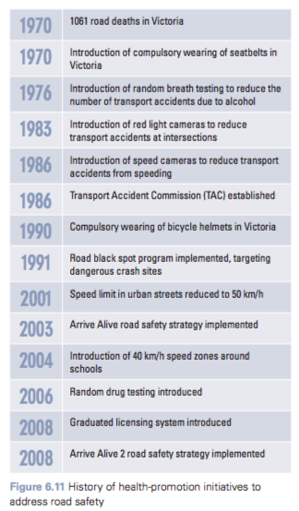

**WHY IS ROAD SAFETY TARGETED**

* Also targeted as deaths from road accidents are preventable
* Traffic accidents affect all road users including drivers, passengers, motorcyclists, pedestrians and cyclists.
* Transport accidents were the leading cause of hospitalisation for males aged 15–24 years in 2013–14 (613 per 100 000)
* In 2015, 252 people died on Victorian roads
* In 2016 292 people died on Victorian roads
* Some population groups are more effected than others
  + Younger drivers + males in rural areas (56%) and metropolitan areas are (44%)
  + People in rural areas only account for 25 per cent of the population
    - * males are approximately 3.5 times more likely than females to die on Australian roads.

*EXAMPLES OF HEALTH PROMOTION TO ADDRESS ROAD SAFETY*

* Changes to legislation and policy
* Transport Accident Commission (TAC) media   
  campaigns
* Driver Reviver National Campaign (operated by Victoria State Emergency Service and Lions Club members in Victoria)
* programs to target specific population groups, such as Vic Roads’ Kids on the Move
* The PARTY, an initiative of the Royal Melbourne Hospital and the Alfred Hospital   
  in Victoria
* comprehensive road safety strategies such   
  as the Victorian Government’s 2016–20 Towards Zero Strategy and Action Plan, and the National Road Safety Strategy 2011–20.

***TOWARDS ZERO PROGRAM***

* 5 ORGANISATIONS THAT WORK TO OVERSEE TOWARDS ZERO PROGRAM
  + - VicRoads
    - TAC
    - Department of Human Services
    - Department of Justice and Regulation
    - Victoria police
* PRINCIPLES OF TOWARDS ZERO
  + Human health is paramount.
  + People make mistakes.
  + People are fragile.
  + People have a limited tolerance to physical   
    forces.
  + Road safety is a shared responsibility.
* INVESTS IN
  + - Safe roads
    - Safe vehicles
    - Safe speeds
    - Safe people
* INITIATIVES
  + Public engagement program in rural Victoria to support safer speeds
  + Double the amount of hours of supervised night driving required for L platers (10hours - 20)
  + Mandatory training for motorcycles
  + Anyone caught over the alcohol limit (after recieveinf their license back) must have an alcohol interlock installed into their car
  + Barriers/tactile centres and edge lines on risky, highspeed, rural road networks.
  + Online medical reports to allow timely and high-quality assessments to help keep older drivers safer on the roads
  + Safe driving program for secondary schools
  + Removal of 50 of Victorias most dangerous level crossings
  + Community engagement campaigns to increase the understanding of the impact of speed

*How Towards Zero reflects the Ottawa Charter*

* **Build healthy public policy**
  + - Through changing the number of hours of night driving by learner drivers and new legislation requiring that all drink drivers caught over the limit will have to drive vehicles with alcohol interlocks, Towards Zero is building healthy public policy.
* **Strengthen community action**
  + - Involving five key organisations to oversee the Towards Zero program (VicRoads, TAC, Department of Human Services, Department of Justice and Regulation and Victoria Police) encourages community action, as these organisations will need to work together to achieve the common goal of Towards Zero.
* **Create supportive environments**
  + - The addition of barriers or tactile centre and edge lines on more than 2500 km of the riskiest parts of the high-speed rural road network and the removal of 50 of Victoria’s most dangerous level crossings will help to create a supportive physical environment with the aim of reducing the number of transport accidents.
* **Develop personal skills**
  + - Through the initiative to provide mandatory training for motorcyclists and a practical safe driving program for secondary school students, Towards Zero aims to develop personal skills by teaching safe driving behaviours.
* **Reorient health services** 
  + - The development of a better system of online medical reports to allow timely and high-quality asse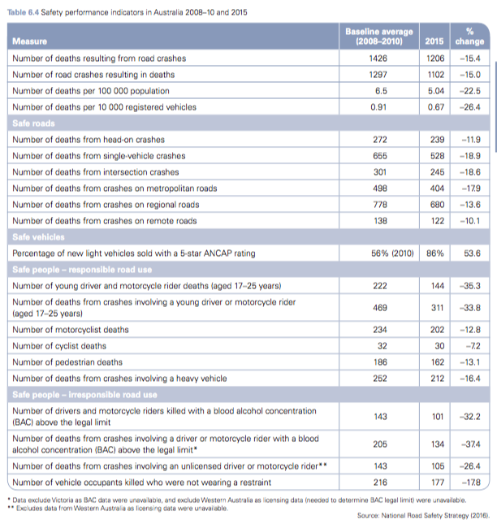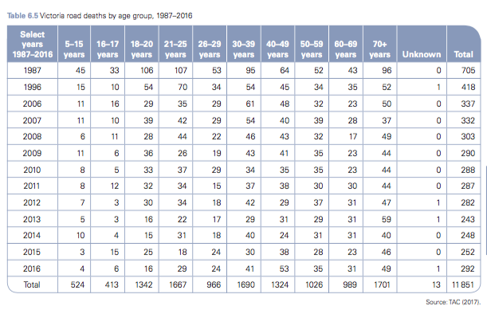ssments to help keep older drivers safer on the roads is reorienting health services as doctors are working to prevent fatalities among older drivers by ensuring that details about their health are easily accessible online.

***THE AUSTRALASIAN NEW CAR ASSESSMENT PROGRAM***

***(ANCAP)***

* VISION: to eliminate road trauma through testing and promotion of safer vehicles
  + - Working cooperatively with and supporting member organisations to help them promote safer vehicles
    - Working cooperatively with vehicle brands to raise the bar on safety whilst remaining independent
    - working cooperatively with Euro NCAP and testing laboratories to develop and implement a common test protocol in 2018
    - testing and interpreting data to-assess the crash avoidance and crash protection safety of new motor vehicles to compare their performance and publish the results
    - educating consumers on new vehicle safety features and safer vehicle choices.
    - educating and influencing decision- makers to advocate for improved vehicle safety
    - maintaining strong links with other NCAPs and international advocates to lift and align safety standards around the world
    - maintaining and improving support for the organisation – leveraging existing and exploring new support streams.

This program aims to improve road safety not only by making consumers more aware of the safety of the vehicle they are purchasing, but also through encouraging car manufacturers to make their vehicles safer.

* + - Has support from 23 member organisations in Aus and NZ
      * + TAC
        + VicRoads
        + Royal Automobile Club of Victoria (RACV)

*How ANCAP reflects the Ottawa Charter*

* **Build healthy public policy**
  + - ANCAP has developed a new policy in an attempt to better align safety rating with Euro NCAP.
* **Develop personal skills**
  + - Through educating consumers on new vehicle safety features and safer vehicle choices, and educating and influencing decision-makers to advocate for improved vehicle safety, ANCAP aims to develop personal skills.
* **Strengthen community action**
  + - ANCAP strengthens community action by working with 23 member organisations in Australia and New Zealand, such as the TAC, VicRoads and Royal Automobile Club of Victoria (RACV). It also maintains strong links with other NCAPs and international advocates   
      to lift and align safety standards around the world and to work with vehicle brands to raise the bar on safety while remaining independent.
* **Creare supportive environments**
  + - Through providing an informative website that con- sumers can access 24 hours a day to check the safety star rating of a vehicle they might be looking to purchase, ANCAP aims to create a supportive environment through supporting consumers to purchase safer vehicles.

EFFECTIVENESS

* Number of vehicles on the road increase but deaths decline
  + - Road deaths reduced from nearly 3800 in 1970 to fewer than 1200 in 2014.
      * Can be attributed to

Change legislation

Improvements in road conditions

Improvements in vehicle safety and initiatives

Improvements in driver behaviour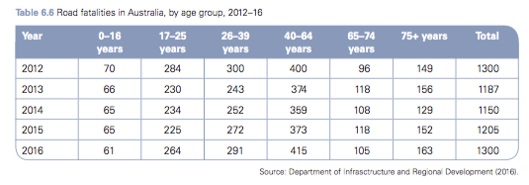

**ROLE OF HEALTH PROMOTION IN REDUCING SKIN CANCER**

Skin Cancer risk factors

* Exposure to UV radiation —> damage DNA and increases risk of melanoma
* Family history —> people with first degree relative (parent, sibling or child) with melanoma have a greater risk of being diagnosed
* Age —> risk increases with age (amount of sun exposure in our lifetime and the number of episode of sun burn increases)
* Skin type —> people with fairer skin are more likely to develop skin cancer BUT people with dark skin are more likely to develop skin cancer at a later stage as it is harder to identify on darker skin
* Gender —> males tend to be more likely to develop melanoma than females
  + - Due to work environment

**WHY IS SKIN CANCER TARGETED**

* 2016 - 3283 deaths
* 2012 - 12036 deaths
* 1982 - 3526 deaths
* Melanoma is the fourth most commonly diagnosed cancer
  + Accounted for almost 10% of all cancers in 2016
* 2017
  + 3rd most common cancer for males and females
    - 8392 deaths in males (1 in 13)
    - 5549 deaths in females (1 in 23)
* Massive economic burden
  + $9.4 million in benefits paid by Medicare
* Largely preventable
* Has a considerable impact on emotional and mental wellbeing of an individual (as well as physical)

***SUNSMART***

* First funded by the Cancer Council and VicHealth in 1988
* Now internationally recognised for providing leadership in UV protection
* SloganL Slip! Slop! Slap! Slide! Seek!
* AIM
  + - improve skin cancer prevention awareness, knowledge, attitudes and behaviours
    - support priority populations to detect skin cancers earlier
    - advocate for measures that aim to reduce the health and economic burdens of skin cancer
* HEALTH PROMOTION IMPLEMENTED BY SUNSMART
  + - SunSmart schools
    - a ‘UV: It All Adds Up’ media campaign
    - the SunSmart app
    - SunSmart’s secondary school UV membership program
    - SunSmart’s workplace education program and UV safety training
    - advocacy for legislation to ban solariums.

*How SUNSMART reflects the Ottawa Charter*

* **Build healthy public policy**
  + - Through lobbying to ban the use of solariums and through the development of policies as part of the SunSmart Schools initiative, the SunSmart program helps to build healthy public policy.
* **Strengthen community action**
  + - Through a range of SunSmart health-promotion initiatives, such as lobbying for changes in legislation and working with schools and workplaces in the SunSmart schools and SunSmart workplaces initiatives, SunSmart helps to strengthen community action.
* **Develop personal skills**
  + - Through working to spread its health-promotion message ‘Slip! Slop! Slap! Seek! Slide!’, SunSmart aims to develop personal skills by educating people about the actions they can take to protect their skin from skin cancer.
* **Create supportive environments**
  + - Through the SunSmart schools initiative, SunSmart creates supportive environments as it encourages schools to build shade to promote supportive physical environments. It also promotes education and the promotion of the Slip, Slop, Slap, Seek and Slide message on posters, which helps to promote a supportive social environment.
* **Reorient health services**
  + - Through providing specialised training and education for doctors and encouraging them to spread the SunSmart message during consultations with patients, the SunSmart program helps to reorient health services.

EFFECTIVENESS

* SunSmart have been very successful in implementing a wide range of health-promotion initiatives that aim to reduce harmful UV exposure and hence skin caner
* It was very successful in advocating for the banning of solariums, with commercial tanning units and solariums banned in Victoria since 1 January —> reduce the risk of melanoma
* SunSmart schools: almost 90% of Victorian primary schools have sun protection policy and are registered as SunSmart schools
  + Benefit has reached more than 430,000 students
  + In 1993 only 17% of schools had a SunSmart policy
  + Victoria has the highest participation rate for any public health intervention
* Very economical $2.20 saving for every $1 spent
* SunSmart app has been downloaded by over 250,000 users —> people have UV alerts and sun protection times
* Independent evaluation: 1000 deaths averted
* In Victoria the overall melanoma incidence is increasing however there are now falling incidence rates in men and women younger than 40
  + This is the subgroup that has been exposed to SnSmart message for 30 years
* The incidence of melanoma rose between 1982 and 2012, and since then it has remained stable. The incidence in 2012 was 49 new cases per 100000 population. While the number of new cases has remained fairly stable, the five- year survival rate has increased during the same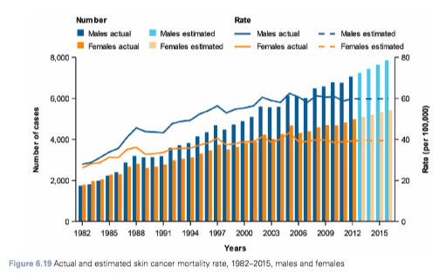 period.