* initiatives to promote healthy eating in Australia including Australian Dietary Guidelines and the work of Nutrition Australia, and the challenges in bringing about dietary change.

The nutritional status of Australians is a key indicator of the population’s overall health.

* Both government and non-government organisations work towards increasing the nutritional knowledge of Australians
* Non-government organisations (NGOs)

**AUSTRALIAN DIETARY GUIDELINE**

* latest edition of ADG was published in 2013
* Development of this food model was funded by Commonwealth Department of Health and Ageing, and was conducted by the National Health and Medical Research Council (NHMRC).
* AIMS
  + - Promote health and wellbeing
    - Reduce the risk of diet- related conditions that act as biological factors influencing overall health and wellbeing, such as high cholesterol, high BP and obesity
    - Reduce the risk of chronic diseases such as type 2 diabetes, CVD and some cancers
* Provides realist and practical guide
* Has a focus on long term health and focus on children
* Designed to help professional, policy-makers and Australian public to make informed decisions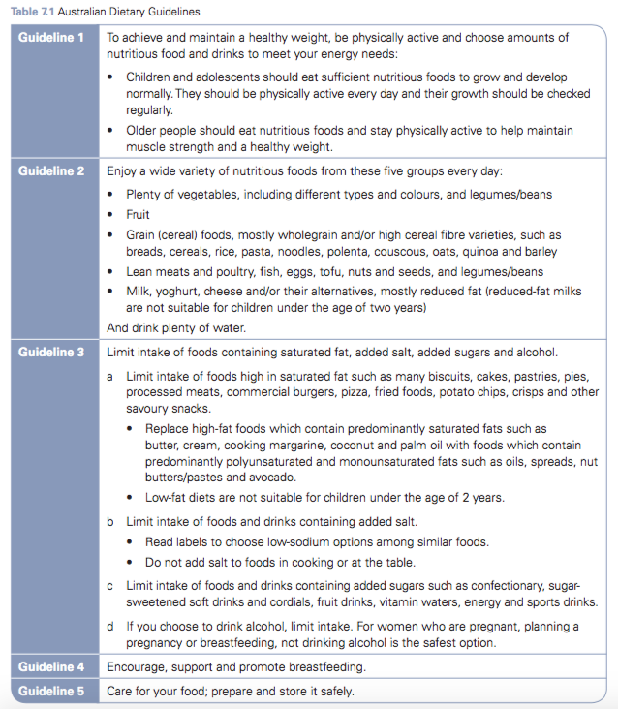

**DECRIPTION**

* Evidence suggests that there is a strong association between adherence to national dietary guidelines and recommendations, and reduced morbidity and mortality. More recent evidence from countries comparable with Australia con- rms that dietary patterns consistent with guidelines recommending relatively high amounts of vegetables, fruit, whole grains, poultry, fish, and reduced-fat milk, yoghurt and cheese products may be associated with superior nutritional status, quality of life and survival in older adults (NHMRC, 2013).
  + This is why ADG recommends WHOLE FOODS (**whole foods:** Refers to foods themselves – for example, fruit, vegetables, bread, pasta, lean meat, milk, yoghurt – and not the food component – for example, calcium, iron, protein.)
  + This practical approach makes the recommendations easier to apply

**SIGNIFICANCE OF EACH GUIDELINE**

*Guideline 1: To achieve and maintain a healthy weight, be physically active and choose amounts of nutritious food and drinks to meet your energy needs.*

* primary factors that influence energy balance are physical activity and dietary energy intake
* Regularly obtaining more energy from food eaten than is needed to meet energy requirements can lead to the energy storage in the form of excess body fat
* Insufficient physical activity can also lead to excess body fat - associated with adverse health consequences including increased mortality (now a major health problem in Australia)
* however, good diet and physical exercise has many more benefits than simply body weight

*Guideline 2: Enjoy a wide variety of nutritious foods from these five food groups every day.*

* consuming different food types in appropriate amounts —> enables the attainment of all the required nutrients without excess intake
* 5 vegetables per day
* Protection against non-communicable chronic diseases
  + - CVD
    - Obesity
    - Diabetes
    - Hypertension
    - Some cancers
* **Eat plenty of vegetables of different types and colours and legumes/beans**
* there is strong evidence that different coloured vegetables play a protective tole against the development of a number of non communicable chronic diseases (as listed above)
* This may be partly due to the phytochemical that are present in them (antioxidants)
* Intake of vitamins, minerals and fibre from vegetables

**Brassica vegetables** Vegetables from the Brassica or crucifer family, collectively known as cabbages or mustards and including broccoli, cabbage and Brussels sprouts. —> good

* **Eat fruit**
* Most fruits have low energy density and high dietary fibre and water content and adequate consumption is linked to a reduced risk of weight gain
* Other advantages are coronary heart disease, stroke and some cancers (reduced risk)
* 2 fruit per say
* **Eat grain (cereal) food, mostly wholegrain and/or high cereal fibre varieties, such as breads, cereals, rice, couscous, oats, quinoa and barley** 
  + - **grain (cereal) foods:**The entire class of cereal/grain foods, including whole or partially processed cereal grains (e.g. rice, breads, cereals, rice, oats, corn and barley), breads, cereals, rice, pasta, noodles, polenta, couscous, oats, quinoa and barley. It excludes cereal or grain-based products with a significant amount of added fat and sugar, such as cakes, pastries, pasta, noodles, polenta and biscuits
* Can contribute to a variety of nutrient and phytochemical benefits
* Excellent source of carbohydrate and dietary fibre, also an important part of dietary fibre and protein
* Low in fat
* Good source of B-group vitamins, vitamin E and minerals (iron, magnesium, zinc and phosphorus in particular)
* **Eat lean meats and poultry, fish, eggs, tofu, nuts and seeds, and legumes/beans.**
* Helps to ensure adequate intake of protein, iron, zinc and vitamin B12
* Fish is also a good source of omega-3-fats
* Low iron intakes are common in Australia and iron-de ciency anaemia is a signi cant public health concern. Vegetarians and semi-vegetarians may also be at increased risk because of the higher intake needs resulting from the low bioavailability of plant-based iron sources. They also need to ensure an adequate intake of zinc and   
  vitamin B12.
* **Eat milk, yoghurt, cheese and/or their alternatives, mostly reduced fat**
* Milk based food are the richest source of calcium
* Also contribute to portion, vitamin A, riboflavin, vitamin B12 and zinc
* Calcium is required for normal development and maintenance of bones and teeth
  + Low intake of calcium is associated with osteoporosis —> results in bone fracture (one of the main causes of morbidity among older Australian women)
* Adequate calcium helps delay the loss of bone density and onset of osteoporosis
* However, milk is often high in saturated fat so reduced fat varieties should be chosen where possible
* **Drink plenty of water**
* Water is an essential nutrient for life
* Part of the seminal reactions in the body
* Helps form structures of large molecules such as protein and glycogen
* Water is required for digestion, absorption and transportation and as a solvent for nutrients
* The elimination of waste products
* Thermoregulation
* Adequate fluid consumption is an integral component of a healthy diet.

*Guideline 3a: Limit intake of foods containing saturated fat, added salt, added sugars and alcohol.*

* **Limit intake of foods high in saturated fat**, such as many biscuits, cakes, pastries, pies, processed meats, commercial burgers, pizza, fried foods, potato chips, crisps and other savoury snacks.
* **Replace high-fat foods**, which contain predominately saturated fats such as butter, cream, cooking margarine, coconut and palm oil, with foods that contain predominately polyunsaturated and monounsaturated fats such as oils, spreads, nut butters/pastes   
  and avocado.
* Overweight and obesity have been increasing rapidly in Australia.
* Fats are the most concentrated form of energy, providing 37 kilojoules per gram —> obesity
* Overweight and obesity are diet-related risk factors for type 2 diabetes.
* Many processed foods are high in saturated fats and are overall extremely energy-dense, so it is recommended that these foods be avoided altogether
* Saturated fatty acids raise plasma LDL cholesterol, a major risk factor for coronary heart disease. Polyunsaturated fats and monounsaturated fatty acids do not raise plasma cholesterol. The evidence indicates that replacing dietary saturated fat with monounsaturated and polyunsaturated fats is associated with improved blood lipid proteins and reduced risk of cardiovascular disease. Therefore, for adult Australians who are not overweight, a moderate total fat intake is around 25–35 per cent of energy, of which saturated fat should contribute a maximum of 10 per cent and at least 4–10 per cent of the fat intake should come from omega-3 and omega-6 fatty acids.
* **Low-fat diets are not suitable for children under the age of 2 years.**
* For infants under the age of around 6 months, breastmilk provides an ideal amount and type of fat
* Children aged less than 2 years are not recommended to have a reduced-fat intake as even a small energy shortage during this period of rapid development may affect their growth
* In particular, the developing nervous tissue needed for brain development requires an adequate supply of essential fatty acids, particularly omega-3
* After the age of 2 years, reduced-fat foods are recommended as, even at a young age, a diet high in saturated fats may predispose children and adolescents to cardiovascular disease later in life.

*Guideline 3b: Limit intake of foods and drinks containing added salt.*

* Read labels to choose low-sodium options   
  among similar foods.
* Do not add salt to foods in cooking or at the table.
* Dietary salt is an inorganic compound consisting of sodium and chloride ions.
* It is found naturally in many foods, but it is also added to many foods because of its preservative and flavouring characteristics.
* It is now well accepted that a reduction in dietary sodium intake will decrease the mean population blood pressure and reduce the prevalence of hypertension —> stroke and ischaemic heart disease increases with BP

*Guideline 3c: Limit intake of foods and drinks containing added sugars.*

* Many of the foods found in the Australian diet contain naturally occurring sugars
* In other foods, sugars (particularly sucrose) may be added increase the food’s palatability and acceptability, and sometimes to add bulk.
* Diets high in added sugar have been associated with development of obesity.
* Sugar is also a contributing factor to dental caries.
* Sugar- sweetened drinks (soft drinks and cordials, fruit drinks, vitamin waters, energy and sports drinks)—> largest source of sugars in the Australian diet, highes consumption t in adolescents and children (NHMRC, 2013).

*Guideline 3d: If you choose to drink alcohol, limit intake. For women who are pregnant, planning a pregnancy or breastfeeding, not drinking alcohol is the safest option.*

* Energy dense 00> contribute to weight gain
* Can be linked to choric illnesses such as hypertension and stroke, colorectal cancer, liver cancer and hepatitis
* Associated with dementia
* Associated wit nutritional deficiencies such as folate and vitamin A
* Alcohol use during pregnancy can harm the unborn baby
  + The NHMRC indicates that there is no alcohol intake during pregnancy that can be guaranteed to be completely safe, so avoiding alcohol while pregnant is considered the safest option.
* Data indicates: mothers who consume alcohol are more likely to stop breastfeeding before six months compared to mothers who don’t drink Alcohol levels in breastmilk parallel blood alcohol levels,—> longer the time between drinking alcohol and breastfeeding, the safer it will be for the baby. The safest option for women who are breastfeeding is to not drink(NHMRC, 2013).

*Guideline 4: Encourage, support and promote breastfeeding*

* contributes to the health of all Australians from birth
* Breast-feeding is the normal and appropriate method of feeding infants and is closely related to immediate and long term health outcomes
* improved health benefits to infants
  + Reduced risk of infection
  + Reduced risk of asthma
  + Contributes to intellectual development
* Protective against
  + Obesity
  + Hypertension
  + Other chronic diseases
* Colostrum and mature human milk are hygienic and provide immunoglobulins and anti infective agents —> protect infant against infection and disease

*Guideline 5: Care for your food; prepare and store it safely*

* *recent increase in food borne illnesses* 
  + *Can have serious consequences on health (esp, elderly)*
  + *Correct handling is required at all stages (consumers ‘food chain’) - purchasing, transport, storage, preparation, cooking, serving and cleaning*

**USING THE AUSTRALIAN DIETARY GUIDELINES FOR FOOD SELECTION**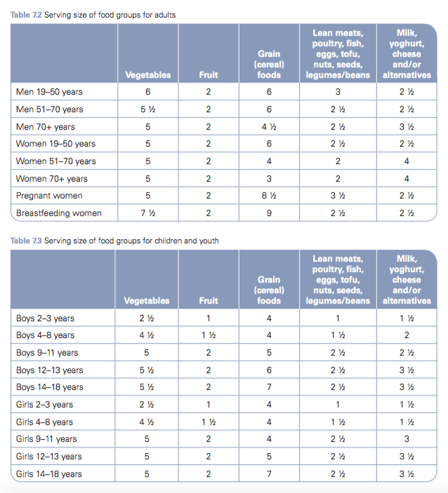

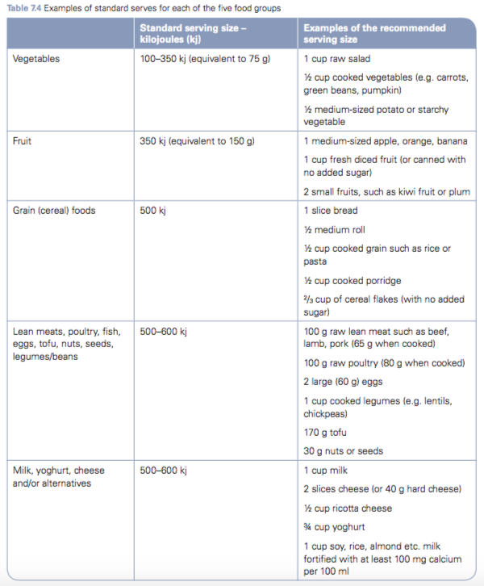

**THE WORK OF NUTRITION AUSTRALIA IN PROMOTING HEALTHY EATING**

* Non-government organisations often have special knowledge of the speci c issues or population groups they represent.
* can also act as policy advocates, lobbying the government on behalf of the community
* KEY NGOs
  + - * Nutrition Australia,
      * Australian Cancer Councils,
      * Diabetes Australia,
      * National Heart Foundation of Australia
      * Dietitian Association of Australia (DAA).

***NUTRITION AUSTRALIA***

* Non-government, non-profit, community based —> aims to promote health and wellbeing of all Australians.
* Originally founded in 1979 as the Australian Nutrition Foundation (ANF)
* Provides scientifically based nutrition information —> encourage Australians to achieve optimal health through food variety and physical activity
* Worked with commonwealth health departments
  + - For nutrition for all ages of lifespan
    - Through setting such as: schools, workplace, university, hospital and aged care facilities
* Nutrition Australia operates through a national Board, which is responsible for policy and national programs
* Have applied a multi-strategic approach to public health nutrition work
  + - Awareness rasiing
    - Information provision for public and health professionals
    - Education
    - Provides the latest research on nutrition, current food, health trends
    - Coordinated events in annual National Nutrition Week campaign
    - Webinars for health professionals
    - Extensive media and public speaking experience
    - Media commentary
    - Sale of nutrition education publications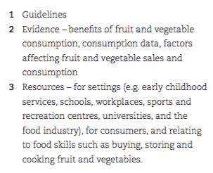
    - Food industry consultancies
    - Nutrition training and presentations
    - Menu assessments

***VHEE FRUET AND VEGETABLE NETWORK***

* Victorian Health Eating Enterprise
* network of organisations coordinated by Nutrition Australia (Victorian Division) that works towards improving the supply and consumption of fruit and vegetables in Victoria
  + Partners in the network include representatives from local and stage governments, industry, health, education and community organisation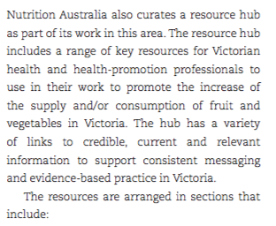
* INCREASES THE REACH AND IMPACT THROUGH
  + - Sharing information and resources
    - Promoting each other’s initiatives
    - Collaborating on initiatives

***Product and menu assessments***

**PRODUCT ASSESSMENTS**

Victoria division of Nutrition Australia works with food and drink manufacturers so their food products can be independently reviewed to determine whether they fit within the guidelines outlines in the School Canteens and Food Services Policy and he Healthy Choices: Food and Drink guidelines.

**ONLINE ASSESSMENT TOOL**

Nutrition Australia Vic Division’s Healthy Eating Advisory Service has developed an online menu, product and recipe assessment tool, **FoodChecker.**

FoodChecker allows anyone working daycare, school or retail food outlet to review food and drinks they supply against relevant Victorian healthy food and drink guidelines

Also provides tailored recommendations for healthy changes to meet the guidelines

***Workshops and programs***

**HEALTH AND WELLBEING PROGRAM @ WORKPLACE**

* provide various services in the workplace to promote health and well-being in relation to food and nutrition
  + - Cooking demonstrations with a range of possible focuses (quick, family friendly, affordable..)
    - Nutrition education seminars (some topics: understanding food labels, weight management, energy boosting and increasing the variety of food eaten)
    - Personal one-to-one consultations that include advice from a dietitian (at workplace rather than dietitian office)
    - Assessment of workplace vending machines and catering services —? Allows workplaces to improve the nutritional quality and variety of food available to employees
    - Interactive health display with qualified nutrition professionals that provides up-to date information as well as ebbing able to address individual queries

**ROY ROYCE HEALHY FOOD EDUCATION PROGRAM**

Healthy eating workshop for Victorian primary schools

* Provides information through active game play, story telling and discussion aimed at motivating children to enjoy healthy food
* Children learn about
  + - ‘everyday’ and ‘sometime; foods
    - The way food can make us feel
    - How to be responsible for making healthy choices
* The school receives a curriculum-linked resource kit to continue their learning in the classroom throughout the year
* Each child receives a Nutrition Australia take home resource pack —> provides information on making healthy choices at home

**HEALTHY EATING ADVISORY SERVICE**

* Supports various places (early childhood services, primary and secondary schools, workplaces and hospital retail food outlets) to provide healthier food and drinks
* Run by a ream of experienced dietitians and nutritionists who provide information and resources
* PROVIDE SUPPORT VIA:
  + Phone advice - including menu planning
  + Staff training on development and modifying menu planning, product assessments, and developing an internal healthy food policy
  + Information on establishing and maintaining a health promoting environment, through the provision of healthy food and drinks.

**RECIPES, FACT SHEETS AND PUBLICATIONS**

* variety of recipes, and factsheets available to the public —> on the website
* also has a wide range of publications promoting healthy eating and food variety available for use in homes, schools and workplaces that include recipe, nutrition and activity books; teacher resource packages; educational posters; and booklets and leaflets
* Series of webinars are also available - online shop

**NATIONAL NUTRITION WEEK**

* Nutrition Australia coordinates the annual Nation Nutrition week campaign
* During this week activities and challenges are hosted by early childhood services, schools and workplaces relating to a specific theme (different every year)
* Also provides a variety of recipes and information resources
* Also provides cooking demonstrations for workplace and seminars

**A HEALTHY EATING PYRAMID**

* has been Nutrition Australia’s iconic guide to a healthy and balanced diet for over 30 years
* Has continually evolved as a guide for Australians toward a balanced and varied diet in line with current guidelines
* 1980 - ‘healthy eating pyramid’
* 2004 - ‘healthy living pyramid’ (layer was added)
* 2015 - back to ‘healthy eating pyramid’ (changed back to reflect four back on food/nutrition)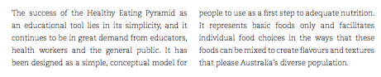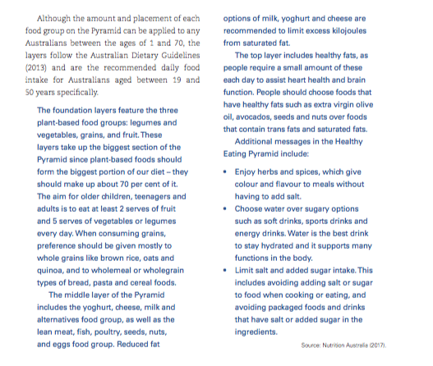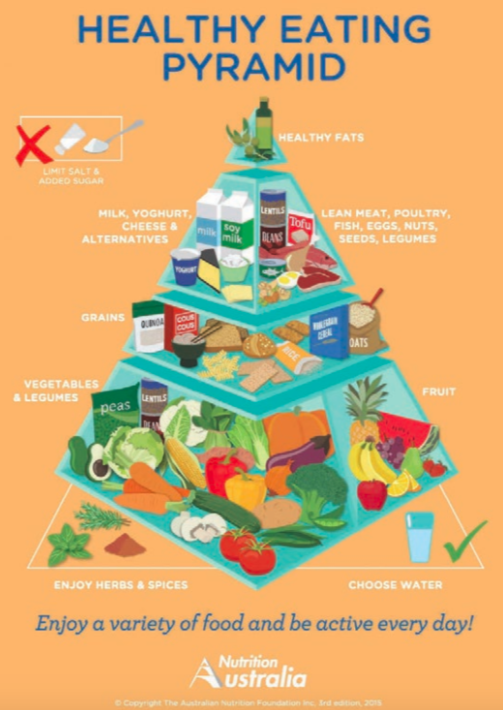

**CHALLENGES TO BRINGING ABOUT CHANGE IN DIETARY INTAKE**

* while hunger is a persons primary motivation for consuming food, the nutritional choices are not driven by their physiological or nutritional requirement
* Other factors include
  + - Sociocultural influences (income, culture, family, attitudes, education, knowledge and skills)
    - Behavioural influences (personal taste preference, meal patterns)
    - Biological influences (age, stress)
    - Environmental influences (food availability/security)

**INCOME**

* food selection is often influences by the prices of good and the individuals SES position and household income
* Nutrient dense diets are more likely to be consumed by high SES people
* Due to limited economy means - low SES groups are more likely to consume nutrient poor diets
* Main differences have been in relation to the intake of energy, fat, sodium and simple sugars
  + High SES groups are more likely to eat whole grains, lean meats, fish, low fat dairy products and fresh vegetables and fruit
  + Low SES groups are more likely to eat refined grains and added fats
    - * This could be due to the high cost of fresh food and relatively low cost of processed food
      * More processed food and chapter options often require less time to prepare

**FAMILY AND PEERS**

* Dietary /health choices develop early (from infancy it is influenced by parents)
  + Some research suggests that children pick up eating behaviours by observing others
* Children often share food with peers and can be another influence on food choices
* People often alter how much they eat depending the people around them (may eat less or more)

**CULTURE**

* Culture = set of values, beliefs and practices shared by a group —> effects emotions, behaviours and thoughts BUT also adoption of health education messages
* Growing up in a distinctive culture is bound to influence your lifestyle, your belief system and food intake
* Food plays an important role in the lives of families and in most cultures
  + - The degree of importance may vary cultures to culture
    - Some food traditions are more healthful than others —> people in different cultures with different health risks can be influenced by cultural food choices
      * + Examples

Asian cultures with low-fat food and lots of vegetables can reduce the risk of diabetes and cancer

Muslims fast during Ramadan

Jewish people follow kosher diet

Buddists/hindus are often vegetarian

**ATTITUDES AND BELIEFS**

* People adjust their eating to fit with perceived societal beliefs (similar to the influence of culture)
  + example: teenagers desire to conform to their peer group expectations which may cause them to chose unhealthy food choices

**EDUCATION/KNOWLEDGE/SKILS**

* People with lower levels of education may eat larger amounts of unhealthy, energy dense food than those with higher education level
* Health literacy/nutrition knowledge is essential to enabling healthy food choices
* Ways for people to obtain information regarding good nutrition
  + - Labels
    - Advertising
    - Nutrition information
    - Health star rating
* People are still fining it difficult to understand food labels, portion sizes and how to balance their diet in relation to more complex concepts such as macronutrients
* Major barrier - lack of time for preparation and limited skill levels in creating variety of food intake
* Nutrition education in school is fundamental for supporting young people to develop sustainable , health promoting eating behaviours —> empower them to make better decisions

**PERSONAL TASTE PREFERENCE**

* Many people make food choices simply based on taste
* People eat what they are used to and healthy options often don’t taste as good/unsatsfying

**MEAL PATTERNS**

* One of the most unhealthy meal patterns are skipping breakfast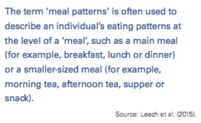
  + Increases snacking, also results in lower intake of essential nutrients such as fibre
  + Shared family meals also contribute to a healthier more sustainable diet
  + A meals-based approach could complement the dietary advice that  
    uses a food-based model as part of its framework (for example, the Australian Dietary Guidelines, the Healthy Eating Pyramid) to assist people in achieving the recommended daily intakes of foods and nutrients. Simply, dietary advice in the context of meals could help populations with their daily meal preparation and therefore be a more practical way to assist populations to make changes.

**AGEING**

* People eat less and make different food choices as they get older
  + Low energy intake or low nutrient density —> increases the risk of diet related illnesses
* Combination of: Daily volume of foods and beverages declines as a function of age. Physiological changes associated with age, including slower gastric emptying, altered hormonal responses, decreased basal metabolic rate, and altered senses of taste and smell, together with dental problems that make some foods too difficult to eat, may contribute to this reduced food intake.

**STRESS**

* In the short term stress can shut down appetite (a structure called the hypothalamus releases a hormone that surprises appetite
* If stress persists cortisol is released —> increases appetite and motivation to eat
  + If stress is elevated or remains (cortisol remains) which may result in eating even if not hungry
* Stress also influences food preference
  + Numerous studies have shown that physical or emotional distress increases the intake of foods high in fat, sugar or both
    - Hormones such as cortisol, leptin, epinephrine and ghrelin may be responsible for this
* After consumption of high fat-filled and high sugar foods give feedback and inhibit activity in parts of the brain that produce and process stress related emotions
  + Hence the name - comfort foods

**FOOD AVAILABILITY/SECURITY**

* 4 DIMENSIONS
  + - ***Food availability*** (sufficient quantities of food are available on a consistent basis)
    - ***Food access*** (sufficient resources are available to obtain appropriate foods for a nutritious diet)
    - ***Food use*** (appropriate use, based on knowledge of basic nutrition and care, as well as adequate food preparation facilities
    - ***Food stability*** (stability of availability and access over time
* Availability and cost are major barriers to accessing adequate food

***THE CHALLENGES INVOLVED IN ADDRESSING THESE INFLUENCES TO BRING ABOUT DIETARY CHANGE***

**INVOLVEMENT OF ALL STAKEHOLDERS**

* to bring about dietary change in a population a coordinated strategic plan is necessary
  + Includes all sectors of society
    - Individuals
    - Families
    - Educators
    - Communities
    - Physicians
    - Allied health professionals
    - Public health advocates
    - Policy makers
    - Businesses (farmers, agriculture, producers, food retailers, food scientists)
* However, not all stakeholders see the benefit of changing dietary intake as it may have a negative impact on their business/profit
  + - example: food manufacturers

**TAILORED APPROACH INSTEAD OF ‘ONE-SIZE-FITS-ALL’ APPROACH**

* One size fits all cannot be applied to the wider population
* Organisations who aim to change dietary intake must work together with dieticians, nutritionists and counsellors
  + Guidance needs to be personalised based on needs and priorities of an individual consumer in order t influence change
    - Comprehensive and long term approach needs to be applied that encompasses a range of strategies (incl. education, provisions of information, legislative changes)

**HELPING THE UNMOTIVATED**

* Providing information and resources
  + - Counselling
  + Main challenges
    - Motivating people who are disinclined to healthy behaviour
    - People who feel like there is no need to make changed or effort is not worth it
  + Lack of motivation may stem from
    - feelings of low self-worth
    - Low outcome expectations
    - Not believing they can do something successfully
  + Hence approach focuses on confidence building targeting decisional balance and also focus on changing efforts and beliefs

**FOCUSING ON THE ENVIRONMENT**

* Studies have focused mostly on individual factors such as taste preference and nutrition knowledge
* Nutrient education (such as ******) tend to have mostly short-lived effects at the best
* Recently argues that the environment we live in may be the driving force behind many of our less healthy dietary intake practices
  + example: now days whoever you go there is high availability and accessibility (at any time) to energy dense foods that appeal to preferences for sweet, fat and salty foods
* The focus on environmental influences on dietary practices is concerned with a health-protection approach to promotion of healthy eating – for example, changing the environment to protect the population against exposure to foods and eating patterns that contribute to chronic disease risk.

**AFFORDABILITY OF INTERVENTIONS**

* Major challenge: creating campaigns that incorporate practical solutions in a way that is affordable for all stakeholders.

**TARGETING CHANGE IN CHILDREN’S DIETARY INTAKE**

* Evidence shows that interventions are required in early life to change dietary intake