* characteristics of high- , middle- and low-income countries
* similarities and differences in health status and burden of disease in low- , middle- and high-income countries, including Australia
* the concept and dimensions of sustainability (environmental, social, economic) and its role in the promotion of health and wellbeing
* the concept of human development, including advantages and limitations of the Human Development Index

General statistics: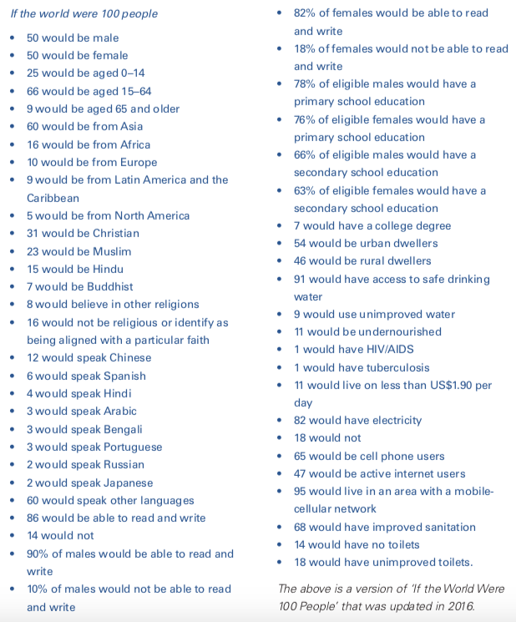

**GNI:** Value of country’s total annual income, expressed in US dollars, and divided by its population to indicate the average income of the country’s citizens.

| CHARACTERISTICS OF LOW MIDDLE HIGH INCOME COUNTRIES | | | |
| --- | --- | --- | --- |
| **Low**  $1,025 -  **middle**  $1026 - $12475  **high**  $12,476 + | **Low**  - Afghanistan, Chad, Mozambique, Nepal, Sierra Leone and Zimbabwe- | **Middle**   * Bangladesh, Cambodia, Argentina, Malaysia, Turkey and Vanuatu-   5 billion out of 7 billion live in middle income | **High**  - Australia, Canada, Japan, New Zealand, Singapore and the United States - |
| Economic | * a lack of social support such as welfare | Have characteristics of both high and low income countries depending on wether they are high-middle or low-middle | * availability of social support services such as social welfare |
| Environmental | * less infrastructure * lower levels of food security * lower agricultural productivity * poor access to improved sanitation | * improved infrastructure * improved food security * higher agricultural productivity * access to improved sanitation |
| Social | * poor access to healthcare * high population growth * low levels of educational attainment | * access to healthcare * lower population growth * higher levels of education attainment |

**Other characteristics of high income countries:**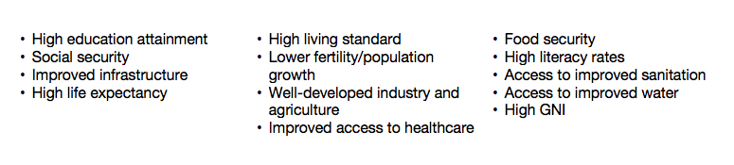

***SIMILARITIES AND DIFFERENCES IN HEALTH STATUS (between low, middle and high income countries)***

| Measure of health status | Similarities | Differences |
| --- | --- | --- |
| Life expectancy   * high: 80.6 * Middle: 70.6 * Low: 61.3 |  | * high income countries have a higher life expectancy * Due to better access to health resources that a stronger economy is able to provide. |
| Infant mortality rates |  | * lower in higher income countries * Influences life expectancy * Same reason as above |
| Under-5 mortality rates   * low: 76 per 1000 * high: 7 per 1000 |  | * inequities are significant (refer to data) * Low income countries have nearly 11 times the infant mortality rate than high income * Takes into account number of babe being born as it is a ratio * Leading cause of U6M   + Australia is congenital abnormalities (28%)   + In Sierra Leone congenital abnormalities (4.3%) malaria (19.8%) and pneumonia (14%) are leading causes   + This does not mean more kids in Australia have congenital abnormalities it just means less kids have communicable diseases like malaria and pneumonia but because so fewU5 kids die the % of CA is high * Other factors in low income countries: low birthweight, diarrhoea, under nutrition, measles, whooping cough, tetanus, TB … |
| Maternal mortality  - globally dropped 44% from 1990 to 2015 |  | * higher in low income countries and also fro adolescent mothers and women living in rural areas * Higher in low income countries due to: lack of access to medical care, trained attendants at birth and antenatal (before, during or relating to pregnancy) care, lack of nutrition and working long hours right before birth * ex. Chad: only 53% receive antenatal care and 24% have trained attendants at birth BUT in Australia close to 100% recieve antenatal care |
| causes of mortality | Common leading causes of death   * ischaemic heart disease, cerebrovascular ideas, lower respiratory diease, COPD | * many in low income countries are associated with nutrition, parietal conditions, diarrhoea ideas and infections and parasitic diseases * Increase in number of deaths form non-communicable diseases in low income countries (cancer, CVD) * higher income countries have overall lower death rates from all diseases * In high income most are due to non-communicable diseases (cancer, CVD) * In low income tend to be from communicate diseases * More low income country adults facing the same health concerns as high income countries —> partly due to change in lifestyle |
| morbidity |  | - difficult to measure morbidity so it is often measured in prevalence and incidence |
| Burden of disease |  | * low income countries leading causes of BOD   + HIV/AIDS, lower respiratory infections and diarrhoea disease * High income countries leading cause fo BOD   + ischaemic heart disease, stroke, depression, lung cancer, dementia, diabetes mellitus, asthma, osteoarthritis and road trauma. |
| Non-communicable diseases  4 types   * CVD * Cancer * Diabetes * Chronic respiratory diseases | - risk factors: BIOLOGICAL (gender, age, blood pressure, body weight, blood cholesterol or blood glucose levels) SOCIOCULTURAL, ENVIRONMENTAL and BEHAVIOURAL (diet, physical activity levels, sun protection behaviours, tobacco and alcohol use) | * Millions of deaths each year   + 80% are in low/middle income countries   + But: most of the population is in low/middle income countries   + Two battles: dealing with under nutrition and also with growing population especially in urban areas, who present with non-communicable diseases. This is called a ‘double burden’ of disease. |
| Obesity | worldwide obesity has more than doubled since 1980 and, according to WHO, more than 42 million children under the age of 5 were overweight in 2013, most of them in low- income countries. Overweight and obesity are a leading risk for global deaths, as they are a major risk factor for many non-communicable diseases such as cardiovascular disease and type 2 diabetes. |  |
| HIV/AIDS   * Children of women who have HIV are also at high risk due to the risk of transmission during pregnancy or birth, or through breastmilk. * HIV/AIDS has the highest infection rate among people aged 15–49 years; however, the highest rate of mortality in developing countries is among the elderly and children. |  | * The countries worst affected by HIV/AIDS are in Sub- Saharan Africa, including Swaziland, Zimbabwe, Botswana, Zambia, Malawi, South Africa and Namibia. * Women in the cycle of poverty may resort to sex work/prostitution which increases their risk fo HIV/AIDs especially where there are fewer safety measures * Individuals with HIV are more susceptible to health problems such as respiratory infection, diarrhoea, fever, weight loss and cancer. |

* for definitions of health status look at U3 AOS1 Notes

**THE ROLE OF SUSTAINABILITY IN THE PROMOTION OF HEALTH AND WELLBEING**

**sustainability**: ‘Meeting the needs of the present without compromising the ability of future generations to meet their own needs’ (UN, 1987).

* + - * Using this definition, sustainability can be viewed as a goal, while sustainable development is more about the many examples of action that can be taken as part of a broad process, plan or pathway to achieve this goal.
      * The capacity to endure
      * Quality of life (not just income growth)
      * Equity between people (prevention of poverty)
      * Intergenerational equity (ensuring future generations enjoy the current if not improved environment)

**Economic stability** (involves the efficient and responsible use of available resources to ensure that all financial obligations over time can be met.)

* ensuring employment opportunities and the payment of a fair wage for goods and services
* promoting economic growth at the national and international level
* investing in education and improving the skills and knowledge of the workforce
* having access to appropriate technology, transport, communication systems, tools and energy.

**Environmental stability** (involves making decisions and implementing practices that minimise the degradation of the planet and having an awareness of natural resources and fragility of the physical environment.)

* protecting natural resources
* reducing energy usage and promoting greater efficiency in the use of energy
* reducing pollution
* encouraging industry and agriculture to use natural resources responsibly.

**Social stability** (is about equitably meeting and promoting the needs of all people now and in the future.)

* empowering people to take control of their lives
* respecting the values and knowledge of people
* promoting equity by including all people in decisions and activities that will impact on their community.

**HOW SUSTAINABILITY PROMOTES HEALTH AND WELLBEING**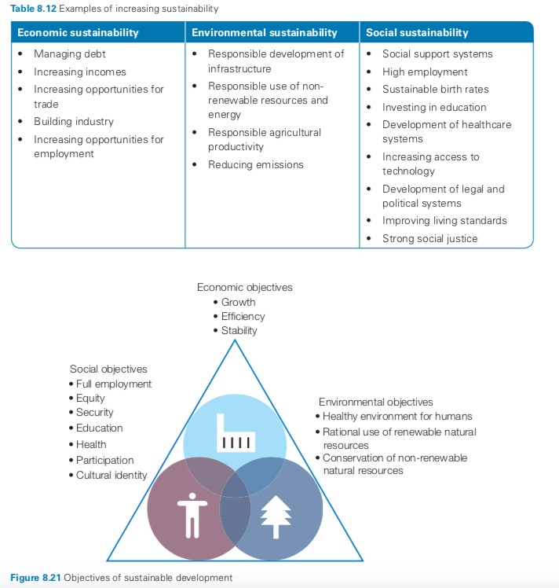

* Ensuring the needs of the current generation are being met for essential resources such as food, shelter and access to a safe water supply helps to promote the physical health and wellbeing of the population now. (CURRENT DOESN’T COMPROMISE FUTURE NEEDS)
* Ensuring that these resources are not depleted and are therefore available for future generations to meet their needs means that physical health and wellbeing will also be promoted in future generations. (NOT DEPLETING RESOURCES)
* Promoting economic sustainability by increasing income at a national level through trade means that governments have more money to invest in services such as education and healthcare. This improves physical health and wellbeing as people enjoy improved access to the treatment they need, which reduces the impact of illness. (ECONOMIC STABILITY - ACCESS TO SERVICES)
* Increasing income at a personal level gives individuals and families better access to  
  the resources they need, such as food and shelter, and services such as healthcare and education. This promotes physical health and wellbeing by reducing malnutrition and infectious disease. (PERSONAL INCOME)

***PAGE 331 (TB) AND 340 OF PDF PRINT***

**HUMAN DEVELOPMENT CONCEPT**

**Human development:** The process of increasing the opportunities and freedoms that people have to develop to their *full potential and lead productive*, creative lives in accord with their needs and interests (adapted from the UN Development Programme, 1990).

* it is about enlarging people’s choices - focusing on the *richness of human* lives rather than simply the richness of economies.
* Increasing choices, enjoying freedom to lead lives that they value
* Is also objective

Human development is based on **3 basic elements**:

Adequate nutrition Education Decent standard of living

**3 themes** of human development concept:

*People* : focused on improving the lives of people rather than economic growth as an assumption this will result in improved wellbeing. Economic growth is viewed as a means to achieve human development rather than as the end goal

*Opportunities*: Providing people with more freedom to live a life that they value. Providing a range of skills, abilities, knowledge and the opportunity to use them.

*Choice*: happiness and satisfaction can’t be guaranteed but people need to be provided with the opportunities and have the choice to make sue of them.

Overarching idea/theme/goal: create sustainable human development where people have the opportunity to reach their full potential as do the future generations and doing this by improving choices and enhanding/developing capabilities. Inter-sectorial approaches to eradicating issues such as poverty, food insecurity etc, through the Sustainable Development Goals.

**Issues** most **central to human development**

* social progress (access to knowledge, better nutrition and services)
* Economics
* Efficiency (the use and availability of resources)
* Equity (equality of opportunity)
* Participation and freedom (emphasis on empowerment and gender equality)
* Sustainability (ecological, economic and social)
* Human security (security in daily life against chronic threats such as violence, disease and famine.)

**HUMAN DEVELOPMENT INDEX**

* relatively new measure introduced by UN (1990)
  + - **A decent standard of living**
    - **Knowlege**
    - **Long and healthy life**
* Used to assess the health and development outcomes of a nation
* In the past development was measured using economic data, it still does provide some indication but wealth is not distributed evenly so does not provide an accurate indication off the level of wellbeing or development of a nation.
* Human development is seen as a resource for promoting wellbeing of a population and promoting an environment where people can live long, healthy and productive lives.
* Looks broader then GDP
* It identifies human development as being about enlarging people’s choices, allowing them to develop their full potential and lead productive, creative lives in dignity and in accordance with their needs and interests.

| Knowledge | A decent standard of living | Long and healthy life |
| --- | --- | --- |
| * Education index   + Mean years of schooling completed by people aged 25 years and over   + Expected years of schooling | * GNI Index   + GNI per capita (PPP $) | * Life expectancy index   + Life expectancy at birth |

Rank: 0-1 (1 is high)

tracks progress overtime

Compares countries

Classified into four clusters

* Very high (0.800+)
* High (0.700-0.799)
* Medium (0.550-0.699)
* Low (0.550-)

In 2015 Australia was ranked 2 out of 188 with a HDI of 0.935 (very high cluster)

| HDI | |
| --- | --- |
| *ADVANTAGES* | *DISADVANTAGES* |
|  | * Not all countries can receive a ranking |
| * May not capture all aspects but is is still more accurate than simply using life expectancy or GNI alone | * If values can’t be found or are missing estimated are made |
| * Still provides a broader persecutive fo evaluating human progress and the complex relationship between income and wellbeing. | * Is not a complete measure as it does not include important indicators such as gender, income ineuqaliy and other things hard to measure such was respect for human, political rights |

