* factors that contribute to similarities and differences in health status and burden of disease, including access to safe water; sanitation; poverty; inequality and discrimination (race, religion, sex, sexual orientation and gender identity); and global distribution and marketing of tobacco, alcohol and processed foods
* implications for health and wellbeing of global trends including:
  + - * climate change (rising sea levels, changing weather patterns and more extreme weather events)
      * conflict and mass migration
      * increased world trade and tourism
      * digital technologies that enable increased knowledge sharing.

**DIFFERENCES IN GLOBAL HEALTH**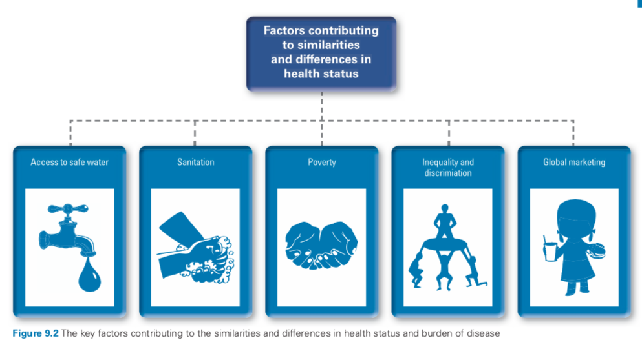

**ACCESS TO SAFE WATER**

* Unsafe water can result in: diarrhoea, cholera, malaria and hookworm
* WHO estimated that 8-% of all sickness and diseases in the world is attributed to inadequate water or sanitation
* When water is safe to drink it is not in needless resource - drought, over-use and pollution all pose as a threat
* UNICEF: 36 countries are currently facing high levels of water stress
  + - factors: warmer temperatures, rising sea levels, increased floods, droughts, melting ice (effect both the quality and availability of water)
* Drought affected areas —> children walk to collect water —> miss school
* No safe water —> spread of communicable water borne diseases
* No safe water —> can’t grow food/keep livestock alive

10 FACTS

1. Globally at least 1.8 billion people use a source of drinking water water contaminated by faecal matter
2. Every day, 1000 children die due to preventable diseases related to water and sanitation
3. Water scarcity impacts more than 40% of the global population
4. Floods and other water-related disasters. Account fro 70% of deaths caused by natural disasters
5. Irrigation yields twice the food production on unirrigated land - critical for meeting the 70% increase in food needs by 2050
6. Agriculture accounts for 70% of global withdrawals
7. Water scarcity, exacerbated by climate change , could cost some regions up to 6% of their GDP
8. When governments respond to water shortages by allocating 25% of water to more highly values uses, losses decline dramatically
9. An estimated 60,000 large dams exist worldwide; more than half have been in operation for more than 50 years
10. Hydropower provides around 85% of the world’s supply of renewable electricity

**SANITATION**

* Includes: poor access to amenities for washing, cooking and going to the toilet; overcrowded living conditions, inappropriate housing and poor drainage; a lack of developed sewerage systems; and insufficient knowledge about the spread of infectious diseases; no collection and safe disposal of garbage
* Around the world 946 million people defecate in the open due to lack of toilet facilities
* People living in rural areas have significantly less access to clean water and sanitation. The number of people living without sanitation in urban areas is increasing too, due to rapid urbanisation.

**POVERTY**

* The World Bank: people living under US$1.90 a day
  + - * BUT, it is not just a low income but also a lack of food, services and essential goods
* Extreme poverty rates have been cut by half since 1990
  + - * BUT 1 in 5 people in low income countries still live in extreme poverty
* A country that is experiencing poverty is generally unable to provide such resources as safe water and sanitation, education, social security and adequate healthcare for its citizens. The consequences are low literacy and immunisation rates, high maternal and infant mortality, and high rates of infectious diseases.
* Every year, many children are born into poverty, a life of poor health, missed education and increased violence, insecurity and discrimination. Poverty means that people do not have their needs met in relation to basic requirements such as food, water, healthcare and education, nor do they have the opportunity and choice to improve their living standards.
* 70% of the world’s poor live in middle income countries (shift)
* There is a direct link between poverty and ill-health. The consequences of poverty are far reaching and long lasting, including child deaths and mental health issues.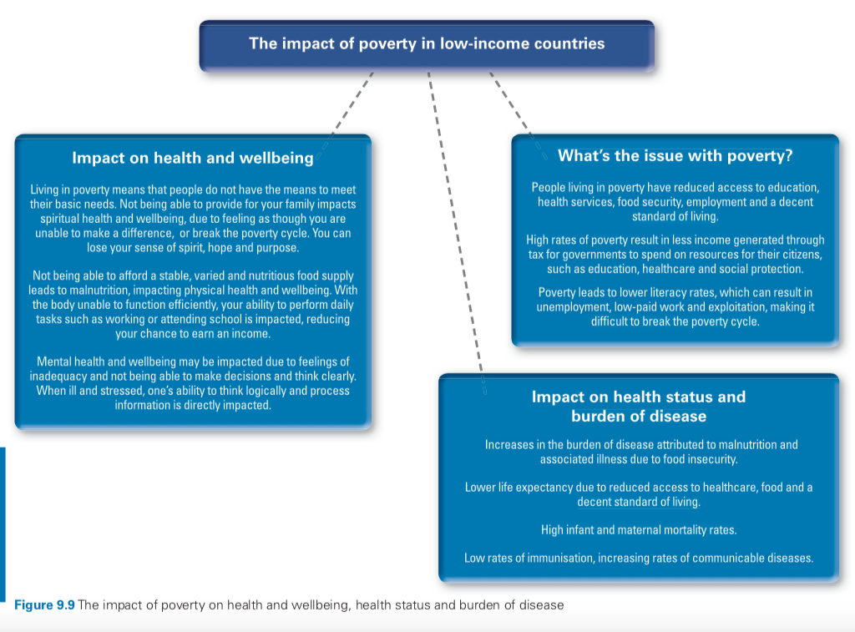

**INEQUALITY AND DISCRIMINATION**

DISCRIMINATION

‘All human beings are born free and equal in dignity and rights.’ - (Universal declaration of Human Rights)

* The United Nations has established a world- wide effort to end discrimination, including against people with minority gender identities and sexual orientation
* In high-income countries, there are laws and regulations to fight discrimination based on race, religion, gender and sex, but not all people living in low- and middle-income countries experience what should be their guaranteed human rights.
* RACE
  + - Racial discrimination occurs daily - impacts mainly mental health
    - All victims of racism can experience mental and social health impacts from bullying and social exclusion, as well as physical health impacts. Ongoing racism increases psychological distress, with most people experiencing discrimination based on their race multiple times
* RELIGION
  + - Involves treating a person differently or unfavourably because of their religious beliefs.
    - This can include restrictions on their civil, cultural, economic, political and social rights. For some, impacts also extend to discrimination with regard to access to education and healthcare, arrest or even death due to their religion.
* SEX
  + - Life expectancy varies between males and females
    - Major differences exist in mortality and morbidity, particularly in low- and middle-income countries.
    - In high income countries females and males have mostly the same opportunities, there are also laws that protect the rights of both males and females - anti-discrimination based on race, religion, sex, sexual orientation or gender identity
    - In many low- and middle- income countries, the status and treatment of women is worse then men in almost all areas, including access to education, income, early marriage, child labour, exploitation, employment and legal rights.
* SEXUAL ORIENTATION AND GENDER IDENTITY
  + - Rates of homelessness, joblessness, food insecurity depression and suicide are much higher among LGBTQI population
    - Between half and two-thirds of the LGBTQI youth experienced bullying during childhood —> skipping or dropping out of school and reduced mental health
    - Don't access healthcare <— education, employment, housing <— discrimination
    - People may also be disowned and mistreated by their own family

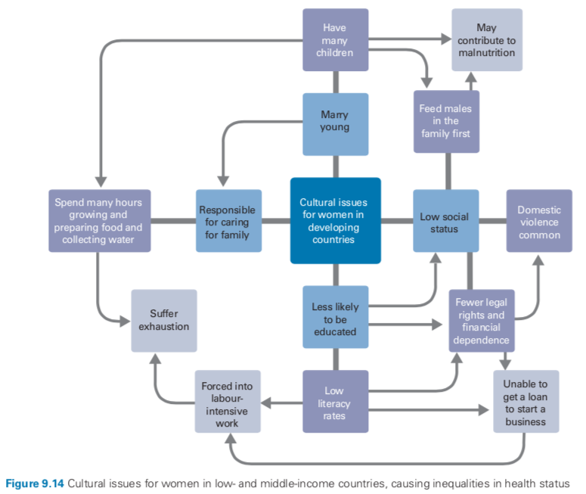

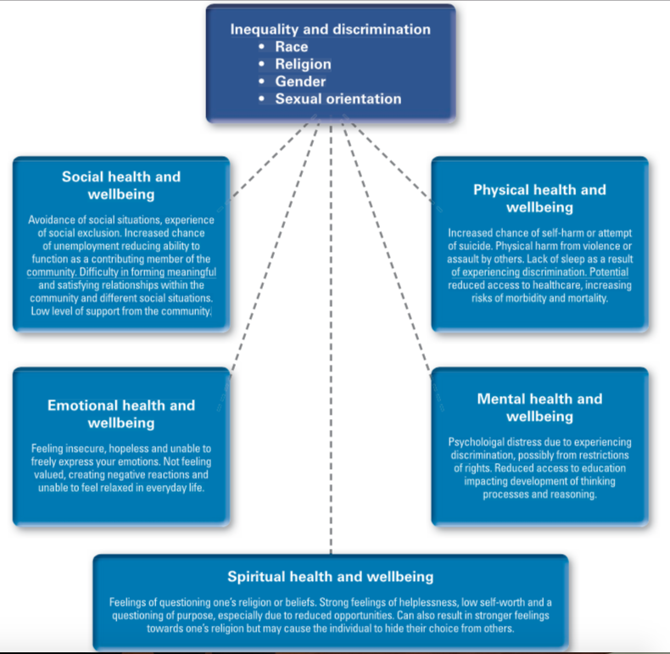

**GLOBAL MARKETING - tobacco, alcohol, processed food**

* *TOBACCO*
  + - Past 20 years - increase in number of people in low and middle income countries who smoke
    - Leading cause of death, illness and impoverishment
    - WHO: tobacco epidemic is one of the biggest health threats the world has ever faced
    - Killing 6 million people a year
      * More than 5 million are a result of infect tobacco use
      * 600,000+ are as a result of passive smoking/secondhand smoke
    - Tobacco companies have moved their target away from high-income countries, as smoking rates have fallen in those nations, to more vulnerable low- and middle-income countries.
    - 80% of the world’s smokers are in low and middle income countries —> access to healthcare is often limited and governments are ‘lax’ about regulating the industry
    - Low income countries are being urged to adopt measures to deter people from smoking
    - Many high income countries have banned tobacco advertising on billboards, radio, television and even in films as a product (ex. Australia, US)
    - BUT in low income countries multinational tobacco companies advertise and target vulnerable population there ads are unchecked (example. Africa, South-east Asia)
      * Governments are often happy to earn money from the sale of tobacco and they do not have health promotion organisations to advocate against or educate people about the risks of tobacco smoking
    - (!!) In low and middle income countries cigarettes are the only ingested substance not governed by laws on content – which is how tobacco companies are able to add ammonia to cigarettes to help the nicotine reach the brain faster.
    - People who die prematurely of tobacco mean they can’t support their family and the economy
    - Tobacco has an effect on the environment as trees needed to cure the tobacco leads to deforestation —> soil loses nutrients —> food can’t be grown
    - In low socio-economic countries there is a lower level of public awareness about the consequences fo smoking —> less educated - more likely to smoke
* *ALCOHOL*
  + - Increased availability and changes in trade agreements —> increase alcohol use in some low and middle income countries
    - Alcohol misuse can contribute to: cancer, CVD, cirrhosis (liver), mental illness, injuries, traffic accidents and premature death
    - In low and middle income countries people are more vulnerable to social consequences of alcohol such as poverty, under-nutrition and violence
    - Worldwide 3.3million deaths have been due to the harmful use of alcohol
    - 139 million DALYs or 5.1% of the global BOD and injury is due to alcohol
    - 3rd largest risk factor for BOD
    - In relation to the production, distribution, marketing and sales of alcohol, policy-makers in low- and middle- income countries have a real challenge facing them.
      * The sale of alcohol creates employment and generates income and tax for governments. Public health measures to reduce harmful use of alcohol are sometimes judged to be in conflict with other goals like consumer choice, and can be seen as harmful to the economy.
* *PROCESSED FOODs*
  + - More variety of food available in L&M income countries
    - Significant amount of multinational processed food manufacturers coming into L&M income country marketplaces —> consumption of unhealthy food is reaching, and in some cases exceeding, the level witnessed in high-income countries.
      * More people in L&M income countries eating more saturated fats, sugar, salt and refined carbohydrates
    - Due to this there are a number of countries with both childhood under-nutrition and obesity (especially in urban areas)
      * In rural areas, staple foods are cheaper but in urban areas processed foods are less expensive, and therefore more accessible
      * It is not uncommon to find under-nutrition and obesity coexisting in the same community

**GLOBAL TRENDS AND THEIR IMPLICATIONS FOR HEALTH AND WELLBEING**

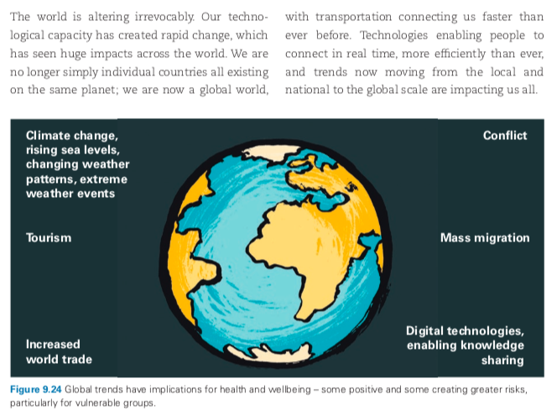

**CLIMATE CHANGE**

* Climate change is due to global warming
* among the greatest health risks of the 21st century
  + Rising temperatures
  + Changing weather patterns
  + Extreme weather lives
    - * ALL directly costing lives, increasing transition and spread of infectious diseases
      * Impacting clean air, water and food
* Between 2030 and 2050 climate change is expected to cause approximately 250,000 additional deaths per year from malnourishment, malaria, diarrhoea and heat stress
* Contributing to: expansion of deserts through poor rainfall, rising sea levels, increased flooding, change in weather patterns (ex. Cyclones) and increased health risks due to increases speed of diseases such as malaria - all from increasing temperatures
* Causes fo climate change: during of fossil fuels (oil, coal, gas), clearing forests (increase CO2)
* Poorest nations will experience greatest impact
* High income countries are predominantly responsible for climate change BUT L&M income countries will be impacted the most - they are hit the hardest by natural disasters such as extreme weather conditions and do not have resources to cope
* *RISING SEA LEVELS*
  + - Glaciers melt —> sea level rises
    - More than half the worlds population lives within 60kms of the sea —> people are being forced to leave their homes leading to stress and anxiety —> impacting mental and emotional health and wellbeing
    - Food supply is reduced —> Reduced physical health and well-being
    - Communities need to re-establish —> reduction in social health and well-being (loss of sense of security and belonging and ability to function as a contributing member)
    - Loss of land, change in home landscape, loss of cultural connection to land —> spiritual health and well-being impacted
* *CHANGING WEATHER PATTERNS*
  + Extreme heat
    - * Extreme heat - occurring more often and for longer (2014-2016) have been the hottest years ever
      * Contributes directly to deaths from CVD and respiratory disease particularly with elderly
      * Pollen and other air pollutants is higher
        + Can trigger asthma - affecting 300 million people
        + Exacerbating CVD and respiratory
      * Overall, heatwaves accounted for 148000 of the 164000 lives lost due to extreme temperatures, with 92 per cent occurring in high-income countries.
  + Changing rainfall patterns
    - * Impacts supply of freshwater
      * Lack of safe water —> compromises sanitation, increases risk of communicable diseases such as diarrhoea
      * Water scarcity affects 40% of people
      * Impacts food production
      * Increases rates of malnutrition (particularly L&M income)
      * Predicted that frequency and intensity of drought and change rainfall patters are likely to increase across the globe
  + More extreme weather events
    - * More intense and more frequent - exacerbated by climate change
      * Records for extreme temperature continues to be broken annually
      * Occurrence of floods has increased in both intensity and frequency - predicted to continue —>. Directly causes injury and death, contaminate fresh water supplies, increase risk of water borne diseases and create breeding ground for disease-carrying insects (mosquitos)—> increases the risk of malaria
      * Floods cause displacement of people —> stress, tension and conflict
      * Can also impact health services and supply of medicine
      * Places most at risks of floods are coastal areas, small islands, low income countries (as they cannot cope sufficiently with natural disasters)

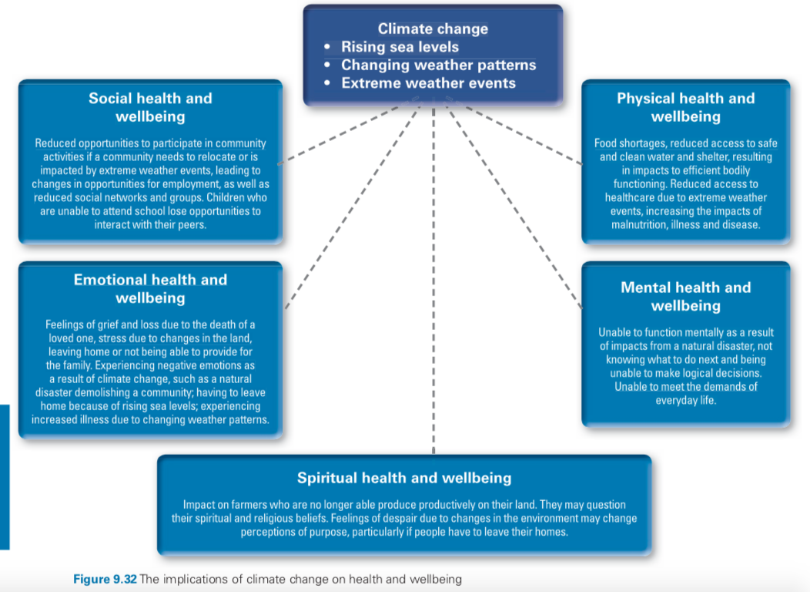

**CONFLICT AND MASS MIGRATION**

* *CONFLICT*
  + - Directly impacts mortality rates
    - Reduced life expectancy
    - Increase in morbidity due to injury and communicable diseases
    - War situations put pressure on
      * resources and issues of food insecurity
      * Decreases access to healthcare
      * Decreased access to education
    - People who live in the midst of conflict have less freedom, opportunity and choice about their lives and fewer resources that are needed for health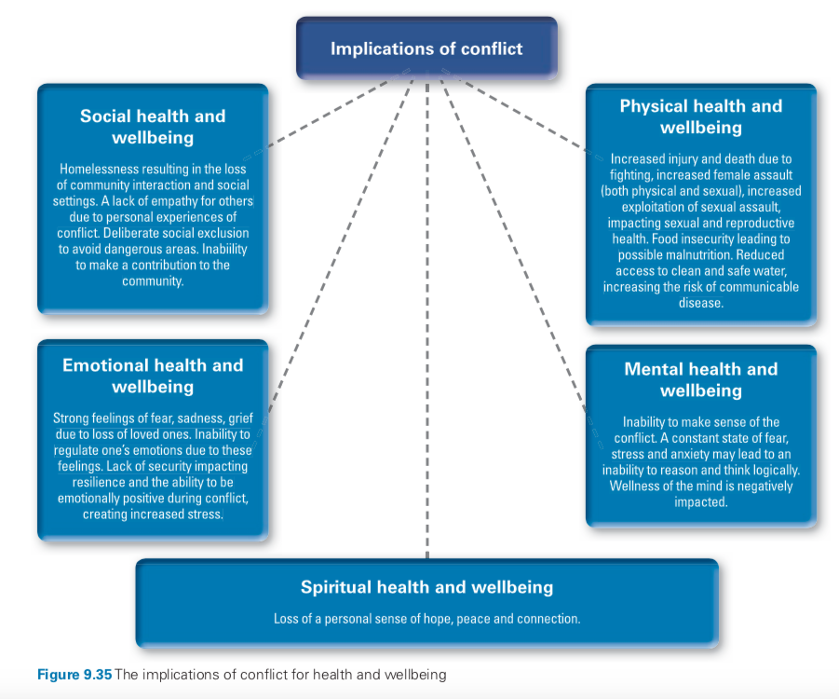
* *MASS MIGRATION*
  + - The world is currently facing its worst refugee/mass migration crisis since WWII, with people being forced to flee their homes due to conflict, persecutions and natural disasters that have been intensified due to climate change
    - Migrants today are too often met with suspicion and intolerance
    - Migrants spend many years in refugee camps - crowded conditions, sharing tents and resources, basic supplies —> increased risk of communicable diseases spreading (example. Respiratory infections, gastrointestinal illnesses)
    - Many have to flee —> can cause life threatening physical and mental health issues (injuries, stress, ADHD MANY MANY MORE)
    - Other than physical issues due to lack of services, health care, sanitation medication etc.. people can feel a loss of identity, language and cultural barriers, licing in fear, financial insecurity and poverty due to having to start all over again

**INCREASED WORLD TRADE AND TOURISM**

* *WORLD TRADE*
  + - Both a negative and positive impact
    - Many L&M income countries are dependent on exports for income. While increased global trade does have the potential to assist poorer countries, it is often the wealthier nations who benefit most from trade arrangements.
    - With only a small range of agricultural or mineral products for export, low- and middle-income countries are vulnerable to the global market and price fluctuations. But with a focus on fair trade, international trade arrangements, trade restrictions and taxes, increased world trade does have the potential to provide increased economic security to people in low- and middle-income countries and enable them to break the poverty cycle. Increased trade generates increased income which has positive impacts on health and wellbeing, increasing life expectancy, enabling people to reach their full potential, increasing the standard of living and improving lives. Fair trade is an example of ensuring producers in low- and middle-income countries are getting a ‘fair deal’ for their products, services and labour, which is enabling them to break the poverty cycle.
      * Essentially people working/producing goods in L&M income countries are likely to get exploited so that’s why we have fair side as a security for them
* *TOURISM*
  + - World is more interconnected than before
    - Tourism boom
    - L&M income countries have benefitted from this increased flow of people bringing income to their economies, providing jobs and creating new markets for goods and services, especially in traditional products
    - Negative impacts: biodiversity and environmental ecosystems from increased pollution, transportation and human interaction - increased communicate ideas transfer around the world
    - People are also travelling to other countries to receive medical treatment, dental and surgical care because fo affordability and better access to care or higher quality of care

**DIGITAL TECHNOLOGIES THAT ENABLE INCREASED KNOWLEDGE-SHARING**

* ADD INFO: