* rationale and objectives of the UN’s SDGs
* key features of SDG 3 ‘Ensure healthy lives and promote wellbeing for all at all ages’
* relationships between SDG 3 and SDGs 1, 2, 4, 5, 6 and 13 that illustrate collaboration between the health sector and other sectors in working towards health-related goals

**THE SUSTAINABLE DEVELOPMENT GOALS**

* Also known as Global Goals
* Plan to help
  + People
  + Planet
  + Prosperity
* 17 goals to transform our world
* 70 countries contributes to develop these goals
  + 193 agree to them
* **5 target areas/domains: people, planet, partnership, peace, prosperity**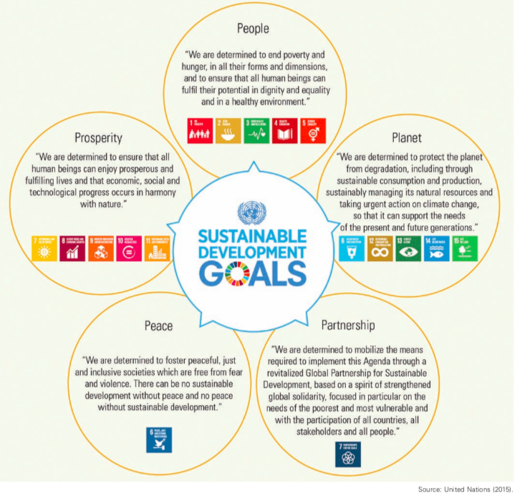

|  | RATIONALE | OBJECTIVE |
| --- | --- | --- |
| Definition + synonyms | a set of reasons or a logical basis for a course of action or belief. | A goal or aim |
| Examples | * Work in partnership and pragmatism —> right choices—> improve live in sustainable way * Build on MDG (Millennium Development Goals) * 3 dimensions   + - Environmental     - Social     - Economic * Seek to   + Free people from the tyranny of poverty (eradicate in all forms and dimensions)   + Strengthen universal peace | * + - End extreme poverty     - Fight inequality and injustice     - Address climate change |

*PURPOSE*

* Focus on action and implementation through
  + - capacity building
    - Technology
    - Financial resources
    - Global focus
    - Accountability
* To solve big issues/objectives such as poverty range of factors need to be addressed
  + - Education
    - Health
    - Social protection
    - Job opportunities
    - Climate change
    - Environmental protection

*VISION*

* Create an environment - at the national and global levels alike which is conducive to development and elimination of poverty
  + - Fairer
    - More prosperous
    - Peaceful
    - Sustainable
    - No one left behind

**COLLABORATIVE APPROACH**

* Achieving the SDGs requires collaborative approaches between:
  + - high, middle and low countries,
    - groups within communities
    - health sector and other sectors
    - each of the SDGs, involving or working together with two or more parties towards achieving the same goals.
* The SDGs are very interrelated and effect each other
  + - EXAMPLE:

**SDG 3**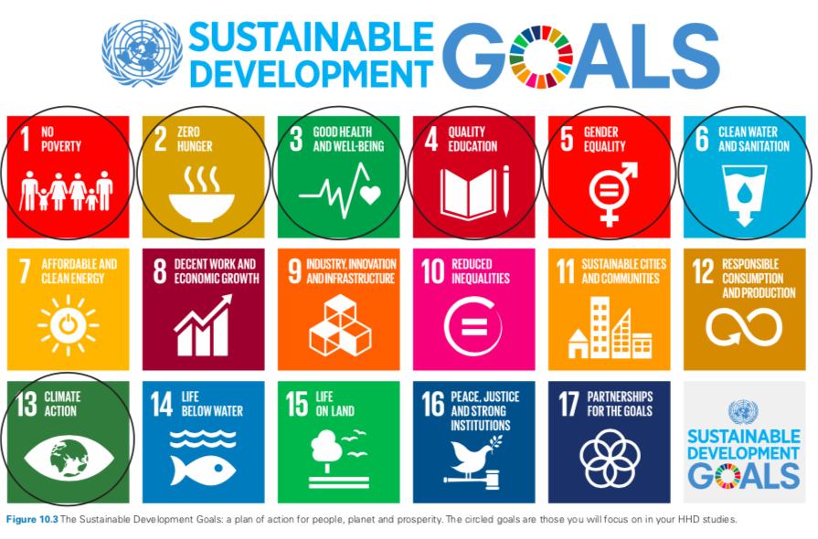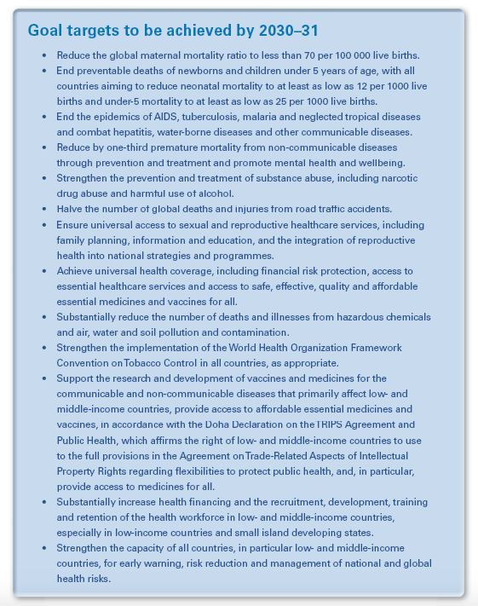

Ensure healthy lives and promote wellbeing for all at all ages aims to ensure health and wellbeing for all people at all ages by improving *reproductive*, *maternal* and *child* *health*; ending the *epidemics* of major *communicable diseases*; reducing *non-communicable* and *environmental diseases*; achieving *universal health coverage*; and ensuring *access* to *safe, affordable* and *effective* *medicines* and *vaccines* for all.

Ensuring healthy lives and promoting the well-being for all at all ages is essential to sustainable development. Significant strides have been made in increasing life expectancy and reducing some of the common killers associated with child and maternal mortality. Major progress has been made on increasing access to clean water and sanitation, reducing malaria, tuberculosis, polio and the spread of HIV/AIDS. However, many more efforts are needed to fully eradicate a wide range of diseases and address many different persistent and emerging health issues.

- without SDG 3 other SDGs can’t be achieved -

**REDUCE THE GLOBAL MATERNAL MORTALITY RATIO**

* From 990 and 2015, the global mortality ratio declined by 44 per cent
* Globally, maternal mortality is the second highest cause of death among women of reproductive age.
* 830 women die every day due to complications of pregnancy and childbirth, and most of these deaths could be prevented (WHO)
* Gap in maternal deaths between developed and developing coun- ties is often termed the greatest health divide in the world (UNICEF)
* Major causes of mortality
  + - Haemorrhage
    - Infection
    - High blood pressure
    - Unsafe abortion
    - Obstructed labour
* Solution
  + - good quality antenatal, childbirth and postpartum care
    - Family planning information (stop unwanted pregnancies)
* Preventative factors to improvement
  + - Availability and affordability of healthcare
    - Lack of information and knowledge
    - Gender inequity
    - Poverty
    - Geographic location (rural areas)
* Women are more likely to suffer (compared to men)
  + - Malnutrition
    - Anaemia
    - Chronic ill-health
    - Forced marriage at a young age —> have babies younger —> increased maternal mortality/morbidity —> mother dies —> child is 10 times more likely to die before 2years old (increase under five mortality rate)
    - Education —> less likely to get married early —> more knowledge of healthcare

**END PREVENTABLE DEATHS OF NEWBORNS AND CHILDREN UNDER 5**

* 2015: 5.9 million children under 5 years of age died( 45 per cent of them newborns)
* MAIN CAUSES:
  + malaria
  + diarrhoea
  + pneumonia.
* Currently 79 countries don’t meet target for U5, 83 do not for neonatal mortality
* INTERVENTIONS
  + Healthcare
  + Vaccination
  + Clean and safe water
  + Bed nets (malaria prevention)

**END THE EPIDEMICS OF**

* **AIDS,**
* **TUBERCULOSIS,**
* **MALARIA AND**
* **OTHER NEGLECTED TROPICAL DISEASES AND**

**COMBAT**

* **HEPATITIS,**
* **WATER BORNE DISEASES AND**
* **OTHER COMMUNICABLE DISEASES**
* Rates have declines from 2000-2015 (HIV, TB, malaria)
* Globally major causes of morbidity and mortality - esp. low income countries
* Unhealthy environments —> increase risk of both infectious and non-communicable diseases
* Deaths from infectious are caused mostly by
  + - faecal contamination of water and soil,
    - inadequate hand washing facilities
    - Hygiene practices

HIV

* Increased education on the transmission, testing, diagnosis and provision of anti-retroviral treatment —> will impact new infections and HIV related deaths

TB

* Occurs almost everywhere in the world - but is treatable/curable
* Rate of TB in low income countries is nearly 10 times higher than high income countries
  + Mortality rates almost 20 time higher
* Treatment is very successful BUT relies on timely diagnosis and correct treatment - need for quality healthcare —> focused on prevention and treatment to address issue

MALARIA

* More than 2/3 of the deaths due to malaria in 2015 were children under 5
* Focus of goal: universal access to malaria prevention (through mosquito nets!!)
  + Reduce the incidence of malaria worldwide - re-establishment of all countries as malaria free
* Biggest barrier: inadequate funding to provide resources needed - esp. to those most vulnerable - women and children + those in rural and remote communities
* How to treat: educate women about importance of malaria prevention, provide affordable mosquito nets and essential medical treatments when malaria is diagnosed
  + Incidence of malaria will reduce significantly

**REDUCE PREMATURE MORTALITY FROM NON-COMMUNICABLE DISEASES THROUGH PREVENTION AND TREATMENT, AND PROMOTE MENTAL HEALTH AND WELLBEING**

* Major interventions addressing
  + - * Tobacco use
      * Physical activity
      * Unhealthy diet
      * High salt intake
      * Obesity
      * Diabetes
      * Hypertension
* emphasising education about risk factors/prevention/treatment
* Access to medicine and technology
* Increased globalisation and marketing, and increasing world populations

**STRENGTHEN THE PREVENTION AND TREATMENT OF SUBSTANCE ABUSE, INCLUDING NARCOTIC DRUG ABUSE AND HARMFUL USE OF ALCOHOL.**

* Significant health burden for most WHO regions
  + 3.3 million deaths (6%) of deaths were attributable to alcohol
* prevention through strengthening health systems, policies and education
* Care and treatment + social strategies/rehab to all regardless of SES

**REDUCE THE NUMEBR OF GLOBAL DEATHS AND INJURIES FROM ROAD TRAFFIC INCIDENTS (HALVING)**

* more occurring in poorer countries
  + - Vulnerable users (pedestrians, cyclists, motorbike, children, elderly, disables)
* increasing number and usage —> more vulnerable people
* Effort by government
  + - Legislation
    - Improved vehicle standards
    - Road infrastructure
    - Post-crash healthcare

**ENSURE UNIVERSAL ACCESS TO SEXUAL AND REPRODUCTIVE HEALTHCARE SERVICES, INCLUDING FOR FAMILY PLANNING, INFORMATION AND EDUCATION, AND THE INTEGRATION OF REPRODUCTIVE HEALTH INTO NATIONAL STRATEGIES AND PROGRAMS**

* Especially important for women and girls
  + - Child marriage
* Access to family planning —> reduce girls maternal mortality (15-19y highest cause of death)
  + - Hard to break free form poverty cycle

**ACHIEVE UNIVERSAL HEALTH COVERAGE, INCLUDING FINANCIAL PROTECTION, ACCESS TO QUALITY ESSENTIAL HEALTHCARE SERVICES AND ACCESS TO SAFE, EFFECTIVE, QUALITY AND AFFORDABLE ESSENTIAL MEDICINES AND VACCINES FOR ALL**

* **Universal health coverage** ‘The goal of universal health coverage is to ensure that all people obtain the health services they need without suffering financial hardship when paying for them.’ (WHO, 2014)
* To achieve universal health coverage the factors below must be in place
  + - * A strong, efficient, well-run health system that meets priority health needs through people-centred integrated care (including services for HIV, TB, malaria, non- communicable diseases, maternal and child health) by:

informing and encouraging people to stay healthy and prevent illness

detecting health conditions early

having the capacity to treat disease

 helping patients with rehabilitation

* + - * Affordability - a system for financing health services so people don’t suffer financial hardship to use them
      * Access to essential medicines and technologies to diagnose and treat medical problems
      * Sufficient capacity of well-trained, motivated health workers to provide services to set patients’ needs based on the best available evidence.
  + Different sectors must work together - transport, education and urban planning
  + Direct impact on health —> people more productive —> contribute to community and family
  + Universal health coverage is a critical com- ponent of sustainable development and poverty reduction, and a key element of any effort to reduce social inequities. Universal coverage is the hallmark of a government’s commitment to improve the wellbeing of all of its citizens.

**SUBSTANTIALLY REDUCE THE NUMBER OF DEATHS AND ILLNESS FROM HAZARDOUS CHEMICALS, AND AIR, WATER AND SOIL POLLUTION CONTAMINATION**

* caused by: cooking, fuels, traffic and industrial waste
  + LARGEST SINGLE ENVIRONMENTAL HEALTH RISK
* While mortality rates vary, air pollution is a major risk factor for NCDs in adults, and a large number of deaths can be attributed to pollution.
* Air pollution is estimated to cause half of all U5 child pneumonia deaths
* Environmental contamination, industrial emissions or occupational exposures (pesticides, paints, solvents and cleaning substances)
* Chemicals available in the market
* To improve
  + - Water infrastructure and sanitation facilities
    - Safe waste management systems
    - Proper hand-washing
    - Hygiene practices
    - Improved healthcare

**STRENGTHEN THE IMPLEMENTATION OF THE WHO FRAMEWORK CONVENTION ON TOBACCO CONTROL IN ALL COUNTRIES AS APPROPRIATE**

* the WHO framework convention on Tobacco control is designed to counter the tobacco epidemic
  + - Includes raising taxes
    - Banning smoking in public places
    - Pictorial warnings
    - Bans on tobacco advertising
    - Preventing sales to minors

**SUPPORT THE RESEARCH AND DEVELOPMENT OF VACCINES AND MEDICINES FOR THE COMMUNICABLE AND NON-COMMUNICABLE DISEASES THAT PRIMARILY AFFECT LOW- AND MIDDLE-INCOME COUNTRIES**

**PROVIDE ACCESS TO AFFORDABLE ESSENTIAL MEDICINES AND VACCINES, IN ACCORDANCE WITH THE DOHA DECLARATION ON THE TRIPS AGREEMENT AND PUBLIC HEALTH, WHCIH AFFIRMS THE RIGHT OF LOW- AND MIDDLE-INCOME COUNTRIES TO USE TO THE FULL THE PROVISIONS IN THE AGREEMENT ON TRADE RELATED ASPECTS OF INTELLECTUAL PROPERTY RIGHTS REGARDING FLEXIBILITIES TO PROTECT PUBLIC HEALTH AND, IN PARTICULAR, PROVIDE ACCESS TO MEDICINES FOR ALL**

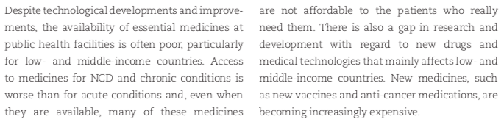

**SUBSTANTIALLY INCREASE HEALTH FINANCING AND THE RECRUITMENT, DEVELOPMENT, TRAINING AND RETENTION OF THE HEALTH WORKFORCE IN LOW- AND MIDDLE-INCOME COUNTRIES, ESPECIALLY IN LEAST HIGH-INCOME COUNTRIES AND SMALL ISLAND DEVELOPING STATES**

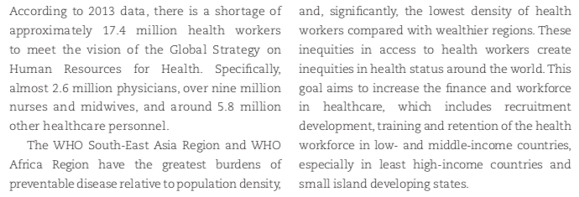

**STRENGTHEN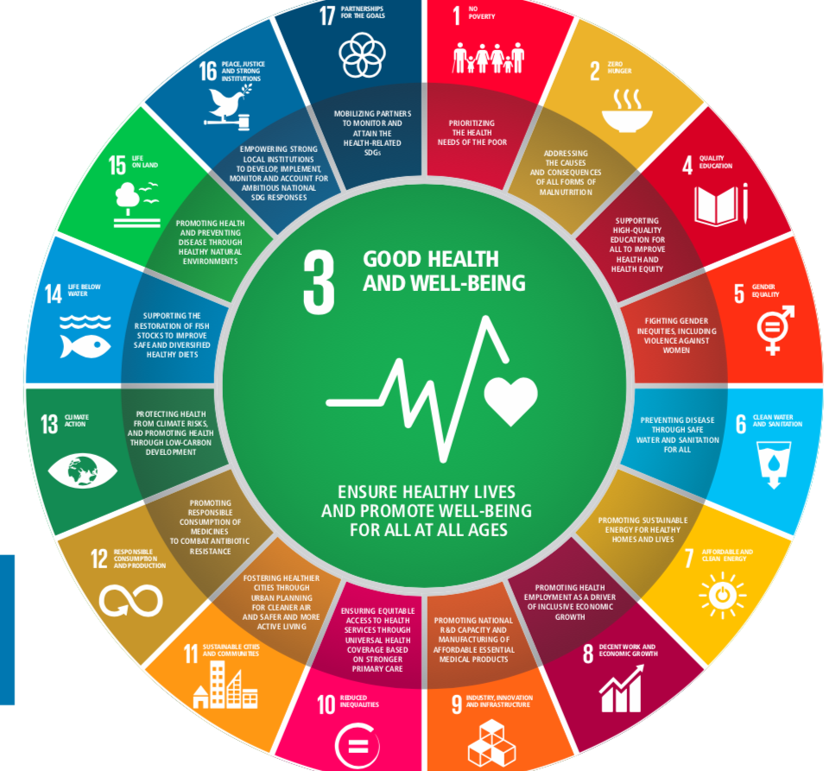 THE CAPACITY OF ALL COUNTRIES, IN PARTICULAR LOW- AND MIDDLE-INCOME COUNTRIES, FOR EARLY WARNING, RISK-EDUCATION AND MANAGEMENT OF NATIONAL AND GLOBAL HEALTH RISKS**

* Disease epidemics, floods, transport accidents, storms and industrial accidents
  + Impact health status AND disrupt the available anda accessible healthcare, food and water supply —> economy and environment
* Effect vulnerable communities/populations (poor, children, women, elderly, disabled, displaced) people more
* Public health risks-> ebola
* Countries must strengthen their level of preparedness and enhance their capacity to respond to hazards and reduce and respond to global threats to health

**RELATIONSHIPS AND INTERDEPENDENCIES BETWEEN SDG 3 AND SDG 1, 2, 4, 5, 6, 13**

**SDG 1: NO POVERTY**

AIMS

* End poverty in all its forms
  + - Extreme poverty (living on less than USD$1.9 a day)
* everyone should enjoy a basic standard of living
* Social protection for poor and vulnerable
  + - Access to basic services and support
      * Impacted bay disaster (natural and human-made)

TARGETS (summarised)

* Eradicate poverty
* Reduce by 1/2 at least proportion of men, woman and shielded in poverty
* Social protection system
* Equal rights to economic resources as well as basic services, ownership and control over and financial services (ex. Microfinance: small, low-cost loans)
* Build resilience of the poor and those in vulnerable situations - reduce exposure to shocks
* Mobilisation of resources
* Sound policy framework in national, regional and International levels

RELATIONSHIP TO SDG 3 **[promising the health needs of the poor]**

* People living in poverty suffer from hunger/malnutrition
* Can’t afford medicine
* Lack of access to safe/clean water
* Lack of access to sanitation
* Living in unsafe homes/areas
* Not able to afford education
* Socially and politically isolated
* Poverty impacts rate of mortality and morbidity
  + - Increased income —> afford nutritious food, access to education, medicine and decent standard of living —> increases life expectancy, reduced mortality rates due to communicable diseases (cholera and malaria) —> improved health and wellbeing
    - Increased income —> education —> better understanding of their rights and responsibilities and have increased access to services such as sexual and reproductive health clinics —> less children to one woman —> lower rated of maternal mortality —> reduced infant mortality —> improved health and well-being (mother and child)
* all sectors must work together to ensure social protection programs such as healthcare targeted food assistance, school feeding, savings program and skills and training subsidies will provide people with access to essential healthcare —> generated income can be spent on other needs (not basic needs like healthcare or access for al children to receive vaccinations)
* Social protection - meant to support the poorest and most vulnerable
  + - Access to healthcare
    - Protection against unemployment
    - Basic services
    - Technology
    - Business and job opportunities
    - Basic services (transport, meds etc…)

**SDG 2: ZERO HUNGER**

AIMS

* end hunger in all forms
* end malnutrition
* Achieve sustainable food production
* Everyone should have access to sufficient nutritious food
  + - requires widespread promotion of sustainable agriculture, agricultural productivity, increased investments and properly functioning food markets

TARGETS

* End hunger (esp. for people in vulnerable situations - infants): safe and nutrirotus food
* End all forms of malnutrition
  + Stunting and wasting in children under 5
  + Address nutritional needs of adolescent girls, pregnant/lactating women and older people
* Double agriculture productivity and income of producers
* Sustainable food protection
* Maintain genetic diversity of seeds, plants etc…

RELATIONSHIP TO SDG 3: **[addressing the causes and consequences of all forms of malnutrition]**

* good nqutrition is the foundation for healthy, productive and sustainable communities
* Required for optimal growth + essential for good health
* Chronic hunger —> nutrient deficiencies, under- nourishment, physical and mental weakness, increased vulnerability to diseases and starvation
* Hurry child —> less likely to have an education —> unable to become productive adults
* Poor nutrition —> child death rates (weak immune system, starvation)
* Good health relies on food security
* Rather than spending money on healthcare needs, money can be redirected into the land and agricultural practices. This will protect biodiversity and enable producers to grow and protect their variety of crops and livestock.

**SDG 4: QUALITY EDUCATION**

AIM

* ensuring that everybody has access to quality education and lifelong learning opportunities
* Gaining foundational and higher order skills at all stages of education and development
* Greater and more equitable access to quality education
* Knowledge, skills and values needed to function well and contribute in society

TARGETS

* Ensure all boys and girls complete free, equitable and quality primary and secondary education —> relevant and effective learning outcomes
* Access to quality early childhood development (preschool/kinder/childcare)
* Equal access for all women and men to affordable and quality technical, vocational and tertiary education, including university.
* Substantially increase the number of youths and adults who have relevant skills, including technical and vocational skills, for employment, decent jobs and entrepreneurship.
* Eliminate gender disparities in education at all stages (including. disabled, indigenous and vulnerable people)
* All youth and a substantial proportion of adults achieve literacy and numeracy
* Learners acquire the knowledge and skills needed to promote sustainable development
  + - Education for sustainable development
    - Sustainable lifestyles
    - Huam rights
    - Gender equality
    - Promotion of culture of peace and non-violence
    - Global citizenship and appreciation of cultural diversity
* Build and upgrade education facilities that are child, disability and gender sensitive and provide safe, non-violent, inclusive and effective learning environments for all.
* Expand globally the number of scholarships available to low- and middle-income countries
* Increase the supply of qualified teachers

RELATIONSHIP TO SDG 3: **[supporting high-quality education for all to improve health and healthy equity]**

* correlation between increased education levels and increased living standards
* Only achievable if all of the world’s children have a access to education and the chance to learn
* Children born to women who have completed secondary school and twice as likely to survive compared to uneducated mothers
* Too many children (esp girls) are denied education —> can’t/less likely to make a better life for themselves
* Young people who have completed a primary school education are less than half as likely to contract HIV
* School —> causes of ill health and factors that promote good health —> prevent the onset of disease and illness —> better knowledge on how to prevent ill health
* No/lack of education —> more likely tp work in vulnerable, dangerous and insecure jobs such as labour-intensive work + increasing child exploitation risk —> physical and mental health —> hard to break poverty cycles even though employed
* With good health/parents have good health —> can attend school/ send kids to school [inter-relationship]

**SDG 5: GENDER EQUALITY**

AIM

* Empower women and girls to reach their full potential—> equal opportunities
* Eliminating all forms of discrimination and violence against women and girls (inc. family, sexual)
* Eliminating female genital mutilation and sexual violence
* Women have better access to paid employment
* Women have better sexual and reproductive rights
* Women have real decision making power in public and private spheres - sustainable

TARGET

* End discrimination in all forms everywhere
* end violence - including trafficking and sexual and other exploitation methods
* End harmful practices
  + - FGM
    - Forced and early marriage
* Promotion of shared responsibility within the household and the family as nationally appropriate
* Ensure women’s full and effective participation and equal opportunities for leadership at all levels of decision- making in political, economic and public life
* Access to sexual and reproductive health rights
* Reforms to give women equal rights to economic resources, as well as access to ownership and control over land and other forms of property, financial services, inheritance and natural resources, in accordance with national laws.
* Enabling technology, in particular information and communications technology,  
  to promote the empowerment of women.
* Adopt and strengthen sound policies and enforceable legislation for the promotion of gender equality and the empowerment of all women and girls at all levels.

RELATIONSHIP TO SDG 3: [**fighting gender inequalities, including violence against women]**

* Some countries girls are deprives healthcare or proper nutrition (because of gender) —> higher mortality rates
* Healthy women —> healthier family + children
* FGM —> risk of infection (HIV), prolonged bleeding, childbirth complications, infertility + death —> physical mental and sexual health (social, emotional and spiritual health)
* Women complete majority of unpaid work (cooking, cleaning, caring for family, collecting water) —> less time for other things (leisure, education, relaxation, social activities, self-care)
* Education—>increase farm productivity, illness/disease prevention + delay marriage —> delay childbirth —> decrease maternal mortality —> better health of family too

**SDG 6: CLEAN WATER AND SANITATION**

AIM

* drinking, sanitation and hygiene
* AND quality and sustainability of water resources —> survival of people and planet
* Impacts other areas - health, education and poverty reduction
* Not just infrastructure but education

TARGETS

* Universal and suitable access to safe and affordable drinking water for all
* Adequate and equitable sanitation and hygiene
* End open defecation - esp for girls/women
* Improve water quality - reducing pollution, eliminate dumping, minimising release of hazardous chemicals and materials, halving the proportion of untreated wastewater and substantially increasing recycling and safe refuse globally.
* Ensure sustainable withdrawals and supply of freshwater to address water scarcity
* Implement integrated water resources management
* Protect and restore water-related ecosystems, including mountains, forests, wetlands, rivers, aquifers and lakes.

RELATIONSHIP TO SDG 3: **[preventing disease through safe water and sanitation for all]**

* Adequate and safe water is critical for health
* Water - hydration BUT also production of food, sanitation, hygiene and protection from disease
* Healthy people cannot exist without healthy and sustainable environment
* Dehydration —> mortality risk increase
* Unclean water—> spread diseases (diarrhoea) —> physical health —> can’t go to school/work
  + Cannot break poverty cycle
* Better access to clean water —> improved health status and life expectancy —> contribute to and engage in their community
* Healthy —> attend school —> learn the importance of water/sanitation etc —> shared with fam

**SDG 13: CLIMATE ACTION**

AIM

* Biggest threat to development —> effects disproportionately burden the poorest
* Combat climate change
* Build resilience in responding to climate related hazards and natural disasters

TARGET

* Strengthen resilience and adaptive capacity to climate-related hazards and natural disasters in all countries.
* Integrate climate change measures into national policy, strategies and planning
* Improve education/awareness on climate change mitigation, adaption, impact reduction and early warning.

RELATIONSHIP TO SDG 3: **[protecting health from climate risks, and promoting health through low-carbon development]**

* Climate change —> biggest threat to development (esp. vulnerable populations)
* Climate change —> threatening global food security, water systems,
* Reduced pollution, temperature rise and greenhouse gases —> impact health
* Natural disasters —> impact individuals and communities —> mortality + spread of communicable diseases —> death rates spoke —> have to respond to urgent emergency aid needs, dedicating their resources to food, safe water, temporary shelter and health, rather than being able to focus on issues of development such as economic growth
* Climate change —> water —> food insecurity —> poverty —> health and wellbeing
* Climate change —> rising sea levels/natural disaster —> displaced people
* Work on climate action —> improve the lives of individuals and communities —> security, stability —> good health and wellbeing—> governments and communities —> strengthening their environment and economy
* Policy and initiatives to promotes climate change
* Citizens who focus on reducing their individual impacts

