* priorities and work of the WHO
* the purpose and characteristics of different types of aid including emergency, bilateral and multilateral
* features of Australia’s aid program including its priority areas and the types of partnerships involved
* the role of non-government organisations in promoting health and wellbeing, and human development

**WHO**

* established 1984
* UN agency for promoting good health for all

**AREAS OF WHO**

* *Health systems* - moving towards universal health coverage. Policy making, civil society, academia and private sector—> support countries to develop, implement and monitor national health plans. assure the availability of equitable integrated people-centred health services at an affordable price
* *Non-communicable diseases* - [heart disease, stroke, cancer, diabetes and chronic lung disease, and mental health conditions – together with violence and injuries – are collectively responsible for more than 70% of all deaths worldwide] —>These diseases reach beyond the health sector and solutions require more than a system that prevents and treats disease.
* *Promoting health through the life-course* - cuts across all work done by WHO, and takes into account the need  
  to address environment risks and social determinants of health, as well as gender, equity and human rights.The work in this biennium has a crucial focus on finishing the agenda of the Millennium Development Goals (MDG) and reducing disparities between and within countries.
* *Communicable diseases* - increase and sustain access to prevention, treatment and  
  care for HIV, tuberculosis, malaria and neglected tropical diseases and to reduce vaccine-preventable diseases. MDG 6 (combat HIV/AIDS, malaria and other diseases) has driven remarkable progress but much work remains.
* P*reparedness, surveillance and response* - operational role includes leading and coordinating the health response in support of countries, undertaking risk assessments, identifying priorities  
  and setting strategies, providing critical technical guidance, supplies and financial resources as well as monitoring the health situation. WHO also helps countries to strengthen their national core capacities for emergency risk management to prevent, prepare for, respond to, and recover from emergencies due to any hazard that pose a threat to human health security.
* *Corporate services* - provide the enabling functions, tools and resources that makes all of this work possible.

**PRIORITIES OF WHO**

| Priority | Definition | info/importance | work of WHO |
| --- | --- | --- | --- |
| * Advancing universal health coverage | Enabling countries to sustain or expand access to all needed health services and financial protection, and promoting universal health coverage as a unifying concept in global health. |  |  |
| * Health related SDGs | Addressing unfinished and future challenges: accelerating the achievement of the current health-related goals up to and beyond 2015.This priority includes completing the eradication of poliomyelitis and selected neglected tropical diseases. |  |  |
| * Addressing the challenge of non- communicable diseases and mental health, violence, and injuries and disabilities | This trend is most significant in Africa, where the burden of disease due to non-communicable diseases is expected to exceed the total of communicable, maternal, perinatal and nutritional diseases and then become the most common cause of death by 2030. |  |  |
| * Implementing the provisions of the International Health Regulations (2005) | Ensuring that all countries can meet the capacity requirements specified in the Regulations. |  |  |
| * Increasing access to essential, high- quality, effective and affordable medical products (medicines, vaccines, diagnostics and other health technologies) |  |  |  |
| * Addressing the social, economic and environmental determinants |  |  |  |

**TYPES OF AID**

| Type | What | Purpose | Characteristic | Example |
| --- | --- | --- | --- | --- |
| Emergency | The rapid assistance given to people or countries in immediate distress to relieve suffering, during and after human-made emergencies, such as wars, and natural disasters, such as a food, tsunami or earthquake; can also be called ‘humanitarian aid’. | * meet immediate need * Save lives + reduce suffering * Reduce further impacts by meeting the needs of those effected | * rapid assistance * Provision of basic supplies   + Fod   + Water   + Shelter   + Medicine * Short term provision |  |
| Bilateral | Where aid is given by one country directly to another. An example of bilateral aid is when Australia provides aid to East Timor. | * Meet the needs of the country and its people * Builds relationships between countries (may be given for political or strategic reasons) * Promotes health and wellbeing, sustainable economic growth and prosperity | * Long-term assistance * Focused on development * Provision of essential infrastructure such as roads, electricity, improving water supplies * Focus on education such as building schools and training teachers * Building civil society, providing governance and support |  |
| Multilateral | Where aid is provided through an international organisation, such as the World Bank, United Nations or World Health Organization. Combines donations from a number of countries and then distributes them to the recipients. | * Large-scale programs focused on global health and wellbeing, and sustainable development * Can reach and impact the lives of many people * Provided to those most in need | * Provided by an international organisation such as the UN or World Bank * Funded by donations from a number of countries * Medical programs such as large-scale vaccination to reduce the burden of diseases such as polio * Provision of food where most needed by WFP to prevent malnutrition |  |

Bilateral aid - from one country to another.

Multilateral aid - from international organisations which receive money from several countries

**Australian Aid (all of Australian Aid is run by DFAT - gov organisations NGOS are private)**

* **Based on** 
  + Promoting prosperity
  + Reducing poverty
  + Enhancing stability
* P**urpose**: promote Australia’s national interests by contributing sustainable economic growth and poverty reduction
* Aid is delivered on the **strategic framework** that ensures Australian aid:
  + - Pursues our national interests and extends Australia’s influence
    - Impacts on promotion and reducing poverty
    - Reflects Australia’s value-aadd leverage
    - Makes performance count
* **Contributions** of Australian aid
  + - *Emergency aid:* disaster and crisis times - direct to country/area that needs help (Australia is able to send food, water, medicine and personnel and shelter)
    - *Bilateral aid:* work with government of another country to supply aid, such as the training of medical professionals or infrastructure. Australia works with75 other countries through bilateral aid.
    - *Funding non-government organisations and supporting their aid programs (example: surfaid, Red Cross, CARE, Caritas, World Food Program)*: the most effective in meeting the needs of the most vulnerable populations
    - *Funding international multilateral aid programs:* (the UN and the WHO) extends the impact of Australia’s aid, as these large-scale programs are not able to be provided effectively by individual countries.
    - *Expert aid:* companies and individual experts develop projects that will address the Australian governments aid priorities

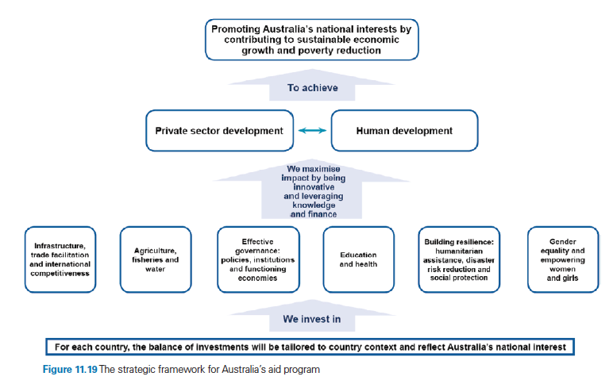

**PRORTIY AREAS**

| Priority area | Info | Examples |
| --- | --- | --- |
| Infrastructure, trade facilitation and international competitiveness | * lack: impact trade opportunities and international competitiveness * Australia's focus: right conditions for sustainable economic growth, trade development and investment opportunities across the Indo-Pacic region. * Infrastructure such as roads, large-scale water and sanitation projects, energy and transport have all been a focus of this aid priority area. * Infrastructure —>opportunities for trade and investment —> employment —>basic services —> economic growth * Not only in physical infrastructure development but also the governance and policy capacity needed to provide safe, sustainable, -affordable and reliable infrastructure.   + - Grants     - Loans     - Skills and knowledge     - Economic empowerment | * a water and sanitation initiative in Indonesia, an economic program encouraging local governments to invest in their own water infrastructure * a focus on roads, including maintenance of existing roads and the construction of new roads, rail and airports |
| Agriculture, fisheries and water |  |  |
| Effective governance: Policies, institutions and functioning economies |  |  |
| Education and health |  |  |
| Building resilience: Humanitarian assistance, disaster risk-reduction and social protection |  |  |
| Gender equality and empowering women and girls |  |  |

**ROLE OF NON-GOVERNMENT ORGANISATIONS**

NGO FOCUS - TABITHA FOUNDATION CAMBODIA

NGO FOCUS - WORLD VISION